Visual step cards
Autumn 2 · Week 2 · Lesson 2 · Tuesday 10 November 2026
I can join a group part and keep the beat.
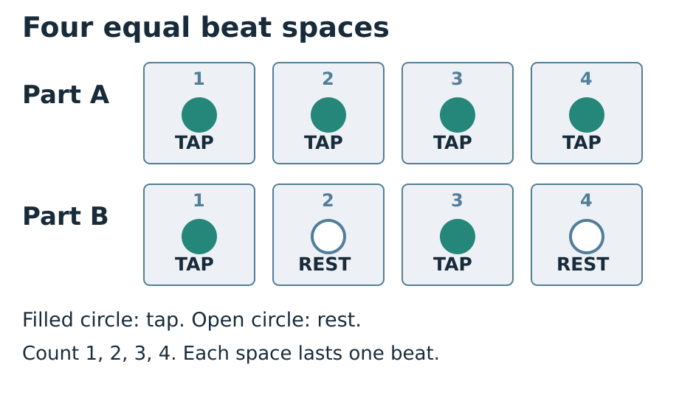
1. Choose: Choose A or B. Keep your own four spaces.
2. Watch: Watch the count-in. Start on the next one.
3. Join: Play your part twice. Keep every rest.
4. Stop: Watch the flat hand. Stop with the group.
You can tap, point, sign, nod or use a quiet hand move. Ask for less sound or a pause. Use your usual way to show what you know.

Words for our group piece
Autumn 2 · Week 2 · Lesson 2 · Tuesday 10 November 2026

part
The bit each player does in the group.

cue
A sign that tells us what to do.

repeat
Do the same part again.

pulse
The even beat that goes on under a part.

Words for my record
My part was ___.
________________________________________________________________
I started when ___.
________________________________________________________________
At REST I ___.
________________________________________________________________
Picture colours: navy headings; blue outlines and beat numbers; teal TAP circles; white REST circles and paper; grey beat spaces; red STOP reminder. Logo: navy background, mint green ring, cream M, amber star, black corners. Words, numbers and shapes give the meaning.

Knowledge organiser
Autumn 2 · Week 2 · Lesson 2 · Tuesday 10 November 2026
I can join a group part and keep the beat.
I can start after a clear count-in.
I can keep my part for two rounds.
I can watch the cue and stop with the group.
part — The bit each player does in the group.
cue — A sign that tells us what to do.
repeat — Do the same part again.
pulse — The even beat that goes on under a part.
Count every rest for one full beat. Watch the count-in and stop signal.
Picture colours: navy headings; blue outlines and beat numbers; teal TAP circles; white REST circles and paper; grey beat spaces; red STOP reminder. Logo: navy background, mint green ring, cream M, amber star, black corners. Words, numbers and shapes give the meaning.
My record: A_Take_Part.pdf · page 2

Fit two parts together
Autumn 2 · Week 2 · Lesson 2 · Tuesday 10 November 2026
Use one count-in. Each line has four beat spaces.
Part A: TAP · TAP · TAP · TAP.
Part B: TAP · REST · TAP · REST.
Play both parts for two rounds.
Watch the cue. Stop together.
My check or next step
________________________________________________________________
________________________________________________________________

Supported route
Autumn 2 · Week 2 · Lesson 2 · Tuesday 10 November 2026

Recall
Show four even beats from last time.
Show a full quiet rest.

In your book
1. Choose A or B with a partner.
2. Point through your four spaces first.
3. Watch a clear count-in of four.
4. Play one round, then try two with help.
5. Show STOP. Pick one next step and retry.
My words or sketch
________________________________________________________________
________________________________________________________________
________________________________________________________________

Check before you finish
Which part did you play or show?
How did you keep your quiet beats?
What will you keep or change next time?
You can tap, point, sign, nod or use a quiet hand move. Ask for less sound or a pause. Use your usual way to show what you know.
Prompt used __________ Support given __________________

Independent route
Autumn 2 · Week 2 · Lesson 2 · Tuesday 10 November 2026

Recall
Show four even beats from last time.
Show a full quiet rest.

In your book
1. Choose your part: A or B.
2. Watch the count-in, then start.
3. Keep your own part for two rounds.
4. Stop at the cue with the group.
5. Say what helped. Use one next step and retry.
My words or sketch
________________________________________________________________
________________________________________________________________
________________________________________________________________

Check before you finish
Which part did you play or show?
How did you keep your quiet beats?
What will you keep or change next time?
You can tap, point, sign, nod or use a quiet hand move. Ask for less sound or a pause. Use your usual way to show what you know.
Prompt used __________ Support given __________________

Aspire route
Autumn 2 · Week 2 · Lesson 2 · Tuesday 10 November 2026

Recall
Show four even beats from last time.
Show a full quiet rest.

In your book
1. Lead a clear, even count-in.
2. Keep B while a partner plays A.
3. After round one, use less spoken counting.
4. Explain how the quiet beats help both parts fit.
5. Swap parts, then compare the two tries.
My words or sketch
________________________________________________________________
________________________________________________________________
________________________________________________________________

Check before you finish
Which part did you play or show?
How did you keep your quiet beats?
What will you keep or change next time?
You can tap, point, sign, nod or use a quiet hand move. Ask for less sound or a pause. Use your usual way to show what you know.
Prompt used __________ Support given __________________

My group part
Autumn 2 · Week 2 · Lesson 2 · Tuesday 10 November 2026
Pupil code __________ Actual date __________
A_Take_Part.pdf · page 2
Draw or mark the four beat spaces in your part.
________________________________________________________________
________________________________________________________________
Pupil code ___ Date ___
________________________________________________________________
My part and way to play were ___.
________________________________________________________________
I kept with the group by ___.
________________________________________________________________
My next step was ___.
________________________________________________________________
On my new try ___.
________________________________________________________________
Give your response in the same colour, on the same page or usual mode.
An adult wrote my words: yes / no. I checked them: yes / not yet.
A helper may write your checked words. Keep the real attempt.

Compare the two original parts
Autumn 2 · Week 2 · Lesson 2 · Tuesday 10 November 2026
Try two short class parts. Part A has four taps. Part B has a tap, a rest, a tap and a rest. Each part has four beat spaces.
Both parts have ___ beat spaces.
________________________________________________________________
Part A has ___. Part B has ___.
________________________________________________________________
In a rest I ___.
________________________________________________________________
I keep the beat by ___.
________________________________________________________________
These are new class patterns. Count each rest for one full beat. A rest is quiet time; it does not remove the beat.

My short book tasks
Autumn 2 · Week 2 · Lesson 2 · Tuesday 10 November 2026

Look back
Show four even beats from last time.
________________________________________________________________
Show a full quiet rest.
________________________________________________________________
Read A or B with a pointer.
________________________________________________________________
Choose one next step from your last try.
________________________________________________________________

Look and choose
A and B both use four even beat spaces. Do they last the same time?
My choice and reason
________________________________________________________________

At the end
Which part did you play or show?
How did you keep your quiet beats?
What will you keep or change next time?
My next step
________________________________________________________________
Respond in the same colour, on the same page or usual mode.

TA brief
Autumn 2 · Week 2 · Lesson 2 · Tuesday 10 November 2026
Use Supported as needed, Independent for a pupil ready to take the lead, and Aspire for more depth. The route changes help, not the shared beat goal. Use five individual records within a pair and a trio; rotate beat keeper, part player and watcher. Never require solo performance. Quiet finger taps, a visible nod or pointing can show the same timing. Teach a raised flat hand as STOP; agree it before sound starts. Keep volume low and use a soft surface. Wait for each pupil to opt into a role and use a trusted partner when needed. Read back scribed words and let the pupil correct them. Give one clear success and one next step. A pupil responds in the same colour, on the same page or usual mode. Mark R only when Voice and Audience are present, one NS has been given and the pupil has made the response. Use VF, WS, I, NS, //, ?, E and R only for what happened. A photograph or class tick does not prove an individual skill. Pupil code and staff fields stay blank until actual use.

Prompt ladder
1. Point to the place or instruction.
2. Ask one short question.
3. Say the instruction in a new way.
4. Give a choice or a small guide.
5. Show the first step only. Then give the task back.

Focus through the lesson
I do: Check each pupil can see the aligned strips and count-in. Identify a comfortable timed movement.
We do: Track one learner per round; note entry, quiet beats and stop. Do not supply a part for them.
Independent: Fade pointing or spoken counts one at a time. Give one timing next step and check the retry before marking a response.

One end question
What helped you join and stay with the group?
Give one next step. Respond in the same colour, on the same page or usual mode. Record R only after Voice and Audience are present, one NS is set, and the pupil responds.

Staff answers and checks
Autumn 2 · Week 2 · Lesson 2 · Tuesday 10 November 2026

Arrival
Any comfortable even timed movement; note whether extra help is needed.
Keep one beat space silent, with a nod or pointer maintaining time.
A is four taps; B is taps on one and three and rests on two and four.
A real next step from lesson one, or a fresh observed need if the pupil was absent. Do not invent prior evidence.

Starter
Yes, if each beat space stays even. A has four sounds. B has two sounds and two rests, all with the same full beat length. Both end after four beats.

Guided practice
A supplies four quiet taps per round. B taps on one and three, keeping two and four as full quiet beats. Both parts start after the same count-in, last eight beats across two rounds and stop together. Observe each pupil’s own timing rather than awarding a group tick.

Exit
A or B, or a pulse/pointer role; the pupil identifies the actual part and mode used.
Count, watch the pointer, nod or follow an even pulse. A rest remains a full quiet beat.
One specific action from the real attempt. Accept a demonstrated change and record the actual prompt.
Accept pointing, quiet movement, speech, signs, drawing and checked scribing. Check the actual beat positions and part; participation alone does not show that a pulse or part was learnt.

