Community care picture cards
Pink supported edition

Picture A A nurse
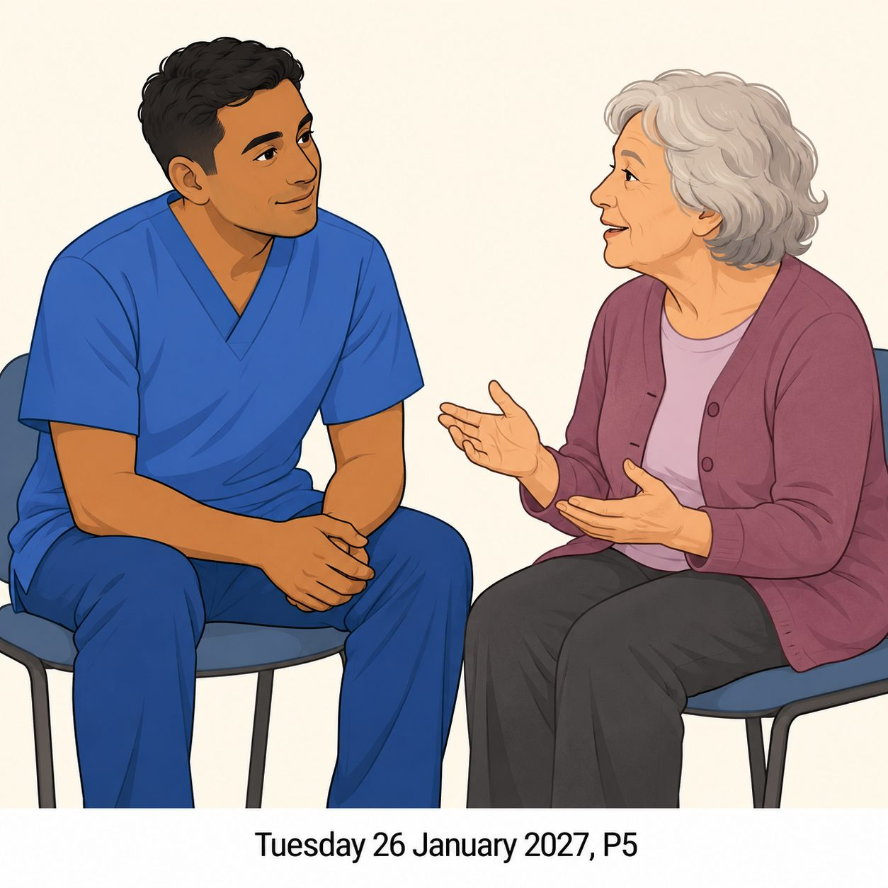
A nurse listens to an adult who needs health care.
This is an invented caring scene.
What care can you see?
Which care card matches?

Community care picture cards continued
Pink supported edition

Picture B A food-bank volunteer
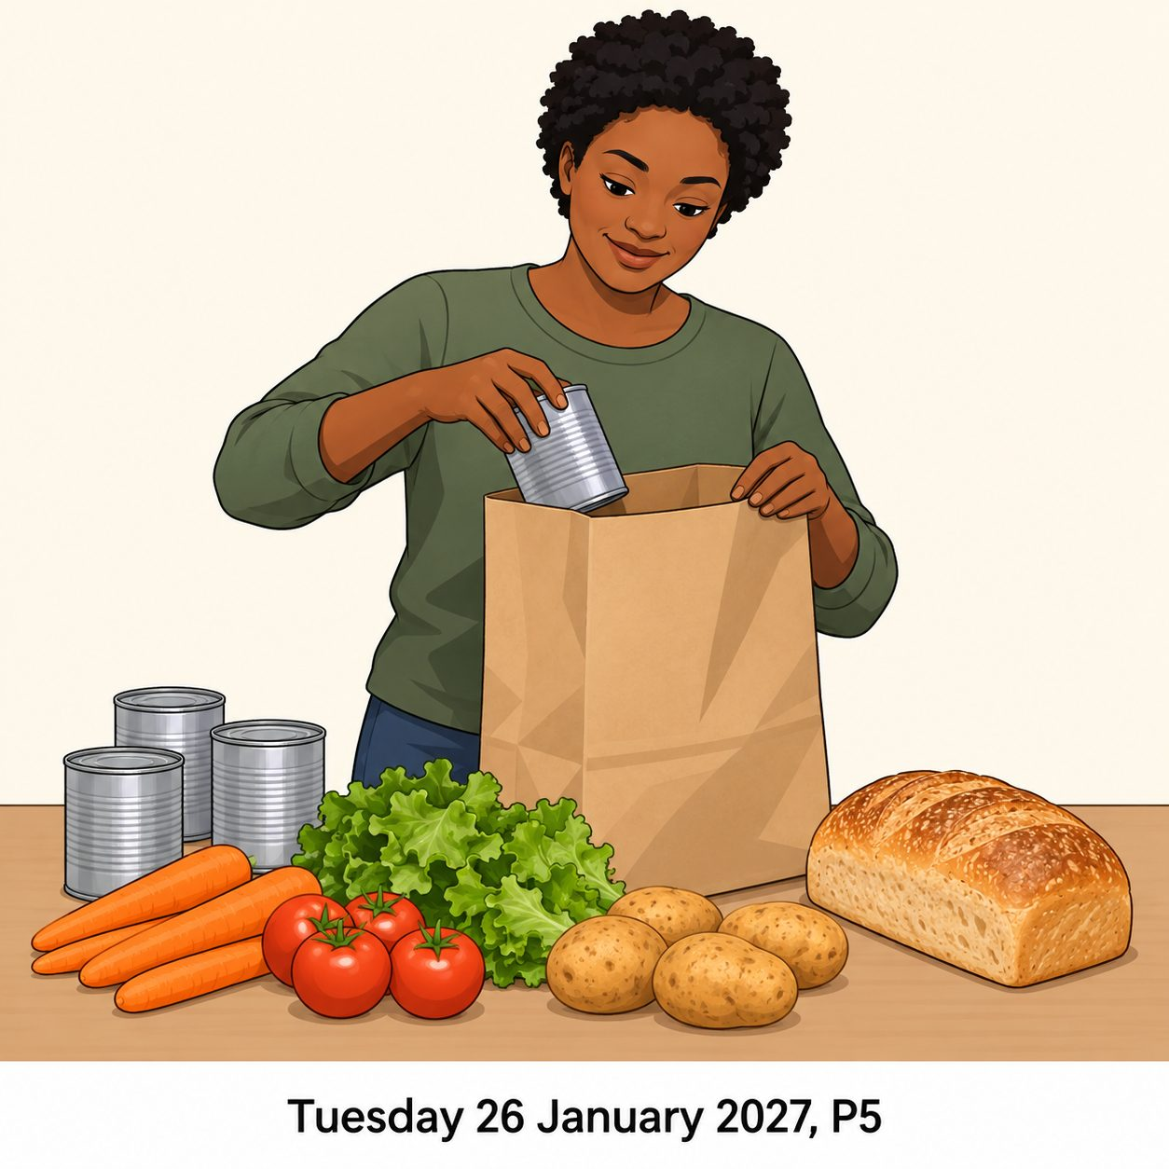
A food-bank volunteer packs food for people who need it.
This is an invented caring scene.
What care can you see?
Which care card matches?

Community care picture cards continued
Pink supported edition

Picture C A neighbour
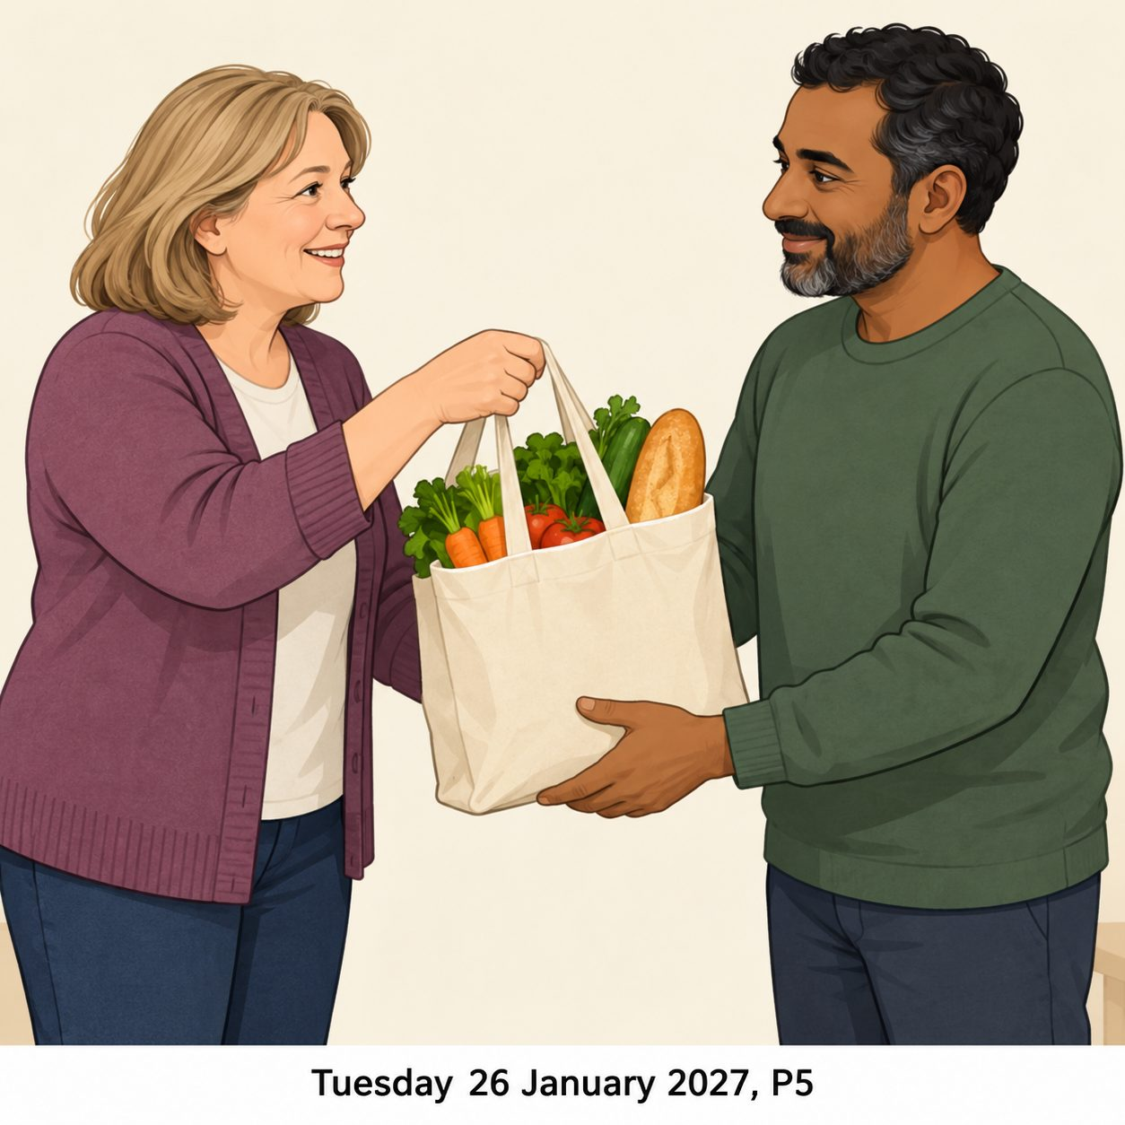
A neighbour brings shopping after an adult asks for help.
This is an invented caring scene.
What care can you see?
Which care card matches?

Community care picture cards continued
Pink supported edition

Picture D A faith group’s helpers

Some faith group helpers prepare a shared meal to show care.
This is an invented caring scene.
What care can you see?
Which care card matches?

Community care picture cards continued
Pink supported edition
These care cards describe the actions shown in the invented pictures.

Care card 1
Prepare a shared meal.

Care card 2
Bring shopping the person asked for.

Care card 3
Listen to a health worry.

Care card 4
Pack food ready to share.
Match each pictured role. A person can care in other ways too.

