Community care picture cards
White standard edition

Picture A A nurse
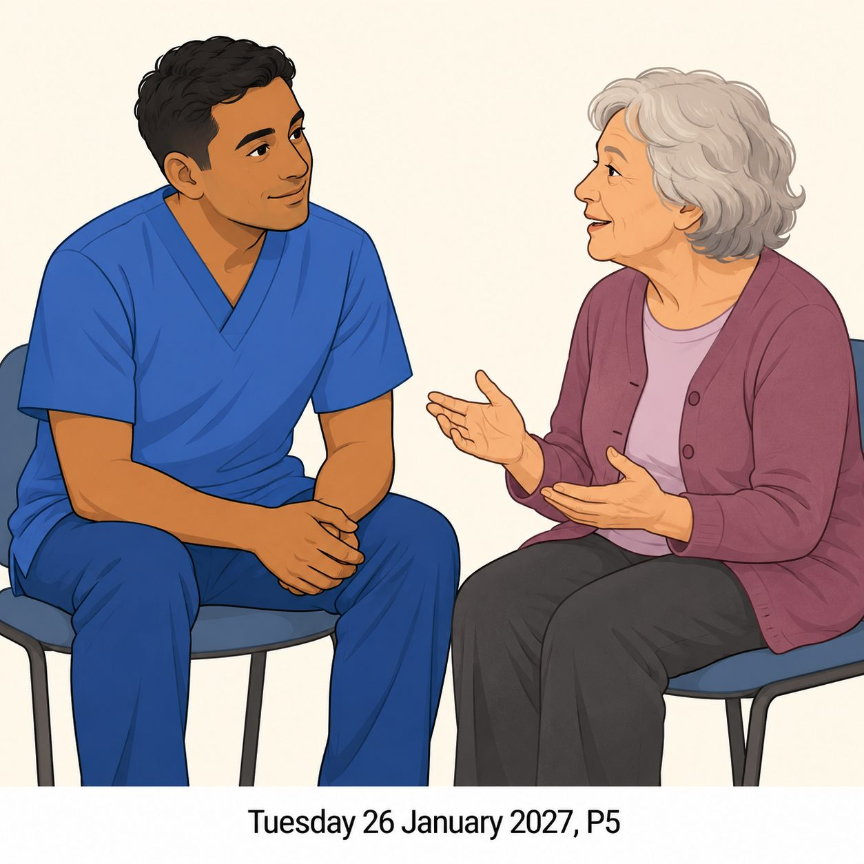
A nurse listens to an adult’s health worry and helps them feel heard.
This is an invented caring scene.
What care can you see?
Which care card matches?

Community care picture cards continued
White standard edition

Picture B A food-bank volunteer
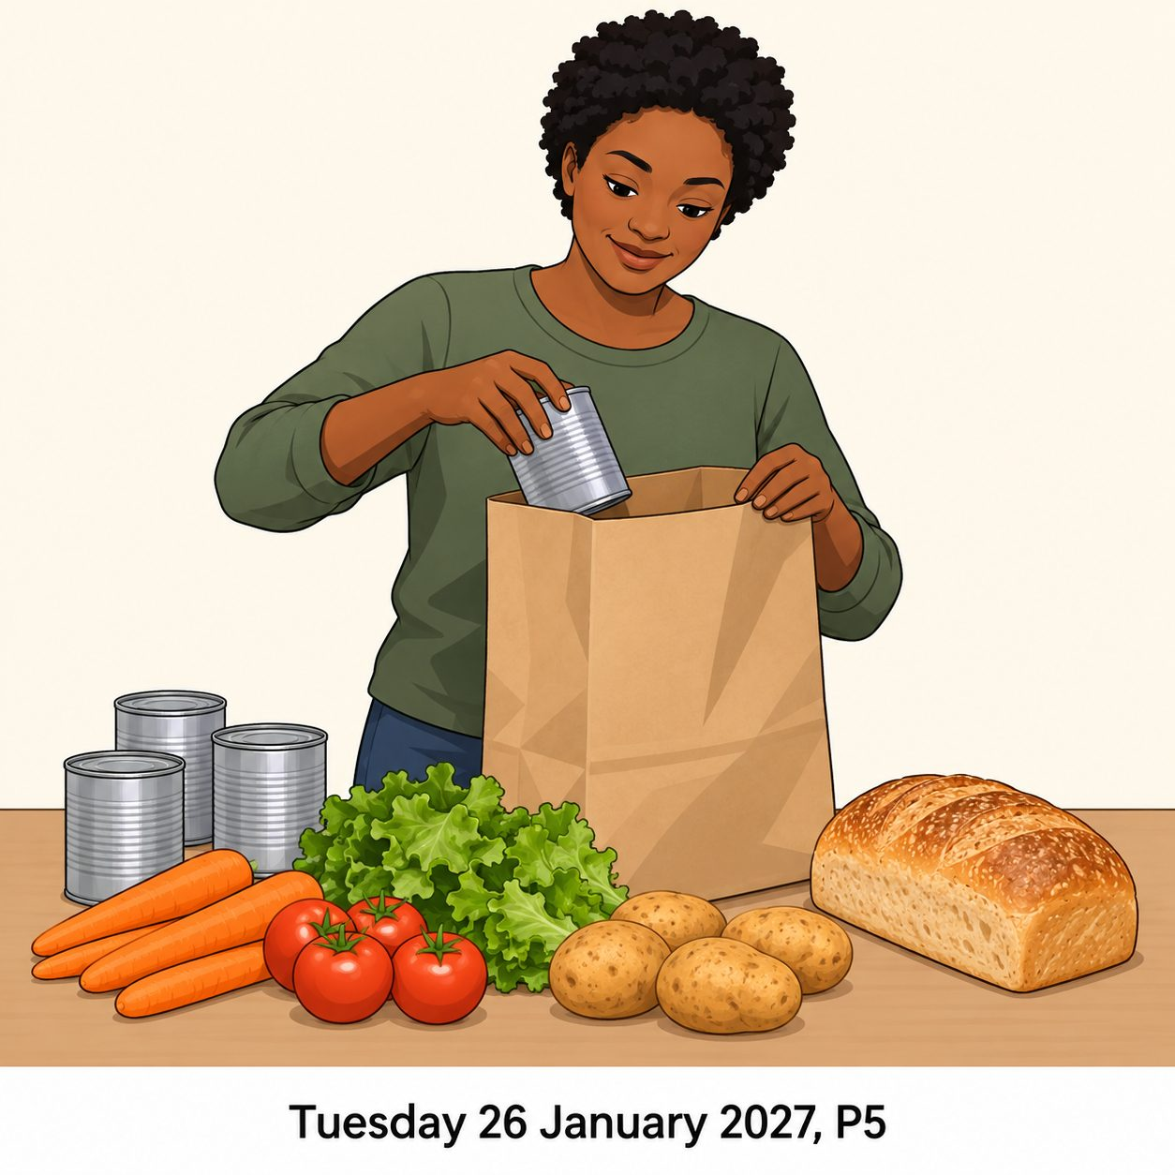
A food-bank volunteer packs food with care so people can collect what they need.
This is an invented caring scene.
What care can you see?
Which care card matches?

Community care picture cards continued
White standard edition

Picture C A neighbour
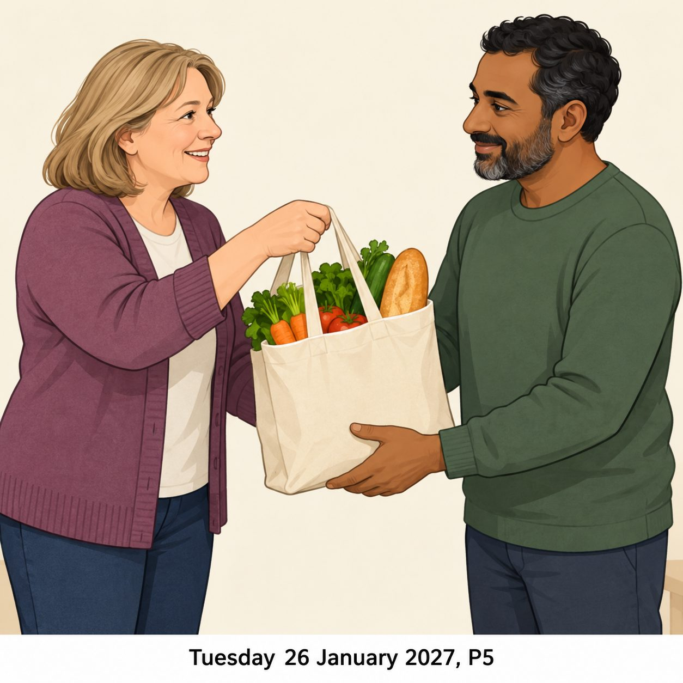
A neighbour brings shopping that an adult has asked for. They check before helping.
This is an invented caring scene.
What care can you see?
Which care card matches?

Community care picture cards continued
White standard edition

Picture D A faith group’s helpers

Some faith group helpers prepare a shared meal. Their beliefs encourage them to offer care.
This is an invented caring scene.
What care can you see?
Which care card matches?

Community care picture cards continued
White standard edition
These care cards describe the actions shown in the invented pictures.

Care card 1
Prepare a shared meal.

Care card 2
Bring shopping the person asked for.

Care card 3
Listen to a health worry.

Care card 4
Pack food ready to share.
Match each pictured role. A person can care in other ways too.

