Book strip
Creative Arts · GROW · Autumn 2 · Week 6 · ART-GROW-A2-W06-P1
I can use an actual observation to explain a strength in the group piece.
□ I can distinguish an observation from a general comment.
□ I can link a strength to a specific real moment.
□ I can compare what two records support.
Made by Matt

Reference sheets

Find a real clue
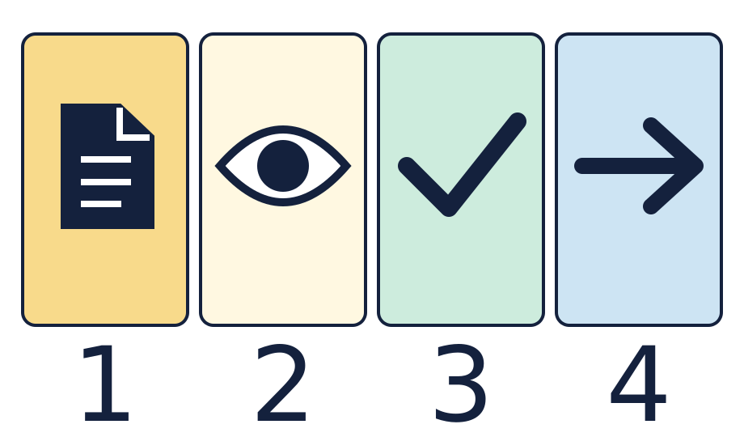
The page is a record. The eye means look. The tick means a part that worked. The arrow means one next step.

Choose a small change and check it
Keep the real clue, the strength and one checkable next step together. These symbols give prompts, not completed answers.

Worked model

Ask the question
Watch the model: distinguish a real observation from a general comment.

Find the evidence
Identify what was visible or audible at a specific moment in the piece.

Explain the link
Link the observation to a strength. Check that the record refers to that moment.

Check what we know
Compare two comments. If they differ, check what each person observed.

Shared investigation
Find a real cue sketch, art piece or note from the group piece.
Point to one part that went well. Use a quiet role if that was your part.
Say or show what was seen or heard at that moment.
Link the clue to the strength. Check that both refer to the same part.
Compare a clear note with a note that just says it was good.
In your book, keep one real clue and one short strength note.

We do decision checkpoint
Which note shows what went well?
A · We stopped at the square cue.
B · It was good.

Catch up for absence or access
Watch the model: distinguish a real observation from a general comment.
Try the first step with the group or point through it quietly.

Arrival · Supported
Start with the picture. Point or make a mark in your book.
1. How many pages can you see?
2. Point to the first box.
3. Point to the last box.
4. Which word fits: ready, help or pause?
Green · Ready, Amber · Help, Red · Pause. Choose in private or pass.

You do · Supported

Show one good part
In your book
Point, speak, sign, draw, write or choose. You may pass.
Choose your real work or note with an adult.
Point to one part that went well.
Show a clue from that part.
In your book, draw or record the link.
Keep it for Lesson 2.
The ___ went well. My clue is ___.
In your book, keep a real clue and one review note.
You may point to the real work, draw a clue, or tell an adult what to record. A quiet review has the same value. You may pass.
Staff mark I · S · C beside the task.

Review and exit · Supported
Show the clue for your strength.
Use one next step to make the note clear.
Check the note against the real work.
Optional: show or tell an adult what you changed after feedback. You may use your usual response mode or pass.

Exit ticket
Which actual observation supports your chosen strength?
What can you do if comments appear to disagree?

Pupil voice
What helped you most today, or what would you change next time?
Point, speak, sign, draw, write or choose. You may pass.

Feedback and response
In your book or usual mode
VF · WS · I · NS + … · E · R · // · ?
NS + ____________________
Edit in the same colour, on the same page or usual mode.
Mark R only after the pupil has responded to the next step and an adult has received and reflected the response.
My response
________________________
Adult ticks the improved work.

Arrival · Independent
Start with the picture. Point or make a mark in your book.
1. How many pages can you see?
2. Point to the first box.
3. What comes just after the page?
4. Which word fits: ready, help or pause?
Green · Ready, Amber · Help, Red · Pause. Choose in private or pass.

You do · Independent

Explain a strength using a record
In your book
Point, speak, sign, draw, write or choose. You may pass.
Choose an actual cue sketch, artwork or observation from the group piece.
Identify a specific moment that shows a strength.
Explain how the record supports that judgement rather than a general feeling.
Check whether a comment refers to the same moment. Keep any difference clear.
In your book, record the strength, source and explanation. Keep it for Lesson 2.
The observation supports ___ because ___.
In your book, keep a real clue and one review note.
You may point to the real work, draw a clue, or tell an adult what to record. A quiet review has the same value. You may pass.
Staff mark I · S · C beside the task.

Review and exit · Independent
Show the clue for your strength.
Use one next step to make the note clear.
Check the note against the real work.
Optional: show or tell an adult what you changed after feedback. You may use your usual response mode or pass.

Exit ticket
Which actual observation supports your chosen strength?
What can you do if comments appear to disagree?

Pupil voice
What helped you most today, or what would you change next time?
Point, speak, sign, draw, write or choose. You may pass.

Feedback and response
In your book or usual mode
VF · WS · I · NS + … · E · R · // · ?
NS + ____________________
Edit in the same colour, on the same page or usual mode.
Mark R only after the pupil has responded to the next step and an adult has received and reflected the response.
My response
________________________
Adult ticks the improved work.

Arrival · Aspire
Start with the picture. Point or make a mark in your book.
1. How many pages can you see?
2. Point to the first box.
3. Point to the shape just before the arrow.
4. Which word fits: ready, help or pause?
Green · Ready, Amber · Help, Red · Pause. Choose in private or pass.

You do · Aspire

Evaluate two records
In your book
Point, speak, sign, draw, write or choose. You may pass.
Compare two actual records that appear to describe the same moment.
Identify what each record directly supports and what it leaves uncertain.
Explain a strength using the strongest available observation.
If the records differ, check their context instead of guessing.
Keep both records and a balanced judgement in your book.
The records support ___, while ___ remains uncertain.
In your book, keep a real clue and one review note.
You may point to the real work, draw a clue, or tell an adult what to record. A quiet review has the same value. You may pass.
Staff mark I · S · C beside the task.

Review and exit · Aspire
Show the clue for your strength.
Use one next step to make the note clear.
Check the note against the real work.
Optional: show or tell an adult what you changed after feedback. You may use your usual response mode or pass.

Exit ticket
Which actual observation supports your chosen strength?
What can you do if comments appear to disagree?

Pupil voice
What helped you most today, or what would you change next time?
Point, speak, sign, draw, write or choose. You may pass.

Feedback and response
In your book or usual mode
VF · WS · I · NS + … · E · R · // · ?
NS + ____________________
Edit in the same colour, on the same page or usual mode.
Mark R only after the pupil has responded to the next step and an adult has received and reflected the response.
My response
________________________
Adult ticks the improved work.

Arrival · Choice
Start with the picture. Point or make a mark in your book.
1. How many pages can you see?
2. Point to the first box.
3. Do any two boxes have the same shape?
4. Which word fits: ready, help or pause?
Green · Ready, Amber · Help, Red · Pause. Choose in private or pass.

You do · Choice

Choose how to show a strength
In your book
Point, speak, sign, draw, write or choose. You may pass.
Choose a real piece of work or direct an adult to it.
Point, draw or choose one part that went well.
Show the clue or ask an adult to read the real note.
In your book, keep the link in your usual way.
Keep it for Lesson 2.
I chose ___ as a clue for ___.
In your book, keep a real clue and one review note.
You may point to the real work, draw a clue, or tell an adult what to record. A quiet review has the same value. You may pass.
Staff mark I · S · C beside the task.

Review and exit · Choice
Show the clue for your strength.
Use one next step to make the note clear.
Check the note against the real work.
Optional: show or tell an adult what you changed after feedback. You may use your usual response mode or pass.

Exit ticket
Which actual observation supports your chosen strength?
What can you do if comments appear to disagree?

Pupil voice
What helped you most today, or what would you change next time?
Point, speak, sign, draw, write or choose. You may pass.

Feedback and response
In your book or usual mode
VF · WS · I · NS + … · E · R · // · ?
NS + ____________________
Edit in the same colour, on the same page or usual mode.
Mark R only after the pupil has responded to the next step and an adult has received and reflected the response.
My response
________________________
Adult ticks the improved work.

