Book strip
Creative Arts · GROW · Autumn 2 · Week 7 · ART-GROW-A2-W07-P1
I can verify a link between my arts learning and an actual record.
□ I can distinguish a claim from its supporting record.
□ I can check that a locator opens to the matching work.
□ I can identify what remains unverified.
Made by Matt

Reference sheets

Match a claim to real work
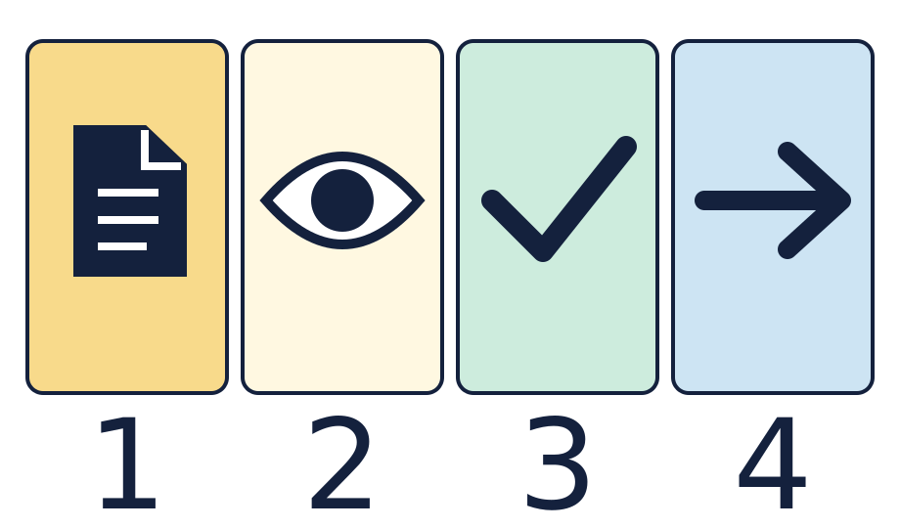
The page is a real record. The eye means look at the record. The tick means the link was checked. The arrow means a link or next action.

Keep an honest log
Open the right page, match the detail to your words, then keep the real link. Leave a gap open when the work or reply is missing.

Worked model

Ask the question
Watch the model: connect an account of learning to an actual record.

Find the evidence
Identify the specific feature that supports the claim.

Explain the link
Follow its locator and explain what the record can show.

Check what we know
Verify the matching item, or retain a clear gap and one retrieval action.

Shared investigation
Find a real cue sketch, art piece or practice note.
Choose one thing the work shows we learnt.
Point to the detail as we give a short account.
Find the same item from its page note or file title.
Compare a checked link with a gap. Keep each one clear.
In your book, keep the work, the link and one short note.

Decision checkpoint
Which link can we keep as checked?
A · The page opens to the work that fits the claim.
B · The box is ticked but the work is not found.

Catch up for absence or access
Watch the model: connect an account of learning to an actual record.
Try the first step with the group or point through it quietly.

Arrival · Supported
Start with the picture. Point or make a mark in your book.
1. How many pages can you see?
2. Point to the first box.
3. Point to the last box.
4. Which word fits: ready, help or pause?
Green · Ready, Amber · Help, Red · Pause. Choose in private or pass.

You do · Supported
Start in your book.

Find one real link
In your book
Point, speak, sign, draw, write or choose. You may pass.
Choose a real piece of your work with an adult.
Point to a part you liked or a skill you learnt.
Find the page that shows it.
In your book, keep the page note and your own words.
Keep it for Lesson 2. Leave any gap open.
I learnt ___. This part shows ___.
In your book, keep the real link, your own words and any gap to check.
You may point to real work, draw a clue, or tell an adult what to record. A quiet share has the same value. You may pass.
Staff mark I · S · C beside the task.

Review and improve
Show the real detail behind your note.
Use one next step to make the link clear.
Check the same page once more.
Optional: show or tell an adult what you changed after feedback. You may use your usual response mode or pass.

Exit ticket
What did you learn? Show the real work that fits.
What do you do if the page shows the wrong work?

Pupil voice
What helped you most today, or what would you change next time?
Point, speak, sign, draw, write or choose. You may pass.

Feedback and response
In your book or usual mode
VF · WS · I · NS + … · E · R · // · ?
NS + ____________________
Edit in the same colour, on the same page or usual mode.
Mark R only after the pupil has responded to the next step and an adult has received and reflected the response.
My response
________________________
Adult ticks the improved work.

Arrival · Independent
Start with the picture. Point or make a mark in your book.
1. How many pages can you see?
2. Point to the first box.
3. What comes just after the page?
4. Which word fits: ready, help or pause?
Green · Ready, Amber · Help, Red · Pause. Choose in private or pass.

You do · Independent
Start in your book.

Verify a claim and its locator
In your book
Point, speak, sign, draw, write or choose. You may pass.
Choose actual art, practice notes or a look-back record.
Explain one skill or choice using a specific feature of that work.
Open the matching item using its locator and check the detail.
Keep the checked claim, record and locator together in your book.
Identify any unverified claim or missing item. Keep it for Lesson 2.
The record supports ___ because ___. The locator is ___.
In your book, keep the real link, your own words and any gap to check.
You may point to real work, draw a clue, or tell an adult what to record. A quiet share has the same value. You may pass.
Staff mark I · S · C beside the task.

Review and improve
Show the real detail behind your note.
Use one next step to make the link clear.
Check the same page once more.
Optional: show or tell an adult what you changed after feedback. You may use your usual response mode or pass.

Exit ticket
What did you learn? Show the real work that fits.
What do you do if the page shows the wrong work?

Pupil voice
What helped you most today, or what would you change next time?
Point, speak, sign, draw, write or choose. You may pass.

Feedback and response
In your book or usual mode
VF · WS · I · NS + … · E · R · // · ?
NS + ____________________
Edit in the same colour, on the same page or usual mode.
Mark R only after the pupil has responded to the next step and an adult has received and reflected the response.
My response
________________________
Adult ticks the improved work.

Arrival · Aspire
Start with the picture. Point or make a mark in your book.
1. How many pages can you see?
2. Point to the first box.
3. Point to the shape just before the arrow.
4. Which word fits: ready, help or pause?
Green · Ready, Amber · Help, Red · Pause. Choose in private or pass.

You do · Aspire
Start in your book.

Compare the value of two records
In your book
Point, speak, sign, draw, write or choose. You may pass.
Compare two actual records supporting a claim about your learning.
Explain what each record supports and what remains uncertain.
Justify which record provides the clearer link to the specific skill.
Open both locators and distinguish verified links from gaps.
Keep a balanced account and one retrieval action for any missing record.
Compare the records. Explain why one supports the claim more clearly.
The stronger link is ___ because ___. It cannot show ___.
In your book, keep the real link, your own words and any gap to check.
You may point to real work, draw a clue, or tell an adult what to record. A quiet share has the same value. You may pass.
Staff mark I · S · C beside the task.

Review and improve
Show the real detail behind your note.
Use one next step to make the link clear.
Check the same page once more.
Optional: show or tell an adult what you changed after feedback. You may use your usual response mode or pass.

Exit ticket
What did you learn? Show the real work that fits.
What do you do if the page shows the wrong work?

Pupil voice
What helped you most today, or what would you change next time?
Point, speak, sign, draw, write or choose. You may pass.

Feedback and response
In your book or usual mode
VF · WS · I · NS + … · E · R · // · ?
NS + ____________________
Edit in the same colour, on the same page or usual mode.
Mark R only after the pupil has responded to the next step and an adult has received and reflected the response.
My response
________________________
Adult ticks the improved work.

Arrival · Choice
Start with the picture. Point or make a mark in your book.
1. How many pages can you see?
2. Point to the first box.
3. Do any two boxes have the same shape?
4. Which word fits: ready, help or pause?
Green · Ready, Amber · Help, Red · Pause. Choose in private or pass.

You do · Choice
Start in your book.

Choose how to show a link
In your book
Point, speak, sign, draw, write or choose. You may pass.
Choose a real item or direct an adult to it.
Point, draw or show one part you liked or learnt.
Find the matching page with help if needed.
Keep the link in your book in your usual way.
Keep it for Lesson 2. Leave any gap open.
I chose ___. The work is at ___.
In your book, keep the real link, your own words and any gap to check.
You may point to real work, draw a clue, or tell an adult what to record. A quiet share has the same value. You may pass.
Staff mark I · S · C beside the task.

Review and improve
Show the real detail behind your note.
Use one next step to make the link clear.
Check the same page once more.
Optional: show or tell an adult what you changed after feedback. You may use your usual response mode or pass.

Exit ticket
What did you learn? Show the real work that fits.
What do you do if the page shows the wrong work?

Pupil voice
What helped you most today, or what would you change next time?
Point, speak, sign, draw, write or choose. You may pass.

Feedback and response
In your book or usual mode
VF · WS · I · NS + … · E · R · // · ?
NS + ____________________
Edit in the same colour, on the same page or usual mode.
Mark R only after the pupil has responded to the next step and an adult has received and reflected the response.
My response
________________________
Adult ticks the improved work.

