My wellbeing wheel
Use the five sections as prompts. Add a word, symbol or optional mark if you wish. Leave any section blank. There are no scores to add or right-shaped wheels.
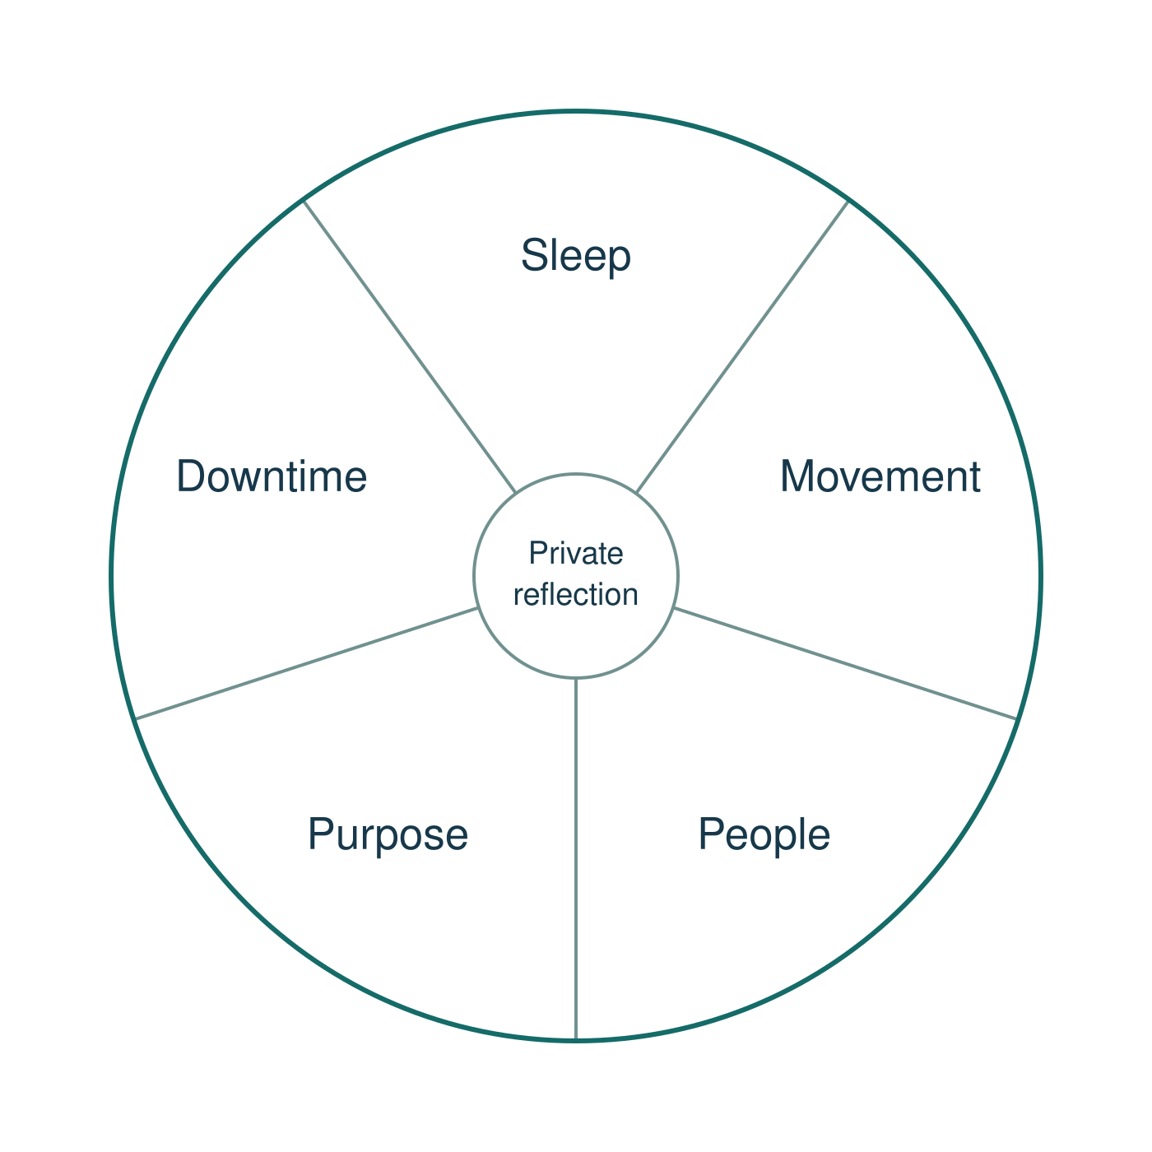
Sleep · Movement · People · Purpose · Downtime
This is a reflection aid, not a mood or health score. A blank or uneven wheel does not show how healthy a person is. You can use the invented learner, leave any area blank or pass.
Keep your personal wheel with you. Do not add a name, health history, family details, sleep hours or a private worry. You do not have to show or explain it to anyone.

One realistic change
Choose ONE change for one area, privately. A change may make a helpful habit easier to keep by agreeing when or where it fits. Use the invented learner instead, leave blank or pass if you prefer.
A small step may help; it is not a guaranteed fix. No spending, exercise, sleep target or family contact is required.

Area I choose
________________________________________________

One small step
________________________________________________

When or where it could fit
________________________________________________

Help or resources needed
________________________________________________

If a barrier gets in the way
________________________________________________

A time or chance to review it
________________________________________________

A fictional model
At the next agreed break, the invented learner tries a short quiet making activity. Staff help check available materials. If materials are missing, a quiet drawing or reading activity is the fallback. Review at a later agreed check-in.
This plan stays private and with you. Do not put names, health or family details on it. No personal plan has to be shown. Choose one step, not five goals.

Safe help and a discreet pause
Use class questions and optional pair talk for the invented learner. Do not use a partner’s wheel or health as an example.

Pause card
I would like to use my agreed pause.
Show this card or use your usual signal. You do not need a public explanation. An adult will acknowledge it and support the agreed supervised route. Keep the usual adult support; do not go off alone. You can return with support or use a neutral task and catch up later.

Help in private
Ask trusted school staff for a private conversation or help to find the right support. Support can include a trusted adult, school staff, a family doctor or a suitable helpline. If a concern persists, worsens, affects everyday life or feels unsafe, ask for help; no diagnosis is needed first. If the first adult is unavailable or unhelpful, try another through the agreed route. For an immediate concern, get school staff straight away.

A fictional alternative
A learner starts a new weekly routine. They are unsure what to do first and want some time to unwind. They enjoy making things. A trusted member of school staff can explain the new routine. The learner chooses one short quiet activity during an agreed break and plans to ask the staff member for a check-in.
You can reflect on this learner’s five areas and choose one realistic step for them. Blank or pass is also valid. No sleep, health, family or private worry details are needed.

Aids for the first tasks
Keep words, starter and visible model in view. Your usual aids stay.

Starter claim
Words: everyone, health, thoughts, feelings
Start: Everyone has mental health because ... .
Model: Mental health is part of everyone's health.

Model check
Words: wellbeing, resilience, support, change
Start: The learner shows resilience by ... .
Model: The learner asks for help and adapts the plan.

Private hinge
Words: pause, adapt, support, safe
Start: A helpful response could be ... because ... .
Model: A helpful response could be asking staff because the learner needs a clearer first step.

Wheel reflection
Words: sleep, movement, people, purpose, downtime
Start: For the invented learner, ... could support ... .
Model: A safe check-in could support the people area.
Use the invented learner for class explanations. Personal wheel reflection is optional and private.

Aids for one step and review

One realistic change
Words: one step, cue, support, barrier, review
Start: They could try ... at ... . If ... , they could ... .
Model: They could choose a quiet activity at an agreed break. If materials are missing, they could choose another quiet activity.

Learning self-check
Words: explain, example, prompt, help
Start: I can explain ... using the example ... .
Model: I can explain resilience using the learner's supported plan change.

Feedback and exit
Words: next step, response, adult, private
Start: A next step in the story could be ... .
Model: A next step in the story could be checking the plan with trusted school staff.

Keep one step realistic
Small enough to try.
Within the learner's choices, access and resources, or names needed support.
Has a simple time or cue and an alternative if a barrier appears.
One change per learner. A fallback is used if a barrier appears; it is not another goal to complete. Keep first fictional work, use one next step and reply in the same colour, on the same page or usual mode.
A discreet pause, fictional alternative, blank or pass is valid. Ask trusted school staff for private support.

