Our class community map
Knowledge organiser

Learning goal
Contribute to a class community map.

Enquiry
Who helps us belong to a community?
Word | Meaning
community | People linked by a place or activity
care | An action that meets a need
belong | Feel included in a group
service | Work that helps people

Key knowledge
The park, in square 1122.
It shows what each learner can locate and explain.

A frame to use
My contribution is ___. It matters because ___. North of the hall is ___.

Remember
Use a fictional person or place if preferred. The practice map is invented and is not a route to follow outside school.

Supported arrival
Begin with questions 1 and 2. Continue when ready. Choose one route; reading, pointing and exact scribing are available on every route.
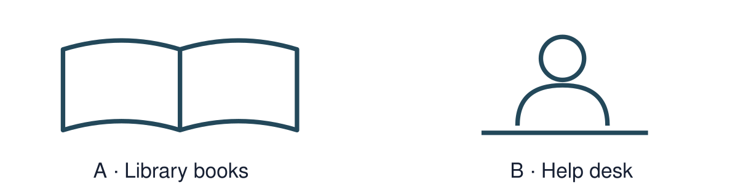

1 Which picture can help someone find a book?
Help: Choose A or B. Point first; an adult can record your choice.
__________________________________________________________________
__________________________________________________________________

2 What lies north of the hall?
Help: Read or listen to the relevant evidence card; point first.
__________________________________________________________________
__________________________________________________________________

3 Find “care” in word help. What does it mean?
Help: Use the word and meaning cards together.
__________________________________________________________________
__________________________________________________________________

4 Why keep an individual contribution?
Help: Use the source limit or map key as a clue.
__________________________________________________________________
__________________________________________________________________

Standard arrival
Begin with questions 1 and 2. Continue when ready. Choose one route; reading, pointing and exact scribing are available on every route.

1 Which picture can help someone find a book? Explain your choice.
Help: Choose A or B. Point first; an adult can record your choice.
__________________________________________________________________
__________________________________________________________________

2 What lies north of the hall?
Help: Use one source detail or labelled map feature.
__________________________________________________________________
__________________________________________________________________

3 Explain care using an example.
Help: Choose an example from the evidence cards.
__________________________________________________________________
__________________________________________________________________

4 Why keep an individual contribution?
Help: State the reason for your answer.
__________________________________________________________________
__________________________________________________________________

Stretch arrival
Begin with questions 1 and 2. Continue when ready. Choose one route; reading, pointing and exact scribing are available on every route.

1 Which picture can help someone find a book? What can this teaching picture not tell us?
Help: Separate the illustration from historical or personal evidence.
__________________________________________________________________
__________________________________________________________________

2 What lies north of the hall? Give supporting evidence.
Help: Name the source or data label.
__________________________________________________________________
__________________________________________________________________

3 How does care help answer today’s enquiry?
Help: Explain the connection, not only the definition.
__________________________________________________________________
__________________________________________________________________

4 Why keep an individual contribution? Explain a limit or further check.
Help: Think about what the supplied evidence leaves uncertain.
__________________________________________________________________
__________________________________________________________________

Evidence cards
Read or listen to the cards. Original historical records, authored summaries and fictional teaching cases are labelled separately.

A Alex and Sam
Fictional case: Alex is new to the youth club. Sam, a trusted club worker, explains the choices and shows Alex a quiet place.
Authored classroom case
Limit: This example does not describe every person or place.

B Library
A library lends books and can offer space to read or find information. Our practice map puts the library in square 1021.
Authored classroom case
Limit: This example does not describe every person or place.

C Health centre
The practice health centre is in square 1221. A receptionist helps people arrange appointments; trained health staff provide care.
Authored classroom case
Limit: This example does not describe every person or place.

D Park and hall
Our practice park is in 1122 and community hall in 1121. The hall hosts a drawing club with an optional quiet table.
Authored classroom case
Limit: This example does not describe every person or place.

Visual resources and data
Keep this page beside the shared and independent tasks.
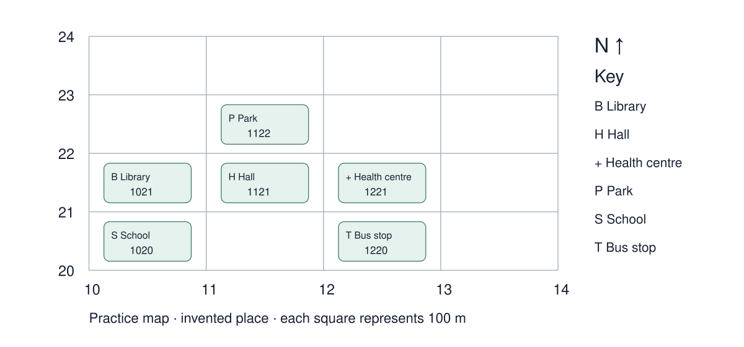

Use the resource
What lies north of the hall?
__________________________________________________________________
__________________________________________________________________
__________________________________________________________________
Why keep an individual contribution?
__________________________________________________________________
__________________________________________________________________

Shared investigation
Make a decision, check the evidence, then explain. An individual or private response can replace speaking to the group.
1. Agree a map key.
2. Each person adds or identifies one place without moving someone else’s contribution.
Record | Our response
Feature
Location
Key clue
Limit

Support choices
Supported: Start with a labelled place and a reduced set of location choices.
Standard: Use the key, direction and location clues before answering.
Stretch: Explain the effect of map scale or the limits of the location evidence.

Our explanation
__________________________________________________________________
__________________________________________________________________
__________________________________________________________________

Supported independent task
Complete this route only. Keep your own decisions; an adult may read, organise access or scribe your exact words.
1. Add one place or helper to a class map, with your own labelled copy.
2. Explain why the place or person matters.
3. Answer independently: what lies north of the hall on the practice map?

Help
Begin with one step. Read the sources with an adult, reduce the visible choice set and use: My contribution is ___. It matters because ___. North of the hall is ___.
Keep all required evidence; speech, pointing, drawing and exact scribing are available.

My outcome and supporting evidence
__________________________________________________________________
__________________________________________________________________
__________________________________________________________________
__________________________________________________________________
__________________________________________________________________
__________________________________________________________________
__________________________________________________________________
__________________________________________________________________
__________________________________________________________________
__________________________________________________________________
Check: individual contribution plus one independent location/pattern question.

Standard independent task
Complete this route only. Keep your own decisions; an adult may read, organise access or scribe your exact words.
1. Add one place or helper to a class map, with your own labelled copy.
2. Explain why the place or person matters.
3. Answer independently: what lies north of the hall on the practice map?

Help
My contribution is ___. It matters because ___. North of the hall is ___.
Check your evidence before adding a final explanation.

My outcome and supporting evidence
__________________________________________________________________
__________________________________________________________________
__________________________________________________________________
__________________________________________________________________
__________________________________________________________________
__________________________________________________________________
__________________________________________________________________
__________________________________________________________________
__________________________________________________________________
__________________________________________________________________
Check: individual contribution plus one independent location/pattern question.

Stretch independent task
Complete this route only. Keep your own decisions; an adult may read, organise access or scribe your exact words.
1. Add one place or helper to a class map, with your own labelled copy.
2. Explain why the place or person matters.
3. Answer independently: what lies north of the hall on the practice map?

Help
Plan your answer using the source labels. Use the frame if useful.
Check whether the key lets another person understand the map; make one improvement.

My outcome and supporting evidence
__________________________________________________________________
__________________________________________________________________
__________________________________________________________________
__________________________________________________________________
__________________________________________________________________
__________________________________________________________________
__________________________________________________________________
__________________________________________________________________
__________________________________________________________________
__________________________________________________________________
Check: individual contribution plus one independent location/pattern question.

Exit ticket choices
Choose one route. Answer both questions individually using your normal access support.

Supported
What lies north of the hall?
Why keep an individual contribution?
Help: Use the word bank and a named evidence card.
__________________________________________________________________
__________________________________________________________________

Standard
What lies north of the hall?
Why keep an individual contribution?
Help: Include a source detail, location or value.
__________________________________________________________________
__________________________________________________________________

Stretch
What lies north of the hall? Justify with evidence.
Why keep an individual contribution? Evaluate a limitation.
Help: Weigh the evidence and name a limitation.
__________________________________________________________________
__________________________________________________________________

Teacher planning and alignment
Staff pages begin here. Print pupil routes selectively; keep answers separate.

Scheme of work
BUILD_A1_W06; My family my community and special people; SOW page 4
Exact outcome: Contribute to a class community map.
Teaching and application: Co-construct a photo/symbol map. Each learner adds a person or place and explains its importance; use a simplified map and clear role.
Assessment evidence: F: individual contribution plus one independent location/pattern question.

Forty minute sequence
Time | Stage
0–4 | Arrival route
4–7 | Starter and visual enquiry
7–13 | Explicit model and optional captioned film
13–20 | Shared interactive activity
20–22 | Method check
22–34 | Independent application
34–37 | Review and improve
37–40 | Two exit questions

Access and assessment
Use one-step instructions, symbols and a model first. Offer talk, point, draw, type or write. Reduce the number of choices; extend by asking for a reason or a second example. Adults prompt the first response then fade support.
Routes are flexible. Check the learner can begin within two minutes. Use reading, typing, exact scribing or oral responses without lowering the Humanities thinking. Fade prompts. Record what was independent. For a summative outcome, rehearse on a practice example and keep the final response individual.

Teacher answers and scaffolding

Core and exit answers
The park, in square 1122.
It shows what each learner can locate and explain.

Shared task feedback
Review the pupil’s evidence against: F: individual contribution plus one independent location/pattern question. Open explanations are not automatically graded. Accept a different justified response that meets the outcome.

Arrival answers
Supported: 1. A: the library books. 2. The park, in square 1122. 3. An action that meets a need 4. It shows what each learner can locate and explain.
Standard: 1. A: the library books. 2. The park, in square 1122. 3. An action that meets a need Accept a relevant example. 4. It shows what each learner can locate and explain.
Stretch: 1. A: the library books. It cannot establish a real person’s whole experience or belief. 2. The park, in square 1122. 3. An action that meets a need Accept a supported connection. 4. It shows what each learner can locate and explain.

Stage scaffolding
Starter, model and shared task: Start with a labelled place and a reduced set of location choices. Use the key, direction and location clues before answering.
Further challenge: Explain the effect of map scale or the limits of the location evidence.
Review: check the exact required outcome before improving presentation. Retain first and revised responses when useful.

Sources and evidence record

Sources and resource preparation

UAS mapping before submission
The scheme provides no approved unit codes. The centre must select the exact unit and check every requirement. These resources prepare evidence; task completion does not establish an award.
Record | Complete for this learner
Learner and date
Selected unit title and code
Exact criterion and evidence page
Independent response and support used
Decision and next step

Calendar and editing
Schedule Black History Month, remembrance, Human Rights Day, Holocaust Memorial Day and International Women’s Day against the school calendar. The SOW sequence controls week numbering. Word text and tables are editable; HTML is the editable lesson source. Recheck layout and keep source details and answers aligned after changes.

