The sequence of a celebration
Learning goal: Sequence the events of a celebration.

Words to use
Word | Meaning
festival | A special period of celebration or remembrance
belief | Something a person accepts as true
tradition | A practice passed on
respect | Care for people and what matters to them

Remember
What comes first in our family’s plan? Prepare a welcoming space.
Is the plan a rule for every Diwali celebration? No, it is a fictional example.

How to show your learning
Order the four cards from the supplied family plan.
First ___. Next ___. Later ___. Finally ___.

Evidence matters
Fictional cases are teaching examples. Historical, geographical and religious claims use the named sources. A model video demonstrates a method.
You can respond by speaking, pointing, drawing, typing or writing. A fictional personal example is welcome.
Sources: Hindu American Foundation Diwali; Chabad What is Hanukkah

Arrival choices
Previous lesson reminder:

Start with 1 and 2. Try 3 and 4 when ready. Reading and exact scribing are available.

1 What should we do before handling a borrowed artefact
Support: Use the reminder strip or talk it through with an adult.
My response
________________________________________________________________________

2 Which meaning fits festival
Support: Choose: A special period of celebration or remembrance OR Something a person accepts as true.
My response
________________________________________________________________________

3 What comes first in our family s plan
Support: Use the model evidence anchor S or read one relevant card together.
My response
________________________________________________________________________

4 Is the plan a rule for every Diwali celebration
Support: Give a reason when ready.
My response
________________________________________________________________________
Stretch: use a precise example or explain which detail supports your answer.

Evidence cards
Read, point or listen. Keep the source label with any detail you use.

D Diwali
Many Hindus mark Diwali with lamps, worship and gatherings. Light can express good overcoming evil and knowledge overcoming ignorance. Practices and stories vary.
Source: Hindu American Foundation, Diwali
Limit: This Hindu explanation does not cover every Hindu practice or other religions’ observances.

H Hanukkah
Hanukkah is a Jewish festival lasting eight nights. Lights recall the Temple’s rededication and the traditional account of oil lasting eight days. A hanukkiah has eight festival lights and a helper light.
Source: Chabad, What is Hanukkah
Limit: This explains one Jewish religious perspective; not all Jewish households observe identically.

O Objects and meanings
A diya is a small lamp associated with Diwali. A hanukkiah is used at Hanukkah. Ask before touching borrowed objects; use an unlit replica or a drawing.
Source: Authored classroom case
Limit: This example does not describe every person or place.

S One family’s celebration plan
Fictional Diwali plan: prepare a welcoming space; arrange unlit lamps with an adult; gather for worship; share food and greetings. This is one sequence, not a rule for every family.
Source: Authored classroom case
Limit: This example does not describe every person or place.

Visual resource
Use this visual with the evidence cards and enquiry questions.
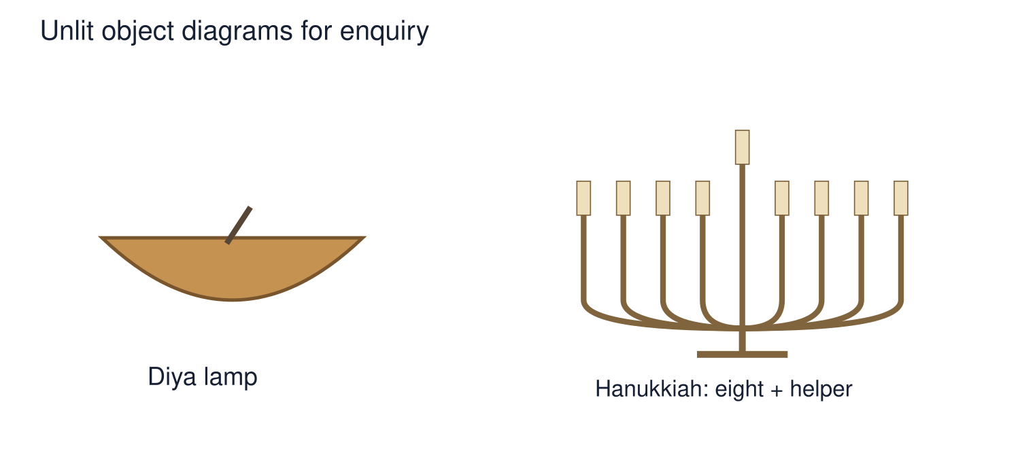
A detail I noticed and what it helps me explain
________________________________________________________________________
________________________________________________________________________
________________________________________________________________________
________________________________________________________________________

Shared investigation
1. Arrange the fictional family’s plan.
2. Use first, next and later to retell it.
Work with a partner or adult, or use your own table. One person suggests; the other checks the evidence. Swap after one turn. Passing is allowed.

Move or match the cards
Cards to use
Share food and greetings
Gather for worship
Arrange unlit lamps
Prepare a welcoming space

Our explanation
________________________________________________________________________
________________________________________________________________________
________________________________________________________________________
Support: Show two choices. Read one short instruction. Point, match or say a word, then add a reason when ready.
Further challenge: Explain why another family could use a different order or different practices.

Supported independent task
Complete this route only. Sequence the events of a celebration.
1. Order the four cards from the supplied family plan.
2. Retell the sequence with captions or speech.
3. Say that this is one family’s example.
Support: Show two choices. Read one short instruction. Point, match or say a word, then add a reason when ready. Complete the organiser one space at a time. First ___. Next ___. Later ___. Finally ___.
First event and date or time cue
________________________________________________________________________
________________________________________________________________________
Next event and date or time cue
________________________________________________________________________
________________________________________________________________________
Later event and date or time cue
________________________________________________________________________
________________________________________________________________________
Why this order fits the evidence
________________________________________________________________________
________________________________________________________________________
An adult may read or scribe your exact response. They should not choose the answer.

Standard independent task
Complete this route only. Sequence the events of a celebration.
1. Order the four cards from the supplied family plan.
2. Retell the sequence with captions or speech.
3. Say that this is one family’s example.
Support: First ___. Next ___. Later ___. Finally ___.
First event and date or time cue
________________________________________________________________________
________________________________________________________________________
Next event and date or time cue
________________________________________________________________________
________________________________________________________________________
Later event and date or time cue
________________________________________________________________________
________________________________________________________________________
Why this order fits the evidence
________________________________________________________________________
________________________________________________________________________
Check the required evidence and revise one detail.

Stretch independent task
Complete this route only. Sequence the events of a celebration.
1. Order the four cards from the supplied family plan.
2. Retell the sequence with captions or speech.
3. Say that this is one family’s example.
4. Explain why another family could use a different order or different practices.
Support: Choose the evidence independently. Use the frame only if it helps.
First event and date or time cue
________________________________________________________________________
________________________________________________________________________
Next event and date or time cue
________________________________________________________________________
________________________________________________________________________
Later event and date or time cue
________________________________________________________________________
________________________________________________________________________
Why this order fits the evidence
________________________________________________________________________
________________________________________________________________________
Explain why another family could use a different order or different practices.

Exit ticket
Choose a response mode. You may give your answers privately to an adult.

What comes first in our family s plan
My response
________________________________________________________________________
________________________________________________________________________
________________________________________________________________________

Is the plan a rule for every Diwali celebration
My response
________________________________________________________________________
________________________________________________________________________
________________________________________________________________________
Support: First ___. Next ___. Later ___. Finally ___.
Further challenge: Explain why another family could use a different order or different practices.
One thing I changed or want to check
________________________________________________________________________
________________________________________________________________________

