Countries continents and oceans
Learning goal: Locate countries continents and oceans using maps and atlases.

Words to use
Word | Meaning
continent | A large land region
ocean | A large body of salt water
location | Where something is
connection | A link between places or people

Remember
Which of the three countries lies beside the Pacific? Japan.
What changes when a map shows a much larger area? It shows less local detail at the smaller scale.

How to show your learning
Label the UK, India and Japan, their continents and two oceans.
___ is in ___. It lies beside ___.

Evidence matters
Fictional cases are teaching examples. Historical, geographical and religious claims use the named sources. A model video demonstrates a method.
You can respond by speaking, pointing, drawing, typing or writing. A fictional personal example is welcome.
Sources: Natural Earth public domain map data

Arrival choices
You can begin without previous learning. Word help: continent means a large land region.
Start with 1 and 2. Try 3 and 4 when ready. Reading and exact scribing are available.

1 What does continent mean
Support: Use the reminder strip or talk it through with an adult.
My response
________________________________________________________________________

2 Which meaning fits continent
Support: Choose: A large land region OR A large body of salt water.
My response
________________________________________________________________________

3 Which of the three countries lies beside the Pacific
Support: Use the model evidence anchor B or read one relevant card together.
My response
________________________________________________________________________

4 What changes when a map shows a much larger area
Support: Give a reason when ready.
My response
________________________________________________________________________
Stretch: use a precise example or explain which detail supports your answer.

Evidence cards
Read, point or listen. Keep the source label with any detail you use.

A United Kingdom
The UK lies in Europe, beside the Atlantic Ocean. Teesside is in north-east England. A map can show different scales, from a neighbourhood to the world.
Source: Natural Earth world map and labelled place coordinates
Limit: This small-scale map cannot show a safe street route.

B India and Japan
India and Japan are in Asia. India borders the Indian Ocean; Japan is an island country beside the Pacific Ocean.
Source: Natural Earth world map
Limit: A country is not a single culture or belief.

C A community link
Fictional case: a Middlesbrough community group shares festival greetings with a partner group in Mumbai. The link can involve people and communication without a physical journey.
Source: Authored classroom case
Limit: This example does not describe every person or place.

D Celebrations across places
Diwali and Hanukkah are observed by communities in different countries. Locate examples using the map; a festival is not confined to one country.
Source: Hindu American Foundation and Chabad accounts
Limit: Do not assign a religion to everyone living in a country.

Visual resource
Use this visual with the evidence cards and enquiry questions.
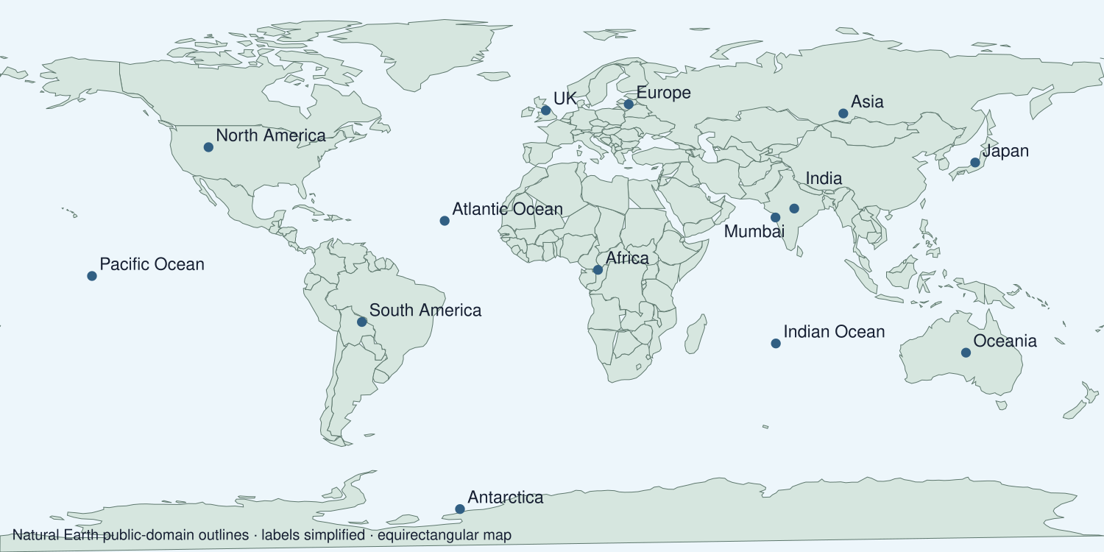
A detail I noticed and what it helps me explain
________________________________________________________________________
________________________________________________________________________
________________________________________________________________________
________________________________________________________________________

Shared investigation
1. Zoom from Teesside to the world.
2. Locate the UK, India, Japan and their neighbouring oceans.
Work with a partner or adult, or use your own table. One person suggests; the other checks the evidence. Swap after one turn. Passing is allowed.
Use the evidence cards and any visual sheet. Follow the two shared steps above, then record one decision.
Our explanation
________________________________________________________________________
________________________________________________________________________
________________________________________________________________________
Support: Read one evidence card together. Highlight a useful detail. Rehearse with: ___ is in ___. It lies beside ___.
Further challenge: Explain why the world map is useful for this question but not for a street route.

Supported independent task
Complete this route only. Locate countries continents and oceans using maps and atlases.
1. Label the UK, India and Japan, their continents and two oceans.
2. Use an atlas or the supplied map key.
3. Answer independently: which country lies beside the Pacific Ocean?
Support: Read one evidence card together. Highlight a useful detail. Rehearse with: ___ is in ___. It lies beside ___. Complete the organiser one space at a time. ___ is in ___. It lies beside ___.
Places and symbols or grid references
________________________________________________________________________
________________________________________________________________________
Location or direction statement
________________________________________________________________________
________________________________________________________________________
Pattern using the map evidence
________________________________________________________________________
________________________________________________________________________
What this map does not show
________________________________________________________________________
________________________________________________________________________
An adult may read or scribe your exact response. They should not choose the answer.

Standard independent task
Complete this route only. Locate countries continents and oceans using maps and atlases.
1. Label the UK, India and Japan, their continents and two oceans.
2. Use an atlas or the supplied map key.
3. Answer independently: which country lies beside the Pacific Ocean?
Support: ___ is in ___. It lies beside ___.
Places and symbols or grid references
________________________________________________________________________
________________________________________________________________________
Location or direction statement
________________________________________________________________________
________________________________________________________________________
Pattern using the map evidence
________________________________________________________________________
________________________________________________________________________
What this map does not show
________________________________________________________________________
________________________________________________________________________
Check the required evidence and revise one detail.

Stretch independent task
Complete this route only. Locate countries continents and oceans using maps and atlases.
1. Label the UK, India and Japan, their continents and two oceans.
2. Use an atlas or the supplied map key.
3. Answer independently: which country lies beside the Pacific Ocean?
4. Explain why the world map is useful for this question but not for a street route.
Support: Choose the evidence independently. Use the frame only if it helps.
Places and symbols or grid references
________________________________________________________________________
________________________________________________________________________
Location or direction statement
________________________________________________________________________
________________________________________________________________________
Pattern using the map evidence
________________________________________________________________________
________________________________________________________________________
What this map does not show
________________________________________________________________________
________________________________________________________________________
Explain why the world map is useful for this question but not for a street route.

Exit ticket
Choose a response mode. You may give your answers privately to an adult.

Which of the three countries lies beside the Pacific
My response
________________________________________________________________________
________________________________________________________________________
________________________________________________________________________

What changes when a map shows a much larger area
My response
________________________________________________________________________
________________________________________________________________________
________________________________________________________________________
Support: ___ is in ___. It lies beside ___.
Further challenge: Explain why the world map is useful for this question but not for a street route.
One thing I changed or want to check
________________________________________________________________________
________________________________________________________________________

