Connections across the world
Learning goal: Describe how communities are connected across the world.

Words to use
Word | Meaning
continent | A large land region
ocean | A large body of salt water
location | Where something is
connection | A link between places or people

Remember
Can communities connect without people travelling? Yes, through messages or shared online activity.
Does one example describe everyone in either place? No.

How to show your learning
Create a connection map for the fictional partner groups.
___ connects with ___ through ___. The account shows ___.

Evidence matters
Fictional cases are teaching examples. Historical, geographical and religious claims use the named sources. A model video demonstrates a method.
You can respond by speaking, pointing, drawing, typing or writing. A fictional personal example is welcome.
Sources: Natural Earth public domain map data

Arrival choices
Previous lesson reminder:
Start with 1 and 2. Try 3 and 4 when ready. Reading and exact scribing are available.

1 What is the park s four figure reference on the practice grid
Support: Use the reminder strip or talk it through with an adult.
My response
________________________________________________________________________

2 Which meaning fits continent
Support: Choose: A large land region OR A large body of salt water.
My response
________________________________________________________________________

3 Can communities connect without people travelling
Support: Use the model evidence anchor C or read one relevant card together.
My response
________________________________________________________________________

4 Does one example describe everyone in either place
Support: Give a reason when ready.
My response
________________________________________________________________________
Stretch: use a precise example or explain which detail supports your answer.

Evidence cards
Read, point or listen. Keep the source label with any detail you use.

A United Kingdom
The UK lies in Europe, beside the Atlantic Ocean. Teesside is in north-east England. A map can show different scales, from a neighbourhood to the world.
Source: Natural Earth world map and labelled place coordinates
Limit: This small-scale map cannot show a safe street route.

B India and Japan
India and Japan are in Asia. India borders the Indian Ocean; Japan is an island country beside the Pacific Ocean.
Source: Natural Earth world map
Limit: A country is not a single culture or belief.

C A community link
Fictional case: a Middlesbrough community group shares festival greetings with a partner group in Mumbai. The link can involve people and communication without a physical journey.
Source: Authored classroom case
Limit: This example does not describe every person or place.

D Celebrations across places
Diwali and Hanukkah are observed by communities in different countries. Locate examples using the map; a festival is not confined to one country.
Source: Hindu American Foundation and Chabad accounts
Limit: Do not assign a religion to everyone living in a country.

Visual resource
Use this visual with the evidence cards and enquiry questions.
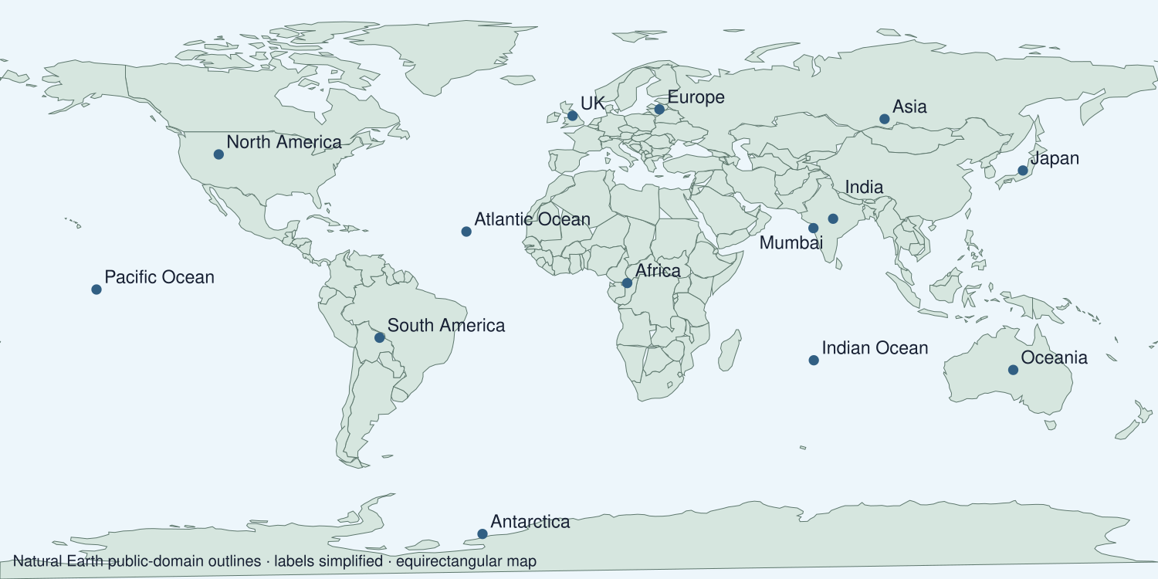
A detail I noticed and what it helps me explain
________________________________________________________________________
________________________________________________________________________
________________________________________________________________________
________________________________________________________________________

Shared investigation
1. Build a connection from Middlesbrough to Mumbai.
2. Distinguish movement of people, goods and messages.
Work with a partner or adult, or use your own table. One person suggests; the other checks the evidence. Swap after one turn. Passing is allowed.

Move or match the cards
Cards to use
Mumbai group
Shared greetings
Middlesbrough group

Possible labels: Link / Place
Our explanation
________________________________________________________________________
________________________________________________________________________
________________________________________________________________________
Support: Read one evidence card together. Highlight a useful detail. Rehearse with: ___ connects with ___ through ___. The account shows ___.
Further challenge: Explain how a connection might continue without a journey.

Supported independent task
Complete this route only. Describe how communities are connected across the world.
1. Create a connection map for the fictional partner groups.
2. Label both places and explain one link using the account.
3. State that the example does not describe every community.
Support: Read one evidence card together. Highlight a useful detail. Rehearse with: ___ connects with ___ through ___. The account shows ___. Complete the organiser one space at a time. ___ connects with ___ through ___. The account shows ___.
Cause and supporting detail
________________________________________________________________________
________________________________________________________________________
Event or change
________________________________________________________________________
________________________________________________________________________
Consequence and supporting detail
________________________________________________________________________
________________________________________________________________________
How the links connect
________________________________________________________________________
________________________________________________________________________
An adult may read or scribe your exact response. They should not choose the answer.

Standard independent task
Complete this route only. Describe how communities are connected across the world.
1. Create a connection map for the fictional partner groups.
2. Label both places and explain one link using the account.
3. State that the example does not describe every community.
Support: ___ connects with ___ through ___. The account shows ___.
Cause and supporting detail
________________________________________________________________________
________________________________________________________________________
Event or change
________________________________________________________________________
________________________________________________________________________
Consequence and supporting detail
________________________________________________________________________
________________________________________________________________________
How the links connect
________________________________________________________________________
________________________________________________________________________
Check the required evidence and revise one detail.

Stretch independent task
Complete this route only. Describe how communities are connected across the world.
1. Create a connection map for the fictional partner groups.
2. Label both places and explain one link using the account.
3. State that the example does not describe every community.
4. Explain how a connection might continue without a journey.
Support: Choose the evidence independently. Use the frame only if it helps.
Cause and supporting detail
________________________________________________________________________
________________________________________________________________________
Event or change
________________________________________________________________________
________________________________________________________________________
Consequence and supporting detail
________________________________________________________________________
________________________________________________________________________
How the links connect
________________________________________________________________________
________________________________________________________________________
Explain how a connection might continue without a journey.

Exit ticket
Choose a response mode. You may give your answers privately to an adult.

Can communities connect without people travelling
My response
________________________________________________________________________
________________________________________________________________________
________________________________________________________________________

Does one example describe everyone in either place
My response
________________________________________________________________________
________________________________________________________________________
________________________________________________________________________
Support: ___ connects with ___ through ___. The account shows ___.
Further challenge: Explain how a connection might continue without a journey.
One thing I changed or want to check
________________________________________________________________________
________________________________________________________________________

