Festivals of light around the world
Learning goal: Investigate festivals of light around the world with a Geography link.

Words to use
Word | Meaning
festival | A special period of celebration or remembrance
belief | Something a person accepts as true
tradition | A practice passed on
respect | Care for people and what matters to them

Remember
Does Diwali belong to only one country? No. Communities observe it in several countries.
What supports an explanation of a festival’s meaning? A credited account from people or organisations explaining the observance.

How to show your learning
Locate one festival example on a map.
In ___, some communities ___. The source explains ___.

Evidence matters
Fictional cases are teaching examples. Historical, geographical and religious claims use the named sources. A model video demonstrates a method.
You can respond by speaking, pointing, drawing, typing or writing. A fictional personal example is welcome.
Sources: Hindu American Foundation Diwali; Chabad What is Hanukkah

Arrival choices
Previous lesson reminder:
Start with 1 and 2. Try 3 and 4 when ready. Reading and exact scribing are available.

1 Can communities connect without people travelling
Support: Use the reminder strip or talk it through with an adult.
My response
________________________________________________________________________

2 Which meaning fits festival
Support: Choose: A special period of celebration or remembrance OR Something a person accepts as true.
My response
________________________________________________________________________

3 Does Diwali belong to only one country
Support: Use the model evidence anchor D or read one relevant card together.
My response
________________________________________________________________________

4 What supports an explanation of a festival s meaning
Support: Give a reason when ready.
My response
________________________________________________________________________
Stretch: use a precise example or explain which detail supports your answer.

Evidence cards
Read, point or listen. Keep the source label with any detail you use.

D Diwali
Many Hindus mark Diwali with lamps, worship and gatherings. Light can express good overcoming evil and knowledge overcoming ignorance. Practices and stories vary.
Source: Hindu American Foundation, Diwali
Limit: This Hindu explanation does not cover every Hindu practice or other religions’ observances.

H Hanukkah
Hanukkah is a Jewish festival lasting eight nights. Lights recall the Temple’s rededication and the traditional account of oil lasting eight days. A hanukkiah has eight festival lights and a helper light.
Source: Chabad, What is Hanukkah
Limit: This explains one Jewish religious perspective; not all Jewish households observe identically.

O Objects and meanings
A diya is a small lamp associated with Diwali. A hanukkiah is used at Hanukkah. Ask before touching borrowed objects; use an unlit replica or a drawing.
Source: Authored classroom case
Limit: This example does not describe every person or place.

S One family’s celebration plan
Fictional Diwali plan: prepare a welcoming space; arrange unlit lamps with an adult; gather for worship; share food and greetings. This is one sequence, not a rule for every family.
Source: Authored classroom case
Limit: This example does not describe every person or place.

Visual resource
Use this visual with the evidence cards and enquiry questions.
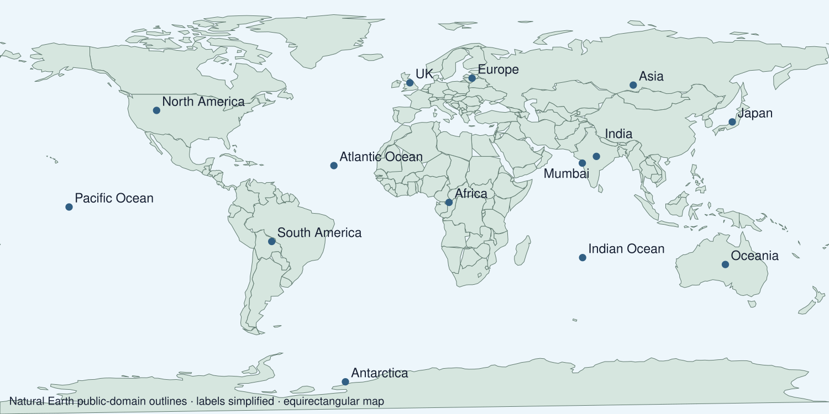
A detail I noticed and what it helps me explain
________________________________________________________________________
________________________________________________________________________
________________________________________________________________________
________________________________________________________________________

Shared investigation
1. Locate India and the UK, then compare festival source details.
2. Discuss why a celebration can be observed in several places.
Work with a partner or adult, or use your own table. One person suggests; the other checks the evidence. Swap after one turn. Passing is allowed.
Use the evidence cards and any visual sheet. Follow the two shared steps above, then record one decision.
Our explanation
________________________________________________________________________
________________________________________________________________________
________________________________________________________________________
Support: Read one evidence card together. Highlight a useful detail. Rehearse with: In ___, some communities ___. The source explains ___.
Further challenge: Explain why a national location does not tell us an individual’s religion.

Supported independent task
Complete this route only. Investigate festivals of light around the world with a Geography link.
1. Locate one festival example on a map.
2. Explain an accurate feature, its meaning and a connection between places.
3. Record a short reflection using careful language.
Support: Read one evidence card together. Highlight a useful detail. Rehearse with: In ___, some communities ___. The source explains ___. Complete the organiser one space at a time. In ___, some communities ___. The source explains ___.
Places and symbols or grid references
________________________________________________________________________
________________________________________________________________________
Location or direction statement
________________________________________________________________________
________________________________________________________________________
Pattern using the map evidence
________________________________________________________________________
________________________________________________________________________
What this map does not show
________________________________________________________________________
________________________________________________________________________
An adult may read or scribe your exact response. They should not choose the answer.

Standard independent task
Complete this route only. Investigate festivals of light around the world with a Geography link.
1. Locate one festival example on a map.
2. Explain an accurate feature, its meaning and a connection between places.
3. Record a short reflection using careful language.
Support: In ___, some communities ___. The source explains ___.
Places and symbols or grid references
________________________________________________________________________
________________________________________________________________________
Location or direction statement
________________________________________________________________________
________________________________________________________________________
Pattern using the map evidence
________________________________________________________________________
________________________________________________________________________
What this map does not show
________________________________________________________________________
________________________________________________________________________
Check the required evidence and revise one detail.

Stretch independent task
Complete this route only. Investigate festivals of light around the world with a Geography link.
1. Locate one festival example on a map.
2. Explain an accurate feature, its meaning and a connection between places.
3. Record a short reflection using careful language.
4. Explain why a national location does not tell us an individual’s religion.
Support: Choose the evidence independently. Use the frame only if it helps.
Places and symbols or grid references
________________________________________________________________________
________________________________________________________________________
Location or direction statement
________________________________________________________________________
________________________________________________________________________
Pattern using the map evidence
________________________________________________________________________
________________________________________________________________________
What this map does not show
________________________________________________________________________
________________________________________________________________________
Explain why a national location does not tell us an individual’s religion.

Exit ticket
Choose a response mode. You may give your answers privately to an adult.

Does Diwali belong to only one country
My response
________________________________________________________________________
________________________________________________________________________
________________________________________________________________________

What supports an explanation of a festival s meaning
My response
________________________________________________________________________
________________________________________________________________________
________________________________________________________________________
Support: In ___, some communities ___. The source explains ___.
Further challenge: Explain why a national location does not tell us an individual’s religion.
One thing I changed or want to check
________________________________________________________________________
________________________________________________________________________

