Presenting belief and belonging
Learning goal: Present findings on belief and belonging.

Words to use
Word | Meaning
festival | A special period of celebration or remembrance
belief | Something a person accepts as true
tradition | A practice passed on
respect | Care for people and what matters to them

Remember
Why should a presentation use evidence? It allows the audience to check the claims.
What should be recorded after presenting? A question response and one reflection or improvement.

How to show your learning
Plan and present three points on place, celebration and meaning.
My first point is ___. The source or map shows ___. A limit is ___.

Evidence matters
Fictional cases are teaching examples. Historical, geographical and religious claims use the named sources. A model video demonstrates a method.
You can respond by speaking, pointing, drawing, typing or writing. A fictional personal example is welcome.
Sources: Hindu American Foundation Diwali; Chabad What is Hanukkah

Arrival choices
Previous lesson reminder:
Start with 1 and 2. Try 3 and 4 when ready. Reading and exact scribing are available.

1 What shared feature can the sources support
Support: Use the reminder strip or talk it through with an adult.
My response
________________________________________________________________________

2 Which meaning fits festival
Support: Choose: A special period of celebration or remembrance OR Something a person accepts as true.
My response
________________________________________________________________________

3 Why should a presentation use evidence
Support: Use the model evidence anchor D,H or read one relevant card together.
My response
________________________________________________________________________

4 What should be recorded after presenting
Support: Give a reason when ready.
My response
________________________________________________________________________
Stretch: use a precise example or explain which detail supports your answer.

Evidence cards
Read, point or listen. Keep the source label with any detail you use.

D Diwali
Many Hindus mark Diwali with lamps, worship and gatherings. Light can express good overcoming evil and knowledge overcoming ignorance. Practices and stories vary.
Source: Hindu American Foundation, Diwali
Limit: This Hindu explanation does not cover every Hindu practice or other religions’ observances.

H Hanukkah
Hanukkah is a Jewish festival lasting eight nights. Lights recall the Temple’s rededication and the traditional account of oil lasting eight days. A hanukkiah has eight festival lights and a helper light.
Source: Chabad, What is Hanukkah
Limit: This explains one Jewish religious perspective; not all Jewish households observe identically.

O Objects and meanings
A diya is a small lamp associated with Diwali. A hanukkiah is used at Hanukkah. Ask before touching borrowed objects; use an unlit replica or a drawing.
Source: Authored classroom case
Limit: This example does not describe every person or place.

S One family’s celebration plan
Fictional Diwali plan: prepare a welcoming space; arrange unlit lamps with an adult; gather for worship; share food and greetings. This is one sequence, not a rule for every family.
Source: Authored classroom case
Limit: This example does not describe every person or place.

Visual resource
Use this visual with the evidence cards and enquiry questions.
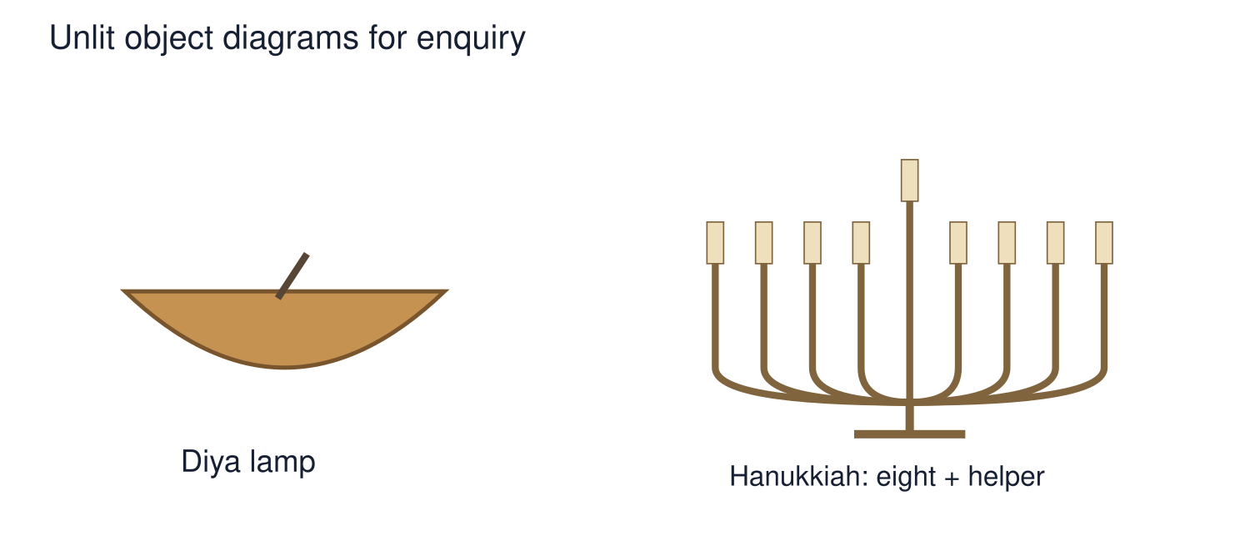
A detail I noticed and what it helps me explain
________________________________________________________________________
________________________________________________________________________
________________________________________________________________________
________________________________________________________________________

Shared investigation
1. Assemble three points supported by source cards and a map.
2. Practise answering a respectful evidence question.
Work with a partner or adult, or use your own table. One person suggests; the other checks the evidence. Swap after one turn. Passing is allowed.
Use the evidence cards and any visual sheet. Follow the two shared steps above, then record one decision.
Our explanation
________________________________________________________________________
________________________________________________________________________
________________________________________________________________________
Support: Read one evidence card together. Highlight a useful detail. Rehearse with: My first point is ___. The source or map shows ___. A limit is ___.
Further challenge: Respond to a question about differences within communities.

Supported independent task
Complete this route only. Present findings on belief and belonging.
1. Plan and present three points on place, celebration and meaning.
2. Use a visual and source reference.
3. Answer one question and record self or peer feedback; live, recorded or private delivery is valid.
Support: Read one evidence card together. Highlight a useful detail. Rehearse with: My first point is ___. The source or map shows ___. A limit is ___. Complete the organiser one space at a time. My first point is ___. The source or map shows ___. A limit is ___.
My main message
________________________________________________________________________
________________________________________________________________________
My factual evidence and source
________________________________________________________________________
________________________________________________________________________
My visual or presentation choice
________________________________________________________________________
________________________________________________________________________
My reason or response to a question
________________________________________________________________________
________________________________________________________________________
An adult may read or scribe your exact response. They should not choose the answer.

Standard independent task
Complete this route only. Present findings on belief and belonging.
1. Plan and present three points on place, celebration and meaning.
2. Use a visual and source reference.
3. Answer one question and record self or peer feedback; live, recorded or private delivery is valid.
Support: My first point is ___. The source or map shows ___. A limit is ___.
My main message
________________________________________________________________________
________________________________________________________________________
My factual evidence and source
________________________________________________________________________
________________________________________________________________________
My visual or presentation choice
________________________________________________________________________
________________________________________________________________________
My reason or response to a question
________________________________________________________________________
________________________________________________________________________
Check the required evidence and revise one detail.

Stretch independent task
Complete this route only. Present findings on belief and belonging.
1. Plan and present three points on place, celebration and meaning.
2. Use a visual and source reference.
3. Answer one question and record self or peer feedback; live, recorded or private delivery is valid.
4. Respond to a question about differences within communities.
Support: Choose the evidence independently. Use the frame only if it helps.
My main message
________________________________________________________________________
________________________________________________________________________
My factual evidence and source
________________________________________________________________________
________________________________________________________________________
My visual or presentation choice
________________________________________________________________________
________________________________________________________________________
My reason or response to a question
________________________________________________________________________
________________________________________________________________________
Respond to a question about differences within communities.

Exit ticket
Choose a response mode. You may give your answers privately to an adult.

Why should a presentation use evidence
My response
________________________________________________________________________
________________________________________________________________________
________________________________________________________________________

What should be recorded after presenting
My response
________________________________________________________________________
________________________________________________________________________
________________________________________________________________________
Support: My first point is ___. The source or map shows ___. A limit is ___.
Further challenge: Respond to a question about differences within communities.
One thing I changed or want to check
________________________________________________________________________
________________________________________________________________________

