Maps symbols and grid references
Learning goal: Use maps OS symbols and grid references.

Words to use
Word | Meaning
settlement | A place where people live
urbanisation | Growth in the share of people living in urban places
land use | What land is used for
GIS | Mapping information in separate data layers

Remember
What area does a four-figure reference locate? A whole grid square.
Why consult the actual map key? Symbol meanings and map detail depend on the map series; our practice symbols are labelled teaching symbols.

How to show your learning
Identify the genuine OS abbreviations Sch, PO and FB using the supplied key.
The key identifies ___. Easting ___ then northing ___ gives ___.

Evidence matters
Fictional cases are teaching examples. Historical, geographical and religious claims use the named sources. A model video demonstrates a method.
You can respond by speaking, pointing, drawing, typing or writing. A fictional personal example is welcome.
Sources: OpenStreetMap Middlesbrough; OpenStreetMap Helmsley

Arrival choices
You can begin without previous learning. Word help: settlement means a place where people live.
Start with 1 and 2. Try 3 and 4 when ready. Reading and exact scribing are available.

1 What does settlement mean
Support: Use the reminder strip or talk it through with an adult.
My response
________________________________________________________________________

2 Which meaning fits settlement
Support: Choose: A place where people live OR Growth in the share of people living in urban places.
My response
________________________________________________________________________

3 What area does a four figure reference locate
Support: Use the model evidence anchor grid or read one relevant card together.
My response
________________________________________________________________________

4 Why consult the actual map key
Support: Give a reason when ready.
My response
________________________________________________________________________
Stretch: use a precise example or explain which detail supports your answer.

Evidence cards
Read, point or listen. Keep the source label with any detail you use.

A Local reference points
The Middlesbrough railway station and the Transporter Bridge are reference points on our digital map. Toggle layers to examine their positions. Town Hall lies beyond this map’s southern boundary.
Source: OpenStreetMap place references; approximate labelled coordinates
Limit: These points alone cannot show population density or prove why development happened.

B Reasons places grow
Work, transport and services can attract people and businesses. A growing town may need more homes and infrastructure. Population growth can also occur within existing settlements.
Source: Authored geographical explanation
Limit: A reason is a hypothesis until tested against evidence for a particular place.

C Practice land-use sample
Fictional practice tally: shops 8, homes 12, public services 4, green spaces 6. This is training data only. Replace it with your dated observations for the fieldwork enquiry.
Source: Authored classroom case
Limit: This example does not describe every person or place.

D Contrasting reference place
Compare a small centre such as Helmsley with central Middlesbrough at comparable map scales. Record the area, source and date used.
Source: OpenStreetMap linked views
Limit: One sampled street does not represent a whole settlement.

Visual resource
Use this visual with the evidence cards and enquiry questions.
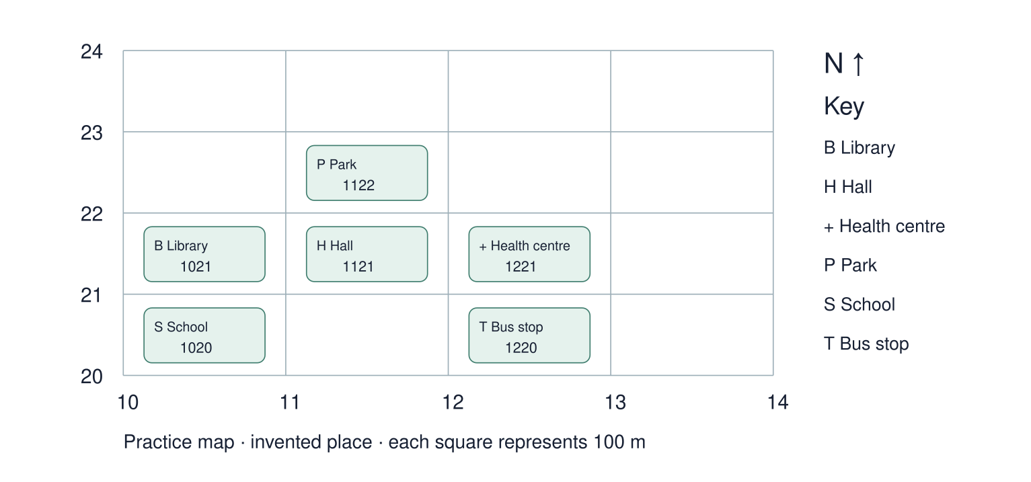
A detail I noticed and what it helps me explain
________________________________________________________________________
________________________________________________________________________
________________________________________________________________________
________________________________________________________________________

Shared investigation
1. Compare the practice-map key with the linked OS symbol guide.
2. Read eastings before northings and practise four-figure references.
Work with a partner or adult, or use your own table. One person suggests; the other checks the evidence. Swap after one turn. Passing is allowed.
Use the evidence cards and any visual sheet. Follow the two shared steps above, then record one decision.
Our explanation
________________________________________________________________________
________________________________________________________________________
________________________________________________________________________
Support: Use the glossary and one chunk of evidence. Plan the claim and supporting detail before explaining.
Further challenge: Give a six-figure location within a square and explain the difference in precision.

Supported independent task
Complete this route only. Use maps OS symbols and grid references.
1. Identify the genuine OS abbreviations Sch, PO and FB using the supplied key.
2. Locate three features on the separate practice map using grid references and direction.
3. Answer one independent location or pattern question.
Support: Use the glossary and one chunk of evidence. Plan the claim and supporting detail before explaining. Complete the organiser one space at a time. The key identifies ___. Easting ___ then northing ___ gives ___.
Places and symbols or grid references
________________________________________________________________________
________________________________________________________________________
Location or direction statement
________________________________________________________________________
________________________________________________________________________
Pattern using the map evidence
________________________________________________________________________
________________________________________________________________________
What this map does not show
________________________________________________________________________
________________________________________________________________________
An adult may read or scribe your exact response. They should not choose the answer.

Standard independent task
Complete this route only. Use maps OS symbols and grid references.
1. Identify the genuine OS abbreviations Sch, PO and FB using the supplied key.
2. Locate three features on the separate practice map using grid references and direction.
3. Answer one independent location or pattern question.
Support: The key identifies ___. Easting ___ then northing ___ gives ___.
Places and symbols or grid references
________________________________________________________________________
________________________________________________________________________
Location or direction statement
________________________________________________________________________
________________________________________________________________________
Pattern using the map evidence
________________________________________________________________________
________________________________________________________________________
What this map does not show
________________________________________________________________________
________________________________________________________________________
Check the required evidence and revise one detail.

Stretch independent task
Complete this route only. Use maps OS symbols and grid references.
1. Identify the genuine OS abbreviations Sch, PO and FB using the supplied key.
2. Locate three features on the separate practice map using grid references and direction.
3. Answer one independent location or pattern question.
4. Give a six-figure location within a square and explain the difference in precision.
Support: Choose the evidence independently. Use the frame only if it helps.
Places and symbols or grid references
________________________________________________________________________
________________________________________________________________________
Location or direction statement
________________________________________________________________________
________________________________________________________________________
Pattern using the map evidence
________________________________________________________________________
________________________________________________________________________
What this map does not show
________________________________________________________________________
________________________________________________________________________
Give a six-figure location within a square and explain the difference in precision.

Exit ticket
Choose a response mode. You may give your answers privately to an adult.

What area does a four figure reference locate
My response
________________________________________________________________________
________________________________________________________________________
________________________________________________________________________

Why consult the actual map key
My response
________________________________________________________________________
________________________________________________________________________
________________________________________________________________________
Support: The key identifies ___. Easting ___ then northing ___ gives ___.
Further challenge: Give a six-figure location within a square and explain the difference in precision.
One thing I changed or want to check
________________________________________________________________________
________________________________________________________________________

