From fieldwork to spreadsheet and graph
Learning goal: Record fieldwork in a spreadsheet and graph it.

Words to use
Word | Meaning
settlement | A place where people live
urbanisation | Growth in the share of people living in urban places
land use | What land is used for
GIS | Mapping information in separate data layers

Remember
Why is a bar chart suitable for land-use categories? It compares counts across separate categories.
What if fieldwork data are missing? Use clearly labelled practice data for the skill, then collect genuine observations before assessing the fieldwork enquiry.

How to show your learning
Enter your own previous-lesson data into the editable spreadsheet.
The largest category is ___ with ___. Compared with ___, ___. Our sample is limited because ___.

Evidence matters
Fictional cases are teaching examples. Historical, geographical and religious claims use the named sources. A model video demonstrates a method.
You can respond by speaking, pointing, drawing, typing or writing. A fictional personal example is welcome.
Sources: OpenStreetMap Middlesbrough; OpenStreetMap Helmsley

Arrival choices
Previous lesson reminder:
Start with 1 and 2. Try 3 and 4 when ready. Reading and exact scribing are available.

1 Why agree categories before counting
Support: Use the reminder strip or talk it through with an adult.
My response
________________________________________________________________________

2 Which meaning fits settlement
Support: Choose: A place where people live OR Growth in the share of people living in urban places.
My response
________________________________________________________________________

3 Why is a bar chart suitable for land use categories
Support: Use the model evidence anchor dataset or read one relevant card together.
My response
________________________________________________________________________

4 What if fieldwork data are missing
Support: Give a reason when ready.
My response
________________________________________________________________________
Stretch: use a precise example or explain which detail supports your answer.

Evidence cards
Read, point or listen. Keep the source label with any detail you use.

A Local reference points
The Middlesbrough railway station and the Transporter Bridge are reference points on our digital map. Toggle layers to examine their positions. Town Hall lies beyond this map’s southern boundary.
Source: OpenStreetMap place references; approximate labelled coordinates
Limit: These points alone cannot show population density or prove why development happened.

B Reasons places grow
Work, transport and services can attract people and businesses. A growing town may need more homes and infrastructure. Population growth can also occur within existing settlements.
Source: Authored geographical explanation
Limit: A reason is a hypothesis until tested against evidence for a particular place.

C Practice land-use sample
Fictional practice tally: shops 8, homes 12, public services 4, green spaces 6. This is training data only. Replace it with your dated observations for the fieldwork enquiry.
Source: Authored classroom case
Limit: This example does not describe every person or place.

D Contrasting reference place
Compare a small centre such as Helmsley with central Middlesbrough at comparable map scales. Record the area, source and date used.
Source: OpenStreetMap linked views
Limit: One sampled street does not represent a whole settlement.

Visual resource
Use this visual with the evidence cards and enquiry questions.
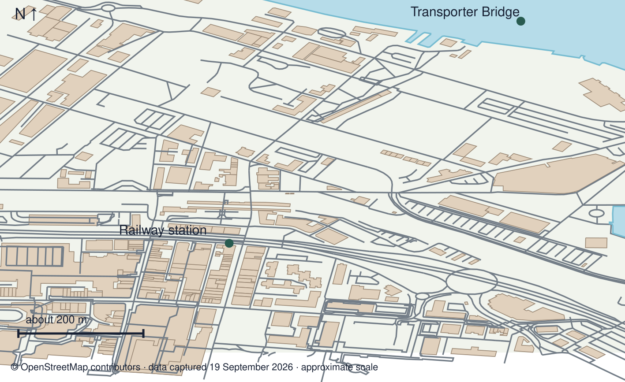
A detail I noticed and what it helps me explain
________________________________________________________________________
________________________________________________________________________
________________________________________________________________________
________________________________________________________________________

Data for the enquiry
Fictional land-use practice tally
Category | Count
Shops | 8
Homes | 12
Services | 4
Green spaces | 6

Units: Count
Source: Authored training data; replace with dated learner observations for fieldwork assessment
Limit: These are not actual observations of Middlesbrough or Helmsley.
My labelled graph or data notes
________________________________________________________________________
________________________________________________________________________
________________________________________________________________________
________________________________________________________________________
________________________________________________________________________
________________________________________________________________________
________________________________________________________________________
________________________________________________________________________

Shared investigation
1. Transfer a practice tally into the prepared table.
2. Choose a bar chart and check category names, values and units.
Work with a partner or adult, or use your own table. One person suggests; the other checks the evidence. Swap after one turn. Passing is allowed.
Use the evidence cards and any visual sheet. Follow the two shared steps above, then record one decision.
Our explanation
________________________________________________________________________
________________________________________________________________________
________________________________________________________________________
Support: Use the glossary and one chunk of evidence. Plan the claim and supporting detail before explaining.
Further challenge: Explain why a pie chart or line graph might be less suitable for your particular data.

Supported independent task
Complete this route only. Record fieldwork in a spreadsheet and graph it.
1. Enter your own previous-lesson data into the editable spreadsheet.
2. Create a labelled graph and verify the transfer against the raw tally.
3. Describe a pattern and one limitation of the sample.
Support: Use the glossary and one chunk of evidence. Plan the claim and supporting detail before explaining. Complete the organiser one space at a time. The largest category is ___ with ___. Compared with ___, ___. Our sample is limited because ___.
Data source and date or capture time
________________________________________________________________________
________________________________________________________________________
Variables units and graph labels
________________________________________________________________________
________________________________________________________________________
A pattern supported by values
________________________________________________________________________
________________________________________________________________________
What the data cannot establish
________________________________________________________________________
________________________________________________________________________
An adult may read or scribe your exact response. They should not choose the answer.

Standard independent task
Complete this route only. Record fieldwork in a spreadsheet and graph it.
1. Enter your own previous-lesson data into the editable spreadsheet.
2. Create a labelled graph and verify the transfer against the raw tally.
3. Describe a pattern and one limitation of the sample.
Support: The largest category is ___ with ___. Compared with ___, ___. Our sample is limited because ___.
Data source and date or capture time
________________________________________________________________________
________________________________________________________________________
Variables units and graph labels
________________________________________________________________________
________________________________________________________________________
A pattern supported by values
________________________________________________________________________
________________________________________________________________________
What the data cannot establish
________________________________________________________________________
________________________________________________________________________
Check the required evidence and revise one detail.

Stretch independent task
Complete this route only. Record fieldwork in a spreadsheet and graph it.
1. Enter your own previous-lesson data into the editable spreadsheet.
2. Create a labelled graph and verify the transfer against the raw tally.
3. Describe a pattern and one limitation of the sample.
4. Explain why a pie chart or line graph might be less suitable for your particular data.
Support: Choose the evidence independently. Use the frame only if it helps.
Data source and date or capture time
________________________________________________________________________
________________________________________________________________________
Variables units and graph labels
________________________________________________________________________
________________________________________________________________________
A pattern supported by values
________________________________________________________________________
________________________________________________________________________
What the data cannot establish
________________________________________________________________________
________________________________________________________________________
Explain why a pie chart or line graph might be less suitable for your particular data.

Exit ticket
Choose a response mode. You may give your answers privately to an adult.

Why is a bar chart suitable for land use categories
My response
________________________________________________________________________
________________________________________________________________________
________________________________________________________________________

What if fieldwork data are missing
My response
________________________________________________________________________
________________________________________________________________________
________________________________________________________________________
Support: The largest category is ___ with ___. Compared with ___, ___. Our sample is limited because ___.
Further challenge: Explain why a pie chart or line graph might be less suitable for your particular data.
One thing I changed or want to check
________________________________________________________________________
________________________________________________________________________

