Writing up a fieldwork enquiry
Learning goal: Complete a fieldwork enquiry write up.

Words to use
Word | Meaning
settlement | A place where people live
urbanisation | Growth in the share of people living in urban places
land use | What land is used for
GIS | Mapping information in separate data layers

Remember
What should the conclusion refer to? The enquiry question and actual collected data.
Why include a limitation? It shows the boundaries of what the method and sample can establish.

How to show your learning
Assemble question, method, location map, actual data, graph and conclusion.
Our question was ___. The method ___. Data show ___. Therefore ___. A limitation is ___.

Evidence matters
Fictional cases are teaching examples. Historical, geographical and religious claims use the named sources. A model video demonstrates a method.
You can respond by speaking, pointing, drawing, typing or writing. A fictional personal example is welcome.
Sources: OpenStreetMap Middlesbrough; OpenStreetMap Helmsley

Arrival choices
Previous lesson reminder:
Start with 1 and 2. Try 3 and 4 when ready. Reading and exact scribing are available.

1 Why compare maps at similar scales
Support: Use the reminder strip or talk it through with an adult.
My response
________________________________________________________________________

2 Which meaning fits settlement
Support: Choose: A place where people live OR Growth in the share of people living in urban places.
My response
________________________________________________________________________

3 What should the conclusion refer to
Support: Use the model evidence anchor assessment or read one relevant card together.
My response
________________________________________________________________________

4 Why include a limitation
Support: Give a reason when ready.
My response
________________________________________________________________________
Stretch: use a precise example or explain which detail supports your answer.

Evidence cards
Read, point or listen. Keep the source label with any detail you use.

A Local reference points
The Middlesbrough railway station and the Transporter Bridge are reference points on our digital map. Toggle layers to examine their positions. Town Hall lies beyond this map’s southern boundary.
Source: OpenStreetMap place references; approximate labelled coordinates
Limit: These points alone cannot show population density or prove why development happened.

B Reasons places grow
Work, transport and services can attract people and businesses. A growing town may need more homes and infrastructure. Population growth can also occur within existing settlements.
Source: Authored geographical explanation
Limit: A reason is a hypothesis until tested against evidence for a particular place.

C Practice land-use sample
Fictional practice tally: shops 8, homes 12, public services 4, green spaces 6. This is training data only. Replace it with your dated observations for the fieldwork enquiry.
Source: Authored classroom case
Limit: This example does not describe every person or place.

D Contrasting reference place
Compare a small centre such as Helmsley with central Middlesbrough at comparable map scales. Record the area, source and date used.
Source: OpenStreetMap linked views
Limit: One sampled street does not represent a whole settlement.

Visual resource
Use this visual with the evidence cards and enquiry questions.
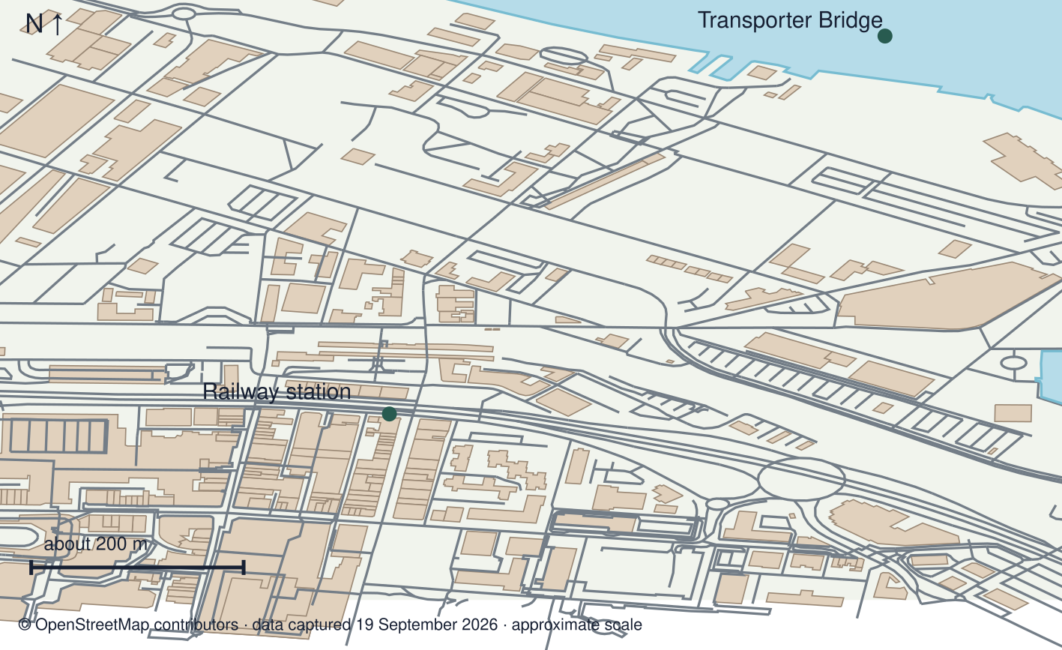
A detail I noticed and what it helps me explain
________________________________________________________________________
________________________________________________________________________
________________________________________________________________________
________________________________________________________________________

Shared investigation
1. Review a sample conclusion against its data.
2. Check that the report answers the original enquiry.
Work with a partner or adult, or use your own table. One person suggests; the other checks the evidence. Swap after one turn. Passing is allowed.
Use the evidence cards and any visual sheet. Follow the two shared steps above, then record one decision.
Our explanation
________________________________________________________________________
________________________________________________________________________
________________________________________________________________________
Support: Use the glossary and one chunk of evidence. Plan the claim and supporting detail before explaining.
Further challenge: Explain how an improved method could strengthen or change the conclusion.

Supported independent task
Complete this route only. Complete a fieldwork enquiry write up.
1. Assemble question, method, location map, actual data, graph and conclusion.
2. Explain what the evidence supports.
3. Evaluate one method limitation and retain your individual contribution.
Support: Use the glossary and one chunk of evidence. Plan the claim and supporting detail before explaining. Complete the organiser one space at a time. Our question was ___. The method ___. Data show ___. Therefore ___. A limitation is ___.
My answer to the assessment enquiry
________________________________________________________________________
________________________________________________________________________
My evidence and source
________________________________________________________________________
________________________________________________________________________
My explanation or comparison
________________________________________________________________________
________________________________________________________________________
My conclusion and what the evidence does not show
________________________________________________________________________
________________________________________________________________________
An adult may read or scribe your exact response. They should not choose the answer.

Standard independent task
Complete this route only. Complete a fieldwork enquiry write up.
1. Assemble question, method, location map, actual data, graph and conclusion.
2. Explain what the evidence supports.
3. Evaluate one method limitation and retain your individual contribution.
Support: Our question was ___. The method ___. Data show ___. Therefore ___. A limitation is ___.
My answer to the assessment enquiry
________________________________________________________________________
________________________________________________________________________
My evidence and source
________________________________________________________________________
________________________________________________________________________
My explanation or comparison
________________________________________________________________________
________________________________________________________________________
My conclusion and what the evidence does not show
________________________________________________________________________
________________________________________________________________________
Check the required evidence and revise one detail.

Stretch independent task
Complete this route only. Complete a fieldwork enquiry write up.
1. Assemble question, method, location map, actual data, graph and conclusion.
2. Explain what the evidence supports.
3. Evaluate one method limitation and retain your individual contribution.
4. Explain how an improved method could strengthen or change the conclusion.
Support: Choose the evidence independently. Use the frame only if it helps.
My answer to the assessment enquiry
________________________________________________________________________
________________________________________________________________________
My evidence and source
________________________________________________________________________
________________________________________________________________________
My explanation or comparison
________________________________________________________________________
________________________________________________________________________
My conclusion and what the evidence does not show
________________________________________________________________________
________________________________________________________________________
Explain how an improved method could strengthen or change the conclusion.

Exit ticket
Choose a response mode. You may give your answers privately to an adult.

What should the conclusion refer to
My response
________________________________________________________________________
________________________________________________________________________
________________________________________________________________________

Why include a limitation
My response
________________________________________________________________________
________________________________________________________________________
________________________________________________________________________
Support: Our question was ___. The method ___. Data show ___. Therefore ___. A limitation is ___.
Further challenge: Explain how an improved method could strengthen or change the conclusion.
One thing I changed or want to check
________________________________________________________________________
________________________________________________________________________

