Old and new objects
Learning goal: Compare old and new objects.

Words to use
Word | Meaning
past | A time before now
present | The time we are in now
change | Something that becomes different
continuity | Something that stays the same

Remember
What function do both phones share? They allow a conversation over distance.
Does newer always mean better for everyone? No. Suitability depends on the user and purpose.

How to show your learning
Make an object comparison card.
Both objects ___. One difference is ___.

Evidence matters
Fictional cases are teaching examples. Historical, geographical and religious claims use the named sources. A model video demonstrates a method.
You can respond by speaking, pointing, drawing, typing or writing. A fictional personal example is welcome.

Arrival choices
Previous lesson reminder:

Start with 1 and 2. Try 3 and 4 when ready. Reading and exact scribing are available.

1 Which comes first Wednesday or Friday
Support: Use the reminder strip or talk it through with an adult.
My response
________________________________________________________________________

2 Which meaning fits past
Support: Choose: A time before now OR The time we are in now.
My response
________________________________________________________________________

3 What function do both phones share
Support: Use the model evidence anchor B or read one relevant card together.
My response
________________________________________________________________________

4 Does newer always mean better for everyone
Support: Give a reason when ready.
My response
________________________________________________________________________
Stretch: use a precise example or explain which detail supports your answer.

Evidence cards
Read, point or listen. Keep the source label with any detail you use.

A A fictional week
Monday: choose a club activity. Wednesday: practise the activity. Friday: share what was made. The words Monday, Wednesday and Friday supply the order.
Source: Authored classroom case
Limit: This example does not describe every person or place.

B Telephone comparison
A rotary telephone and a smartphone both support conversations over distance. A smartphone can also show a video call; a rotary dial selects numbers differently.
Source: Authored comparison of familiar objects
Limit: A newer object is not automatically better for every person or purpose.

C Photo enquiry
Use the paired local photographs supplied with this unit. Read the captions and dates. Point to one feature in each image before deciding what changed.
Source: See photograph captions and credits
Limit: A camera angle or season can make features appear different; a photograph alone may not explain why.

D Questions worth asking
Who used this object? When was this photo made? A dated catalogue entry can help with time; a user’s account can help with experience.
Source: Authored classroom case
Limit: This example does not describe every person or place.

Visual resource
Use this visual with the evidence cards and enquiry questions.
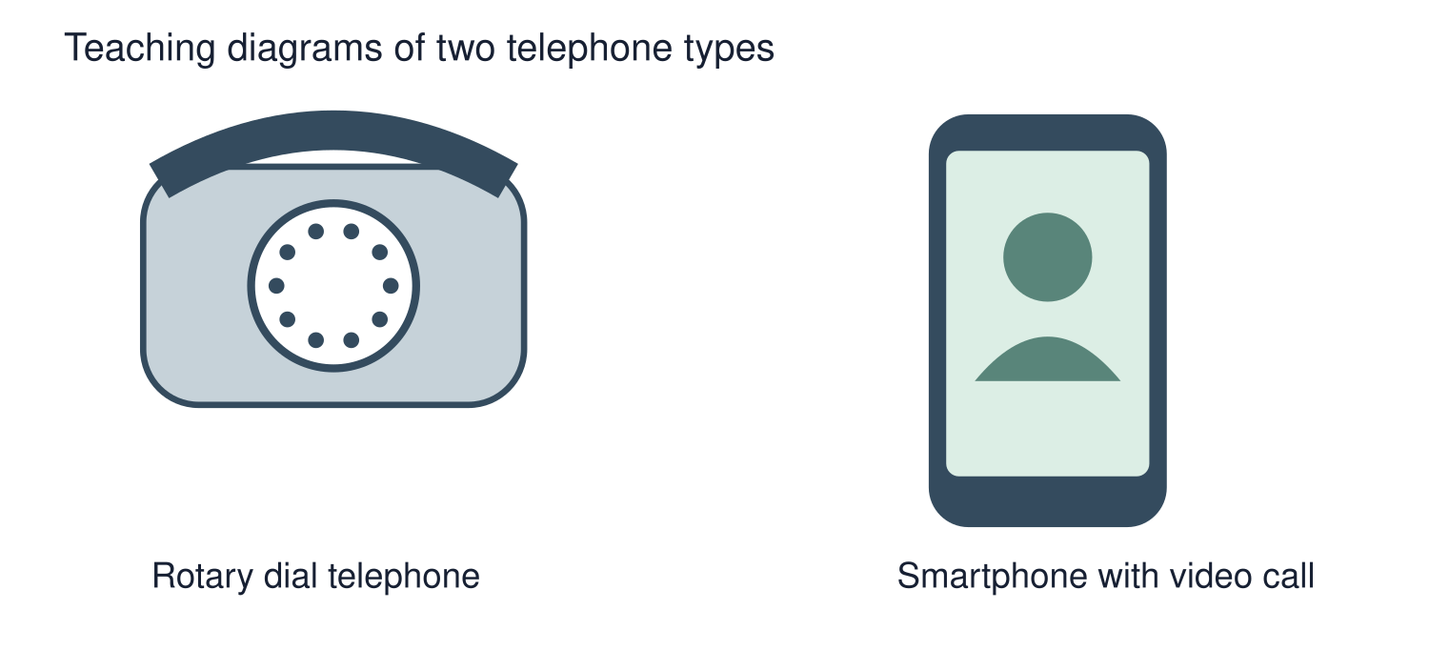
A detail I noticed and what it helps me explain
________________________________________________________________________
________________________________________________________________________
________________________________________________________________________
________________________________________________________________________

Shared investigation
1. Pair-match a rotary telephone and smartphone.
2. Sort visible differences from functions they share.
Work with a partner or adult, or use your own table. One person suggests; the other checks the evidence. Swap after one turn. Passing is allowed.
Use the evidence cards and any visual sheet. Follow the two shared steps above, then record one decision.
Our explanation
________________________________________________________________________
________________________________________________________________________
________________________________________________________________________
Support: Show two choices. Read one short instruction. Point, match or say a word, then add a reason when ready.
Further challenge: Explain why a different user might prefer one object for a particular purpose.

Supported independent task
Complete this route only. Compare old and new objects.
1. Make an object comparison card.
2. Record one change and one thing unchanged.
3. Add a caption based on a diagram or an object you can inspect.
Support: Show two choices. Read one short instruction. Point, match or say a word, then add a reason when ready. Complete the organiser one space at a time. Both objects ___. One difference is ___.
Evidence from the first example
________________________________________________________________________
________________________________________________________________________
Evidence from the second example
________________________________________________________________________
________________________________________________________________________
One similarity
________________________________________________________________________
________________________________________________________________________
One difference or change
________________________________________________________________________
________________________________________________________________________
An adult may read or scribe your exact response. They should not choose the answer.

Standard independent task
Complete this route only. Compare old and new objects.
1. Make an object comparison card.
2. Record one change and one thing unchanged.
3. Add a caption based on a diagram or an object you can inspect.
Support: Both objects ___. One difference is ___.
Evidence from the first example
________________________________________________________________________
________________________________________________________________________
Evidence from the second example
________________________________________________________________________
________________________________________________________________________
One similarity
________________________________________________________________________
________________________________________________________________________
One difference or change
________________________________________________________________________
________________________________________________________________________
Check the required evidence and revise one detail.

Stretch independent task
Complete this route only. Compare old and new objects.
1. Make an object comparison card.
2. Record one change and one thing unchanged.
3. Add a caption based on a diagram or an object you can inspect.
4. Explain why a different user might prefer one object for a particular purpose.
Support: Choose the evidence independently. Use the frame only if it helps.
Evidence from the first example
________________________________________________________________________
________________________________________________________________________
Evidence from the second example
________________________________________________________________________
________________________________________________________________________
One similarity
________________________________________________________________________
________________________________________________________________________
One difference or change
________________________________________________________________________
________________________________________________________________________
Explain why a different user might prefer one object for a particular purpose.

Exit ticket
Choose a response mode. You may give your answers privately to an adult.

What function do both phones share
My response
________________________________________________________________________
________________________________________________________________________
________________________________________________________________________

Does newer always mean better for everyone
My response
________________________________________________________________________
________________________________________________________________________
________________________________________________________________________
Support: Both objects ___. One difference is ___.
Further challenge: Explain why a different user might prefer one object for a particular purpose.
One thing I changed or want to check
________________________________________________________________________
________________________________________________________________________

