Pictures on a timeline
Learning goal: Order pictures on a simple timeline.

Words to use
Word | Meaning
past | A time before now
present | The time we are in now
change | Something that becomes different
continuity | Something that stays the same

Remember
What information establishes the order? The source dates.
Does putting one event after another prove a cause? No. Order alone does not show why something happened.

How to show your learning
Place two to four pictures on a timeline.
___ belongs before ___ because ___ is earlier than ___.

Evidence matters
Fictional cases are teaching examples. Historical, geographical and religious claims use the named sources. A model video demonstrates a method.
You can respond by speaking, pointing, drawing, typing or writing. A fictional personal example is welcome.

Arrival choices
Previous lesson reminder:
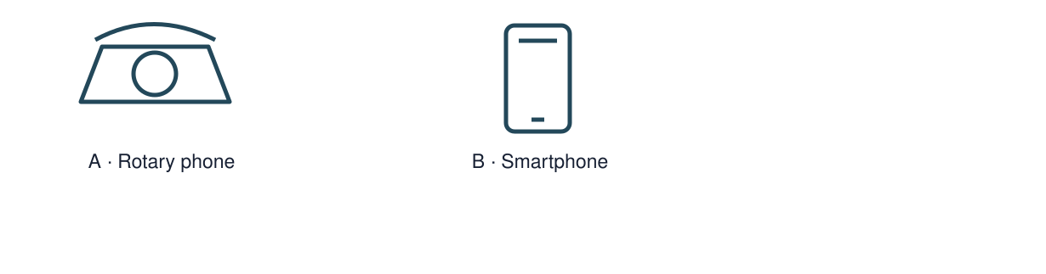
Start with 1 and 2. Try 3 and 4 when ready. Reading and exact scribing are available.

1 What function do both phones share
Support: Use the reminder strip or talk it through with an adult.
My response
________________________________________________________________________

2 Which meaning fits past
Support: Choose: A time before now OR The time we are in now.
My response
________________________________________________________________________

3 What information establishes the order
Support: Use the model evidence anchor C or read one relevant card together.
My response
________________________________________________________________________

4 Does putting one event after another prove a cause
Support: Give a reason when ready.
My response
________________________________________________________________________
Stretch: use a precise example or explain which detail supports your answer.

Evidence cards
Read, point or listen. Keep the source label with any detail you use.

A A fictional week
Monday: choose a club activity. Wednesday: practise the activity. Friday: share what was made. The words Monday, Wednesday and Friday supply the order.
Source: Authored classroom case
Limit: This example does not describe every person or place.

B Telephone comparison
A rotary telephone and a smartphone both support conversations over distance. A smartphone can also show a video call; a rotary dial selects numbers differently.
Source: Authored comparison of familiar objects
Limit: A newer object is not automatically better for every person or purpose.

C Photo enquiry
Use the paired local photographs supplied with this unit. Read the captions and dates. Point to one feature in each image before deciding what changed.
Source: See photograph captions and credits
Limit: A camera angle or season can make features appear different; a photograph alone may not explain why.

D Questions worth asking
Who used this object? When was this photo made? A dated catalogue entry can help with time; a user’s account can help with experience.
Source: Authored classroom case
Limit: This example does not describe every person or place.

Visual resource 1
Use this visual with the evidence cards and enquiry questions.
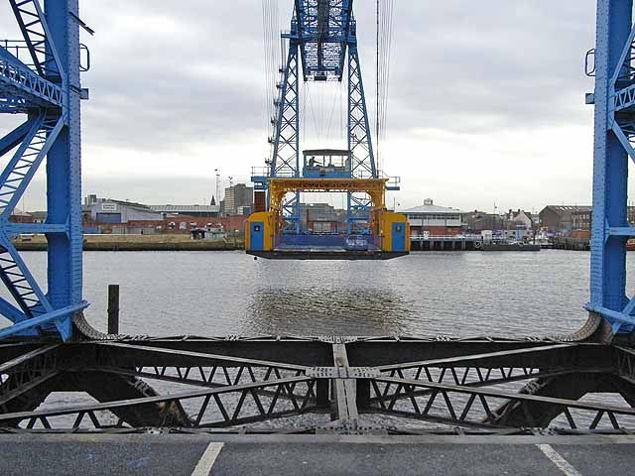
Source: 21 November 2008 · Oliver Dixon · CC BY-SA 2.0
The viewpoints differ. Compare visible details; do not infer rebuilding from the camera angle. These are historical photographs, not a live view.
A detail I noticed and what it helps me explain
________________________________________________________________________
________________________________________________________________________
________________________________________________________________________
________________________________________________________________________

Visual resource 2
Use this visual with the evidence cards and enquiry questions.
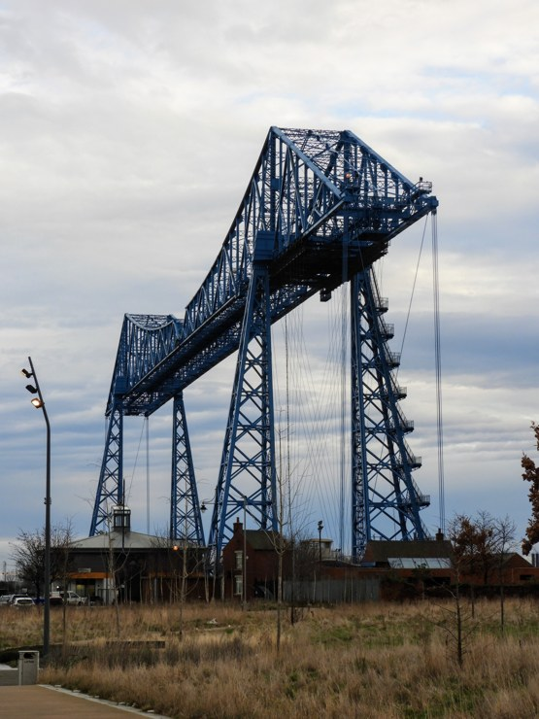
Source: 31 January 2020 · Reading Tom · CC BY 2.0
The viewpoints differ. Compare visible details; do not infer rebuilding from the camera angle. These are historical photographs, not a live view.
A detail I noticed and what it helps me explain
________________________________________________________________________
________________________________________________________________________
________________________________________________________________________
________________________________________________________________________

Shared investigation
1. Make a floor or desk timeline from the dated source cards.
2. Check the date before moving a card.
Work with a partner or adult, or use your own table. One person suggests; the other checks the evidence. Swap after one turn. Passing is allowed.

Move or match the cards
Cards to use
31 January 2020 photograph
21 November 2008 photograph

Our explanation
________________________________________________________________________
________________________________________________________________________
________________________________________________________________________
Support: Show two choices. Read one short instruction. Point, match or say a word, then add a reason when ready.
Further challenge: Explain why unequal gaps between dates should not be treated as equal time.

Supported independent task
Complete this route only. Order pictures on a simple timeline.
1. Place two to four pictures on a timeline.
2. Explain one placement using before or after and the supplied dates.
3. Keep an individual copy or photograph of your order.
Support: Show two choices. Read one short instruction. Point, match or say a word, then add a reason when ready. Complete the organiser one space at a time. ___ belongs before ___ because ___ is earlier than ___.
First event and date or time cue
________________________________________________________________________
________________________________________________________________________
Next event and date or time cue
________________________________________________________________________
________________________________________________________________________
Later event and date or time cue
________________________________________________________________________
________________________________________________________________________
Why this order fits the evidence
________________________________________________________________________
________________________________________________________________________
An adult may read or scribe your exact response. They should not choose the answer.

Standard independent task
Complete this route only. Order pictures on a simple timeline.
1. Place two to four pictures on a timeline.
2. Explain one placement using before or after and the supplied dates.
3. Keep an individual copy or photograph of your order.
Support: ___ belongs before ___ because ___ is earlier than ___.
First event and date or time cue
________________________________________________________________________
________________________________________________________________________
Next event and date or time cue
________________________________________________________________________
________________________________________________________________________
Later event and date or time cue
________________________________________________________________________
________________________________________________________________________
Why this order fits the evidence
________________________________________________________________________
________________________________________________________________________
Check the required evidence and revise one detail.

Stretch independent task
Complete this route only. Order pictures on a simple timeline.
1. Place two to four pictures on a timeline.
2. Explain one placement using before or after and the supplied dates.
3. Keep an individual copy or photograph of your order.
4. Explain why unequal gaps between dates should not be treated as equal time.
Support: Choose the evidence independently. Use the frame only if it helps.
First event and date or time cue
________________________________________________________________________
________________________________________________________________________
Next event and date or time cue
________________________________________________________________________
________________________________________________________________________
Later event and date or time cue
________________________________________________________________________
________________________________________________________________________
Why this order fits the evidence
________________________________________________________________________
________________________________________________________________________
Explain why unequal gaps between dates should not be treated as equal time.

Exit ticket
Choose a response mode. You may give your answers privately to an adult.

What information establishes the order
My response
________________________________________________________________________
________________________________________________________________________
________________________________________________________________________

Does putting one event after another prove a cause
My response
________________________________________________________________________
________________________________________________________________________
________________________________________________________________________
Support: ___ belongs before ___ because ___ is earlier than ___.
Further challenge: Explain why unequal gaps between dates should not be treated as equal time.
One thing I changed or want to check
________________________________________________________________________
________________________________________________________________________

