A person who challenged unfairness
Learning goal: Recognise people who stood up for fairness linked to International Womens Day.

Words to use
Word | Meaning
fairness | Giving people a fair chance and meeting needs
care | Acting to help with a need
right | A basic entitlement held by people
responsibility | Something we should take care to do

Remember
What does Malala campaign for? Children’s education, especially girls’ education.
What does the 2014 prize show and not show? It recognises her work; it does not prove all education barriers ended.

How to show your learning
Create a contribution card for Malala.
Malala campaigns for ___. This challenges ___ because ___.

Evidence matters
Fictional cases are teaching examples. Historical, geographical and religious claims use the named sources. A model video demonstrates a method.
You can respond by speaking, pointing, drawing, typing or writing. A fictional personal example is welcome.
Sources: Luke 10 in the King James Version; Nobel Prize Malala facts

Arrival choices
Previous lesson reminder:
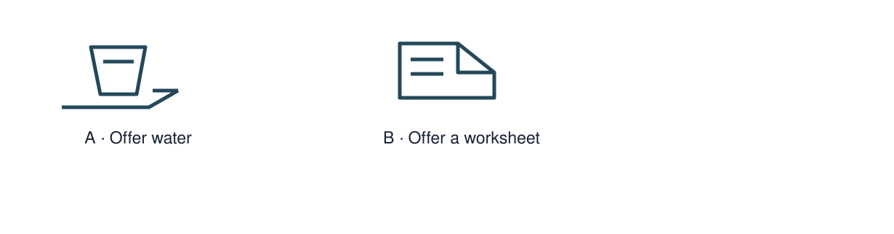
Start with 1 and 2. Try 3 and 4 when ready. Reading and exact scribing are available.

1 What could help someone find resources
Support: Use the reminder strip or talk it through with an adult.
My response
________________________________________________________________________

2 Which meaning fits fairness
Support: Choose: Giving people a fair chance and meeting needs OR Acting to help with a need.
My response
________________________________________________________________________

3 What does Malala campaign for
Support: Use the model evidence anchor M or read one relevant card together.
My response
________________________________________________________________________

4 What does the 2014 prize show and not show
Support: Give a reason when ready.
My response
________________________________________________________________________
Stretch: use a precise example or explain which detail supports your answer.

Evidence cards
Read, point or listen. Keep the source label with any detail you use.

A The Good Samaritan
Easy-read retelling of the Christian parable in Luke 10: A traveller needs help. Two people pass by. A Samaritan stops, cares for him and arranges more help. The story asks what it means to be a neighbour.
Source: Authored retelling of Luke 10:25–37
Limit: A religious story teaches an idea; this retelling is not a quotation or a historical record.

B A fair turn
Fictional case: three pupils share one tablet. Jo needs text read aloud. The group can agree turns and switch on speech support. Equal dignity does not always mean identical support.
Source: Authored classroom case
Limit: This example does not describe every person or place.

C A caring action
Fictional case: a new student cannot find the reading resources. A clear shelf label and a choice of formats could help. Ask what is useful before deciding.
Source: Authored classroom case
Limit: This example does not describe every person or place.

M Malala Yousafzai
Malala campaigns for children’s education, especially girls’ education. She shared the 2014 Nobel Peace Prize with Kailash Satyarthi.
Source: Nobel Prize, Malala Yousafzai facts
Limit: An award recognises work; it does not prove that unequal access to education has ended.

Shared investigation
1. Examine Malala’s biography card.
2. Connect her education campaign to the unfair barrier it challenges.
Work with a partner or adult, or use your own table. One person suggests; the other checks the evidence. Swap after one turn. Passing is allowed.

Move or match the cards
Cards to use
A contribution can challenge unfairness
All education inequality has ended
Campaigning for girls’ education

Possible labels: Not established / Reasoned link / Supported
Our explanation
________________________________________________________________________
________________________________________________________________________
________________________________________________________________________
Support: Show two choices. Read one short instruction. Point, match or say a word, then add a reason when ready.
Further challenge: Explain why an award does not prove the problem has been solved.

Supported independent task
Complete this route only. Recognise people who stood up for fairness linked to International Womens Day.
1. Create a contribution card for Malala.
2. Use one accurate fact and link her action to fairness in education.
3. Add a source credit.
Support: Show two choices. Read one short instruction. Point, match or say a word, then add a reason when ready. Complete the organiser one space at a time. Malala campaigns for ___. This challenges ___ because ___.
Source label and origin
________________________________________________________________________
________________________________________________________________________
A detail I can point to
________________________________________________________________________
________________________________________________________________________
What this detail helps me explain
________________________________________________________________________
________________________________________________________________________
What I still need to check
________________________________________________________________________
________________________________________________________________________
An adult may read or scribe your exact response. They should not choose the answer.

Standard independent task
Complete this route only. Recognise people who stood up for fairness linked to International Womens Day.
1. Create a contribution card for Malala.
2. Use one accurate fact and link her action to fairness in education.
3. Add a source credit.
Support: Malala campaigns for ___. This challenges ___ because ___.
Source label and origin
________________________________________________________________________
________________________________________________________________________
A detail I can point to
________________________________________________________________________
________________________________________________________________________
What this detail helps me explain
________________________________________________________________________
________________________________________________________________________
What I still need to check
________________________________________________________________________
________________________________________________________________________
Check the required evidence and revise one detail.

Stretch independent task
Complete this route only. Recognise people who stood up for fairness linked to International Womens Day.
1. Create a contribution card for Malala.
2. Use one accurate fact and link her action to fairness in education.
3. Add a source credit.
4. Explain why an award does not prove the problem has been solved.
Support: Choose the evidence independently. Use the frame only if it helps.
Source label and origin
________________________________________________________________________
________________________________________________________________________
A detail I can point to
________________________________________________________________________
________________________________________________________________________
What this detail helps me explain
________________________________________________________________________
________________________________________________________________________
What I still need to check
________________________________________________________________________
________________________________________________________________________
Explain why an award does not prove the problem has been solved.

Exit ticket
Choose a response mode. You may give your answers privately to an adult.

What does Malala campaign for
My response
________________________________________________________________________
________________________________________________________________________
________________________________________________________________________

What does the 2014 prize show and not show
My response
________________________________________________________________________
________________________________________________________________________
________________________________________________________________________
Support: Malala campaigns for ___. This challenges ___ because ___.
Further challenge: Explain why an award does not prove the problem has been solved.
One thing I changed or want to check
________________________________________________________________________
________________________________________________________________________

