Mapping climate zones and hazards
Learning goal: Use atlases and maps to locate climate zones and hazards.

Words to use
Word | Meaning
climate | Weather patterns over a long period
hazard | A process or event with potential to cause harm
effect | A consequence
response | An action taken because of a situation

Remember
Are earthquakes caused by being in a warm climate zone? No. They are mainly related to tectonic processes.
What helps explain broad temperature patterns? Latitude, with other influences such as altitude.

How to show your learning
Use the atlas and map to locate a tropical, temperate and polar example.
The ___ zone lies ___. Earthquakes are linked mainly to ___.

Evidence matters
Fictional cases are teaching examples. Historical, geographical and religious claims use the named sources. A model video demonstrates a method.
You can respond by speaking, pointing, drawing, typing or writing. A fictional personal example is welcome.
Sources: NASA Causes of climate change

Arrival choices
You can begin without previous learning. Word help: climate means weather patterns over a long period.
Start with 1 and 2. Try 3 and 4 when ready. Reading and exact scribing are available.

1 What does climate mean
Support: Use the reminder strip or talk it through with an adult.
My response
________________________________________________________________________

2 Which meaning fits climate
Support: Choose: Weather patterns over a long period OR A process or event with potential to cause harm.
My response
________________________________________________________________________

3 Are earthquakes caused by being in a warm climate zone
Support: Use the model evidence anchor A or read one relevant card together.
My response
________________________________________________________________________

4 What helps explain broad temperature patterns
Support: Give a reason when ready.
My response
________________________________________________________________________
Stretch: use a precise example or explain which detail supports your answer.

Evidence cards
Read, point or listen. Keep the source label with any detail you use.

A Zones and events
Broad temperature zones relate to latitude. Near the equator is generally warmer; high latitudes are generally colder. Local climate also depends on altitude and other factors. Earthquakes relate mainly to plate boundaries, not climate zones.
Source: Authored map explanation
Limit: Broad bands simplify climate; they are not a detailed climate classification.

B Human influence
Burning fossil fuels adds carbon dioxide. Greenhouse gases slow heat loss to space. Human activity is the main cause of recent global warming.
Source: NASA Causes of climate change
Limit: One local hot or cold day does not establish the global trend.

C Two responses
Reducing fossil-fuel use tackles a cause of warming. Shade, water access and cooler buildings can reduce harm during heat. These responses do different jobs.
Source: Authored examples based on climate mechanisms
Limit: Their suitability depends on the place and the needs of people there.

D Community accounts
Fictional account 1: a faith group explains caring for creation as its reason for planting shade trees. Fictional account 2: a non-religious residents’ group gives human wellbeing as its reason for a cool-room project.
Source: Two authored teaching accounts with explicitly stated values
Limit: These are not reports of real organisations and do not represent every religious or non-religious person.

Visual resource
Use this visual with the evidence cards and enquiry questions.
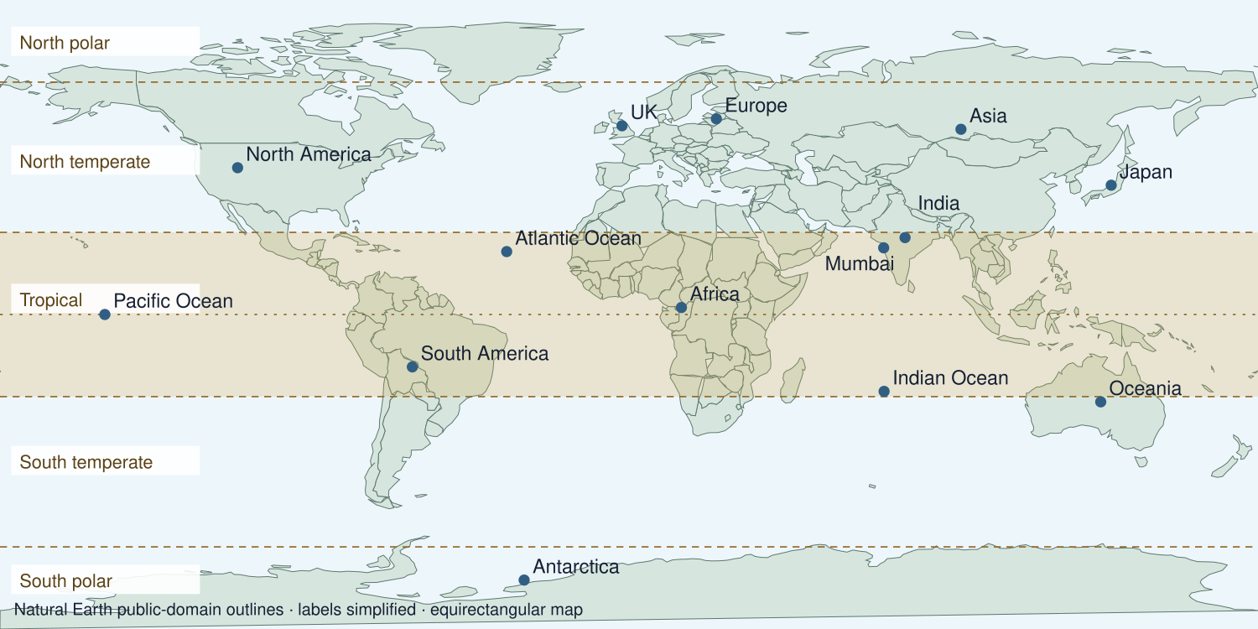
A detail I noticed and what it helps me explain
________________________________________________________________________
________________________________________________________________________
________________________________________________________________________
________________________________________________________________________

Shared investigation
1. Toggle broad temperature bands and earthquake locations.
2. Discuss why the two patterns need different explanations.
Work with a partner or adult, or use your own table. One person suggests; the other checks the evidence. Swap after one turn. Passing is allowed.
Use the evidence cards and any visual sheet. Follow the two shared steps above, then record one decision.
Our explanation
________________________________________________________________________
________________________________________________________________________
________________________________________________________________________
Support: Read one evidence card together. Highlight a useful detail. Rehearse with: The ___ zone lies ___. Earthquakes are linked mainly to ___.
Further challenge: Explain one limit of the broad climate-zone bands.

Supported independent task
Complete this route only. Use atlases and maps to locate climate zones and hazards.
1. Use the atlas and map to locate a tropical, temperate and polar example.
2. Locate Japan and an earthquake example.
3. Answer an independent pattern question using latitude and the key.
Support: Read one evidence card together. Highlight a useful detail. Rehearse with: The ___ zone lies ___. Earthquakes are linked mainly to ___. Complete the organiser one space at a time. The ___ zone lies ___. Earthquakes are linked mainly to ___.
Places and symbols or grid references
________________________________________________________________________
________________________________________________________________________
Location or direction statement
________________________________________________________________________
________________________________________________________________________
Pattern using the map evidence
________________________________________________________________________
________________________________________________________________________
What this map does not show
________________________________________________________________________
________________________________________________________________________
An adult may read or scribe your exact response. They should not choose the answer.

Standard independent task
Complete this route only. Use atlases and maps to locate climate zones and hazards.
1. Use the atlas and map to locate a tropical, temperate and polar example.
2. Locate Japan and an earthquake example.
3. Answer an independent pattern question using latitude and the key.
Support: The ___ zone lies ___. Earthquakes are linked mainly to ___.
Places and symbols or grid references
________________________________________________________________________
________________________________________________________________________
Location or direction statement
________________________________________________________________________
________________________________________________________________________
Pattern using the map evidence
________________________________________________________________________
________________________________________________________________________
What this map does not show
________________________________________________________________________
________________________________________________________________________
Check the required evidence and revise one detail.

Stretch independent task
Complete this route only. Use atlases and maps to locate climate zones and hazards.
1. Use the atlas and map to locate a tropical, temperate and polar example.
2. Locate Japan and an earthquake example.
3. Answer an independent pattern question using latitude and the key.
4. Explain one limit of the broad climate-zone bands.
Support: Choose the evidence independently. Use the frame only if it helps.
Places and symbols or grid references
________________________________________________________________________
________________________________________________________________________
Location or direction statement
________________________________________________________________________
________________________________________________________________________
Pattern using the map evidence
________________________________________________________________________
________________________________________________________________________
What this map does not show
________________________________________________________________________
________________________________________________________________________
Explain one limit of the broad climate-zone bands.

Exit ticket
Choose a response mode. You may give your answers privately to an adult.

Are earthquakes caused by being in a warm climate zone
My response
________________________________________________________________________
________________________________________________________________________
________________________________________________________________________

What helps explain broad temperature patterns
My response
________________________________________________________________________
________________________________________________________________________
________________________________________________________________________
Support: The ___ zone lies ___. Earthquakes are linked mainly to ___.
Further challenge: Explain one limit of the broad climate-zone bands.
One thing I changed or want to check
________________________________________________________________________
________________________________________________________________________

