How a hazard affects a place
Learning goal: Describe how a natural hazard affects people and places.

Words to use
Word | Meaning
tectonic | Related to movement of Earth’s plates
exposure | People or things in harm’s way
vulnerability | Conditions making harm more likely or severe
risk | Potential harm from a hazard in a particular setting

Remember
What hazard followed seafloor displacement? A tsunami.
Does magnitude directly count people affected? No. Exposure and vulnerability also matter.

How to show your learning
Create a case-study diagram for Japan.
The cause was ___. An effect was ___. A response could reduce ___ by ___.

Evidence matters
Fictional cases are teaching examples. Historical, geographical and religious claims use the named sources. A model video demonstrates a method.
You can respond by speaking, pointing, drawing, typing or writing. A fictional personal example is welcome.
Sources: USGS 2011 Japan event; USGS live earthquake feed

Arrival choices
Previous lesson reminder:
Start with 1 and 2. Try 3 and 4 when ready. Reading and exact scribing are available.

1 Are earthquakes caused by being in a warm climate zone
Support: Use the reminder strip or talk it through with an adult.
My response
________________________________________________________________________

2 Which meaning fits tectonic
Support: Choose: Related to movement of Earth’s plates OR People or things in harm’s way.
My response
________________________________________________________________________

3 What hazard followed seafloor displacement
Support: Use the model evidence anchor A or read one relevant card together.
My response
________________________________________________________________________

4 Does magnitude directly count people affected
Support: Give a reason when ready.
My response
________________________________________________________________________
Stretch: use a precise example or explain which detail supports your answer.

Evidence cards
Read, point or listen. Keep the source label with any detail you use.

A Japan 11 March 2011
A magnitude 9.1 earthquake occurred off north-east Honshu, Japan. Sudden movement on the subduction boundary displaced the seafloor and produced a tsunami.
Source: USGS event record, official20110311054624120_30
Limit: Magnitude measures the earthquake; it is not a direct count of people affected.

B Effects and responses
Shaking and coastal flooding damaged places and disrupted people’s lives. Earthquake-resistant design addresses shaking; warnings, evacuation routes and higher ground address tsunami exposure.
Source: Authored explanation of the case and risk-management principles
Limit: A sea wall or warning cannot eliminate all risk. Do not judge people without considering access and warning time.

C Heat and unequal risk
On 19 July 2022 the Met Office recorded 40.3°C at Coningsby, 40.2°C at St James’s Park and 39.6°C at Topcliffe. Outdoor work increases exposure; difficulty accessing cool spaces can increase vulnerability. Shade and accessible cool spaces can reduce harm.
Source: Met Office July 2022 report, station table; risk explanation authored for teaching
Limit: This explains risk factors, not a medical assessment of an individual.

D Reading a hazard feed
A USGS event row can include UTC time, place, magnitude and depth in kilometres. A short feed is a dated snapshot. It cannot predict the next earthquake.
Source: USGS earthquake feed documentation
Limit: Small samples, reporting thresholds and later revisions affect patterns.

Visual resource
Use this visual with the evidence cards and enquiry questions.
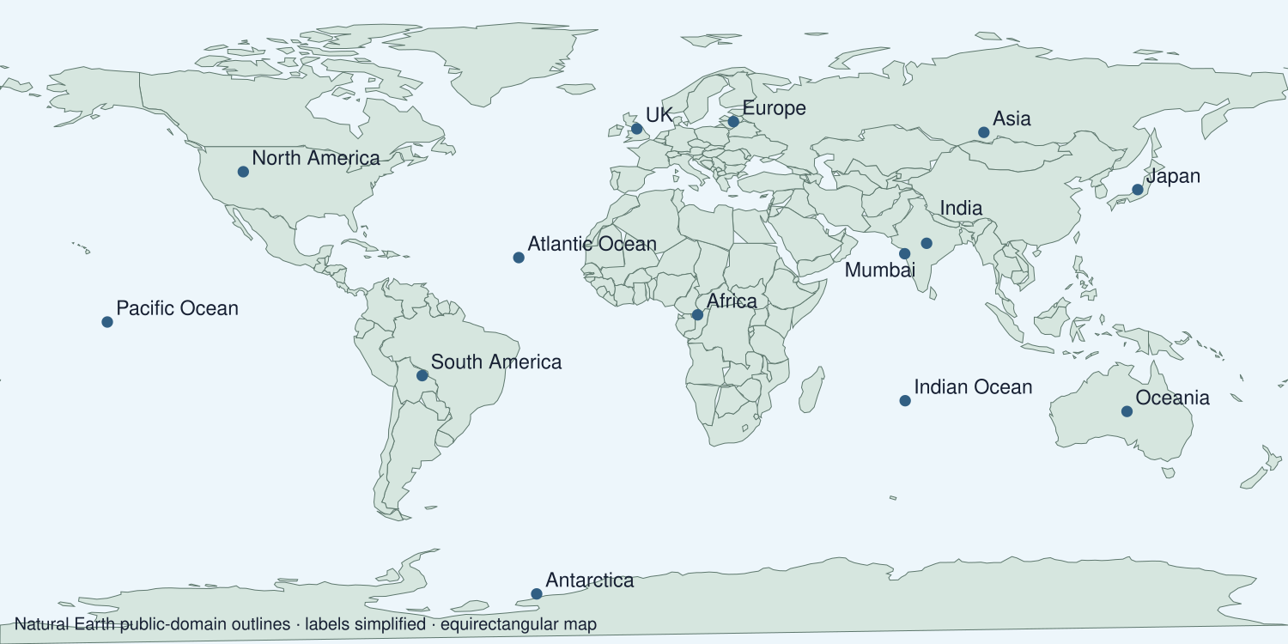
A detail I noticed and what it helps me explain
________________________________________________________________________
________________________________________________________________________
________________________________________________________________________
________________________________________________________________________

Data for the enquiry
Japan earthquake on 11 March 2011
Event | Magnitude
Tohoku Japan 2011 | 9.1

Units: Magnitude
Source: USGS historical event record
Limit: Magnitude measures earthquake size. It does not count people affected or describe tsunami height.
My labelled graph or data notes
________________________________________________________________________
________________________________________________________________________
________________________________________________________________________
________________________________________________________________________
________________________________________________________________________
________________________________________________________________________
________________________________________________________________________
________________________________________________________________________

Shared investigation
1. Locate the 2011 Japan event.
2. Build a cause, effect and response diagram using the case cards.
Work with a partner or adult, or use your own table. One person suggests; the other checks the evidence. Swap after one turn. Passing is allowed.

Move or match the cards
Cards to use
Routes to higher ground
Coastal flooding
Sudden plate-boundary movement

Possible labels: Cause / Effect / Response
Our explanation
________________________________________________________________________
________________________________________________________________________
________________________________________________________________________
Support: Read one evidence card together. Highlight a useful detail. Rehearse with: The cause was ___. An effect was ___. A response could reduce ___ by ___.
Further challenge: Compare a response to shaking with a response to tsunami exposure.

Supported independent task
Complete this route only. Describe how a natural hazard affects people and places.
1. Create a case-study diagram for Japan.
2. Interpret its map location and one data value.
3. Judge a response that addresses a stated effect or risk.
Support: Read one evidence card together. Highlight a useful detail. Rehearse with: The cause was ___. An effect was ___. A response could reduce ___ by ___. Complete the organiser one space at a time. The cause was ___. An effect was ___. A response could reduce ___ by ___.
Cause and supporting detail
________________________________________________________________________
________________________________________________________________________
Event or change
________________________________________________________________________
________________________________________________________________________
Consequence and supporting detail
________________________________________________________________________
________________________________________________________________________
How the links connect
________________________________________________________________________
________________________________________________________________________
An adult may read or scribe your exact response. They should not choose the answer.

Standard independent task
Complete this route only. Describe how a natural hazard affects people and places.
1. Create a case-study diagram for Japan.
2. Interpret its map location and one data value.
3. Judge a response that addresses a stated effect or risk.
Support: The cause was ___. An effect was ___. A response could reduce ___ by ___.
Cause and supporting detail
________________________________________________________________________
________________________________________________________________________
Event or change
________________________________________________________________________
________________________________________________________________________
Consequence and supporting detail
________________________________________________________________________
________________________________________________________________________
How the links connect
________________________________________________________________________
________________________________________________________________________
Check the required evidence and revise one detail.

Stretch independent task
Complete this route only. Describe how a natural hazard affects people and places.
1. Create a case-study diagram for Japan.
2. Interpret its map location and one data value.
3. Judge a response that addresses a stated effect or risk.
4. Compare a response to shaking with a response to tsunami exposure.
Support: Choose the evidence independently. Use the frame only if it helps.
Cause and supporting detail
________________________________________________________________________
________________________________________________________________________
Event or change
________________________________________________________________________
________________________________________________________________________
Consequence and supporting detail
________________________________________________________________________
________________________________________________________________________
How the links connect
________________________________________________________________________
________________________________________________________________________
Compare a response to shaking with a response to tsunami exposure.

Exit ticket
Choose a response mode. You may give your answers privately to an adult.

What hazard followed seafloor displacement
My response
________________________________________________________________________
________________________________________________________________________
________________________________________________________________________

Does magnitude directly count people affected
My response
________________________________________________________________________
________________________________________________________________________
________________________________________________________________________
Support: The cause was ___. An effect was ___. A response could reduce ___ by ___.
Further challenge: Compare a response to shaking with a response to tsunami exposure.
One thing I changed or want to check
________________________________________________________________________
________________________________________________________________________

