Geography and worldviews assessment
Learning goal: Complete a Geography and worldviews assessment and map-skills check and bank UAS evidence.

Words to use
Word | Meaning
climate | Weather patterns over a long period
hazard | A process or event with potential to cause harm
effect | A consequence
response | An action taken because of a situation

Remember
What three kinds of evidence does this assessment combine? Map skills, a climate or hazard explanation and a comparison of community responses.
Why should the source type be named? It distinguishes measured data, an explanatory source and a fictional teaching account.

How to show your learning
Complete a map check locating Japan and two climate-zone examples.
Location ___. Evidence ___. Explanation ___. Similarity or difference ___.

Evidence matters
Fictional cases are teaching examples. Historical, geographical and religious claims use the named sources. A model video demonstrates a method.
You can respond by speaking, pointing, drawing, typing or writing. A fictional personal example is welcome.
Sources: NASA Causes of climate change

Arrival choices
Previous lesson reminder:
Start with 1 and 2. Try 3 and 4 when ready. Reading and exact scribing are available.

1 Why include a data value in a pattern statement
Support: Use the reminder strip or talk it through with an adult.
My response
________________________________________________________________________

2 Which meaning fits climate
Support: Choose: Weather patterns over a long period OR A process or event with potential to cause harm.
My response
________________________________________________________________________

3 What three kinds of evidence does this assessment combine
Support: Use the model evidence anchor assessment or read one relevant card together.
My response
________________________________________________________________________

4 Why should the source type be named
Support: Give a reason when ready.
My response
________________________________________________________________________
Stretch: use a precise example or explain which detail supports your answer.

Evidence cards
Read, point or listen. Keep the source label with any detail you use.

A Zones and events
Broad temperature zones relate to latitude. Near the equator is generally warmer; high latitudes are generally colder. Local climate also depends on altitude and other factors. Earthquakes relate mainly to plate boundaries, not climate zones.
Source: Authored map explanation
Limit: Broad bands simplify climate; they are not a detailed climate classification.

B Human influence
Burning fossil fuels adds carbon dioxide. Greenhouse gases slow heat loss to space. Human activity is the main cause of recent global warming.
Source: NASA Causes of climate change
Limit: One local hot or cold day does not establish the global trend.

C Two responses
Reducing fossil-fuel use tackles a cause of warming. Shade, water access and cooler buildings can reduce harm during heat. These responses do different jobs.
Source: Authored examples based on climate mechanisms
Limit: Their suitability depends on the place and the needs of people there.

D Community accounts
Fictional account 1: a faith group explains caring for creation as its reason for planting shade trees. Fictional account 2: a non-religious residents’ group gives human wellbeing as its reason for a cool-room project.
Source: Two authored teaching accounts with explicitly stated values
Limit: These are not reports of real organisations and do not represent every religious or non-religious person.

Visual resource
Use this visual with the evidence cards and enquiry questions.
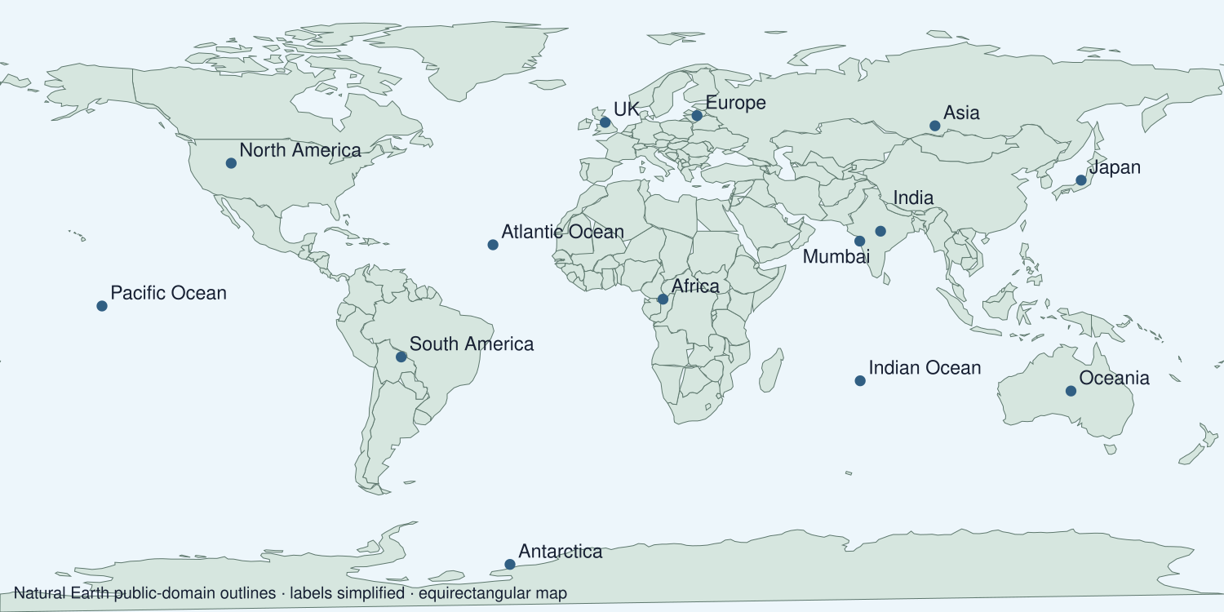
A detail I noticed and what it helps me explain
________________________________________________________________________
________________________________________________________________________
________________________________________________________________________
________________________________________________________________________

Data for the enquiry
Selected global annual temperature anomalies
Year | Anomaly °C
1980 | 0.26
1990 | 0.45
2000 | 0.39
2010 | 0.72
2020 | 1.01
2024 | 1.29

Units: °C relative to 1951–1980
Source: NASA GISTEMP v4 annual J-D column; selected values checked 19 September 2026. The full series can be revised.
Limit: Selected years simplify the record. Use the full annual series to examine variability. An anomaly is a difference from the baseline, not the absolute temperature.
My labelled graph or data notes
________________________________________________________________________
________________________________________________________________________
________________________________________________________________________
________________________________________________________________________
________________________________________________________________________
________________________________________________________________________
________________________________________________________________________
________________________________________________________________________

Shared investigation
1. Review the separate map, explanation and comparison requirements.
2. Practise one unrelated example before working independently.
Work with a partner or adult, or use your own table. One person suggests; the other checks the evidence. Swap after one turn. Passing is allowed.
Use the evidence cards and any visual sheet. Follow the two shared steps above, then record one decision.
Our explanation
________________________________________________________________________
________________________________________________________________________
________________________________________________________________________
Support: Read one evidence card together. Highlight a useful detail. Rehearse with: Location ___. Evidence ___. Explanation ___. Similarity or difference ___.
Further challenge: Evaluate one limitation of the map or data and one of the accounts.

Supported independent task
Complete this route only. Complete a Geography and worldviews assessment and map-skills check and bank UAS evidence.
1. Complete a map check locating Japan and two climate-zone examples.
2. Explain a climate or hazard pattern using supplied evidence.
3. Compare the two community accounts and select labelled unit evidence.
Support: Read one evidence card together. Highlight a useful detail. Rehearse with: Location ___. Evidence ___. Explanation ___. Similarity or difference ___. Complete the organiser one space at a time. Location ___. Evidence ___. Explanation ___. Similarity or difference ___.
My answer to the assessment enquiry
________________________________________________________________________
________________________________________________________________________
My evidence and source
________________________________________________________________________
________________________________________________________________________
My explanation or comparison
________________________________________________________________________
________________________________________________________________________
My conclusion and what the evidence does not show
________________________________________________________________________
________________________________________________________________________
An adult may read or scribe your exact response. They should not choose the answer.

Standard independent task
Complete this route only. Complete a Geography and worldviews assessment and map-skills check and bank UAS evidence.
1. Complete a map check locating Japan and two climate-zone examples.
2. Explain a climate or hazard pattern using supplied evidence.
3. Compare the two community accounts and select labelled unit evidence.
Support: Location ___. Evidence ___. Explanation ___. Similarity or difference ___.
My answer to the assessment enquiry
________________________________________________________________________
________________________________________________________________________
My evidence and source
________________________________________________________________________
________________________________________________________________________
My explanation or comparison
________________________________________________________________________
________________________________________________________________________
My conclusion and what the evidence does not show
________________________________________________________________________
________________________________________________________________________
Check the required evidence and revise one detail.

Stretch independent task
Complete this route only. Complete a Geography and worldviews assessment and map-skills check and bank UAS evidence.
1. Complete a map check locating Japan and two climate-zone examples.
2. Explain a climate or hazard pattern using supplied evidence.
3. Compare the two community accounts and select labelled unit evidence.
4. Evaluate one limitation of the map or data and one of the accounts.
Support: Choose the evidence independently. Use the frame only if it helps.
My answer to the assessment enquiry
________________________________________________________________________
________________________________________________________________________
My evidence and source
________________________________________________________________________
________________________________________________________________________
My explanation or comparison
________________________________________________________________________
________________________________________________________________________
My conclusion and what the evidence does not show
________________________________________________________________________
________________________________________________________________________
Evaluate one limitation of the map or data and one of the accounts.

Exit ticket
Choose a response mode. You may give your answers privately to an adult.

What three kinds of evidence does this assessment combine
My response
________________________________________________________________________
________________________________________________________________________
________________________________________________________________________

Why should the source type be named
My response
________________________________________________________________________
________________________________________________________________________
________________________________________________________________________
Support: Location ___. Evidence ___. Explanation ___. Similarity or difference ___.
Further challenge: Evaluate one limitation of the map or data and one of the accounts.
One thing I changed or want to check
________________________________________________________________________
________________________________________________________________________

