Causes of tectonic hazards
Learning goal: Explain causes of tectonic hazards.

Words to use
Word | Meaning
tectonic | Related to movement of Earth’s plates
exposure | People or things in harm’s way
vulnerability | Conditions making harm more likely or severe
risk | Potential harm from a hazard in a particular setting

Remember
What caused the 2011 tsunami? Sudden seafloor displacement during the earthquake moved the water above it.
Is magnitude the same as risk? No. Exposure and vulnerability also influence potential harm.

How to show your learning
Build an evidence-based cause, effects and responses diagram.
At the boundary ___. Sudden movement ___. This caused ___. Risk also depends on ___.

Evidence matters
Fictional cases are teaching examples. Historical, geographical and religious claims use the named sources. A model video demonstrates a method.
You can respond by speaking, pointing, drawing, typing or writing. A fictional personal example is welcome.
Sources: USGS 2011 Japan event; USGS live earthquake feed

Arrival choices
You can begin without previous learning. Word help: tectonic means related to movement of Earth’s plates.
Start with 1 and 2. Try 3 and 4 when ready. Reading and exact scribing are available.

1 What does tectonic mean
Support: Use the reminder strip or talk it through with an adult.
My response
________________________________________________________________________

2 Which meaning fits tectonic
Support: Choose: Related to movement of Earth’s plates OR People or things in harm’s way.
My response
________________________________________________________________________

3 What caused the 2011 tsunami
Support: Use the model evidence anchor A or read one relevant card together.
My response
________________________________________________________________________

4 Is magnitude the same as risk
Support: Give a reason when ready.
My response
________________________________________________________________________
Stretch: use a precise example or explain which detail supports your answer.

Evidence cards
Read, point or listen. Keep the source label with any detail you use.

A Japan 11 March 2011
A magnitude 9.1 earthquake occurred off north-east Honshu, Japan. Sudden movement on the subduction boundary displaced the seafloor and produced a tsunami.
Source: USGS event record, official20110311054624120_30
Limit: Magnitude measures the earthquake; it is not a direct count of people affected.

B Effects and responses
Shaking and coastal flooding damaged places and disrupted people’s lives. Earthquake-resistant design addresses shaking; warnings, evacuation routes and higher ground address tsunami exposure.
Source: Authored explanation of the case and risk-management principles
Limit: A sea wall or warning cannot eliminate all risk. Do not judge people without considering access and warning time.

C Heat and unequal risk
On 19 July 2022 the Met Office recorded 40.3°C at Coningsby, 40.2°C at St James’s Park and 39.6°C at Topcliffe. Outdoor work increases exposure; difficulty accessing cool spaces can increase vulnerability. Shade and accessible cool spaces can reduce harm.
Source: Met Office July 2022 report, station table; risk explanation authored for teaching
Limit: This explains risk factors, not a medical assessment of an individual.

D Reading a hazard feed
A USGS event row can include UTC time, place, magnitude and depth in kilometres. A short feed is a dated snapshot. It cannot predict the next earthquake.
Source: USGS earthquake feed documentation
Limit: Small samples, reporting thresholds and later revisions affect patterns.

Visual resource
Use this visual with the evidence cards and enquiry questions.
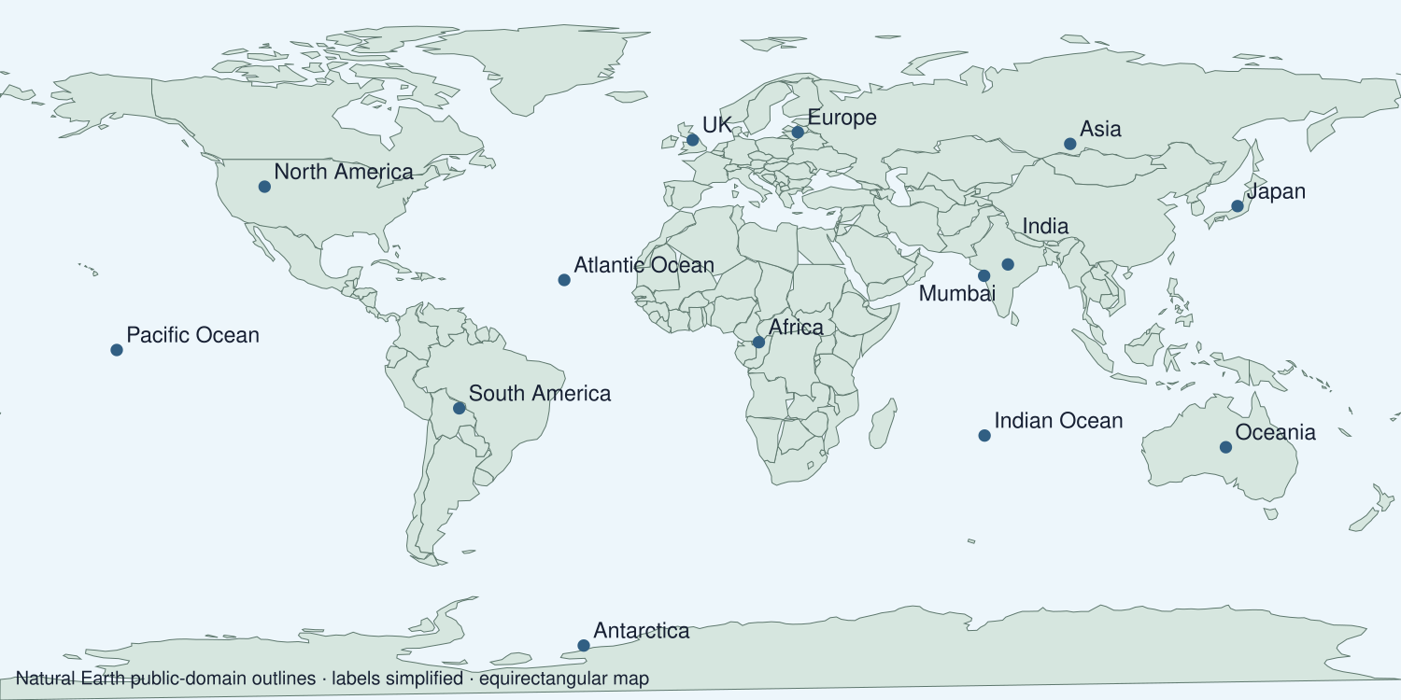
A detail I noticed and what it helps me explain
________________________________________________________________________
________________________________________________________________________
________________________________________________________________________
________________________________________________________________________

Shared investigation
1. Locate the Japan case and model subduction, sudden movement and seafloor displacement.
2. Interpret the event’s magnitude and map.
Work with a partner or adult, or use your own table. One person suggests; the other checks the evidence. Swap after one turn. Passing is allowed.

Move or match the cards
Cards to use
Warnings and accessible evacuation
Sudden movement and shaking
Plate motion and strain

Possible labels: Cause / Event / Response
Our explanation
________________________________________________________________________
________________________________________________________________________
________________________________________________________________________
Support: Use the glossary and one chunk of evidence. Plan the claim and supporting detail before explaining.
Further challenge: Explain why equal-magnitude earthquakes can have different consequences.

Supported independent task
Complete this route only. Explain causes of tectonic hazards.
1. Build an evidence-based cause, effects and responses diagram.
2. Interpret a map or graph using one accurate value.
3. Make a case-study judgement distinguishing hazard from risk.
Support: Use the glossary and one chunk of evidence. Plan the claim and supporting detail before explaining. Complete the organiser one space at a time. At the boundary ___. Sudden movement ___. This caused ___. Risk also depends on ___.
Cause and supporting detail
________________________________________________________________________
________________________________________________________________________
Event or change
________________________________________________________________________
________________________________________________________________________
Consequence and supporting detail
________________________________________________________________________
________________________________________________________________________
How the links connect
________________________________________________________________________
________________________________________________________________________
An adult may read or scribe your exact response. They should not choose the answer.

Standard independent task
Complete this route only. Explain causes of tectonic hazards.
1. Build an evidence-based cause, effects and responses diagram.
2. Interpret a map or graph using one accurate value.
3. Make a case-study judgement distinguishing hazard from risk.
Support: At the boundary ___. Sudden movement ___. This caused ___. Risk also depends on ___.
Cause and supporting detail
________________________________________________________________________
________________________________________________________________________
Event or change
________________________________________________________________________
________________________________________________________________________
Consequence and supporting detail
________________________________________________________________________
________________________________________________________________________
How the links connect
________________________________________________________________________
________________________________________________________________________
Check the required evidence and revise one detail.

Stretch independent task
Complete this route only. Explain causes of tectonic hazards.
1. Build an evidence-based cause, effects and responses diagram.
2. Interpret a map or graph using one accurate value.
3. Make a case-study judgement distinguishing hazard from risk.
4. Explain why equal-magnitude earthquakes can have different consequences.
Support: Choose the evidence independently. Use the frame only if it helps.
Cause and supporting detail
________________________________________________________________________
________________________________________________________________________
Event or change
________________________________________________________________________
________________________________________________________________________
Consequence and supporting detail
________________________________________________________________________
________________________________________________________________________
How the links connect
________________________________________________________________________
________________________________________________________________________
Explain why equal-magnitude earthquakes can have different consequences.

Exit ticket
Choose a response mode. You may give your answers privately to an adult.

What caused the 2011 tsunami
My response
________________________________________________________________________
________________________________________________________________________
________________________________________________________________________

Is magnitude the same as risk
My response
________________________________________________________________________
________________________________________________________________________
________________________________________________________________________
Support: At the boundary ___. Sudden movement ___. This caused ___. Risk also depends on ___.
Further challenge: Explain why equal-magnitude earthquakes can have different consequences.
One thing I changed or want to check
________________________________________________________________________
________________________________________________________________________

