Tracking live hazards
Learning goal: Track live hazards online and interpret data.

Words to use
Word | Meaning
tectonic | Related to movement of Earth’s plates
exposure | People or things in harm’s way
vulnerability | Conditions making harm more likely or severe
risk | Potential harm from a hazard in a particular setting

Remember
Why record the snapshot time? The feed changes, so the evidence must be traceable to a particular capture.
Can this small sample predict the next earthquake? No. A short event list is not a prediction.

How to show your learning
Capture a dated and timed live snapshot or use the explicitly dated archive if offline.
Snapshot UTC ___. Source ___. Variable and units ___. Pattern ___. This cannot tell us ___.

Evidence matters
Fictional cases are teaching examples. Historical, geographical and religious claims use the named sources. A model video demonstrates a method.
You can respond by speaking, pointing, drawing, typing or writing. A fictional personal example is welcome.
Sources: USGS 2011 Japan event; USGS live earthquake feed

Arrival choices
Previous lesson reminder:
Start with 1 and 2. Try 3 and 4 when ready. Reading and exact scribing are available.

1 What caused the 2011 tsunami
Support: Use the reminder strip or talk it through with an adult.
My response
________________________________________________________________________

2 Which meaning fits tectonic
Support: Choose: Related to movement of Earth’s plates OR People or things in harm’s way.
My response
________________________________________________________________________

3 Why record the snapshot time
Support: Use the model evidence anchor D or read one relevant card together.
My response
________________________________________________________________________

4 Can this small sample predict the next earthquake
Support: Give a reason when ready.
My response
________________________________________________________________________
Stretch: use a precise example or explain which detail supports your answer.

Evidence cards
Read, point or listen. Keep the source label with any detail you use.

A Japan 11 March 2011
A magnitude 9.1 earthquake occurred off north-east Honshu, Japan. Sudden movement on the subduction boundary displaced the seafloor and produced a tsunami.
Source: USGS event record, official20110311054624120_30
Limit: Magnitude measures the earthquake; it is not a direct count of people affected.

B Effects and responses
Shaking and coastal flooding damaged places and disrupted people’s lives. Earthquake-resistant design addresses shaking; warnings, evacuation routes and higher ground address tsunami exposure.
Source: Authored explanation of the case and risk-management principles
Limit: A sea wall or warning cannot eliminate all risk. Do not judge people without considering access and warning time.

C Heat and unequal risk
On 19 July 2022 the Met Office recorded 40.3°C at Coningsby, 40.2°C at St James’s Park and 39.6°C at Topcliffe. Outdoor work increases exposure; difficulty accessing cool spaces can increase vulnerability. Shade and accessible cool spaces can reduce harm.
Source: Met Office July 2022 report, station table; risk explanation authored for teaching
Limit: This explains risk factors, not a medical assessment of an individual.

D Reading a hazard feed
A USGS event row can include UTC time, place, magnitude and depth in kilometres. A short feed is a dated snapshot. It cannot predict the next earthquake.
Source: USGS earthquake feed documentation
Limit: Small samples, reporting thresholds and later revisions affect patterns.

Visual resource
Use this visual with the evidence cards and enquiry questions.
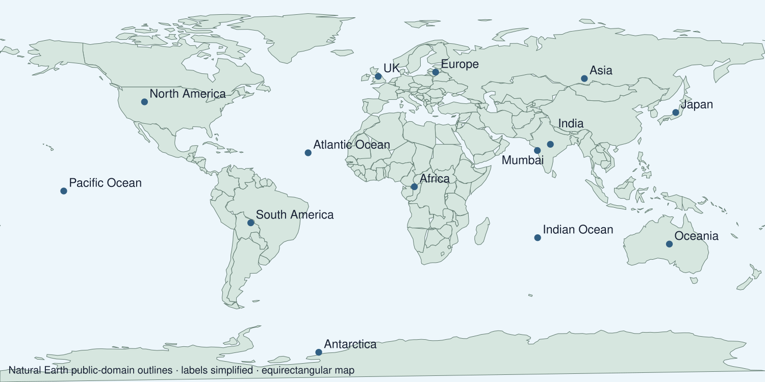
A detail I noticed and what it helps me explain
________________________________________________________________________
________________________________________________________________________
________________________________________________________________________
________________________________________________________________________

Data for the enquiry
Archived USGS feed snapshot
UTC event time | Place | Magnitude | Depth km | Latitude | Longitude
2026-09-19T12:19:55+00:00 | 273 km NNW of Dêqên, China | 4.5 | 10 | 32.0711 | 89.2243
2026-09-19T12:07:12+00:00 | 25 km NW of Ushibukamachi, Japan | 4.6 | 10 | 32.3799 | 129.8568
2026-09-19T10:52:05+00:00 | 10 km ENE of Milpitas, CA | 2.5 | 2.67 | 37.466667175293 | -121.801834106445
2026-09-19T10:31:17+00:00 | 18 km SW of Mongar, Bhutan | 4.8 | 10 | 27.1636 | 91.1016
2026-09-19T09:59:59+00:00 | South Sandwich Islands region | 5 | 77.62 | -55.6255 | -28.1116
2026-09-19T09:56:02+00:00 | 4 km NE of Límni, Greece | 4.4 | 10 | 38.7884 | 23.3566

Units: Magnitude
Source: USGS M2.5+ past-day feed, generated 2026-09-19T14:08:13+00:00
Limit: This saved snapshot is not live at teaching time. Refresh explicitly or label the analysis as archived. A small selected sample cannot predict earthquakes.
My labelled graph or data notes
________________________________________________________________________
________________________________________________________________________
________________________________________________________________________
________________________________________________________________________
________________________________________________________________________
________________________________________________________________________
________________________________________________________________________
________________________________________________________________________

Shared investigation
1. Open the teacher-selected USGS feed and record its snapshot time.
2. Read magnitude and depth as different variables.
Work with a partner or adult, or use your own table. One person suggests; the other checks the evidence. Swap after one turn. Passing is allowed.
Use the evidence cards and any visual sheet. Follow the two shared steps above, then record one decision.
Our explanation
________________________________________________________________________
________________________________________________________________________
________________________________________________________________________
Support: Use the glossary and one chunk of evidence. Plan the claim and supporting detail before explaining.
Further challenge: Explain how threshold, sample duration or revisions can change the apparent pattern.

Supported independent task
Complete this route only. Track live hazards online and interpret data.
1. Capture a dated and timed live snapshot or use the explicitly dated archive if offline.
2. Enter a small event set in the table and graph one variable.
3. Identify a pattern and a conclusion limited to that snapshot.
Support: Use the glossary and one chunk of evidence. Plan the claim and supporting detail before explaining. Complete the organiser one space at a time. Snapshot UTC ___. Source ___. Variable and units ___. Pattern ___. This cannot tell us ___.
Data source and date or capture time
________________________________________________________________________
________________________________________________________________________
Variables units and graph labels
________________________________________________________________________
________________________________________________________________________
A pattern supported by values
________________________________________________________________________
________________________________________________________________________
What the data cannot establish
________________________________________________________________________
________________________________________________________________________
An adult may read or scribe your exact response. They should not choose the answer.

Standard independent task
Complete this route only. Track live hazards online and interpret data.
1. Capture a dated and timed live snapshot or use the explicitly dated archive if offline.
2. Enter a small event set in the table and graph one variable.
3. Identify a pattern and a conclusion limited to that snapshot.
Support: Snapshot UTC ___. Source ___. Variable and units ___. Pattern ___. This cannot tell us ___.
Data source and date or capture time
________________________________________________________________________
________________________________________________________________________
Variables units and graph labels
________________________________________________________________________
________________________________________________________________________
A pattern supported by values
________________________________________________________________________
________________________________________________________________________
What the data cannot establish
________________________________________________________________________
________________________________________________________________________
Check the required evidence and revise one detail.

Stretch independent task
Complete this route only. Track live hazards online and interpret data.
1. Capture a dated and timed live snapshot or use the explicitly dated archive if offline.
2. Enter a small event set in the table and graph one variable.
3. Identify a pattern and a conclusion limited to that snapshot.
4. Explain how threshold, sample duration or revisions can change the apparent pattern.
Support: Choose the evidence independently. Use the frame only if it helps.
Data source and date or capture time
________________________________________________________________________
________________________________________________________________________
Variables units and graph labels
________________________________________________________________________
________________________________________________________________________
A pattern supported by values
________________________________________________________________________
________________________________________________________________________
What the data cannot establish
________________________________________________________________________
________________________________________________________________________
Explain how threshold, sample duration or revisions can change the apparent pattern.

Exit ticket
Choose a response mode. You may give your answers privately to an adult.

Why record the snapshot time
My response
________________________________________________________________________
________________________________________________________________________
________________________________________________________________________

Can this small sample predict the next earthquake
My response
________________________________________________________________________
________________________________________________________________________
________________________________________________________________________
Support: Snapshot UTC ___. Source ___. Variable and units ___. Pattern ___. This cannot tell us ___.
Further challenge: Explain how threshold, sample duration or revisions can change the apparent pattern.
One thing I changed or want to check
________________________________________________________________________
________________________________________________________________________

