Hazard effects and management
Learning goal: Explain effects and management of a hazard.

Words to use
Word | Meaning
tectonic | Related to movement of Earth’s plates
exposure | People or things in harm’s way
vulnerability | Conditions making harm more likely or severe
risk | Potential harm from a hazard in a particular setting

Remember
Which response directly addresses tsunami exposure? Accessible routes and timely warnings that enable movement to higher ground.
Does earthquake-resistant construction remove all tsunami risk? No. Shaking and coastal flooding require different measures.

How to show your learning
Locate the Japan event and build a cause, effects and responses map.
For the risk of ___, I choose ___ because ___. A limitation is ___.

Evidence matters
Fictional cases are teaching examples. Historical, geographical and religious claims use the named sources. A model video demonstrates a method.
You can respond by speaking, pointing, drawing, typing or writing. A fictional personal example is welcome.
Sources: USGS 2011 Japan event; USGS live earthquake feed

Arrival choices
Previous lesson reminder:
Start with 1 and 2. Try 3 and 4 when ready. Reading and exact scribing are available.

1 Why record the snapshot time
Support: Use the reminder strip or talk it through with an adult.
My response
________________________________________________________________________

2 Which meaning fits tectonic
Support: Choose: Related to movement of Earth’s plates OR People or things in harm’s way.
My response
________________________________________________________________________

3 Which response directly addresses tsunami exposure
Support: Use the model evidence anchor B or read one relevant card together.
My response
________________________________________________________________________

4 Does earthquake resistant construction remove all tsunami risk
Support: Give a reason when ready.
My response
________________________________________________________________________
Stretch: use a precise example or explain which detail supports your answer.

Evidence cards
Read, point or listen. Keep the source label with any detail you use.

A Japan 11 March 2011
A magnitude 9.1 earthquake occurred off north-east Honshu, Japan. Sudden movement on the subduction boundary displaced the seafloor and produced a tsunami.
Source: USGS event record, official20110311054624120_30
Limit: Magnitude measures the earthquake; it is not a direct count of people affected.

B Effects and responses
Shaking and coastal flooding damaged places and disrupted people’s lives. Earthquake-resistant design addresses shaking; warnings, evacuation routes and higher ground address tsunami exposure.
Source: Authored explanation of the case and risk-management principles
Limit: A sea wall or warning cannot eliminate all risk. Do not judge people without considering access and warning time.

C Heat and unequal risk
On 19 July 2022 the Met Office recorded 40.3°C at Coningsby, 40.2°C at St James’s Park and 39.6°C at Topcliffe. Outdoor work increases exposure; difficulty accessing cool spaces can increase vulnerability. Shade and accessible cool spaces can reduce harm.
Source: Met Office July 2022 report, station table; risk explanation authored for teaching
Limit: This explains risk factors, not a medical assessment of an individual.

D Reading a hazard feed
A USGS event row can include UTC time, place, magnitude and depth in kilometres. A short feed is a dated snapshot. It cannot predict the next earthquake.
Source: USGS earthquake feed documentation
Limit: Small samples, reporting thresholds and later revisions affect patterns.

Visual resource
Use this visual with the evidence cards and enquiry questions.
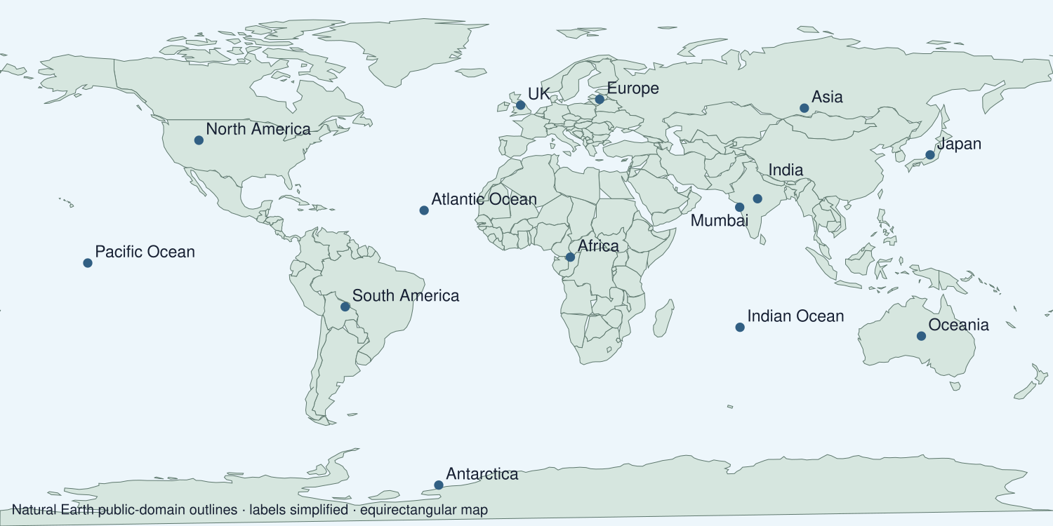
A detail I noticed and what it helps me explain
________________________________________________________________________
________________________________________________________________________
________________________________________________________________________
________________________________________________________________________

Shared investigation
1. Compare earthquake-resistant design, warnings and accessible routes.
2. Match each response to the stated risk it addresses.
Work with a partner or adult, or use your own table. One person suggests; the other checks the evidence. Swap after one turn. Passing is allowed.

Move or match the cards
Cards to use
No clear information
People in low coastal areas
Shaking damages buildings

Possible labels: Accessible evacuation routes / Earthquake-resistant design / Warnings and communication
Our explanation
________________________________________________________________________
________________________________________________________________________
________________________________________________________________________
Support: Use the glossary and one chunk of evidence. Plan the claim and supporting detail before explaining.
Further challenge: Compare immediate response with longer-term preparedness and explain a trade-off.

Supported independent task
Complete this route only. Explain effects and management of a hazard.
1. Locate the Japan event and build a cause, effects and responses map.
2. Interpret one data value or map feature.
3. Judge a management response using a stated risk and a limitation.
Support: Use the glossary and one chunk of evidence. Plan the claim and supporting detail before explaining. Complete the organiser one space at a time. For the risk of ___, I choose ___ because ___. A limitation is ___.
My choice or example
________________________________________________________________________
________________________________________________________________________
A detail from the card story or object
________________________________________________________________________
________________________________________________________________________
My reason
________________________________________________________________________
________________________________________________________________________
My check or next step
________________________________________________________________________
________________________________________________________________________
An adult may read or scribe your exact response. They should not choose the answer.

Standard independent task
Complete this route only. Explain effects and management of a hazard.
1. Locate the Japan event and build a cause, effects and responses map.
2. Interpret one data value or map feature.
3. Judge a management response using a stated risk and a limitation.
Support: For the risk of ___, I choose ___ because ___. A limitation is ___.
My choice or example
________________________________________________________________________
________________________________________________________________________
A detail from the card story or object
________________________________________________________________________
________________________________________________________________________
My reason
________________________________________________________________________
________________________________________________________________________
My check or next step
________________________________________________________________________
________________________________________________________________________
Check the required evidence and revise one detail.

Stretch independent task
Complete this route only. Explain effects and management of a hazard.
1. Locate the Japan event and build a cause, effects and responses map.
2. Interpret one data value or map feature.
3. Judge a management response using a stated risk and a limitation.
4. Compare immediate response with longer-term preparedness and explain a trade-off.
Support: Choose the evidence independently. Use the frame only if it helps.
My choice or example
________________________________________________________________________
________________________________________________________________________
A detail from the card story or object
________________________________________________________________________
________________________________________________________________________
My reason
________________________________________________________________________
________________________________________________________________________
My check or next step
________________________________________________________________________
________________________________________________________________________
Compare immediate response with longer-term preparedness and explain a trade-off.

Exit ticket
Choose a response mode. You may give your answers privately to an adult.

Which response directly addresses tsunami exposure
My response
________________________________________________________________________
________________________________________________________________________
________________________________________________________________________

Does earthquake resistant construction remove all tsunami risk
My response
________________________________________________________________________
________________________________________________________________________
________________________________________________________________________
Support: For the risk of ___, I choose ___ because ___. A limitation is ___.
Further challenge: Compare immediate response with longer-term preparedness and explain a trade-off.
One thing I changed or want to check
________________________________________________________________________
________________________________________________________________________

