Analysing hazard data for a report
Learning goal: Analyse hazard data in spreadsheets and produce a digital report.

Words to use
Word | Meaning
tectonic | Related to movement of Earth’s plates
exposure | People or things in harm’s way
vulnerability | Conditions making harm more likely or severe
risk | Potential harm from a hazard in a particular setting

Remember
Which units belong on the temperature axis? Degrees Celsius.
Can selected station maxima establish the temperature of every street? No. Coverage, exposure and local conditions vary.

How to show your learning
Enter or check the case-study data and create a labelled graph.
The highest value in this selection is ___ at ___. The range is ___. This sample cannot establish ___.

Evidence matters
Fictional cases are teaching examples. Historical, geographical and religious claims use the named sources. A model video demonstrates a method.
You can respond by speaking, pointing, drawing, typing or writing. A fictional personal example is welcome.
Sources: USGS 2011 Japan event; USGS live earthquake feed

Arrival choices
Previous lesson reminder:
Start with 1 and 2. Try 3 and 4 when ready. Reading and exact scribing are available.

1 What was recorded at Coningsby on 19 July 2022
Support: Use the reminder strip or talk it through with an adult.
My response
________________________________________________________________________

2 Which meaning fits tectonic
Support: Choose: Related to movement of Earth’s plates OR People or things in harm’s way.
My response
________________________________________________________________________

3 Which units belong on the temperature axis
Support: Use the model evidence anchor dataset or read one relevant card together.
My response
________________________________________________________________________

4 Can selected station maxima establish the temperature of every street
Support: Give a reason when ready.
My response
________________________________________________________________________
Stretch: use a precise example or explain which detail supports your answer.

Evidence cards
Read, point or listen. Keep the source label with any detail you use.

A Japan 11 March 2011
A magnitude 9.1 earthquake occurred off north-east Honshu, Japan. Sudden movement on the subduction boundary displaced the seafloor and produced a tsunami.
Source: USGS event record, official20110311054624120_30
Limit: Magnitude measures the earthquake; it is not a direct count of people affected.

B Effects and responses
Shaking and coastal flooding damaged places and disrupted people’s lives. Earthquake-resistant design addresses shaking; warnings, evacuation routes and higher ground address tsunami exposure.
Source: Authored explanation of the case and risk-management principles
Limit: A sea wall or warning cannot eliminate all risk. Do not judge people without considering access and warning time.

C Heat and unequal risk
On 19 July 2022 the Met Office recorded 40.3°C at Coningsby, 40.2°C at St James’s Park and 39.6°C at Topcliffe. Outdoor work increases exposure; difficulty accessing cool spaces can increase vulnerability. Shade and accessible cool spaces can reduce harm.
Source: Met Office July 2022 report, station table; risk explanation authored for teaching
Limit: This explains risk factors, not a medical assessment of an individual.

D Reading a hazard feed
A USGS event row can include UTC time, place, magnitude and depth in kilometres. A short feed is a dated snapshot. It cannot predict the next earthquake.
Source: USGS earthquake feed documentation
Limit: Small samples, reporting thresholds and later revisions affect patterns.

Visual resource
Use this visual with the evidence cards and enquiry questions.
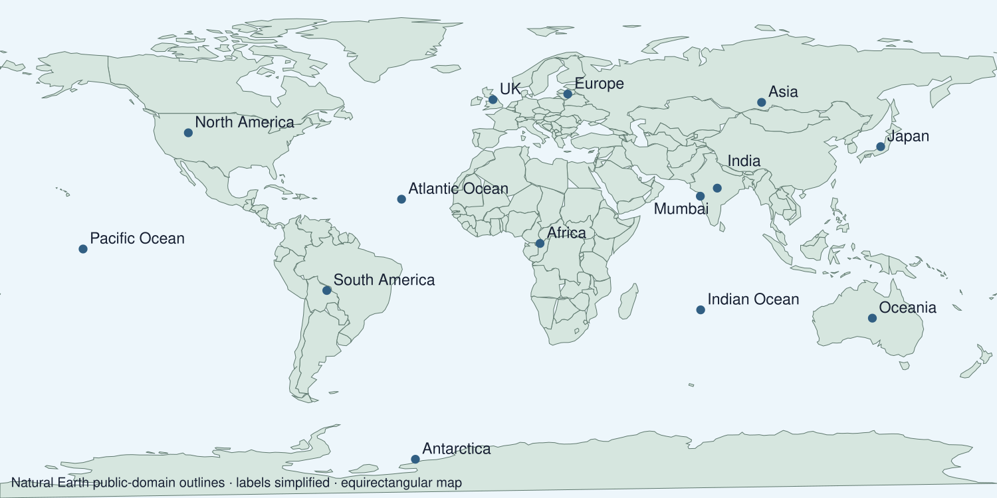
A detail I noticed and what it helps me explain
________________________________________________________________________
________________________________________________________________________
________________________________________________________________________
________________________________________________________________________

Data for the enquiry
Selected station maxima on 19 July 2022
Station | Maximum °C
Coningsby | 40.3
St James’s Park | 40.2
Topcliffe | 39.6
Sheffield | 39.4

Units: °C
Source: Met Office July 2022 heatwave report, table on page 8
Limit: Four selected station maxima are not a national average or a long-term climate trend. The report marked values provisional at publication.
My labelled graph or data notes
________________________________________________________________________
________________________________________________________________________
________________________________________________________________________
________________________________________________________________________
________________________________________________________________________
________________________________________________________________________
________________________________________________________________________
________________________________________________________________________

Shared investigation
1. Transfer the selected heatwave station values into the spreadsheet.
2. Choose a bar chart, label units and check the plotted values.
Work with a partner or adult, or use your own table. One person suggests; the other checks the evidence. Swap after one turn. Passing is allowed.
Use the evidence cards and any visual sheet. Follow the two shared steps above, then record one decision.
Our explanation
________________________________________________________________________
________________________________________________________________________
________________________________________________________________________
Support: Use the glossary and one chunk of evidence. Plan the claim and supporting detail before explaining.
Further challenge: Explain why a bar chart of selected station maxima cannot show an annual climate trend.

Supported independent task
Complete this route only. Analyse hazard data in spreadsheets and produce a digital report.
1. Enter or check the case-study data and create a labelled graph.
2. Write a digital report paragraph describing a pattern with values.
3. State a limitation of the selected stations and data.
Support: Use the glossary and one chunk of evidence. Plan the claim and supporting detail before explaining. Complete the organiser one space at a time. The highest value in this selection is ___ at ___. The range is ___. This sample cannot establish ___.
Data source and date or capture time
________________________________________________________________________
________________________________________________________________________
Variables units and graph labels
________________________________________________________________________
________________________________________________________________________
A pattern supported by values
________________________________________________________________________
________________________________________________________________________
What the data cannot establish
________________________________________________________________________
________________________________________________________________________
An adult may read or scribe your exact response. They should not choose the answer.

Standard independent task
Complete this route only. Analyse hazard data in spreadsheets and produce a digital report.
1. Enter or check the case-study data and create a labelled graph.
2. Write a digital report paragraph describing a pattern with values.
3. State a limitation of the selected stations and data.
Support: The highest value in this selection is ___ at ___. The range is ___. This sample cannot establish ___.
Data source and date or capture time
________________________________________________________________________
________________________________________________________________________
Variables units and graph labels
________________________________________________________________________
________________________________________________________________________
A pattern supported by values
________________________________________________________________________
________________________________________________________________________
What the data cannot establish
________________________________________________________________________
________________________________________________________________________
Check the required evidence and revise one detail.

Stretch independent task
Complete this route only. Analyse hazard data in spreadsheets and produce a digital report.
1. Enter or check the case-study data and create a labelled graph.
2. Write a digital report paragraph describing a pattern with values.
3. State a limitation of the selected stations and data.
4. Explain why a bar chart of selected station maxima cannot show an annual climate trend.
Support: Choose the evidence independently. Use the frame only if it helps.
Data source and date or capture time
________________________________________________________________________
________________________________________________________________________
Variables units and graph labels
________________________________________________________________________
________________________________________________________________________
A pattern supported by values
________________________________________________________________________
________________________________________________________________________
What the data cannot establish
________________________________________________________________________
________________________________________________________________________
Explain why a bar chart of selected station maxima cannot show an annual climate trend.

Exit ticket
Choose a response mode. You may give your answers privately to an adult.

Which units belong on the temperature axis
My response
________________________________________________________________________
________________________________________________________________________
________________________________________________________________________

Can selected station maxima establish the temperature of every street
My response
________________________________________________________________________
________________________________________________________________________
________________________________________________________________________
Support: The highest value in this selection is ___ at ___. The range is ___. This sample cannot establish ___.
Further challenge: Explain why a bar chart of selected station maxima cannot show an annual climate trend.
One thing I changed or want to check
________________________________________________________________________
________________________________________________________________________

