A hazard case-study report
Learning goal: Complete a hazard case-study report.

Words to use
Word | Meaning
tectonic | Related to movement of Earth’s plates
exposure | People or things in harm’s way
vulnerability | Conditions making harm more likely or severe
risk | Potential harm from a hazard in a particular setting

Remember
What makes the report more than a description of the event? It explains risk, evaluates management and justifies a judgement with evidence.
What must accompany the graph or map? A title, source, relevant date, labels or key, and an explanation of what it contributes.

How to show your learning
Produce an independent case-study report for Japan 2011 or the July 2022 heatwave.
Location ___. Cause ___. Effects ___. Exposure and vulnerability ___. Management judgement ___. Evidence limit ___.

Evidence matters
Fictional cases are teaching examples. Historical, geographical and religious claims use the named sources. A model video demonstrates a method.
You can respond by speaking, pointing, drawing, typing or writing. A fictional personal example is welcome.
Sources: USGS 2011 Japan event; USGS live earthquake feed

Arrival choices
Previous lesson reminder:
Start with 1 and 2. Try 3 and 4 when ready. Reading and exact scribing are available.

1 Which units belong on the temperature axis
Support: Use the reminder strip or talk it through with an adult.
My response
________________________________________________________________________

2 Which meaning fits tectonic
Support: Choose: Related to movement of Earth’s plates OR People or things in harm’s way.
My response
________________________________________________________________________

3 What makes the report more than a description of the event
Support: Use the model evidence anchor assessment or read one relevant card together.
My response
________________________________________________________________________

4 What must accompany the graph or map
Support: Give a reason when ready.
My response
________________________________________________________________________
Stretch: use a precise example or explain which detail supports your answer.

Evidence cards
Read, point or listen. Keep the source label with any detail you use.

A Japan 11 March 2011
A magnitude 9.1 earthquake occurred off north-east Honshu, Japan. Sudden movement on the subduction boundary displaced the seafloor and produced a tsunami.
Source: USGS event record, official20110311054624120_30
Limit: Magnitude measures the earthquake; it is not a direct count of people affected.

B Effects and responses
Shaking and coastal flooding damaged places and disrupted people’s lives. Earthquake-resistant design addresses shaking; warnings, evacuation routes and higher ground address tsunami exposure.
Source: Authored explanation of the case and risk-management principles
Limit: A sea wall or warning cannot eliminate all risk. Do not judge people without considering access and warning time.

C Heat and unequal risk
On 19 July 2022 the Met Office recorded 40.3°C at Coningsby, 40.2°C at St James’s Park and 39.6°C at Topcliffe. Outdoor work increases exposure; difficulty accessing cool spaces can increase vulnerability. Shade and accessible cool spaces can reduce harm.
Source: Met Office July 2022 report, station table; risk explanation authored for teaching
Limit: This explains risk factors, not a medical assessment of an individual.

D Reading a hazard feed
A USGS event row can include UTC time, place, magnitude and depth in kilometres. A short feed is a dated snapshot. It cannot predict the next earthquake.
Source: USGS earthquake feed documentation
Limit: Small samples, reporting thresholds and later revisions affect patterns.

Visual resource
Use this visual with the evidence cards and enquiry questions.
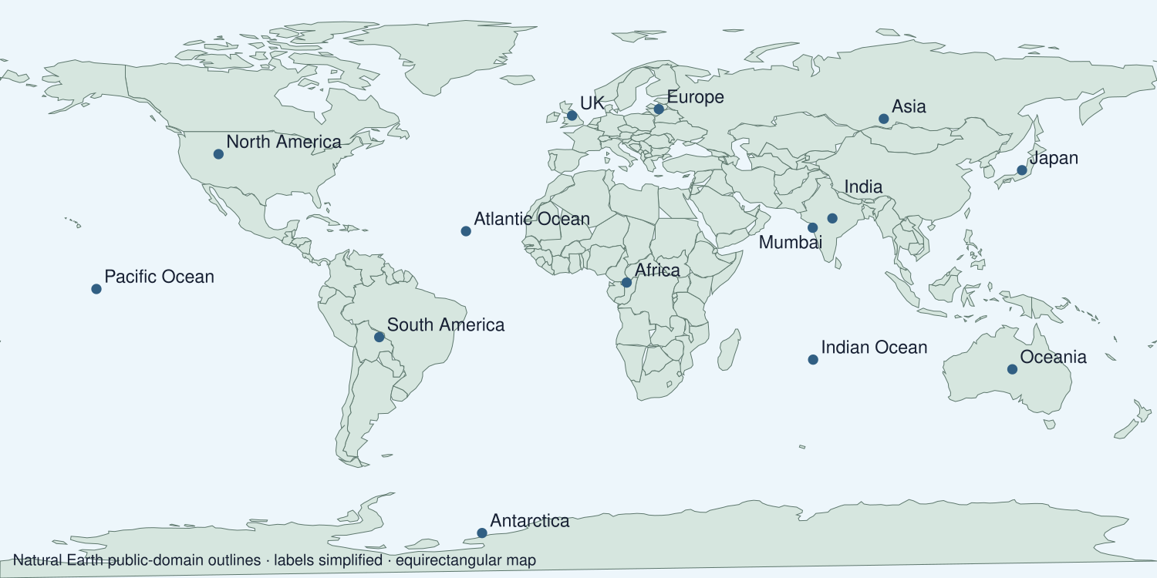
A detail I noticed and what it helps me explain
________________________________________________________________________
________________________________________________________________________
________________________________________________________________________
________________________________________________________________________

Data for the enquiry
Selected station maxima on 19 July 2022
Station | Maximum °C
Coningsby | 40.3
St James’s Park | 40.2
Topcliffe | 39.6
Sheffield | 39.4

Units: °C
Source: Met Office July 2022 heatwave report, table on page 8
Limit: Four selected station maxima are not a national average or a long-term climate trend. The report marked values provisional at publication.
My labelled graph or data notes
________________________________________________________________________
________________________________________________________________________
________________________________________________________________________
________________________________________________________________________
________________________________________________________________________
________________________________________________________________________
________________________________________________________________________
________________________________________________________________________

Shared investigation
1. Audit a practice report against location, causes, effects, risk and management.
2. Choose a useful map or graph and explain why it belongs.
Work with a partner or adult, or use your own table. One person suggests; the other checks the evidence. Swap after one turn. Passing is allowed.
Use the evidence cards and any visual sheet. Follow the two shared steps above, then record one decision.
Our explanation
________________________________________________________________________
________________________________________________________________________
________________________________________________________________________
Support: Use the glossary and one chunk of evidence. Plan the claim and supporting detail before explaining.
Further challenge: Weigh two management approaches and explain how the evidence supports your final judgement.

Supported independent task
Complete this route only. Complete a hazard case-study report.
1. Produce an independent case-study report for Japan 2011 or the July 2022 heatwave.
2. Include location, causes, effects, risk, management and a useful map or graph.
3. Justify a judgement and evaluate a source or data limitation.
Support: Use the glossary and one chunk of evidence. Plan the claim and supporting detail before explaining. Complete the organiser one space at a time. Location ___. Cause ___. Effects ___. Exposure and vulnerability ___. Management judgement ___. Evidence limit ___.
My answer to the assessment enquiry
________________________________________________________________________
________________________________________________________________________
My evidence and source
________________________________________________________________________
________________________________________________________________________
My explanation or comparison
________________________________________________________________________
________________________________________________________________________
My conclusion and what the evidence does not show
________________________________________________________________________
________________________________________________________________________
An adult may read or scribe your exact response. They should not choose the answer.

Standard independent task
Complete this route only. Complete a hazard case-study report.
1. Produce an independent case-study report for Japan 2011 or the July 2022 heatwave.
2. Include location, causes, effects, risk, management and a useful map or graph.
3. Justify a judgement and evaluate a source or data limitation.
Support: Location ___. Cause ___. Effects ___. Exposure and vulnerability ___. Management judgement ___. Evidence limit ___.
My answer to the assessment enquiry
________________________________________________________________________
________________________________________________________________________
My evidence and source
________________________________________________________________________
________________________________________________________________________
My explanation or comparison
________________________________________________________________________
________________________________________________________________________
My conclusion and what the evidence does not show
________________________________________________________________________
________________________________________________________________________
Check the required evidence and revise one detail.

Stretch independent task
Complete this route only. Complete a hazard case-study report.
1. Produce an independent case-study report for Japan 2011 or the July 2022 heatwave.
2. Include location, causes, effects, risk, management and a useful map or graph.
3. Justify a judgement and evaluate a source or data limitation.
4. Weigh two management approaches and explain how the evidence supports your final judgement.
Support: Choose the evidence independently. Use the frame only if it helps.
My answer to the assessment enquiry
________________________________________________________________________
________________________________________________________________________
My evidence and source
________________________________________________________________________
________________________________________________________________________
My explanation or comparison
________________________________________________________________________
________________________________________________________________________
My conclusion and what the evidence does not show
________________________________________________________________________
________________________________________________________________________
Weigh two management approaches and explain how the evidence supports your final judgement.

Exit ticket
Choose a response mode. You may give your answers privately to an adult.

What makes the report more than a description of the event
My response
________________________________________________________________________
________________________________________________________________________
________________________________________________________________________

What must accompany the graph or map
My response
________________________________________________________________________
________________________________________________________________________
________________________________________________________________________
Support: Location ___. Cause ___. Effects ___. Exposure and vulnerability ___. Management judgement ___. Evidence limit ___.
Further challenge: Weigh two management approaches and explain how the evidence supports your final judgement.
One thing I changed or want to check
________________________________________________________________________
________________________________________________________________________

