Special books and places
Learning goal: Recognise one special book or place linked to a faith.

Words to use
Word | Meaning
Bible | The holy book of Christians
Qur’an | The holy book of Muslims
Torah | The most sacred Jewish scripture, often kept as a scroll
sacred | Special and holy to people of a faith

Remember
Where is a Torah scroll kept in a synagogue? In a special cupboard called the Ark.
Is a mosque a book or a place? A place. Many Muslims pray together there.

How to show your learning
Choose one sacred book or place.
The ___ is special to ___ because ___.

Evidence matters
Fictional cases are teaching examples. Historical, geographical and religious claims use the named sources. A model video demonstrates a method.
This is learning about religion and worldviews, not worship. Nobody is asked to share a personal belief, family detail or loss.

Arrival choices
Previous lesson reminder:
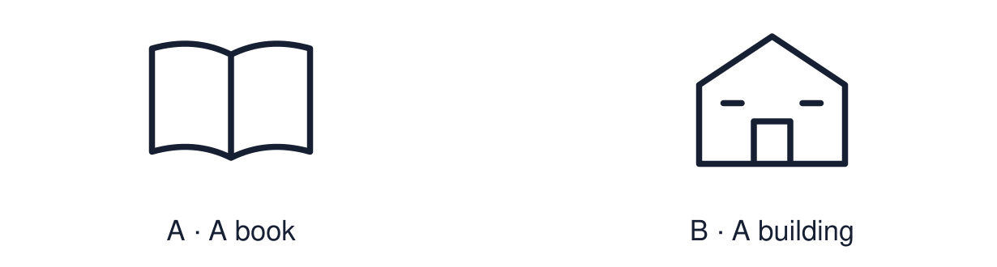
Start with 1 and 2. Try 3 and 4 when ready. Reading and exact scribing are available.

1 Why is the watch special to Mina
Support: Use the reminder strip or talk it through with an adult.
My response
________________________________________________________________________

2 Which meaning fits Bible
Support: Choose: The holy book of Christians OR The holy book of Muslims.
My response
________________________________________________________________________

3 Where is a Torah scroll kept in a synagogue
Support: Use the model evidence anchor C or read one relevant card together.
My response
________________________________________________________________________

4 Is a mosque a book or a place
Support: Give a reason when ready.
My response
________________________________________________________________________
Stretch: use a precise example or explain which detail supports your answer.

Evidence cards
Read, point or listen. Keep the source label with any detail you use.

A Bible and church
The Bible is the holy book of Christians. Many Christians meet to worship in a church. Some read the Bible at home as well.
Source: Authored RE summary
Limit: Christians worship and read in many different ways.

B Qur’an and mosque
The Qur’an is the holy book of Muslims. Many Muslims pray together in a mosque. Many keep the Qur’an in a clean, high place to show respect.
Source: Authored RE summary
Limit: Muslim practice varies between families and communities.

C Torah and synagogue
The Torah is sacred to Jewish people. In a synagogue the Torah scroll is kept in a special cupboard called the Ark. Readers often use a pointer instead of touching the words.
Source: Authored RE summary
Limit: Jewish practice varies between communities.

D Book or place?
A sacred book is read or listened to. A sacred place is somewhere people go. Both can be special to believers.
Source: Authored classroom resource
Limit: A book or place is not the whole religion. It is one part of it.

Shared investigation
1. Sort each book or place under the faith it belongs to.
2. Say one way believers show that it is special.
Work with a partner or adult, or use your own table. One person suggests; the other checks the evidence. Swap after one turn. Passing is allowed.

Move or match the cards
Cards to use
The Bible
A synagogue
The Qur’an

Possible labels: Christianity / Islam / Judaism
Our explanation
________________________________________________________________________
________________________________________________________________________
________________________________________________________________________
Support: Show two choices. Read one short instruction. Point, match or say a word, then add a reason when ready.
Further challenge: Explain one way a believer might show respect for a sacred book.

Supported independent task
Complete this route only. Recognise one special book or place linked to a faith.
1. Choose one book or place card.
2. Match it to its faith: Christianity, Islam or Judaism.
3. Point to or say one reason it is special.
Support: Show two choices. Read one short instruction. Point, match or say a word, then add a reason when ready. Complete the organiser one space at a time. The ___ is special to ___ because ___.
My choice or example
________________________________________________________________________
________________________________________________________________________
A detail from the card story or object
________________________________________________________________________
________________________________________________________________________
My reason
________________________________________________________________________
________________________________________________________________________
My check or next step
________________________________________________________________________
________________________________________________________________________
An adult may read or scribe your exact response. They should not choose the answer.

Standard independent task
Complete this route only. Recognise one special book or place linked to a faith.
1. Choose one sacred book or place.
2. Match it to its faith and label it.
3. Explain simply why it is special to some believers.
Support: The ___ is special to ___ because ___.
My choice or example
________________________________________________________________________
________________________________________________________________________
A detail from the card story or object
________________________________________________________________________
________________________________________________________________________
My reason
________________________________________________________________________
________________________________________________________________________
My check or next step
________________________________________________________________________
________________________________________________________________________
Check the required evidence and revise one detail.

Stretch independent task
Complete this route only. Recognise one special book or place linked to a faith.
1. Choose one book and one place from the same faith.
2. Explain how they are linked.
3. Describe one way believers show respect and say why.
Support: Choose the evidence independently. Use the frame only if it helps.
My choice or example
________________________________________________________________________
________________________________________________________________________
A detail from the card story or object
________________________________________________________________________
________________________________________________________________________
My reason
________________________________________________________________________
________________________________________________________________________
My check or next step
________________________________________________________________________
________________________________________________________________________
Explain one way a believer might show respect for a sacred book.

Exit ticket
Choose a response mode. You may give your answers privately to an adult.

Where is a Torah scroll kept in a synagogue
My response
________________________________________________________________________
________________________________________________________________________
________________________________________________________________________

Is a mosque a book or a place
My response
________________________________________________________________________
________________________________________________________________________
________________________________________________________________________
Support: The ___ is special to ___ because ___.
Further challenge: Explain one way a believer might show respect for a sacred book.
One thing I changed or want to check
________________________________________________________________________
________________________________________________________________________

