A story of belonging
Learning goal: Listen to a story of belonging and identify one example of belonging.

Words to use
Word | Meaning
belonging | Feeling part of a group and welcome in it
community | People linked by a place, belief or activity
welcome | To greet someone kindly and include them
langar | A free shared meal served at a gurdwara

Remember
What is one sign that Sam is welcome at the gurdwara? A volunteer greets him and shows him where to sit.
Did anyone ask Sam what he believes before welcoming him? No. In the story everyone is welcome.

How to show your learning
Put the four story parts in order.
They belong because ___.

Evidence matters
Fictional cases are teaching examples. Historical, geographical and religious claims use the named sources. A model video demonstrates a method.
This is learning about religion and worldviews, not worship. Nobody is asked to share a personal belief, family detail or loss.
Sources: Sikh Coalition introduction to Sikh beliefs and practice

Arrival choices
Previous lesson reminder:
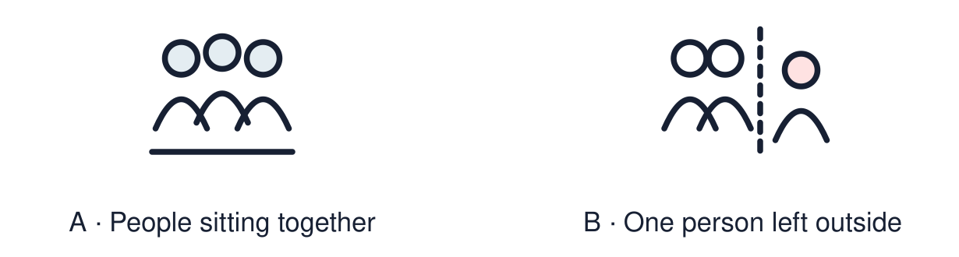
Start with 1 and 2. Try 3 and 4 when ready. Reading and exact scribing are available.

1 Where is a Torah scroll kept in a synagogue
Support: Use the reminder strip or talk it through with an adult.
My response
________________________________________________________________________

2 Which meaning fits belonging
Support: Choose: Feeling part of a group and welcome in it OR People linked by a place, belief or activity.
My response
________________________________________________________________________

3 What is one sign that Sam is welcome at the gurdwara
Support: Use the model evidence anchor B or read one relevant card together.
My response
________________________________________________________________________

4 Did anyone ask Sam what he believes before welcoming him
Support: Give a reason when ready.
My response
________________________________________________________________________
Stretch: use a precise example or explain which detail supports your answer.

Evidence cards
Read, point or listen. Keep the source label with any detail you use.

A The visit
Fictional story: Sam visits a gurdwara with his friend Jas. A gurdwara is a Sikh place of worship. They follow the host’s guidance about covering their heads and removing shoes.
Source: Authored story based on Sikh practice
Limit: One story cannot show every gurdwara or every Sikh family.

B The welcome
A volunteer smiles and says hello. She shows Sam where to sit. Nobody asks what Sam believes. Everyone is welcome.
Source: Authored story based on Sikh practice
Limit: One story cannot show every gurdwara or every Sikh family.

C The shared meal
The visitors share langar, a free community meal. Many people sit on the floor together as a sign of equality. Chairs or other arrangements can support people who need them.
Source: Authored story based on Sikh practice
Limit: One story cannot show every gurdwara or every Sikh family.

D Joining in
Sam chooses to help carry cups after the meal. Jas thanks him. The welcome and shared meal helped him feel included; helping is a choice, not a condition of belonging.
Source: Authored story based on Sikh practice
Limit: Belonging can feel different for different people.

Shared investigation
1. Put the four parts of Sam’s visit in order.
2. Find one thing in the story that shows belonging.
Work with a partner or adult, or use your own table. One person suggests; the other checks the evidence. Swap after one turn. Passing is allowed.

Move or match the cards
Cards to use
Sam helps carry cups to the kitchen
Everyone sits together to eat langar
A volunteer welcomes Sam and shows him where to sit
Sam takes off his shoes and covers his head

Our explanation
________________________________________________________________________
________________________________________________________________________
________________________________________________________________________
Support: Show two choices. Read one short instruction. Point, match or say a word, then add a reason when ready.
Further challenge: Explain why sitting together to eat can show that people are equal.

Supported independent task
Complete this route only. Listen to a story of belonging and identify one example of belonging.
1. Put three story pictures in order.
2. Point to the picture that shows a welcome.
3. Say or finish: They belong because ___.
Support: Show two choices. Read one short instruction. Point, match or say a word, then add a reason when ready. Complete the organiser one space at a time. They belong because ___.
First event and date or time cue
________________________________________________________________________
________________________________________________________________________
Next event and date or time cue
________________________________________________________________________
________________________________________________________________________
Later event and date or time cue
________________________________________________________________________
________________________________________________________________________
Why this order fits the evidence
________________________________________________________________________
________________________________________________________________________
An adult may read or scribe your exact response. They should not choose the answer.

Standard independent task
Complete this route only. Listen to a story of belonging and identify one example of belonging.
1. Put the four story parts in order.
2. Choose one example of belonging from the story.
3. Finish the sentence: They belong because ___.
Support: They belong because ___.
First event and date or time cue
________________________________________________________________________
________________________________________________________________________
Next event and date or time cue
________________________________________________________________________
________________________________________________________________________
Later event and date or time cue
________________________________________________________________________
________________________________________________________________________
Why this order fits the evidence
________________________________________________________________________
________________________________________________________________________
Check the required evidence and revise one detail.

Stretch independent task
Complete this route only. Listen to a story of belonging and identify one example of belonging.
1. Put the four story parts in order.
2. Explain two different signs of belonging in the story.
3. Say what the shared meal teaches about equality.
Support: Choose the evidence independently. Use the frame only if it helps.
First event and date or time cue
________________________________________________________________________
________________________________________________________________________
Next event and date or time cue
________________________________________________________________________
________________________________________________________________________
Later event and date or time cue
________________________________________________________________________
________________________________________________________________________
Why this order fits the evidence
________________________________________________________________________
________________________________________________________________________
Explain why sitting together to eat can show that people are equal.

Exit ticket
Choose a response mode. You may give your answers privately to an adult.

What is one sign that Sam is welcome at the gurdwara
My response
________________________________________________________________________
________________________________________________________________________
________________________________________________________________________

Did anyone ask Sam what he believes before welcoming him
My response
________________________________________________________________________
________________________________________________________________________
________________________________________________________________________
Support: They belong because ___.
Further challenge: Explain why sitting together to eat can show that people are equal.
One thing I changed or want to check
________________________________________________________________________
________________________________________________________________________

