Belonging and the Day of Peace
Learning goal: Reflect quietly on belonging and choose one action that helps create peace.

Words to use
Word | Meaning
peace | When people are safe and not in conflict
include | To let someone join in
reflection | Quiet thinking about something that matters
community | People linked by a place, belief or activity

Remember
When is the International Day of Peace? Every year on 21 September.
Is reflection the same as worship? No. Reflection is quiet thinking.

How to show your learning
Create a peace or belonging card with a word, symbol or sentence.
One action that builds peace is ___ because ___.

Evidence matters
Fictional cases are teaching examples. Historical, geographical and religious claims use the named sources. A model video demonstrates a method.
This is learning about religion and worldviews, not worship. Nobody is asked to share a personal belief, family detail or loss.
Sources: United Nations International Day of Peace

Arrival choices
Previous lesson reminder:
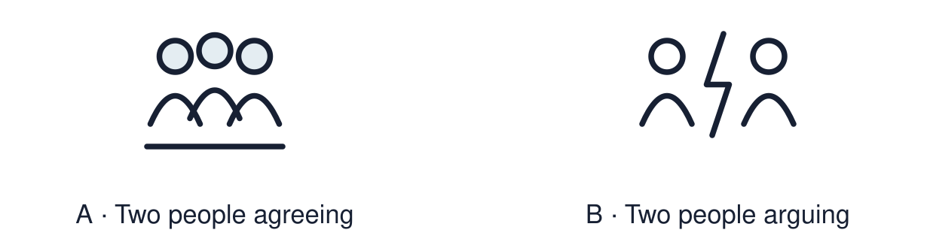
Start with 1 and 2. Try 3 and 4 when ready. Reading and exact scribing are available.

1 What value do Aisha and Tom share
Support: Use the reminder strip or talk it through with an adult.
My response
________________________________________________________________________

2 Which meaning fits peace
Support: Choose: When people are safe and not in conflict OR To let someone join in.
My response
________________________________________________________________________

3 When is the International Day of Peace
Support: Use the model evidence anchor A or read one relevant card together.
My response
________________________________________________________________________

4 Is reflection the same as worship
Support: Give a reason when ready.
My response
________________________________________________________________________
Stretch: use a precise example or explain which detail supports your answer.

Evidence cards
Read, point or listen. Keep the source label with any detail you use.

A The Day of Peace
The United Nations set up the International Day of Peace. It is held every year on 21 September. People around the world think about how to build peace.
Source: Authored summary of the United Nations observance
Limit: A day of peace does not end conflict. It asks people to act.

B Peace starts small
Fictional case: two pupils both want the same seat. They agree to swap each day. A small fair choice keeps the room calm.
Source: Authored classroom case
Limit: This example does not describe every person, family or community.

C Including someone
Fictional case: Rio eats alone at break. Dev asks, “Want to sit with us?” Being included helps Rio feel safe.
Source: Authored classroom case
Limit: This example does not describe every person, family or community.

D Reflection
Reflection is quiet thinking. It is not worship. You can think, draw, or look at a calm picture.
Source: Authored classroom resource
Limit: People reflect in different ways. Silence is one option, not a rule.

Shared investigation
1. Decide whether each action helps build peace.
2. Say who feels safer because of it.
Work with a partner or adult, or use your own table. One person suggests; the other checks the evidence. Swap after one turn. Passing is allowed.

Move or match the cards
Cards to use
Ask someone to sit with you
Leave someone out on purpose
Agree to take turns with the seat

Possible labels: Builds peace / Needs changing
Our explanation
________________________________________________________________________
________________________________________________________________________
________________________________________________________________________
Support: Show two choices. Read one short instruction. Point, match or say a word, then add a reason when ready.
Further challenge: Explain how a small action in one room links to peace in a community.

Supported independent task
Complete this route only. Reflect quietly on belonging and choose one action that helps create peace.
1. Choose a peace symbol or word for your card.
2. Add it to the card template.
3. Point to one action that builds peace.
Support: Show two choices. Read one short instruction. Point, match or say a word, then add a reason when ready. Complete the organiser one space at a time. One action that builds peace is ___ because ___.
My choice or example
________________________________________________________________________
________________________________________________________________________
A detail from the card story or object
________________________________________________________________________
________________________________________________________________________
My reason
________________________________________________________________________
________________________________________________________________________
My check or next step
________________________________________________________________________
________________________________________________________________________
An adult may read or scribe your exact response. They should not choose the answer.

Standard independent task
Complete this route only. Reflect quietly on belonging and choose one action that helps create peace.
1. Create a peace or belonging card with a word, symbol or sentence.
2. Choose one action that builds peace.
3. Say why that action helps.
Support: One action that builds peace is ___ because ___.
My choice or example
________________________________________________________________________
________________________________________________________________________
A detail from the card story or object
________________________________________________________________________
________________________________________________________________________
My reason
________________________________________________________________________
________________________________________________________________________
My check or next step
________________________________________________________________________
________________________________________________________________________
Check the required evidence and revise one detail.

Stretch independent task
Complete this route only. Reflect quietly on belonging and choose one action that helps create peace.
1. Create a peace or belonging card with a short sentence.
2. Choose one action and explain who it helps.
3. Explain how small actions link to peace in a community.
Support: Choose the evidence independently. Use the frame only if it helps.
My choice or example
________________________________________________________________________
________________________________________________________________________
A detail from the card story or object
________________________________________________________________________
________________________________________________________________________
My reason
________________________________________________________________________
________________________________________________________________________
My check or next step
________________________________________________________________________
________________________________________________________________________
Explain how a small action in one room links to peace in a community.

Exit ticket
Choose a response mode. You may give your answers privately to an adult.

When is the International Day of Peace
My response
________________________________________________________________________
________________________________________________________________________
________________________________________________________________________

Is reflection the same as worship
My response
________________________________________________________________________
________________________________________________________________________
________________________________________________________________________
Support: One action that builds peace is ___ because ___.
Further challenge: Explain how a small action in one room links to peace in a community.
One thing I changed or want to check
________________________________________________________________________
________________________________________________________________________

