Retelling a festival story
Learning goal: Retell a festival story in the correct order using symbols or pictures.

Words to use
Word | Meaning
sequence | The order in which things happen
retell | To tell a story again in your own way
Rama | A prince in a story many Hindus tell at Diwali
Sita | Rama’s wife in the story

Remember
What do people do to welcome Rama and Sita home? They light rows of lamps.
Which event comes first in the story? Rama and Sita are sent away to the forest.

How to show your learning
Put four story cards in order.
First ___. Next ___. Then ___. Last ___.

Evidence matters
Fictional cases are teaching examples. Historical, geographical and religious claims use the named sources. A model video demonstrates a method.
This is learning about religion and worldviews, not worship. Nobody is asked to share a personal belief, family detail or loss.
Sources: Hindu American Foundation Diwali

Arrival choices
Previous lesson reminder:
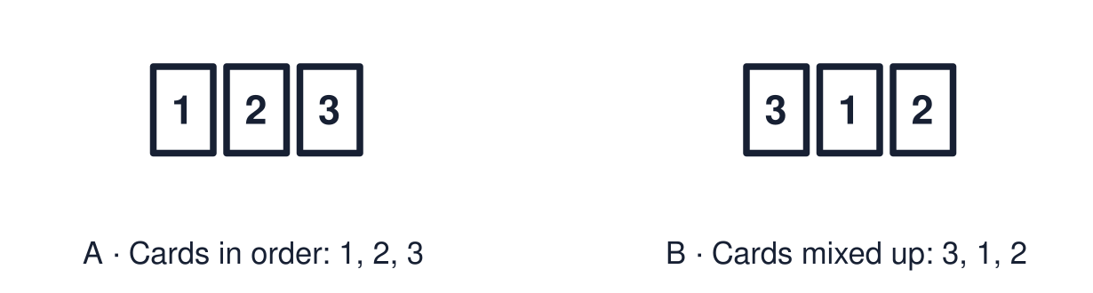
Start with 1 and 2. Try 3 and 4 when ready. Reading and exact scribing are available.

1 Name one thing Diwali and Hanukkah both use
Support: Use the reminder strip or talk it through with an adult.
My response
________________________________________________________________________

2 Which meaning fits sequence
Support: Choose: The order in which things happen OR To tell a story again in your own way.
My response
________________________________________________________________________

3 What do people do to welcome Rama and Sita home
Support: Use the model evidence anchor D or read one relevant card together.
My response
________________________________________________________________________

4 Which event comes first in the story
Support: Give a reason when ready.
My response
________________________________________________________________________
Stretch: use a precise example or explain which detail supports your answer.

Evidence cards
Read, point or listen. Keep the source label with any detail you use.

A Sent away
Easy-read retelling: Prince Rama and his wife Sita are sent away from their home to live in the forest.
Source: Authored retelling of the Rama and Sita story told at Diwali
Limit: This is a short retelling. Longer versions have many more events and names.

B Sita is taken
A demon king called Ravana takes Sita away to his island.
Source: Authored retelling of the Rama and Sita story told at Diwali
Limit: This is a short retelling. Longer versions have many more events and names.

C The rescue
Rama searches for Sita. Hanuman and his army help. Rama defeats Ravana and rescues Sita.
Source: Authored retelling of the Rama and Sita story told at Diwali
Limit: This is a short retelling. Longer versions have many more events and names.

D Lamps light the way
Rama and Sita travel home. People light rows of lamps to welcome them. This is one reason lamps are lit at Diwali.
Source: Authored retelling of the Rama and Sita story told at Diwali
Limit: Not everyone who celebrates Diwali tells this story.

Shared investigation
1. Put the four story cards in order.
2. Retell the story using first, next, then and last.
Work with a partner or adult, or use your own table. One person suggests; the other checks the evidence. Swap after one turn. Passing is allowed.

Move or match the cards
Cards to use
People light lamps to welcome them home
Rama, helped by Hanuman, rescues Sita
Ravana takes Sita away
Rama and Sita are sent away to the forest

Our explanation
________________________________________________________________________
________________________________________________________________________
________________________________________________________________________
Support: Show two choices. Read one short instruction. Point, match or say a word, then add a reason when ready.
Further challenge: Explain how the end of the story links to lighting lamps at Diwali.

Supported independent task
Complete this route only. Retell a festival story in the correct order using symbols or pictures.
1. Put three numbered story cards in order.
2. Point to the first and the last event.
3. Retell using the pre-written captions.
Support: Show two choices. Read one short instruction. Point, match or say a word, then add a reason when ready. Complete the organiser one space at a time. First ___. Next ___. Then ___. Last ___.
First event and date or time cue
________________________________________________________________________
________________________________________________________________________
Next event and date or time cue
________________________________________________________________________
________________________________________________________________________
Later event and date or time cue
________________________________________________________________________
________________________________________________________________________
Why this order fits the evidence
________________________________________________________________________
________________________________________________________________________
An adult may read or scribe your exact response. They should not choose the answer.

Standard independent task
Complete this route only. Retell a festival story in the correct order using symbols or pictures.
1. Put four story cards in order.
2. Retell the story aloud, with labels or with short captions.
3. Use the words first, next, then and last.
Support: First ___. Next ___. Then ___. Last ___.
First event and date or time cue
________________________________________________________________________
________________________________________________________________________
Next event and date or time cue
________________________________________________________________________
________________________________________________________________________
Later event and date or time cue
________________________________________________________________________
________________________________________________________________________
Why this order fits the evidence
________________________________________________________________________
________________________________________________________________________
Check the required evidence and revise one detail.

Stretch independent task
Complete this route only. Retell a festival story in the correct order using symbols or pictures.
1. Put the story cards in order and add your own captions.
2. Retell the story without looking at the cards.
3. Explain how the ending links to Diwali lamps.
Support: Choose the evidence independently. Use the frame only if it helps.
First event and date or time cue
________________________________________________________________________
________________________________________________________________________
Next event and date or time cue
________________________________________________________________________
________________________________________________________________________
Later event and date or time cue
________________________________________________________________________
________________________________________________________________________
Why this order fits the evidence
________________________________________________________________________
________________________________________________________________________
Explain how the end of the story links to lighting lamps at Diwali.

Exit ticket
Choose a response mode. You may give your answers privately to an adult.

What do people do to welcome Rama and Sita home
My response
________________________________________________________________________
________________________________________________________________________
________________________________________________________________________

Which event comes first in the story
My response
________________________________________________________________________
________________________________________________________________________
________________________________________________________________________
Support: First ___. Next ___. Then ___. Last ___.
Further challenge: Explain how the end of the story links to lighting lamps at Diwali.
One thing I changed or want to check
________________________________________________________________________
________________________________________________________________________

