A big question
Learning goal: Give a simple response to a big question using one reason.

Words to use
Word | Meaning
big question | A question about life that has more than one answer
reason | Why you think something
because | A word that joins an answer to its reason
view | What a person thinks about something

Remember
Which word joins an answer to its reason? Because.
Does a big question have only one right answer? No. It has more than one good answer.

How to show your learning
Choose one big question.
I think ___ because ___.

Evidence matters
Fictional cases are teaching examples. Historical, geographical and religious claims use the named sources. A model video demonstrates a method.
This is learning about religion and worldviews, not worship. Nobody is asked to share a personal belief, family detail or loss.
Sources: Humanists UK explanation of Humanism

Arrival choices
Previous lesson reminder:
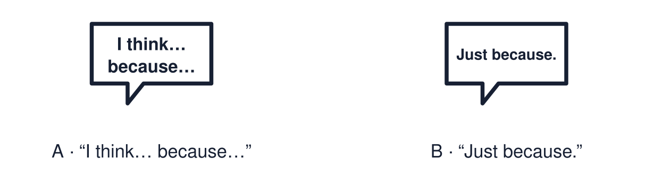
Start with 1 and 2. Try 3 and 4 when ready. Reading and exact scribing are available.

1 What does the red poppy stand for
Support: Use the reminder strip or talk it through with an adult.
My response
________________________________________________________________________

2 Which meaning fits big question
Support: Choose: A question about life that has more than one answer OR Why you think something.
My response
________________________________________________________________________

3 Which word joins an answer to its reason
Support: Use the model evidence anchor C or read one relevant card together.
My response
________________________________________________________________________

4 Does a big question have only one right answer
Support: Give a reason when ready.
My response
________________________________________________________________________
Stretch: use a precise example or explain which detail supports your answer.

Evidence cards
Read, point or listen. Keep the source label with any detail you use.

A Big questions
What makes something special? Why do people celebrate? What helps people feel hope? Big questions have more than one good answer.
Source: Authored classroom resource
Limit: These are three examples. There are many more big questions.

B A weak answer
“Things are special just because.” This gives a view but no reason.
Source: Authored classroom example
Limit: A weak answer can be improved. It is a starting point.

C A stronger answer
“I think an object is special when it reminds you of a person, because the memory matters more than the price.”
Source: Authored classroom example
Limit: A different view with a clear reason is just as strong.

D Different views
A person of faith might say light is special because it reminds them of God. A Humanist might say light is special because it brings people together. Both give a reason.
Source: Authored classroom resource
Limit: These are two examples. People within one worldview also differ.

Shared investigation
1. Decide whether each answer gives a reason.
2. Improve the weak answer together by adding “because”.
Work with a partner or adult, or use your own table. One person suggests; the other checks the evidence. Swap after one turn. Passing is allowed.

Move or match the cards
Cards to use
“Light can mean hope because it helps people see in the dark.”
“I think festivals matter because they bring families together.”
“It just is.”

Possible labels: Gives a reason / Needs a reason
Our explanation
________________________________________________________________________
________________________________________________________________________
________________________________________________________________________
Support: Show two choices. Read one short instruction. Point, match or say a word, then add a reason when ready.
Further challenge: Give a second view that is different from yours and the reason someone might hold it.

Supported independent task
Complete this route only. Give a simple response to a big question using one reason.
1. Choose one big-question card.
2. Choose an answer card from two or three options.
3. Point to or say the reason.
Support: Show two choices. Read one short instruction. Point, match or say a word, then add a reason when ready. Complete the organiser one space at a time. I think ___ because ___.
My choice or example
________________________________________________________________________
________________________________________________________________________
A detail from the card story or object
________________________________________________________________________
________________________________________________________________________
My reason
________________________________________________________________________
________________________________________________________________________
My check or next step
________________________________________________________________________
________________________________________________________________________
An adult may read or scribe your exact response. They should not choose the answer.

Standard independent task
Complete this route only. Give a simple response to a big question using one reason.
1. Choose one big question.
2. Answer using: I think ___ because ___.
3. Check that your reason follows “because”.
Support: I think ___ because ___.
My choice or example
________________________________________________________________________
________________________________________________________________________
A detail from the card story or object
________________________________________________________________________
________________________________________________________________________
My reason
________________________________________________________________________
________________________________________________________________________
My check or next step
________________________________________________________________________
________________________________________________________________________
Check the required evidence and revise one detail.

Stretch independent task
Complete this route only. Give a simple response to a big question using one reason.
1. Answer a big question with a reason.
2. Add a different view and the reason behind it.
3. Say which reason you find stronger and why.
Support: Choose the evidence independently. Use the frame only if it helps.
My choice or example
________________________________________________________________________
________________________________________________________________________
A detail from the card story or object
________________________________________________________________________
________________________________________________________________________
My reason
________________________________________________________________________
________________________________________________________________________
My check or next step
________________________________________________________________________
________________________________________________________________________
Give a second view that is different from yours and the reason someone might hold it.

Exit ticket
Choose a response mode. You may give your answers privately to an adult.

Which word joins an answer to its reason
My response
________________________________________________________________________
________________________________________________________________________
________________________________________________________________________

Does a big question have only one right answer
My response
________________________________________________________________________
________________________________________________________________________
________________________________________________________________________
Support: I think ___ because ___.
Further challenge: Give a second view that is different from yours and the reason someone might hold it.
One thing I changed or want to check
________________________________________________________________________
________________________________________________________________________

