Festival reflection and UAS evidence
Learning goal: Make a simple festival reflection page showing what I have learned.

Words to use
Word | Meaning
reflection | Looking back at what you have learned
evidence | Work that shows what you know or can do
symbol | Something that stands for an idea
meaning | What something stands for or why it matters

Remember
Name one festival symbol and its meaning. For example: a diya stands for hope and good overcoming evil.
What makes evidence strong? It is your own work, it is accurate and you can explain it.

How to show your learning
Add a festival symbol and one meaning.
My symbol is ___. It means ___. I showed respect by ___. I learned ___.

Evidence matters
Fictional cases are teaching examples. Historical, geographical and religious claims use the named sources. A model video demonstrates a method.
This is learning about religion and worldviews, not worship. Nobody is asked to share a personal belief, family detail or loss.
Sources: Hindu American Foundation Diwali; Chabad What is Hanukkah

Arrival choices
Previous lesson reminder:
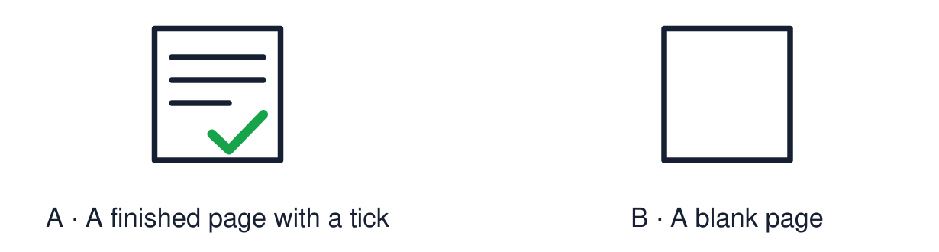
Start with 1 and 2. Try 3 and 4 when ready. Reading and exact scribing are available.

1 Which word joins an answer to its reason
Support: Use the reminder strip or talk it through with an adult.
My response
________________________________________________________________________

2 Which meaning fits reflection
Support: Choose: Looking back at what you have learned OR Work that shows what you know or can do.
My response
________________________________________________________________________

3 Name one festival symbol and its meaning
Support: Use the model evidence anchor B or read one relevant card together.
My response
________________________________________________________________________

4 What makes evidence strong
Support: Give a reason when ready.
My response
________________________________________________________________________
Stretch: use a precise example or explain which detail supports your answer.

Evidence cards
Read, point or listen. Keep the source label with any detail you use.

A The reflection page
Four boxes: a festival symbol, one meaning, one respectful action, one thing I learned.
Source: Authored classroom template
Limit: The page shows a sample of your learning, not all of it.

B A model page
Symbol: diya. Meaning: hope. Respectful action: ask what a symbol means. I learned: Diwali and Hanukkah both use light.
Source: Authored classroom model
Limit: A model shows the layout. Your own choices are what count.

C Evidence this half term
Symbol match, comparison sentence, story sequence, artwork, hope symbol and big-question answer.
Source: Authored classroom resource
Limit: Choose work you can explain. Neat work is not always the strongest evidence.

D Strong evidence
Strong evidence is work you did yourself, that is accurate, and that you can explain.
Source: Authored classroom rules
Limit: An adult note can record what you said or pointed to.

Evidence cards continued
Read, point or listen. Keep the source label with any detail you use.

E1 Assessment source The diya
A diya is a small lamp. Rows of diyas are lit at Diwali. For many people the light stands for good overcoming evil and for hope.
Source: Authored summary; see Hindu American Foundation, Diwali
Limit: A symbol can mean different things to different people.

E2 Assessment source Rangoli
Rangoli are bright patterns made on the floor near the door. Many families make them to welcome guests.
Source: Authored RE summary
Limit: Not every family makes rangoli.

Shared investigation
1. Match each symbol to its meaning.
2. Complete the first box of the reflection page together.
Work with a partner or adult, or use your own table. One person suggests; the other checks the evidence. Swap after one turn. Passing is allowed.

Move or match the cards
Cards to use
Red poppy
Hanukkiah
Diya

Possible labels: Eight nights of light / Hope and good overcoming evil / Remembrance
Our explanation
________________________________________________________________________
________________________________________________________________________
________________________________________________________________________
Support: Show two choices. Read one short instruction. Point, match or say a word, then add a reason when ready.
Further challenge: Explain which piece of evidence is your strongest and why.

Supported independent task
Complete this route only. Make a simple festival reflection page showing what I have learned.
1. Choose a symbol from the picture bank and stick or draw it.
2. Add one meaning word and one respectful action card.
3. Tell an adult one thing you learned. They can write it.
Support: Show two choices. Read one short instruction. Point, match or say a word, then add a reason when ready. Complete the organiser one space at a time. My symbol is ___. It means ___. I showed respect by ___. I learned ___.
My choice or example
________________________________________________________________________
________________________________________________________________________
A detail from the card story or object
________________________________________________________________________
________________________________________________________________________
My reason
________________________________________________________________________
________________________________________________________________________
My check or next step
________________________________________________________________________
________________________________________________________________________
An adult may read or scribe your exact response. They should not choose the answer.

Standard independent task
Complete this route only. Make a simple festival reflection page showing what I have learned.
1. Add a festival symbol and one meaning.
2. Add one respectful action.
3. Write or say one thing you have learned.
Support: My symbol is ___. It means ___. I showed respect by ___. I learned ___.
My choice or example
________________________________________________________________________
________________________________________________________________________
A detail from the card story or object
________________________________________________________________________
________________________________________________________________________
My reason
________________________________________________________________________
________________________________________________________________________
My check or next step
________________________________________________________________________
________________________________________________________________________
Check the required evidence and revise one detail.

Stretch independent task
Complete this route only. Make a simple festival reflection page showing what I have learned.
1. Complete all four boxes in your own words.
2. Link your symbol to a second festival or idea.
3. Choose your strongest evidence and explain the choice.
Support: Choose the evidence independently. Use the frame only if it helps.
My choice or example
________________________________________________________________________
________________________________________________________________________
A detail from the card story or object
________________________________________________________________________
________________________________________________________________________
My reason
________________________________________________________________________
________________________________________________________________________
My check or next step
________________________________________________________________________
________________________________________________________________________
Explain which piece of evidence is your strongest and why.

Exit ticket
Choose a response mode. You may give your answers privately to an adult.

Name one festival symbol and its meaning
My response
________________________________________________________________________
________________________________________________________________________
________________________________________________________________________

What makes evidence strong
My response
________________________________________________________________________
________________________________________________________________________
________________________________________________________________________
Support: My symbol is ___. It means ___. I showed respect by ___. I learned ___.
Further challenge: Explain which piece of evidence is your strongest and why.
One thing I changed or want to check
________________________________________________________________________
________________________________________________________________________

