How beliefs shape identity
Learning goal: Describe one way beliefs can shape a person's identity.

Words to use
Word | Meaning
identity | Who a person is and how they see themselves
influence | To have an effect on something
value | Something a person thinks is important in how to live
choice | A decision between options

Remember
What value does Imran’s belief lead to? Generosity: caring for those in need.
Is belief the only thing that shapes identity? No. Family, friends, place and culture also shape identity.

How to show your learning
Choose one profile.
Belief can shape identity by ___.

Evidence matters
Fictional cases are teaching examples. Historical, geographical and religious claims use the named sources. A model video demonstrates a method.
This is learning about religion and worldviews, not worship. Nobody is asked to share a personal belief, family detail or loss.

Arrival choices
Previous lesson reminder:
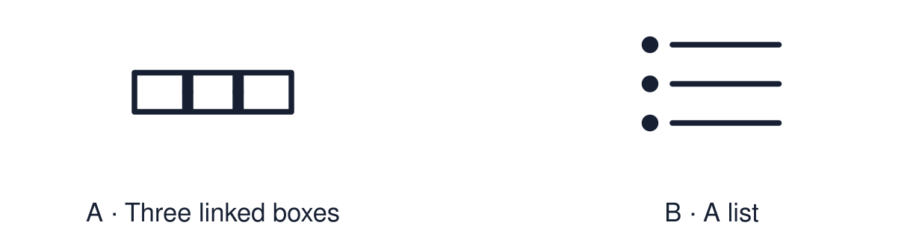
Start with 1 and 2. Try 3 and 4 when ready. Reading and exact scribing are available.

1 Name two different worldviews found in Britain
Support: Use the reminder strip or talk it through with an adult.
My response
________________________________________________________________________

2 Which meaning fits identity
Support: Choose: Who a person is and how they see themselves OR To have an effect on something.
My response
________________________________________________________________________

3 What value does Imran s belief lead to
Support: Use the model evidence anchor A or read one relevant card together.
My response
________________________________________________________________________

4 Is belief the only thing that shapes identity
Support: Give a reason when ready.
My response
________________________________________________________________________
Stretch: use a precise example or explain which detail supports your answer.

Evidence cards
Read, point or listen. Keep the source label with any detail you use.

A Imran’s chain
Fictional profile: Imran believes that God asks people to care for those in need. So he values generosity. So he chooses to help at the food bank each week.
Source: Authored profile
Limit: This is one person's view. Others who share the worldview may describe it differently.

B Ellie’s chain
Fictional profile: Ellie believes this is the one life we have. So she values making a difference now. So she chooses to join a litter pick.
Source: Authored profile
Limit: This is one person's view. Others who share the worldview may describe it differently.

C What shapes identity
Family, friends, place, interests, culture and beliefs can all shape identity. Belief is one influence among many.
Source: Authored classroom resource
Limit: Belief does not fully decide who someone is.

D The chain
Belief → value → choice. Ask: what does the person believe? What do they care about because of it? What do they do?
Source: Authored classroom resource
Limit: Real lives are less tidy than a three-step chain.

Shared investigation
1. Decide whether each statement is a belief, a value or a choice.
2. Highlight the clue that links one step to the next.
Work with a partner or adult, or use your own table. One person suggests; the other checks the evidence. Swap after one turn. Passing is allowed.

Move or match the cards
Cards to use
Helps at the food bank each week
Generosity matters to him
“God asks people to care for those in need.”

Possible labels: Belief / Choice / Value
Our explanation
________________________________________________________________________
________________________________________________________________________
________________________________________________________________________
Support: Read one evidence card together. Highlight a useful detail. Rehearse with: Belief can shape identity by ___.
Further challenge: Explain why two people with the same belief might make different choices.

Supported independent task
Complete this route only. Describe one way beliefs can shape a person's identity.
1. Choose one profile: Imran or Ellie.
2. Put the three chain cards in order: belief, value, choice.
3. Say or finish: Belief can shape identity by ___.
Support: Read one evidence card together. Highlight a useful detail. Rehearse with: Belief can shape identity by ___. Complete the organiser one space at a time. Belief can shape identity by ___.
Cause and supporting detail
________________________________________________________________________
________________________________________________________________________
Event or change
________________________________________________________________________
________________________________________________________________________
Consequence and supporting detail
________________________________________________________________________
________________________________________________________________________
How the links connect
________________________________________________________________________
________________________________________________________________________
An adult may read or scribe your exact response. They should not choose the answer.

Standard independent task
Complete this route only. Describe one way beliefs can shape a person's identity.
1. Choose one profile.
2. Complete the chain: belief → value → choice.
3. Explain one link using the word “so”.
Support: Belief can shape identity by ___.
Cause and supporting detail
________________________________________________________________________
________________________________________________________________________
Event or change
________________________________________________________________________
________________________________________________________________________
Consequence and supporting detail
________________________________________________________________________
________________________________________________________________________
How the links connect
________________________________________________________________________
________________________________________________________________________
Check the required evidence and revise one detail.

Stretch independent task
Complete this route only. Describe one way beliefs can shape a person's identity.
1. Complete the chain for both profiles.
2. Explain one similarity between the two chains.
3. Name one other influence on identity and say how it could change the choice.
Support: Choose the evidence independently. Use the frame only if it helps.
Cause and supporting detail
________________________________________________________________________
________________________________________________________________________
Event or change
________________________________________________________________________
________________________________________________________________________
Consequence and supporting detail
________________________________________________________________________
________________________________________________________________________
How the links connect
________________________________________________________________________
________________________________________________________________________
Explain why two people with the same belief might make different choices.

Exit ticket
Choose a response mode. You may give your answers privately to an adult.

What value does Imran s belief lead to
My response
________________________________________________________________________
________________________________________________________________________
________________________________________________________________________

Is belief the only thing that shapes identity
My response
________________________________________________________________________
________________________________________________________________________
________________________________________________________________________
Support: Belief can shape identity by ___.
Further challenge: Explain why two people with the same belief might make different choices.
One thing I changed or want to check
________________________________________________________________________
________________________________________________________________________

