Hanukkah and the theme of light
Learning goal: Describe how light is used at Hanukkah and explain one meaning it can represent.

Words to use
Word | Meaning
Hanukkah | A Jewish festival of lights that lasts eight nights
menorah | The Hanukkah lamp, also called a hanukkiah, with eight lights and a helper light
Judaism | The religion of Jewish people
rededicate | To make a holy place ready for worship again

Remember
Give one meaning of light at Hanukkah. Remembering the rededication of the Temple, faith or hope.
How many nights does Hanukkah last? Eight nights.

How to show your learning
Answer “What happens?” in one or two sentences.
At Hanukkah people ___. This means ___.

Evidence matters
Fictional cases are teaching examples. Historical, geographical and religious claims use the named sources. A model video demonstrates a method.
This is learning about religion and worldviews, not worship. Nobody is asked to share a personal belief, family detail or loss.
Sources: Chabad What is Hanukkah

Arrival choices
Previous lesson reminder:
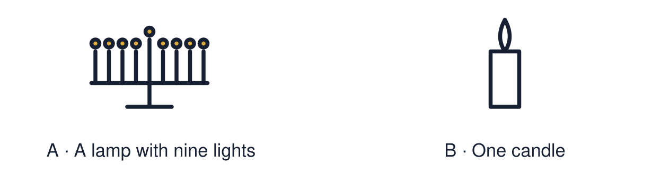
Start with 1 and 2. Try 3 and 4 when ready. Reading and exact scribing are available.

1 Name one thing light can represent at Diwali
Support: Use the reminder strip or talk it through with an adult.
My response
________________________________________________________________________

2 Which meaning fits Hanukkah
Support: Choose: A Jewish festival of lights that lasts eight nights OR The Hanukkah lamp, also called a hanukkiah, with eight lights and a helper light.
My response
________________________________________________________________________

3 Give one meaning of light at Hanukkah
Support: Use the model evidence anchor C,D or read one relevant card together.
My response
________________________________________________________________________

4 How many nights does Hanukkah last
Support: Give a reason when ready.
My response
________________________________________________________________________
Stretch: use a precise example or explain which detail supports your answer.

Evidence cards
Read, point or listen. Keep the source label with any detail you use.

A The Temple
Over 2,000 years ago the Jewish Temple in Jerusalem was taken over and misused by a foreign ruler.
Source: Authored retelling; see Chabad, What is Hanukkah
Limit: This is a short retelling of a longer history.

B The Maccabees
A small group of Jewish fighters, the Maccabees, won the Temple back.
Source: Authored retelling; see Chabad, What is Hanukkah
Limit: This is a short retelling of a longer history.

C The oil
They rededicated the Temple and lit its lamp. Tradition says there was only enough pure oil for one day, but it lasted eight.
Source: Authored retelling; see Chabad, What is Hanukkah
Limit: The oil story is a religious tradition.

D Hanukkah today
Jewish families light one more light each night for eight nights. The lights recall the rededication and stand for faith and hope.
Source: Authored summary; see Chabad, What is Hanukkah
Limit: Jewish families celebrate in different ways.

Shared investigation
1. Put the four story cards in order.
2. Connect the light to remembrance, faith or hope.
Work with a partner or adult, or use your own table. One person suggests; the other checks the evidence. Swap after one turn. Passing is allowed.

Move or match the cards
Cards to use
Families light the menorah for eight nights
The lamp is lit and the oil lasts eight days
The Maccabees win the Temple back
The Temple is taken over and misused

Our explanation
________________________________________________________________________
________________________________________________________________________
________________________________________________________________________
Support: Read one evidence card together. Highlight a useful detail. Rehearse with: At Hanukkah people ___. This means ___.
Further challenge: Compare the meaning of light at Hanukkah with the meaning of light at Diwali.

Supported independent task
Complete this route only. Describe how light is used at Hanukkah and explain one meaning it can represent.
1. Put three story cards in order.
2. Match the menorah picture to one meaning word.
3. Say or finish: The light means ___.
Support: Read one evidence card together. Highlight a useful detail. Rehearse with: At Hanukkah people ___. This means ___. Complete the organiser one space at a time. At Hanukkah people ___. This means ___.
First event and date or time cue
________________________________________________________________________
________________________________________________________________________
Next event and date or time cue
________________________________________________________________________
________________________________________________________________________
Later event and date or time cue
________________________________________________________________________
________________________________________________________________________
Why this order fits the evidence
________________________________________________________________________
________________________________________________________________________
An adult may read or scribe your exact response. They should not choose the answer.

Standard independent task
Complete this route only. Describe how light is used at Hanukkah and explain one meaning it can represent.
1. Answer “What happens?” in one or two sentences.
2. Answer “What does it mean?” using faith, hope or remembrance.
3. Check your answer against card D.
Support: At Hanukkah people ___. This means ___.
First event and date or time cue
________________________________________________________________________
________________________________________________________________________
Next event and date or time cue
________________________________________________________________________
________________________________________________________________________
Later event and date or time cue
________________________________________________________________________
________________________________________________________________________
Why this order fits the evidence
________________________________________________________________________
________________________________________________________________________
Check the required evidence and revise one detail.

Stretch independent task
Complete this route only. Describe how light is used at Hanukkah and explain one meaning it can represent.
1. Answer both questions in your own words.
2. Explain why one more light is added each night.
3. Compare one meaning of light with Diwali.
Support: Choose the evidence independently. Use the frame only if it helps.
First event and date or time cue
________________________________________________________________________
________________________________________________________________________
Next event and date or time cue
________________________________________________________________________
________________________________________________________________________
Later event and date or time cue
________________________________________________________________________
________________________________________________________________________
Why this order fits the evidence
________________________________________________________________________
________________________________________________________________________
Compare the meaning of light at Hanukkah with the meaning of light at Diwali.

Exit ticket
Choose a response mode. You may give your answers privately to an adult.

Give one meaning of light at Hanukkah
My response
________________________________________________________________________
________________________________________________________________________
________________________________________________________________________

How many nights does Hanukkah last
My response
________________________________________________________________________
________________________________________________________________________
________________________________________________________________________
Support: At Hanukkah people ___. This means ___.
Further challenge: Compare the meaning of light at Hanukkah with the meaning of light at Diwali.
One thing I changed or want to check
________________________________________________________________________
________________________________________________________________________

