Remembrance and shared values
Learning goal: Explain one shared value connected to remembrance and respect.

Words to use
Word | Meaning
remembrance | Taking time to remember people and events
gratitude | Being thankful
shared value | Something that people of different worldviews agree is important
reflection | Quiet thinking about something that matters

Remember
Name one value that Ruth and Dan share. Respect, gratitude or hope for peace.
Do people have to be religious to take part in remembrance? No. People of all worldviews remember.

How to show your learning
Create a remembrance reflection using words or symbols.
One shared value is ___. It matters because ___.

Evidence matters
Fictional cases are teaching examples. Historical, geographical and religious claims use the named sources. A model video demonstrates a method.
This is learning about religion and worldviews, not worship. Nobody is asked to share a personal belief, family detail or loss.
Sources: Royal British Legion The poppy; Humanists UK explanation of Humanism

Arrival choices
Previous lesson reminder:
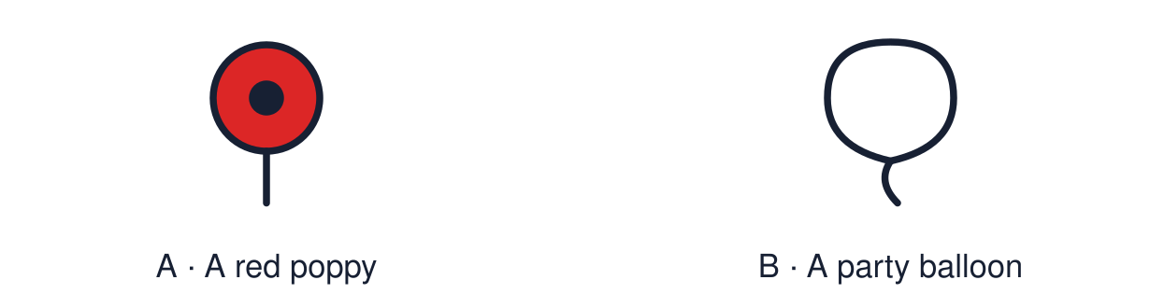
Start with 1 and 2. Try 3 and 4 when ready. Reading and exact scribing are available.

1 Give one similarity between two festivals of light
Support: Use the reminder strip or talk it through with an adult.
My response
________________________________________________________________________

2 Which meaning fits remembrance
Support: Choose: Taking time to remember people and events OR Being thankful.
My response
________________________________________________________________________

3 Name one value that Ruth and Dan share
Support: Use the model evidence anchor B,C or read one relevant card together.
My response
________________________________________________________________________

4 Do people have to be religious to take part in remembrance
Support: Give a reason when ready.
My response
________________________________________________________________________
Stretch: use a precise example or explain which detail supports your answer.

Evidence cards
Read, point or listen. Keep the source label with any detail you use.

A Remembrance in the UK
On 11 November and Remembrance Sunday many people keep two minutes of silence and wear a poppy to remember people who died in wars.
Source: Authored summary; see Royal British Legion, The poppy
Limit: Wearing a poppy is a personal choice. People hold different views.

B A religious response
Fictional profile: Ruth is Christian. At her church service people pray for peace and read out names from the village memorial.
Source: Authored profile
Limit: This is one person's view. Others who share the worldview may describe it differently.

C A non-religious response
Fictional profile: Dan is a Humanist. He stands in silence at the town memorial and thinks about how to prevent war.
Source: Authored profile
Limit: This is one person's view. Others who share the worldview may describe it differently.

D Shared values
Ruth and Dan believe different things. Both show respect, gratitude and a hope for peace.
Source: Authored classroom resource
Limit: Sharing values does not make two worldviews the same.

Shared investigation
1. Inspect each card, then match each action to a value.
2. Name a value that Ruth and Dan share.
Work with a partner or adult, or use your own table. One person suggests; the other checks the evidence. Swap after one turn. Passing is allowed.

Move or match the cards
Cards to use
Keeping two minutes of silence
Thinking about how to prevent war
Reading out the names on a memorial

Possible labels: Gratitude and respect / Peace / Respect
Our explanation
________________________________________________________________________
________________________________________________________________________
________________________________________________________________________
Support: Read one evidence card together. Highlight a useful detail. Rehearse with: One shared value is ___. It matters because ___.
Further challenge: Explain how a religious and a non-religious person can share a value for different reasons.

Supported independent task
Complete this route only. Explain one shared value connected to remembrance and respect.
1. Choose one value card: respect, gratitude or peace.
2. Add a symbol or word to the reflection sheet.
3. Say why it matters, or point to the reason card.
Support: Read one evidence card together. Highlight a useful detail. Rehearse with: One shared value is ___. It matters because ___. Complete the organiser one space at a time. One shared value is ___. It matters because ___.
Source label and origin
________________________________________________________________________
________________________________________________________________________
A detail I can point to
________________________________________________________________________
________________________________________________________________________
What this detail helps me explain
________________________________________________________________________
________________________________________________________________________
What I still need to check
________________________________________________________________________
________________________________________________________________________
An adult may read or scribe your exact response. They should not choose the answer.

Standard independent task
Complete this route only. Explain one shared value connected to remembrance and respect.
1. Create a remembrance reflection using words or symbols.
2. Name one shared value.
3. Explain why it matters.
Support: One shared value is ___. It matters because ___.
Source label and origin
________________________________________________________________________
________________________________________________________________________
A detail I can point to
________________________________________________________________________
________________________________________________________________________
What this detail helps me explain
________________________________________________________________________
________________________________________________________________________
What I still need to check
________________________________________________________________________
________________________________________________________________________
Check the required evidence and revise one detail.

Stretch independent task
Complete this route only. Explain one shared value connected to remembrance and respect.
1. Create a reflection that names a shared value.
2. Explain how Ruth and Dan each show it.
3. Explain why shared values help a community.
Support: Choose the evidence independently. Use the frame only if it helps.
Source label and origin
________________________________________________________________________
________________________________________________________________________
A detail I can point to
________________________________________________________________________
________________________________________________________________________
What this detail helps me explain
________________________________________________________________________
________________________________________________________________________
What I still need to check
________________________________________________________________________
________________________________________________________________________
Explain how a religious and a non-religious person can share a value for different reasons.

Exit ticket
Choose a response mode. You may give your answers privately to an adult.

Name one value that Ruth and Dan share
My response
________________________________________________________________________
________________________________________________________________________
________________________________________________________________________

Do people have to be religious to take part in remembrance
My response
________________________________________________________________________
________________________________________________________________________
________________________________________________________________________
Support: One shared value is ___. It matters because ___.
Further challenge: Explain how a religious and a non-religious person can share a value for different reasons.
One thing I changed or want to check
________________________________________________________________________
________________________________________________________________________

