Belonging across faiths
Learning goal: Describe what belonging can mean in two faith or worldview communities.

Words to use
Word | Meaning
belonging | Feeling part of a group and welcome in it
faith community | People who share a religion and meet together
practice | Something people do as part of their beliefs
support | Help given to someone

Remember
Give one way a faith community can support belonging. For example, sharing a meal, praying together or serving others.
Does everyone in a faith community feel belonging in the same way? No. Belonging varies between individuals.

How to show your learning
Complete the map for both profiles using the four lenses.
In ___ community, belonging can mean ___.

Evidence matters
Fictional cases are teaching examples. Historical, geographical and religious claims use the named sources. A model video demonstrates a method.
This is learning about religion and worldviews, not worship. Nobody is asked to share a personal belief, family detail or loss.
Sources: Sikh Coalition introduction to Sikh beliefs and practice

Arrival choices
You can begin without previous learning. Word help: belonging means feeling part of a group and welcome in it.
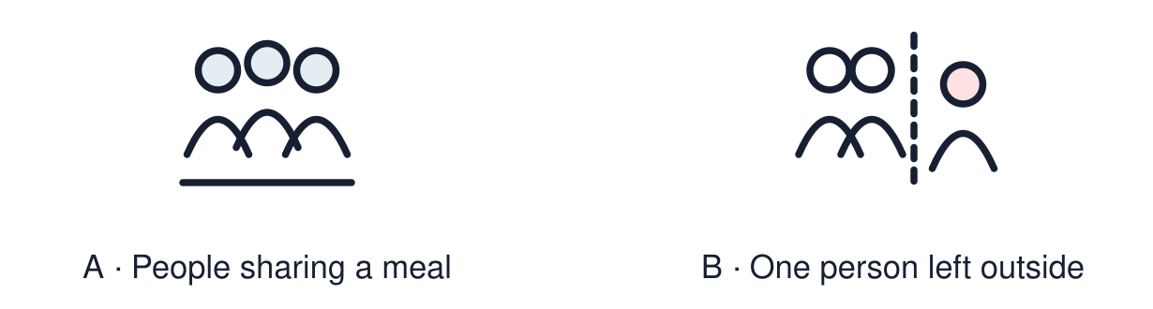
Start with 1 and 2. Try 3 and 4 when ready. Reading and exact scribing are available.

1 What does belonging mean
Support: Use the reminder strip or talk it through with an adult.
My response
________________________________________________________________________

2 Which meaning fits belonging
Support: Choose: Feeling part of a group and welcome in it OR People who share a religion and meet together.
My response
________________________________________________________________________

3 Give one way a faith community can support belonging
Support: Use the model evidence anchor A or read one relevant card together.
My response
________________________________________________________________________

4 Does everyone in a faith community feel belonging in the same way
Support: Give a reason when ready.
My response
________________________________________________________________________
Stretch: use a precise example or explain which detail supports your answer.

Evidence cards
Read, point or listen. Keep the source label with any detail you use.

A Simran
Fictional profile: Simran is Sikh. At the gurdwara she helps serve langar, a free meal for anyone. She says serving others makes her feel part of something.
Source: Authored profile
Limit: This is one person's view. Others who share the worldview may describe it differently.

B Yusuf
Fictional profile: Yusuf is Muslim. At Friday prayers he stands shoulder to shoulder with others. During Ramadan the community breaks the fast together.
Source: Authored profile
Limit: This is one person's view. Others who share the worldview may describe it differently.

C Four lenses
People: who is there? Place: where do they meet? Practice: what do they do? Values: what matters to them?
Source: Authored classroom resource
Limit: Four lenses are a starting point, not the whole picture.

D Belonging varies
Some people feel they belong strongly to a faith community. Others belong in quieter ways, or to several communities.
Source: Authored classroom resource
Limit: Belonging is personal and can change.

Shared investigation
1. Sort each detail: Simran’s community, Yusuf’s community or both.
2. Use the four lenses: people, place, practice, values.
Work with a partner or adult, or use your own table. One person suggests; the other checks the evidence. Swap after one turn. Passing is allowed.

Move or match the cards
Cards to use
Shared food brings people together
Breaking the fast together in Ramadan
Serving langar to anyone who comes

Possible labels: Both / Simran’s community / Yusuf’s community
Our explanation
________________________________________________________________________
________________________________________________________________________
________________________________________________________________________
Support: Read one evidence card together. Highlight a useful detail. Rehearse with: In ___ community, belonging can mean ___.
Further challenge: Explain how a shared practice can build belonging better than words alone.

Supported independent task
Complete this route only. Describe what belonging can mean in two faith or worldview communities.
1. Choose one profile.
2. Fill in two lenses: place and practice.
3. Say or finish: Belonging can mean ___.
Support: Read one evidence card together. Highlight a useful detail. Rehearse with: In ___ community, belonging can mean ___. Complete the organiser one space at a time. In ___ community, belonging can mean ___.
My choice or example
________________________________________________________________________
________________________________________________________________________
A detail from the card story or object
________________________________________________________________________
________________________________________________________________________
My reason
________________________________________________________________________
________________________________________________________________________
My check or next step
________________________________________________________________________
________________________________________________________________________
An adult may read or scribe your exact response. They should not choose the answer.

Standard independent task
Complete this route only. Describe what belonging can mean in two faith or worldview communities.
1. Complete the map for both profiles using the four lenses.
2. Find one similarity.
3. Finish: In ___ community, belonging can mean ___.
Support: In ___ community, belonging can mean ___.
My choice or example
________________________________________________________________________
________________________________________________________________________
A detail from the card story or object
________________________________________________________________________
________________________________________________________________________
My reason
________________________________________________________________________
________________________________________________________________________
My check or next step
________________________________________________________________________
________________________________________________________________________
Check the required evidence and revise one detail.

Stretch independent task
Complete this route only. Describe what belonging can mean in two faith or worldview communities.
1. Complete the map for both profiles.
2. Explain one similarity and one difference.
3. Explain why belonging varies between individuals.
Support: Choose the evidence independently. Use the frame only if it helps.
My choice or example
________________________________________________________________________
________________________________________________________________________
A detail from the card story or object
________________________________________________________________________
________________________________________________________________________
My reason
________________________________________________________________________
________________________________________________________________________
My check or next step
________________________________________________________________________
________________________________________________________________________
Explain how a shared practice can build belonging better than words alone.

Exit ticket
Choose a response mode. You may give your answers privately to an adult.

Give one way a faith community can support belonging
My response
________________________________________________________________________
________________________________________________________________________
________________________________________________________________________

Does everyone in a faith community feel belonging in the same way
My response
________________________________________________________________________
________________________________________________________________________
________________________________________________________________________
Support: In ___ community, belonging can mean ___.
Further challenge: Explain how a shared practice can build belonging better than words alone.
One thing I changed or want to check
________________________________________________________________________
________________________________________________________________________

