Big question: do beliefs make us who we are?
Learning goal: Discuss a big question about identity respectfully and give a reason for a viewpoint.

Words to use
Word | Meaning
viewpoint | What a person thinks about a question
reason | Why you think something
evidence | An example or fact that supports a reason
depends | When the answer changes with the situation

Remember
Give one respectful discussion phrase. For example: “I see your point, but…”.
Is “it depends” an acceptable answer? Yes, when it comes with a reason.

How to show your learning
State your viewpoint on the big question.
I think ___ because ___. For example, ___.

Evidence matters
Fictional cases are teaching examples. Historical, geographical and religious claims use the named sources. A model video demonstrates a method.
This is learning about religion and worldviews, not worship. Nobody is asked to share a personal belief, family detail or loss.

Arrival choices
Previous lesson reminder:
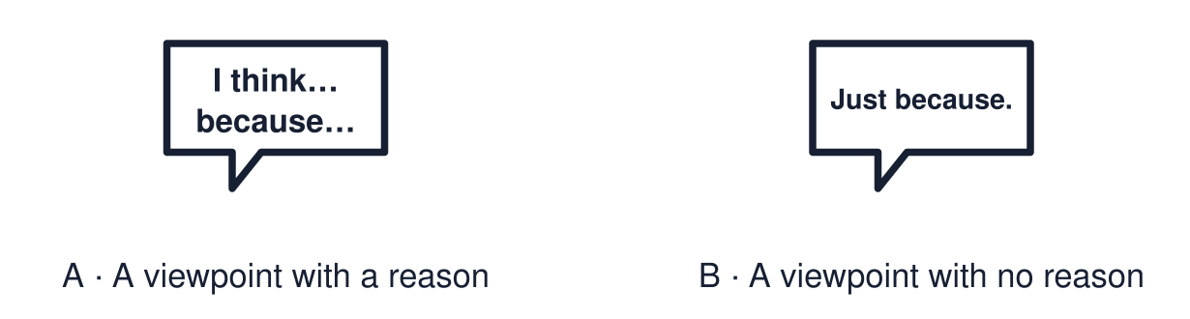
Start with 1 and 2. Try 3 and 4 when ready. Reading and exact scribing are available.

1 Define the word ritual
Support: Use the reminder strip or talk it through with an adult.
My response
________________________________________________________________________

2 Which meaning fits viewpoint
Support: Choose: What a person thinks about a question OR Why you think something.
My response
________________________________________________________________________

3 Give one respectful discussion phrase
Support: Use the model evidence anchor D or read one relevant card together.
My response
________________________________________________________________________

4 Is it depends an acceptable answer
Support: Give a reason when ready.
My response
________________________________________________________________________
Stretch: use a precise example or explain which detail supports your answer.

Evidence cards
Read, point or listen. Keep the source label with any detail you use.

A The big question
Do beliefs make us who we are?
Source: Authored classroom resource
Limit: A big question has more than one good answer.

B Agree
“Yes. Imran’s belief leads to his values and his choices, so it shapes who he is.”
Source: Authored classroom example
Limit: This uses one profile as evidence.

C Disagree
“No. Family, friends and place shape people too. Two people with the same belief can be very different.”
Source: Authored classroom example
Limit: This is one view with a reason.

D Discussion phrases
“I see your point, but…” · “I agree because…” · “It depends on…” · “Can you give an example?”
Source: Authored classroom rules
Limit: Phrases help, but tone matters too.

Shared investigation
1. Decide whether each reply disagrees respectfully.
2. Justify one decision.
Work with a partner or adult, or use your own table. One person suggests; the other checks the evidence. Swap after one turn. Passing is allowed.

Move or match the cards
Cards to use
“It depends. Can you give an example?”
“That’s a stupid thing to say.”
“I see your point, but family matters too.”

Possible labels: Needs changing / Respectful
Our explanation
________________________________________________________________________
________________________________________________________________________
________________________________________________________________________
Support: Read one evidence card together. Highlight a useful detail. Rehearse with: I think ___ because ___. For example, ___.
Further challenge: Give the strongest reason against your own view.

Supported independent task
Complete this route only. Discuss a big question about identity respectfully and give a reason for a viewpoint.
1. Place your card: agree, disagree or depends.
2. Choose a reason card that fits.
3. Say or finish: I think ___ because ___.
Support: Read one evidence card together. Highlight a useful detail. Rehearse with: I think ___ because ___. For example, ___. Complete the organiser one space at a time. I think ___ because ___. For example, ___.
My choice or example
________________________________________________________________________
________________________________________________________________________
A detail from the card story or object
________________________________________________________________________
________________________________________________________________________
My reason
________________________________________________________________________
________________________________________________________________________
My check or next step
________________________________________________________________________
________________________________________________________________________
An adult may read or scribe your exact response. They should not choose the answer.

Standard independent task
Complete this route only. Discuss a big question about identity respectfully and give a reason for a viewpoint.
1. State your viewpoint on the big question.
2. Give one reason.
3. Add an example from a profile.
Support: I think ___ because ___. For example, ___.
My choice or example
________________________________________________________________________
________________________________________________________________________
A detail from the card story or object
________________________________________________________________________
________________________________________________________________________
My reason
________________________________________________________________________
________________________________________________________________________
My check or next step
________________________________________________________________________
________________________________________________________________________
Check the required evidence and revise one detail.

Stretch independent task
Complete this route only. Discuss a big question about identity respectfully and give a reason for a viewpoint.
1. State your viewpoint with a reason and an example.
2. Give the strongest reason against your view.
3. Reply to it respectfully.
Support: Choose the evidence independently. Use the frame only if it helps.
My choice or example
________________________________________________________________________
________________________________________________________________________
A detail from the card story or object
________________________________________________________________________
________________________________________________________________________
My reason
________________________________________________________________________
________________________________________________________________________
My check or next step
________________________________________________________________________
________________________________________________________________________
Give the strongest reason against your own view.

Exit ticket
Choose a response mode. You may give your answers privately to an adult.

Give one respectful discussion phrase
My response
________________________________________________________________________
________________________________________________________________________
________________________________________________________________________

Is it depends an acceptable answer
My response
________________________________________________________________________
________________________________________________________________________
________________________________________________________________________
Support: I think ___ because ___. For example, ___.
Further challenge: Give the strongest reason against your own view.
One thing I changed or want to check
________________________________________________________________________
________________________________________________________________________

