Personal values and respect for others
Learning goal: Identify a value that matters to a person and explain how respecting different values supports community.

Words to use
Word | Meaning
value | Something a person thinks is important in how to live
priority | What a person puts first
tolerance | Accepting that others may think and live differently
respect | Treating people with care, even when you disagree

Remember
Give one way to show respect when values differ. For example, accept their choice without mocking it.
Does respect mean you have to agree? No. Respect does not require agreement.

How to show your learning
Identify the value that matters to each person.
___ values ___. One way to show respect is ___.

Evidence matters
Fictional cases are teaching examples. Historical, geographical and religious claims use the named sources. A model video demonstrates a method.
This is learning about religion and worldviews, not worship. Nobody is asked to share a personal belief, family detail or loss.

Arrival choices
Previous lesson reminder:
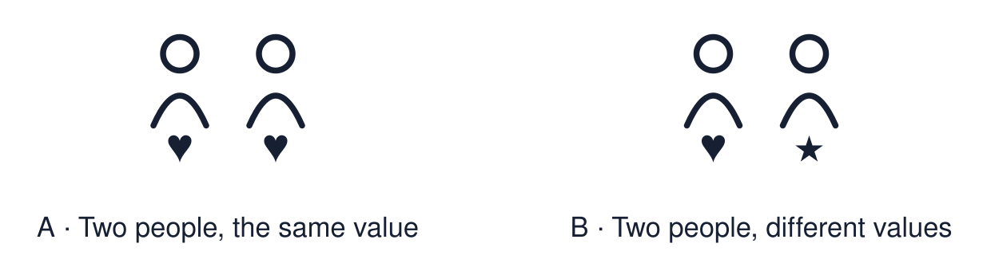
Start with 1 and 2. Try 3 and 4 when ready. Reading and exact scribing are available.

1 Give one respectful question stem
Support: Use the reminder strip or talk it through with an adult.
My response
________________________________________________________________________

2 Which meaning fits value
Support: Choose: Something a person thinks is important in how to live OR What a person puts first.
My response
________________________________________________________________________

3 Give one way to show respect when values differ
Support: Use the model evidence anchor B or read one relevant card together.
My response
________________________________________________________________________

4 Does respect mean you have to agree
Support: Give a reason when ready.
My response
________________________________________________________________________
Stretch: use a precise example or explain which detail supports your answer.

Evidence cards
Read, point or listen. Keep the source label with any detail you use.

A Two priorities
Fictional case: Aaliyah puts family first and leaves a club early for a family meal. Ben puts commitment first and stays to the end. Neither is wrong.
Source: Authored classroom case
Limit: This example does not describe every person, family or community.

B A respectful response
Ben says, “See you next week. Hope the meal is good.” He respects a value he does not share.
Source: Authored classroom case
Limit: This example does not describe every person, family or community.

C A disrespectful response
A team-mate says, “You’re letting us down for a dinner?” This mocks Aaliyah’s value.
Source: Authored classroom case
Limit: This example does not describe every person, family or community.

D Respect is not agreement
You can respect a person’s right to their values without agreeing. Respect has limits: it never means accepting harm.
Source: Authored classroom rules
Limit: Hard cases need a trusted adult, not a slogan.

Shared investigation
1. Decide whether each response shows respect.
2. Rewrite one response that needs changing.
Work with a partner or adult, or use your own table. One person suggests; the other checks the evidence. Swap after one turn. Passing is allowed.

Move or match the cards
Cards to use
“I’d have stayed, but I get why you’re going.”
“You’re letting us down for a dinner?”
“See you next week. Hope the meal is good.”

Possible labels: Needs changing / Respectful
Our explanation
________________________________________________________________________
________________________________________________________________________
________________________________________________________________________
Support: Read one evidence card together. Highlight a useful detail. Rehearse with: ___ values ___. One way to show respect is ___.
Further challenge: Explain why respecting someone’s values is different from agreeing with them.

Supported independent task
Complete this route only. Identify a value that matters to a person and explain how respecting different values supports community.
1. Read the scenario with an adult.
2. Choose the value card for each person.
3. Point to the respectful response.
Support: Read one evidence card together. Highlight a useful detail. Rehearse with: ___ values ___. One way to show respect is ___. Complete the organiser one space at a time. ___ values ___. One way to show respect is ___.
My choice or example
________________________________________________________________________
________________________________________________________________________
A detail from the card story or object
________________________________________________________________________
________________________________________________________________________
My reason
________________________________________________________________________
________________________________________________________________________
My check or next step
________________________________________________________________________
________________________________________________________________________
An adult may read or scribe your exact response. They should not choose the answer.

Standard independent task
Complete this route only. Identify a value that matters to a person and explain how respecting different values supports community.
1. Identify the value that matters to each person.
2. Choose or write a respectful response.
3. Explain how it supports the community.
Support: ___ values ___. One way to show respect is ___.
My choice or example
________________________________________________________________________
________________________________________________________________________
A detail from the card story or object
________________________________________________________________________
________________________________________________________________________
My reason
________________________________________________________________________
________________________________________________________________________
My check or next step
________________________________________________________________________
________________________________________________________________________
Check the required evidence and revise one detail.

Stretch independent task
Complete this route only. Identify a value that matters to a person and explain how respecting different values supports community.
1. Identify both values and the clash.
2. Write a respectful response that still disagrees.
3. Explain one limit to tolerance.
Support: Choose the evidence independently. Use the frame only if it helps.
My choice or example
________________________________________________________________________
________________________________________________________________________
A detail from the card story or object
________________________________________________________________________
________________________________________________________________________
My reason
________________________________________________________________________
________________________________________________________________________
My check or next step
________________________________________________________________________
________________________________________________________________________
Explain why respecting someone’s values is different from agreeing with them.

Exit ticket
Choose a response mode. You may give your answers privately to an adult.

Give one way to show respect when values differ
My response
________________________________________________________________________
________________________________________________________________________
________________________________________________________________________

Does respect mean you have to agree
My response
________________________________________________________________________
________________________________________________________________________
________________________________________________________________________
Support: ___ values ___. One way to show respect is ___.
Further challenge: Explain why respecting someone’s values is different from agreeing with them.
One thing I changed or want to check
________________________________________________________________________
________________________________________________________________________

