Sources of authority and meaning
Learning goal: Recognise a source of authority or meaning and explain how it may guide a believer or non- religious person.

Words to use
Word | Meaning
authority | A source people trust to guide what they believe or do
sacred text | Writing that is holy to a religion, such as the Bible or the Qur’an
conscience | A person’s inner sense of right and wrong
tradition | Beliefs and practices passed down over time

Remember
Define “authority” in RE. A source people trust to guide what they believe or do.
Is authority in RE the same as being in charge? No. It is a trusted source of guidance.

How to show your learning
Choose one scenario.
___ may guide them because ___.

Evidence matters
Fictional cases are teaching examples. Historical, geographical and religious claims use the named sources. A model video demonstrates a method.
This is learning about religion and worldviews, not worship. Nobody is asked to share a personal belief, family detail or loss.

Arrival choices
Previous lesson reminder:
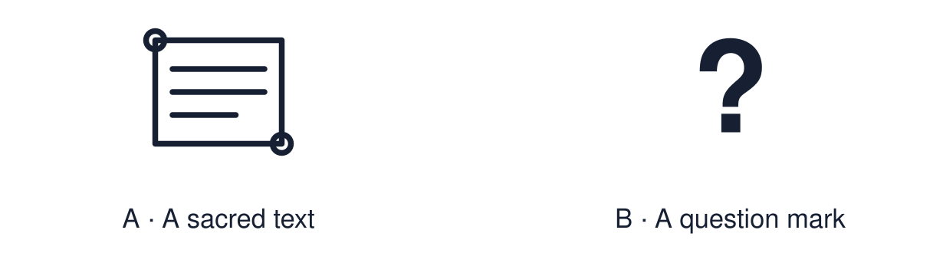
Start with 1 and 2. Try 3 and 4 when ready. Reading and exact scribing are available.

1 Name one belief from each worldview
Support: Use the reminder strip or talk it through with an adult.
My response
________________________________________________________________________

2 Which meaning fits authority
Support: Choose: A source people trust to guide what they believe or do OR Writing that is holy to a religion, such as the Bible or the Qur’an.
My response
________________________________________________________________________

3 Define authority in RE
Support: Use the model evidence anchor C or read one relevant card together.
My response
________________________________________________________________________

4 Is authority in RE the same as being in charge
Support: Give a reason when ready.
My response
________________________________________________________________________
Stretch: use a precise example or explain which detail supports your answer.

Evidence cards
Read, point or listen. Keep the source label with any detail you use.

A Religious sources
Many believers turn to sacred texts, religious leaders such as a priest, imam or rabbi, and the traditions of their community.
Source: Authored RE summary
Limit: Belief and practice vary between individuals and communities.

B Non-religious sources
Many non-religious people turn to reason, evidence, conscience and the experience of people they trust.
Source: Authored RE summary
Limit: Religious people use reason and conscience too.

C Authority is not “being in charge”
A boss can give orders. An authority in RE is a source a person chooses to trust for guidance.
Source: Authored classroom resource
Limit: People can question an authority and still respect it.

D Scenarios
Amira must decide whether to report a friend who is stealing at work. Joe must decide whether to take a job that means working every Sunday.
Source: Authored classroom case
Limit: This example does not describe every person, family or community.

Shared investigation
1. Match each fictional decision to a source the person might turn to.
2. Explain why that source could guide them.
Work with a partner or adult, or use your own table. One person suggests; the other checks the evidence. Swap after one turn. Passing is allowed.

Move or match the cards
Cards to use
Priya weighs the likely consequences for everyone
Joe talks it through with his priest
Amira reads what the Qur’an says about honesty

Possible labels: Reason / Religious leader / Sacred text
Our explanation
________________________________________________________________________
________________________________________________________________________
________________________________________________________________________
Support: Use the glossary and one chunk of evidence. Plan the claim and supporting detail before explaining.
Further challenge: Explain what a person might do when two sources of authority disagree.

Supported independent task
Complete this route only. Recognise a source of authority or meaning and explain how it may guide a believer or non- religious person.
1. Choose one scenario and listen to it read aloud.
2. Choose the source from two or three options.
3. Say or finish: ___ may guide them because ___.
Support: Use the glossary and one chunk of evidence. Plan the claim and supporting detail before explaining. Complete the organiser one space at a time. ___ may guide them because ___.
My choice or example
________________________________________________________________________
________________________________________________________________________
A detail from the card story or object
________________________________________________________________________
________________________________________________________________________
My reason
________________________________________________________________________
________________________________________________________________________
My check or next step
________________________________________________________________________
________________________________________________________________________
An adult may read or scribe your exact response. They should not choose the answer.

Standard independent task
Complete this route only. Recognise a source of authority or meaning and explain how it may guide a believer or non- religious person.
1. Choose one scenario.
2. Explain which source might guide the person.
3. Explain why, using the word “authority”.
Support: ___ may guide them because ___.
My choice or example
________________________________________________________________________
________________________________________________________________________
A detail from the card story or object
________________________________________________________________________
________________________________________________________________________
My reason
________________________________________________________________________
________________________________________________________________________
My check or next step
________________________________________________________________________
________________________________________________________________________
Check the required evidence and revise one detail.

Stretch independent task
Complete this route only. Recognise a source of authority or meaning and explain how it may guide a believer or non- religious person.
1. Choose one scenario and two possible sources.
2. Explain how each might guide the person.
3. Explain what they could do if the sources disagree.
Support: Choose the evidence independently. Use the frame only if it helps.
My choice or example
________________________________________________________________________
________________________________________________________________________
A detail from the card story or object
________________________________________________________________________
________________________________________________________________________
My reason
________________________________________________________________________
________________________________________________________________________
My check or next step
________________________________________________________________________
________________________________________________________________________
Explain what a person might do when two sources of authority disagree.

Exit ticket
Choose a response mode. You may give your answers privately to an adult.

Define authority in RE
My response
________________________________________________________________________
________________________________________________________________________
________________________________________________________________________

Is authority in RE the same as being in charge
My response
________________________________________________________________________
________________________________________________________________________
________________________________________________________________________
Support: ___ may guide them because ___.
Further challenge: Explain what a person might do when two sources of authority disagree.
One thing I changed or want to check
________________________________________________________________________
________________________________________________________________________

