Festivals, shared values and the Day of Peace
Learning goal: Explain how a festival or shared value can bring people together and identify one value linked to peace.

Words to use
Word | Meaning
shared value | Something people of different worldviews agree is important
peace | When people are safe and conflicts are settled without violence
symbol | Something that stands for an idea
community | People linked by a place, belief or activity

Remember
Name one value shared across two worldviews. For example, peace, welcome or dialogue.
Is the Day of Peace only for religious people? No. It is for everyone.

How to show your learning
Create a “Peace in Practice” response.
The value of ___ can lead to ___. This builds peace because ___.

Evidence matters
Fictional cases are teaching examples. Historical, geographical and religious claims use the named sources. A model video demonstrates a method.
This is learning about religion and worldviews, not worship. Nobody is asked to share a personal belief, family detail or loss.
Sources: Humanists UK explanation of Humanism; United Nations International Day of Peace

Arrival choices
Previous lesson reminder:
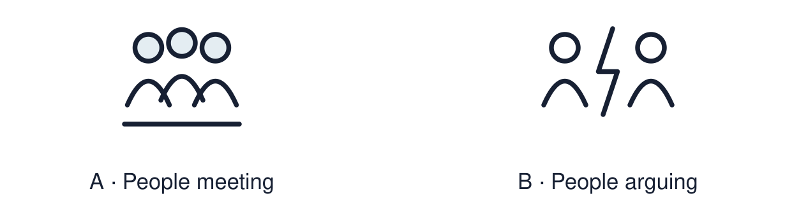
Start with 1 and 2. Try 3 and 4 when ready. Reading and exact scribing are available.

1 Define authority in RE
Support: Use the reminder strip or talk it through with an adult.
My response
________________________________________________________________________

2 Which meaning fits shared value
Support: Choose: Something people of different worldviews agree is important OR When people are safe and conflicts are settled without violence.
My response
________________________________________________________________________

3 Name one value shared across two worldviews
Support: Use the model evidence anchor B,C or read one relevant card together.
My response
________________________________________________________________________

4 Is the Day of Peace only for religious people
Support: Give a reason when ready.
My response
________________________________________________________________________
Stretch: use a precise example or explain which detail supports your answer.

Evidence cards
Read, point or listen. Keep the source label with any detail you use.

A The Day of Peace
The United Nations International Day of Peace is held on 21 September each year. It invites everyone, of any worldview, to act for peace.
Source: Authored summary of the United Nations observance
Limit: A day of peace does not end conflict. It asks people to act.

B A Christian example
Jesus taught “Blessed are the peacemakers”. Fictional case: a church runs a mediation group for neighbours in dispute.
Source: Authored summary; Matthew 5:9
Limit: Belief and practice vary between individuals and communities.

C A Muslim example
The greeting “As-salamu alaykum” means “peace be upon you”. Fictional case: a mosque hosts an open day so neighbours can meet.
Source: Authored RE summary
Limit: Belief and practice vary between individuals and communities.

D A Humanist example
Humanists argue that peace comes through reason, dialogue and human rights. Fictional case: a Humanist group runs a schools debate on resolving conflict.
Source: Authored RE summary
Limit: Belief and practice vary between individuals and communities.

Shared investigation
1. Inspect each example, then name the value behind the action.
2. Trace symbol → meaning → value for one example.
Work with a partner or adult, or use your own table. One person suggests; the other checks the evidence. Swap after one turn. Passing is allowed.

Move or match the cards
Cards to use
A debate on resolving conflict
An open day so neighbours can meet
A mediation group for neighbours

Possible labels: Dialogue / Reconciliation / Welcome and understanding
Our explanation
________________________________________________________________________
________________________________________________________________________
________________________________________________________________________
Support: Use the glossary and one chunk of evidence. Plan the claim and supporting detail before explaining.
Further challenge: Explain why a shared value can unite people who disagree about belief.

Supported independent task
Complete this route only. Explain how a festival or shared value can bring people together and identify one value linked to peace.
1. Choose one value from the word bank.
2. Draw or label one action that shows it.
3. Say how the action builds peace.
Support: Use the glossary and one chunk of evidence. Plan the claim and supporting detail before explaining. Complete the organiser one space at a time. The value of ___ can lead to ___. This builds peace because ___.
Source label and origin
________________________________________________________________________
________________________________________________________________________
A detail I can point to
________________________________________________________________________
________________________________________________________________________
What this detail helps me explain
________________________________________________________________________
________________________________________________________________________
What I still need to check
________________________________________________________________________
________________________________________________________________________
An adult may read or scribe your exact response. They should not choose the answer.

Standard independent task
Complete this route only. Explain how a festival or shared value can bring people together and identify one value linked to peace.
1. Create a “Peace in Practice” response.
2. Link one value to one real-life action.
3. Explain how it brings people together.
Support: The value of ___ can lead to ___. This builds peace because ___.
Source label and origin
________________________________________________________________________
________________________________________________________________________
A detail I can point to
________________________________________________________________________
________________________________________________________________________
What this detail helps me explain
________________________________________________________________________
________________________________________________________________________
What I still need to check
________________________________________________________________________
________________________________________________________________________
Check the required evidence and revise one detail.

Stretch independent task
Complete this route only. Explain how a festival or shared value can bring people together and identify one value linked to peace.
1. Link one value to actions from two worldviews.
2. Explain the different reasons behind the same value.
3. Judge which action would do most in your community, with a reason.
Support: Choose the evidence independently. Use the frame only if it helps.
Source label and origin
________________________________________________________________________
________________________________________________________________________
A detail I can point to
________________________________________________________________________
________________________________________________________________________
What this detail helps me explain
________________________________________________________________________
________________________________________________________________________
What I still need to check
________________________________________________________________________
________________________________________________________________________
Explain why a shared value can unite people who disagree about belief.

Exit ticket
Choose a response mode. You may give your answers privately to an adult.

Name one value shared across two worldviews
My response
________________________________________________________________________
________________________________________________________________________
________________________________________________________________________

Is the Day of Peace only for religious people
My response
________________________________________________________________________
________________________________________________________________________
________________________________________________________________________
Support: The value of ___ can lead to ___. This builds peace because ___.
Further challenge: Explain why a shared value can unite people who disagree about belief.
One thing I changed or want to check
________________________________________________________________________
________________________________________________________________________

