A structured “explain” response
Learning goal: Write or give a structured explanation using a point, evidence/example and explanation.

Words to use
Word | Meaning
point | A clear answer to the question
evidence | An example or fact that supports the point
explain | To say how or why, using “because” or “therefore”
therefore | A word that shows what follows from the evidence

Remember
In the model answer, which sentence is the evidence? “For example, Daniel believes everyone deserves dignity.”
Is a list the same as an explanation? No. An explanation says how or why.

How to show your learning
Choose one explain question from Weeks 1–4.
Point: ___. For example, ___. This shows ___ because ___.

Evidence matters
Fictional cases are teaching examples. Historical, geographical and religious claims use the named sources. A model video demonstrates a method.
This is learning about religion and worldviews, not worship. Nobody is asked to share a personal belief, family detail or loss.

Arrival choices
Previous lesson reminder:
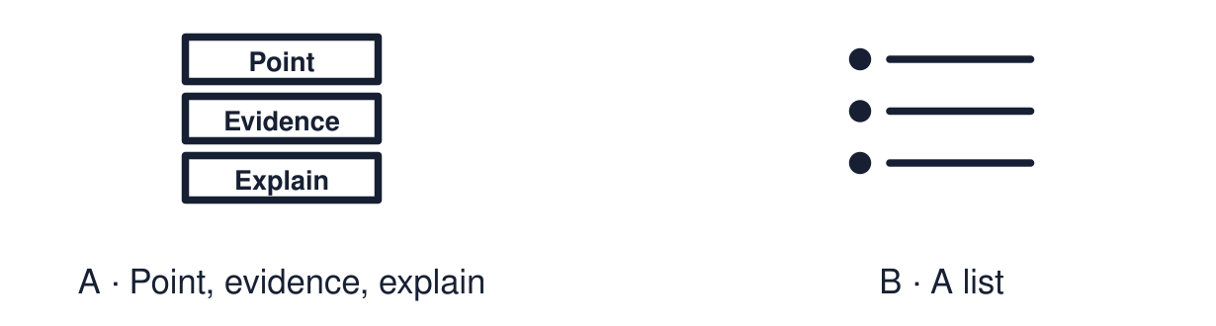
Start with 1 and 2. Try 3 and 4 when ready. Reading and exact scribing are available.

1 Name one value shared across two worldviews
Support: Use the reminder strip or talk it through with an adult.
My response
________________________________________________________________________

2 Which meaning fits point
Support: Choose: A clear answer to the question OR An example or fact that supports the point.
My response
________________________________________________________________________

3 In the model answer which sentence is the evidence
Support: Use the model evidence anchor C or read one relevant card together.
My response
________________________________________________________________________

4 Is a list the same as an explanation
Support: Give a reason when ready.
My response
________________________________________________________________________
Stretch: use a precise example or explain which detail supports your answer.

Evidence cards
Read, point or listen. Keep the source label with any detail you use.

A The structure
Point: answer the question. Evidence or example: “For example…”. Explain: “This shows… because…”. Three sentences are enough.
Source: Authored classroom resource
Limit: This is a support for clear thinking, not an exam technique.

B A list, not an explanation
“Christians pray, go to church and read the Bible.” This lists. It never says why.
Source: Authored classroom example
Limit: A list can be the start of a good answer.

C A model explanation
“A belief can influence a person’s work. For example, Daniel believes everyone deserves dignity. Therefore he chose care work, because it lets him act on that belief.”
Source: Authored classroom model
Limit: A model shows the method. Other good answers exist.

D Question bank
How can a belief influence a choice? Why might someone trust a sacred text? How can a shared value bring people together?
Source: Authored classroom resource
Limit: Choose the question you can support with evidence.

Shared investigation
1. Improve each weak response using the colour-coded structure.
2. Find the evidence in the improved version.
Work with a partner or adult, or use your own table. One person suggests; the other checks the evidence. Swap after one turn. Passing is allowed.

Move or match the cards
Cards to use
The Day of Peace is about peace.
Humanists are nice and do good things.

Rewrite one draft and explain what you changed.
Our explanation
________________________________________________________________________
________________________________________________________________________
________________________________________________________________________
Support: Use the glossary and one chunk of evidence. Plan the claim and supporting detail before explaining.
Further challenge: Add a second piece of evidence and explain which is stronger.

Supported independent task
Complete this route only. Write or give a structured explanation using a point, evidence/example and explanation.
1. Choose one question from the bank.
2. Choose your evidence from three options.
3. Say the three sentences aloud, or have them scribed.
Support: Use the glossary and one chunk of evidence. Plan the claim and supporting detail before explaining. Complete the organiser one space at a time. Point: ___. For example, ___. This shows ___ because ___.
My point
________________________________________________________________________
________________________________________________________________________
Evidence for my point
________________________________________________________________________
________________________________________________________________________
My explanation
________________________________________________________________________
________________________________________________________________________
My checked or improved sentence
________________________________________________________________________
________________________________________________________________________
An adult may read or scribe your exact response. They should not choose the answer.

Standard independent task
Complete this route only. Write or give a structured explanation using a point, evidence/example and explanation.
1. Choose one explain question from Weeks 1–4.
2. Write a point and an example.
3. Explain using “because” or “therefore”.
Support: Point: ___. For example, ___. This shows ___ because ___.
My point
________________________________________________________________________
________________________________________________________________________
Evidence for my point
________________________________________________________________________
________________________________________________________________________
My explanation
________________________________________________________________________
________________________________________________________________________
My checked or improved sentence
________________________________________________________________________
________________________________________________________________________
Check the required evidence and revise one detail.

Stretch independent task
Complete this route only. Write or give a structured explanation using a point, evidence/example and explanation.
1. Answer one question with point, evidence and explanation.
2. Add a second example.
3. Explain which example supports your point better.
Support: Choose the evidence independently. Use the frame only if it helps.
My point
________________________________________________________________________
________________________________________________________________________
Evidence for my point
________________________________________________________________________
________________________________________________________________________
My explanation
________________________________________________________________________
________________________________________________________________________
My checked or improved sentence
________________________________________________________________________
________________________________________________________________________
Add a second piece of evidence and explain which is stronger.

Exit ticket
Choose a response mode. You may give your answers privately to an adult.

In the model answer which sentence is the evidence
My response
________________________________________________________________________
________________________________________________________________________
________________________________________________________________________

Is a list the same as an explanation
My response
________________________________________________________________________
________________________________________________________________________
________________________________________________________________________
Support: Point: ___. For example, ___. This shows ___ because ___.
Further challenge: Add a second piece of evidence and explain which is stronger.
One thing I changed or want to check
________________________________________________________________________
________________________________________________________________________

