Remembrance and peace across beliefs
Learning goal: Compare how two worldviews may respond to remembrance or peace.

Words to use
Word | Meaning
remembrance | Taking time to remember people and events
reflection | Quiet thinking about something that matters
compare | To look for similarities and differences
memorial | Something made to help people remember

Remember
Give one similarity or difference between the two responses. For example: both keep silence, but only the Christian source prays.
Is classroom reflection the same as worship? No. It is quiet thinking.

How to show your learning
Complete a short comparison of the two responses.
Both ___. However, ___ whereas ___.

Evidence matters
Fictional cases are teaching examples. Historical, geographical and religious claims use the named sources. A model video demonstrates a method.
This is learning about religion and worldviews, not worship. Nobody is asked to share a personal belief, family detail or loss.
Sources: Royal British Legion The poppy

Arrival choices
Previous lesson reminder:
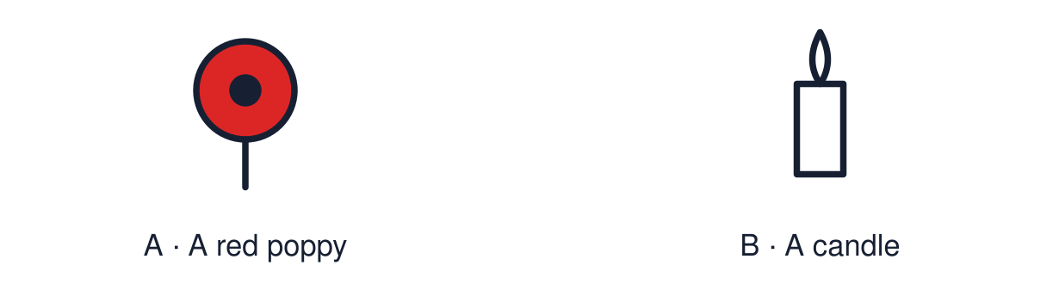
Start with 1 and 2. Try 3 and 4 when ready. Reading and exact scribing are available.

1 In the model answer which sentence is the evidence
Support: Use the reminder strip or talk it through with an adult.
My response
________________________________________________________________________

2 Which meaning fits remembrance
Support: Choose: Taking time to remember people and events OR Quiet thinking about something that matters.
My response
________________________________________________________________________

3 Give one similarity or difference between the two responses
Support: Use the model evidence anchor B,C or read one relevant card together.
My response
________________________________________________________________________

4 Is classroom reflection the same as worship
Support: Give a reason when ready.
My response
________________________________________________________________________
Stretch: use a precise example or explain which detail supports your answer.

Evidence cards
Read, point or listen. Keep the source label with any detail you use.

A Remembrance in the UK
On Remembrance Sunday and 11 November many people keep two minutes of silence. The poppy is a symbol of remembrance and of hope for a peaceful future.
Source: Authored summary; see Royal British Legion, The poppy
Limit: Wearing a poppy is a personal choice.

B A Christian response
Fictional source: “At our service we pray for those who died and for peace. I believe they are in God’s care, which gives me hope.”
Source: Authored source
Limit: This is one person's view. Others who share the worldview may describe it differently.

C A Humanist response
Fictional source: “I don’t pray, but I stand in silence. People live on in what they did and in our memories. Remembering should make us work to prevent war.”
Source: Authored source
Limit: This is one person's view. Others who share the worldview may describe it differently.

D Reflection is not worship
In class, reflection is quiet thinking. Nobody is asked to pray or to share a personal loss.
Source: Authored classroom rules
Limit: A quiet alternative is always available.

Shared investigation
1. Sort each statement: similarity or difference between the two responses.
2. Support one with a quotation from a source.
Work with a partner or adult, or use your own table. One person suggests; the other checks the evidence. Swap after one turn. Passing is allowed.

Move or match the cards
Cards to use
Both hope for peace
Prayer is part of remembering
Both keep silence to remember

Possible labels: Difference / Similarity
Our explanation
________________________________________________________________________
________________________________________________________________________
________________________________________________________________________
Support: Use the glossary and one chunk of evidence. Plan the claim and supporting detail before explaining.
Further challenge: Explain how belief about life after death changes the meaning of remembrance.

Supported independent task
Complete this route only. Compare how two worldviews may respond to remembrance or peace.
1. Choose one similarity card.
2. Point to the words in each source that show it.
3. Say or finish: Both ___.
Support: Use the glossary and one chunk of evidence. Plan the claim and supporting detail before explaining. Complete the organiser one space at a time. Both ___. However, ___ whereas ___.
My choice or example
________________________________________________________________________
________________________________________________________________________
A detail from the card story or object
________________________________________________________________________
________________________________________________________________________
My reason
________________________________________________________________________
________________________________________________________________________
My check or next step
________________________________________________________________________
________________________________________________________________________
An adult may read or scribe your exact response. They should not choose the answer.

Standard independent task
Complete this route only. Compare how two worldviews may respond to remembrance or peace.
1. Complete a short comparison of the two responses.
2. Include one similarity and one difference.
3. Link each to a source.
Support: Both ___. However, ___ whereas ___.
My choice or example
________________________________________________________________________
________________________________________________________________________
A detail from the card story or object
________________________________________________________________________
________________________________________________________________________
My reason
________________________________________________________________________
________________________________________________________________________
My check or next step
________________________________________________________________________
________________________________________________________________________
Check the required evidence and revise one detail.

Stretch independent task
Complete this route only. Compare how two worldviews may respond to remembrance or peace.
1. Compare the two responses using quotations.
2. Explain the belief behind one difference.
3. Or create a reflection and annotate its evidence.
Support: Choose the evidence independently. Use the frame only if it helps.
My choice or example
________________________________________________________________________
________________________________________________________________________
A detail from the card story or object
________________________________________________________________________
________________________________________________________________________
My reason
________________________________________________________________________
________________________________________________________________________
My check or next step
________________________________________________________________________
________________________________________________________________________
Explain how belief about life after death changes the meaning of remembrance.

Exit ticket
Choose a response mode. You may give your answers privately to an adult.

Give one similarity or difference between the two responses
My response
________________________________________________________________________
________________________________________________________________________
________________________________________________________________________

Is classroom reflection the same as worship
My response
________________________________________________________________________
________________________________________________________________________
________________________________________________________________________
Support: Both ___. However, ___ whereas ___.
Further challenge: Explain how belief about life after death changes the meaning of remembrance.
One thing I changed or want to check
________________________________________________________________________
________________________________________________________________________

