Worship, prayer and practice
Learning goal: Describe one form of worship, prayer or reflection and explain its purpose.

Words to use
Word | Meaning
worship | Showing devotion to God or gods
prayer | Communicating with God, aloud or silently
devotion | Deep love and commitment
purpose | What something is for

Remember
Give one purpose of prayer. For example: praise, gratitude, guidance or asking for forgiveness.
Is reflection always addressed to a god? No. Non-religious reflection is not.

How to show your learning
Choose one practice.
In ___, people ___. The purpose is ___ because ___.

Evidence matters
Fictional cases are teaching examples. Historical, geographical and religious claims use the named sources. A model video demonstrates a method.
This is learning about religion and worldviews, not worship. Nobody is asked to share a personal belief, family detail or loss.
Sources: Qur’an 5 6 washing for prayer

Arrival choices
You can begin without previous learning. Word help: worship means showing devotion to God or gods.
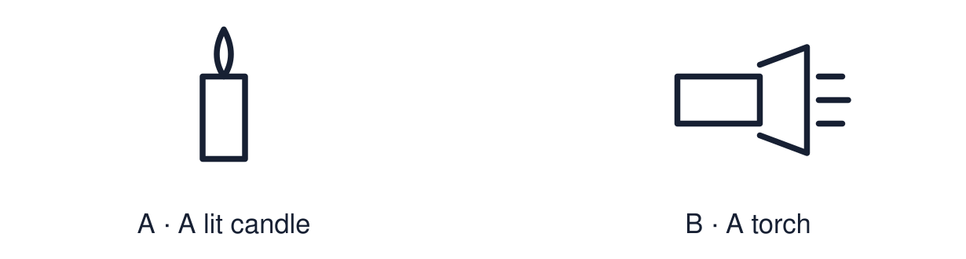
Start with 1 and 2. Try 3 and 4 when ready. Reading and exact scribing are available.

1 What does worship mean
Support: Use the reminder strip or talk it through with an adult.
My response
________________________________________________________________________

2 Which meaning fits worship
Support: Choose: Showing devotion to God or gods OR Communicating with God, aloud or silently.
My response
________________________________________________________________________

3 Give one purpose of prayer
Support: Use the model evidence anchor A,B or read one relevant card together.
My response
________________________________________________________________________

4 Is reflection always addressed to a god
Support: Give a reason when ready.
My response
________________________________________________________________________
Stretch: use a precise example or explain which detail supports your answer.

Evidence cards
Read, point or listen. Keep the source label with any detail you use.

A Salah
Muslims offer salah five times a day facing Makkah, after washing (wudu). Purposes include obedience to God, gratitude and staying mindful of God through the day.
Source: Authored RE summary
Limit: Belief and practice vary between individuals and communities.

B Christian prayer
Christians pray alone and together. The Lord’s Prayer includes praise, asking for daily needs and asking for forgiveness.
Source: Authored RE summary
Limit: Belief and practice vary between individuals and communities.

C Non-religious reflection
Many non-religious people use quiet reflection, mindfulness or time in nature to think about their lives and values. It is not addressed to a god.
Source: Authored RE summary
Limit: Some non-religious people do none of these.

D Purposes
Praise · gratitude · guidance · connection · reflection · asking for help.
Source: Authored classroom resource
Limit: One practice can have several purposes.

Shared investigation
1. Match each practice to a possible purpose.
2. Compare purposes across two worldviews.
Work with a partner or adult, or use your own table. One person suggests; the other checks the evidence. Swap after one turn. Passing is allowed.

Move or match the cards
Cards to use
A quiet walk to think over a decision
Salah five times a day
Saying thank you to God before a meal

Possible labels: Gratitude / Reflection / Staying mindful of God
Our explanation
________________________________________________________________________
________________________________________________________________________
________________________________________________________________________
Support: Use the glossary and one chunk of evidence. Plan the claim and supporting detail before explaining.
Further challenge: Explain how a religious prayer and a non-religious reflection are similar and different in purpose.

Supported independent task
Complete this route only. Describe one form of worship, prayer or reflection and explain its purpose.
1. Choose one practice from the image sequence.
2. Put the steps in order.
3. Choose its purpose from the word bank.
Support: Use the glossary and one chunk of evidence. Plan the claim and supporting detail before explaining. Complete the organiser one space at a time. In ___, people ___. The purpose is ___ because ___.
My choice or example
________________________________________________________________________
________________________________________________________________________
A detail from the card story or object
________________________________________________________________________
________________________________________________________________________
My reason
________________________________________________________________________
________________________________________________________________________
My check or next step
________________________________________________________________________
________________________________________________________________________
An adult may read or scribe your exact response. They should not choose the answer.

Standard independent task
Complete this route only. Describe one form of worship, prayer or reflection and explain its purpose.
1. Choose one practice.
2. Explain what happens.
3. Explain why it matters to the person.
Support: In ___, people ___. The purpose is ___ because ___.
My choice or example
________________________________________________________________________
________________________________________________________________________
A detail from the card story or object
________________________________________________________________________
________________________________________________________________________
My reason
________________________________________________________________________
________________________________________________________________________
My check or next step
________________________________________________________________________
________________________________________________________________________
Check the required evidence and revise one detail.

Stretch independent task
Complete this route only. Describe one form of worship, prayer or reflection and explain its purpose.
1. Explain one practice and two of its purposes.
2. Compare it with a practice from another worldview.
3. Note one way it varies between individuals.
Support: Choose the evidence independently. Use the frame only if it helps.
My choice or example
________________________________________________________________________
________________________________________________________________________
A detail from the card story or object
________________________________________________________________________
________________________________________________________________________
My reason
________________________________________________________________________
________________________________________________________________________
My check or next step
________________________________________________________________________
________________________________________________________________________
Explain how a religious prayer and a non-religious reflection are similar and different in purpose.

Exit ticket
Choose a response mode. You may give your answers privately to an adult.

Give one purpose of prayer
My response
________________________________________________________________________
________________________________________________________________________
________________________________________________________________________

Is reflection always addressed to a god
My response
________________________________________________________________________
________________________________________________________________________
________________________________________________________________________
Support: In ___, people ___. The purpose is ___ because ___.
Further challenge: Explain how a religious prayer and a non-religious reflection are similar and different in purpose.
One thing I changed or want to check
________________________________________________________________________
________________________________________________________________________

