Comparing responses to a life question
Learning goal: Compare how two worldviews respond to one important life question.

Words to use
Word | Meaning
life question | A question about meaning, purpose or how to live
response | How a worldview answers a question
similarity | A way that two things are the same
whereas | A word that introduces a difference

Remember
Give the strongest similarity between the two responses. Both support helping others and reducing harm, although they explain their reasons differently.
Can two sources stand for two whole worldviews? No. They are two individuals.

How to show your learning
Complete the comparison frame.
Both ___. The Muslim source says ___, whereas the Humanist source says ___.

Evidence matters
Fictional cases are teaching examples. Historical, geographical and religious claims use the named sources. A model video demonstrates a method.
This is learning about religion and worldviews, not worship. Nobody is asked to share a personal belief, family detail or loss.
Sources: Humanists UK explanation of Humanism

Arrival choices
Previous lesson reminder:
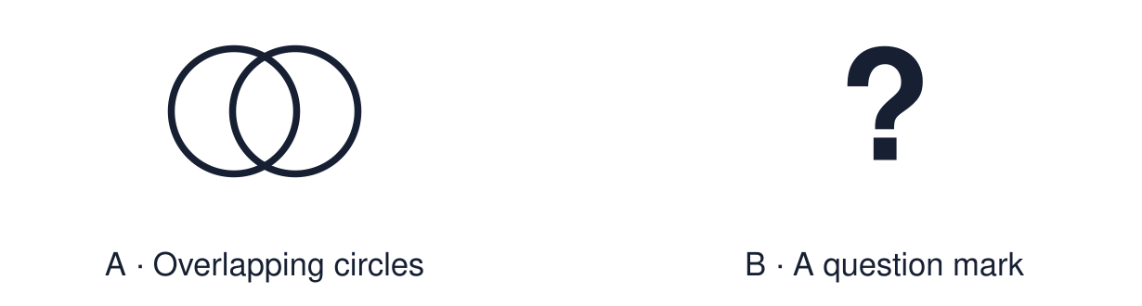
Start with 1 and 2. Try 3 and 4 when ready. Reading and exact scribing are available.

1 Which principle asks you to imagine being the other person
Support: Use the reminder strip or talk it through with an adult.
My response
________________________________________________________________________

2 Which meaning fits life question
Support: Choose: A question about meaning, purpose or how to live OR How a worldview answers a question.
My response
________________________________________________________________________

3 Give the strongest similarity between the two responses
Support: Use the model evidence anchor B,C or read one relevant card together.
My response
________________________________________________________________________

4 Can two sources stand for two whole worldviews
Support: Give a reason when ready.
My response
________________________________________________________________________
Stretch: use a precise example or explain which detail supports your answer.

Evidence cards
Read, point or listen. Keep the source label with any detail you use.

A The question
“How should we treat others?”
Source: Authored classroom resource
Limit: A life question has more than one thoughtful answer.

B A Muslim response
Authored fictional Muslim profile: the speaker connects care for others with teachings about wishing others well and with zakat. They explain giving as a responsibility to God and to people in need.
Source: Authored source drawing on a well-known hadith
Limit: This is one person's view. Others who share the worldview may describe it differently.

C A Humanist response
Authored fictional Humanist profile: the speaker uses empathy and considers consequences for people. They want to reduce suffering and help others, without grounding that choice in a belief in God.
Source: Authored source
Limit: This is one person's view. Others who share the worldview may describe it differently.

D Comparing ideas, not people
Compare what the sources say. Use “Both… whereas…”.
Source: Authored classroom rules
Limit: Two sources cannot stand for two whole worldviews.

Shared investigation
1. Sort each statement: Muslim source, Humanist source or both.
2. Use “Both… whereas…” for one pair.
Work with a partner or adult, or use your own table. One person suggests; the other checks the evidence. Swap after one turn. Passing is allowed.

Move or match the cards
Cards to use
Wanting to help people in need
Reasoning through empathy and consequences
Giving linked to duty to God

Possible labels: Both / Humanist profile / Muslim profile
Our explanation
________________________________________________________________________
________________________________________________________________________
________________________________________________________________________
Support: Use the glossary and one chunk of evidence. Plan the claim and supporting detail before explaining.
Further challenge: Explain whether the different reasons matter if the action is the same.

Supported independent task
Complete this route only. Compare how two worldviews respond to one important life question.
1. Choose the question and listen to both sources.
2. Find one thing both say.
3. Say or finish: Both ___.
Support: Use the glossary and one chunk of evidence. Plan the claim and supporting detail before explaining. Complete the organiser one space at a time. Both ___. The Muslim source says ___, whereas the Humanist source says ___.
My choice or example
________________________________________________________________________
________________________________________________________________________
A detail from the card story or object
________________________________________________________________________
________________________________________________________________________
My reason
________________________________________________________________________
________________________________________________________________________
My check or next step
________________________________________________________________________
________________________________________________________________________
An adult may read or scribe your exact response. They should not choose the answer.

Standard independent task
Complete this route only. Compare how two worldviews respond to one important life question.
1. Complete the comparison frame.
2. Include one similarity and one difference.
3. Refer to each source.
Support: Both ___. The Muslim source says ___, whereas the Humanist source says ___.
My choice or example
________________________________________________________________________
________________________________________________________________________
A detail from the card story or object
________________________________________________________________________
________________________________________________________________________
My reason
________________________________________________________________________
________________________________________________________________________
My check or next step
________________________________________________________________________
________________________________________________________________________
Check the required evidence and revise one detail.

Stretch independent task
Complete this route only. Compare how two worldviews respond to one important life question.
1. Compare the two responses using short quotations.
2. Explain the belief behind the difference.
3. Evaluate whether the reason behind an action matters.
Support: Choose the evidence independently. Use the frame only if it helps.
My choice or example
________________________________________________________________________
________________________________________________________________________
A detail from the card story or object
________________________________________________________________________
________________________________________________________________________
My reason
________________________________________________________________________
________________________________________________________________________
My check or next step
________________________________________________________________________
________________________________________________________________________
Explain whether the different reasons matter if the action is the same.

Exit ticket
Choose a response mode. You may give your answers privately to an adult.

Give the strongest similarity between the two responses
My response
________________________________________________________________________
________________________________________________________________________
________________________________________________________________________

Can two sources stand for two whole worldviews
My response
________________________________________________________________________
________________________________________________________________________
________________________________________________________________________
Support: Both ___. The Muslim source says ___, whereas the Humanist source says ___.
Further challenge: Explain whether the different reasons matter if the action is the same.
One thing I changed or want to check
________________________________________________________________________
________________________________________________________________________

