Science · LAUNCH · Autumn 1 · Week 08 · SCI-LAUNCH-A1-W08-L2 · Date __________  Amylase and pH: Continuous-Sampling Investigation  Today I can… ☐ Order the preparation, timing and sampling steps, and justify one evidence decision ☐ Identify the first observed iodine endpoint and record the time with its sampling limit ☐ Use matched conditions and raw observations to make a supported comparison  Feedback: ☐ VF ☐ WS ☐ I ☐ NS ☐ E ☐ R __________________________ | 
Science · LAUNCH · Autumn 1 · Week 08 · SCI-LAUNCH-A1-W08-L2 · Date __________
Amylase and pH: Continuous-Sampling Investigation
Today I can… ☐ Order the preparation, timing and sampling steps, and justify one evidence decision ☐ Identify the first observed iodine endpoint and record the time with its sampling limit ☐ Use matched conditions and raw observations to make a supported comparison
Feedback: ☐ VF ☐ WS ☐ I ☐ NS ☐ E ☐ R __________________________
Science · LAUNCH · Autumn 1 · Week 08 · SCI-LAUNCH-A1-W08-L2 · Date __________
Amylase and pH: Continuous-Sampling Investigation
Today I can… ☐ Order the preparation, timing and sampling steps, and justify one evidence decision ☐ Identify the first observed iodine endpoint and record the time with its sampling limit ☐ Use matched conditions and raw observations to make a supported comparison
Feedback: ☐ VF ☐ WS ☐ I ☐ NS ☐ E ☐ R __________________________
Science · LAUNCH · Autumn 1 · Week 08 · SCI-LAUNCH-A1-W08-L2 · Date __________
Amylase and pH: Continuous-Sampling Investigation
Today I can… ☐ Order the preparation, timing and sampling steps, and justify one evidence decision ☐ Identify the first observed iodine endpoint and record the time with its sampling limit ☐ Use matched conditions and raw observations to make a supported comparison
Feedback: ☐ VF ☐ WS ☐ I ☐ NS ☐ E ☐ R __________________________
Science · LAUNCH · Autumn 1 · Week 08 · SCI-LAUNCH-A1-W08-L2 · Date __________
Amylase and pH: Continuous-Sampling Investigation
Today I can… ☐ Order the preparation, timing and sampling steps, and justify one evidence decision ☐ Identify the first observed iodine endpoint and record the time with its sampling limit ☐ Use matched conditions and raw observations to make a supported comparison
Feedback: ☐ VF ☐ WS ☐ I ☐ NS ☐ E ☐ R __________________________
Science · LAUNCH · Autumn 1 · Week 08 · SCI-LAUNCH-A1-W08-L2 · Date __________
Amylase and pH: Continuous-Sampling Investigation
Today I can… ☐ Order the preparation, timing and sampling steps, and justify one evidence decision ☐ Identify the first observed iodine endpoint and record the time with its sampling limit ☐ Use matched conditions and raw observations to make a supported comparison
Feedback: ☐ VF ☐ WS ☐ I ☐ NS ☐ E ☐ R __________________________
Science · LAUNCH · Autumn 1 · Week 08 · SCI-LAUNCH-A1-W08-L2 · Date __________
Amylase and pH: Continuous-Sampling Investigation
Today I can… ☐ Order the preparation, timing and sampling steps, and justify one evidence decision ☐ Identify the first observed iodine endpoint and record the time with its sampling limit ☐ Use matched conditions and raw observations to make a supported comparison
Feedback: ☐ VF ☐ WS ☐ I ☐ NS ☐ E ☐ R __________________________
Science · LAUNCH · Autumn 1 · Week 08 · SCI-LAUNCH-A1-W08-L2 · Date __________
Amylase and pH: Continuous-Sampling Investigation
Today I can… ☐ Order the preparation, timing and sampling steps, and justify one evidence decision ☐ Identify the first observed iodine endpoint and record the time with its sampling limit ☐ Use matched conditions and raw observations to make a supported comparison
Feedback: ☐ VF ☐ WS ☐ I ☐ NS ☐ E ☐ R __________________________

Science · LAUNCH · Autumn 1 · Week 08 · SCI-LAUNCH-A1-W08-L2 · Date __________
Amylase and pH: Continuous-Sampling Investigation
Today I can… ☐ Order the preparation, timing and sampling steps, and justify one evidence decision ☐ Identify the first observed iodine endpoint and record the time with its sampling limit ☐ Use matched conditions and raw observations to make a supported comparison
Feedback: ☐ VF ☐ WS ☐ I ☐ NS ☐ E ☐ R __________________________

Amylase and pH: Continuous-Sampling Investigation · Route card
Reference only · use the task and sentence stem in your book.

Arrival · four short answers in your book
1. Identify the enzyme and substrate in amylase acting on starch.
2. At 60 s iodine is blue-black; at 90 s it stays orange-brown. Which sampled time first meets the endpoint?
3. State the independent and dependent variables, then name one condition to keep constant.
4. Why prepare the iodine wells and time headings before mixing?

Starter
Which setup protects the first observations?

Exit ticket
Under the heading Exit ticket: answer the questions in your book.
1. State the first observed endpoint and the window in which it was reached.
2. Give one way to protect a fair comparison across pH values and explain why it matters.

Independent
1. State the first observed endpoint for pH 7 and the interval in which it was reached, using the supplied observations. [2 marks]
2. Order the four method cards. Explain why preparation must happen before mixing. [2 marks]
3. State the independent variable, dependent variable and one matched control, explaining why the control matters. [4 marks]
4. Repair the proposed exact endpoint of 75 s. Explain what should be recorded if a sample is missed. [2 marks]
5. Compare two pH values using their times. State one limit of the conclusion from this first series. [3 marks]

Supported
1. Read the pH 7 timeline. Name the first orange-brown sampled time and say what that colour means.
2. Put the four method cards in order: prepare and check; start together; sample at fixed times; keep the raw observation.
3. Choose one thing to keep matched: temperature / buffer pH. Say why it stays the same.
4. Repair “endpoint = 75 s exactly” using the observed 60 s and 90 s colours.
5. Compare the pH 7 and pH 4 times. Choose the faster breakdown and give one number as evidence.

Choice
1. Choose the first orange-brown time at pH 7: 60 s / 90 s / 120 s. Choose its window: after 60 s and by 90 s / exactly 75 s. Record the time and colour meaning. Record C beside your book response.
2. Order the shuffled cards: keep observations; sample at fixed times; prepare; start together. Choose why preparation precedes mixing: avoid missed early samples / make colour brighter. Match pH / endpoint time / temperature to change / measure / keep the same; give one control reason.
3. Choose the truthful missed-sample record: labelled gap / invented 75 s. Compare pH 7 at 90 s and pH 4 at 240 s: choose the faster result and quote a time. Choose the claim: these trials / every amylase. Give one reason.

Aspire
1. Distinguish the recorded endpoint from the true endpoint window for pH 7. State the window’s width. [3 marks]
2. Explain how preparing the tile first and using a fixed sampling interval protect different parts of the evidence. [2 marks]
3. Explain the different roles of matched temperature and a comparison containing no active amylase. [2 marks]
4. Evaluate this claim: The 60 s sample is missing in a second record; 30 s is blue-black and 90 s orange-brown. State what is now known and repair the claim “the same precision”. [3 marks]
5. Compare pH 4 and pH 7 using the supplied times, limiting your claim to these trials. Explain why neither a smooth expected trend nor a hard-to-read colour justifies altering a raw observation. [3 marks]
Staff mark I, S or C beside this task.

Method strip · stick in your book
1. Prepare the centre-approved setup, labelled iodine wells, timer and roles.
2. Check readiness with the adult. Stop and check before mixing.
3. Mix and start timing together, following the authorised method.
4. Take separate samples at the agreed fixed intervals into prepared iodine wells.
5. Keep the raw time and colour observations, including gaps.
6. Write an observation and one supported conclusion about pH and amylase activity in your book.
Only current-stage apparatus on the table. Teacher demonstration plus the same observation and conclusion is available if safe participation is not possible.

Science · LAUNCH · Autumn 1 · Week 08 · SCI-LAUNCH-A1-W08-L2 · Date __________
Amylase and pH: Continuous-Sampling Investigation
Today I can… ☐ Order the preparation, timing and sampling steps, and justify one evidence decision ☐ Identify the first observed iodine endpoint and record the time with its sampling limit ☐ Use matched conditions and raw observations to make a supported comparison
Feedback: ☐ VF ☐ WS ☐ I ☐ NS ☐ E ☐ R __________________________

LAUNCH · GCSE Biology · Amylase and pH: Continuous-Sampling Investigation
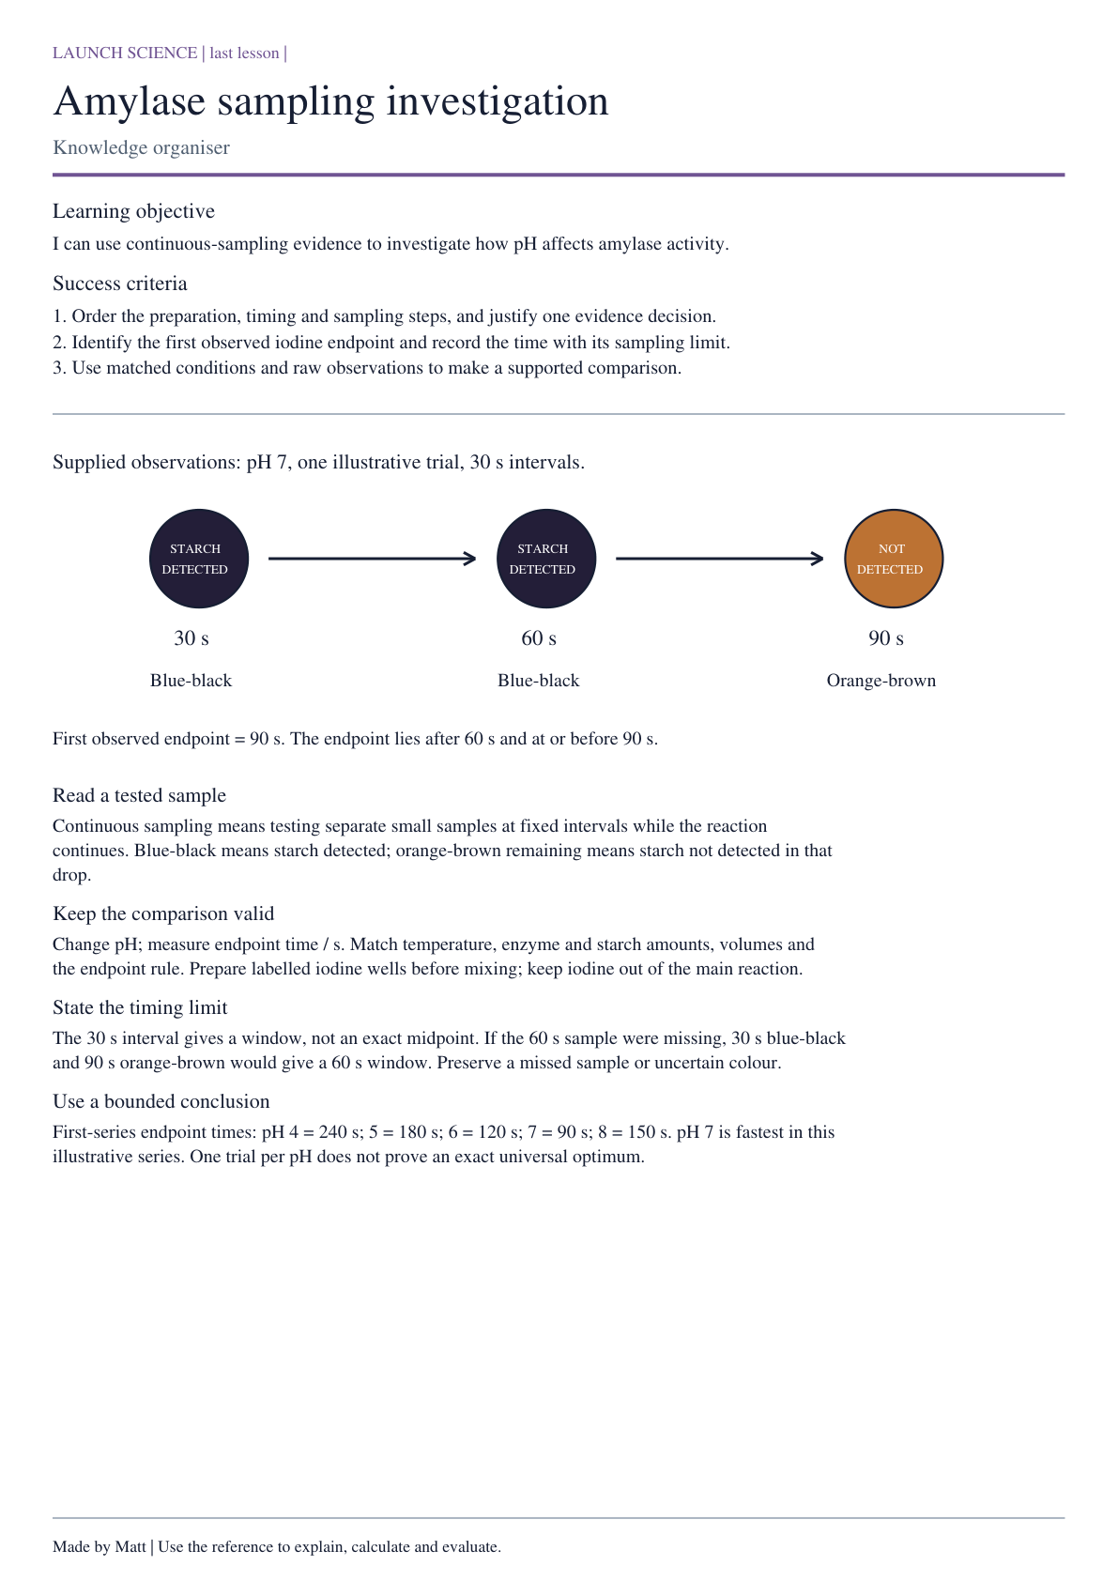

Practical reference data and models
LAUNCH · GCSE Biology · Amylase and pH: Continuous-Sampling Investigation
Enzyme: biological catalyst; speeds a reaction without being used up. Substrate: substance it acts on. pH: a measure of acidity or alkalinity. Amylase acts on starch, producing smaller sugars.
Iodine key: blue-black = starch detected. Orange-brown remains = starch not detected. check separate sampled drops. Endpoint = first sampled drop leaving iodine orange-brown; record its time / s.
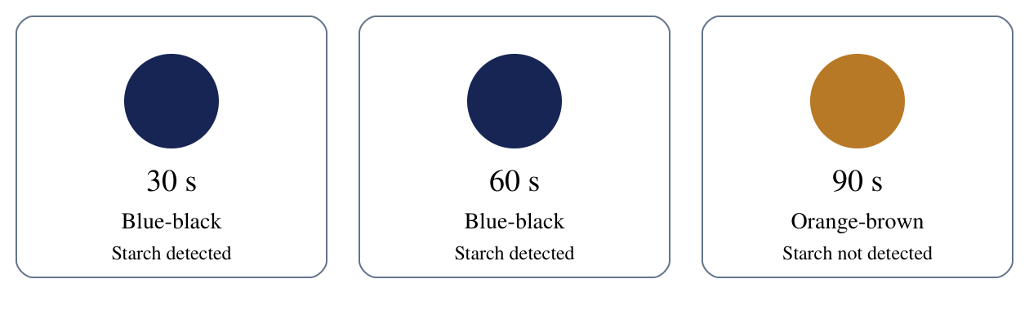
Method card | Action
1 | Prepare and check: approved setup, labelled wells, timer and roles ready.
2 | Start together: mix and start timing as the approved method states.
3 | Sample at fixed times: separate samples into prepared iodine wells.
4 | Keep raw observations: record colour and time honestly as sampling continues.

Supplied illustrative observations — not your practical results. Single runs; equal starting amounts and the same iodine endpoint. Samples every 30 s. pH 7: blue-black at 30/60 s, orange-brown at 90 s. Record 90 s.
pH | First endpoint / s
4 | 240
5 | 180
6 | 120
7 | 90
8 | 150

Valid comparison: change pH; match temperature, enzyme and starch concentrations/volumes, total volume, starting and sampling conditions. A separate no-active-amylase control should remain starch-positive. This is different from a factor kept constant.
A separate pH 7 repeat gave 120 s: keep both 90 s and 120 s. Another run had no endpoint by 300 s: record that observation, not zero. A paper investigation uses supplied observations; it does not show that you completed reagent handling.

Science · LAUNCH · Autumn 1 · Week 08 · SCI-LAUNCH-A1-W08-L2 · Date __________
Amylase and pH: Continuous-Sampling Investigation
Today I can… ☐ Order the preparation, timing and sampling steps, and justify one evidence decision ☐ Identify the first observed iodine endpoint and record the time with its sampling limit ☐ Use matched conditions and raw observations to make a supported comparison
Feedback: ☐ VF ☐ WS ☐ I ☐ NS ☐ E ☐ R __________________________

Staff: cut these apart before the lesson.
Move these pieces for the task. Record the answer and reason in your book.
Ready tile: Goggles are on, iodine wells and labels are ready, roles are agreed and the teacher has authorised the setup. | Iodine spill: Iodine is spilled on the bench or skin.
Unlabelled buffer: A buffer container has no clear pH label. | Missed interval: The 60 s sample was missed but the reaction and later observations are otherwise intact.
Borderline colour: A well looks purple-brown and the agreed endpoint cannot be judged confidently. | Clean fixed sample: A clean transfer is made at the agreed interval to the next labelled iodine well.
Temperature outside range: The monitored temperature is outside the tolerance in the centre method.

