Science · LAUNCH · Autumn 1 · Week 08 · SCI-LAUNCH-A1-W08-L3 · Date __________  Amylase Rate, Graph and Topic 1 Consolidation  Today I can… ☐ Show relative-rate working using 1 ÷ time with the unit s⁻¹ ☐ Read or plot the pH–rate pattern and limit the conclusion to the evidence ☐ Link a method limitation to an improvement, then distinguish digestion from diffusion  Feedback: ☐ VF ☐ WS ☐ I ☐ NS ☐ E ☐ R __________________________ | 
Science · LAUNCH · Autumn 1 · Week 08 · SCI-LAUNCH-A1-W08-L3 · Date __________
Amylase Rate, Graph and Topic 1 Consolidation
Today I can… ☐ Show relative-rate working using 1 ÷ time with the unit s⁻¹ ☐ Read or plot the pH–rate pattern and limit the conclusion to the evidence ☐ Link a method limitation to an improvement, then distinguish digestion from diffusion
Feedback: ☐ VF ☐ WS ☐ I ☐ NS ☐ E ☐ R __________________________
Science · LAUNCH · Autumn 1 · Week 08 · SCI-LAUNCH-A1-W08-L3 · Date __________
Amylase Rate, Graph and Topic 1 Consolidation
Today I can… ☐ Show relative-rate working using 1 ÷ time with the unit s⁻¹ ☐ Read or plot the pH–rate pattern and limit the conclusion to the evidence ☐ Link a method limitation to an improvement, then distinguish digestion from diffusion
Feedback: ☐ VF ☐ WS ☐ I ☐ NS ☐ E ☐ R __________________________
Science · LAUNCH · Autumn 1 · Week 08 · SCI-LAUNCH-A1-W08-L3 · Date __________
Amylase Rate, Graph and Topic 1 Consolidation
Today I can… ☐ Show relative-rate working using 1 ÷ time with the unit s⁻¹ ☐ Read or plot the pH–rate pattern and limit the conclusion to the evidence ☐ Link a method limitation to an improvement, then distinguish digestion from diffusion
Feedback: ☐ VF ☐ WS ☐ I ☐ NS ☐ E ☐ R __________________________
Science · LAUNCH · Autumn 1 · Week 08 · SCI-LAUNCH-A1-W08-L3 · Date __________
Amylase Rate, Graph and Topic 1 Consolidation
Today I can… ☐ Show relative-rate working using 1 ÷ time with the unit s⁻¹ ☐ Read or plot the pH–rate pattern and limit the conclusion to the evidence ☐ Link a method limitation to an improvement, then distinguish digestion from diffusion
Feedback: ☐ VF ☐ WS ☐ I ☐ NS ☐ E ☐ R __________________________
Science · LAUNCH · Autumn 1 · Week 08 · SCI-LAUNCH-A1-W08-L3 · Date __________
Amylase Rate, Graph and Topic 1 Consolidation
Today I can… ☐ Show relative-rate working using 1 ÷ time with the unit s⁻¹ ☐ Read or plot the pH–rate pattern and limit the conclusion to the evidence ☐ Link a method limitation to an improvement, then distinguish digestion from diffusion
Feedback: ☐ VF ☐ WS ☐ I ☐ NS ☐ E ☐ R __________________________
Science · LAUNCH · Autumn 1 · Week 08 · SCI-LAUNCH-A1-W08-L3 · Date __________
Amylase Rate, Graph and Topic 1 Consolidation
Today I can… ☐ Show relative-rate working using 1 ÷ time with the unit s⁻¹ ☐ Read or plot the pH–rate pattern and limit the conclusion to the evidence ☐ Link a method limitation to an improvement, then distinguish digestion from diffusion
Feedback: ☐ VF ☐ WS ☐ I ☐ NS ☐ E ☐ R __________________________
Science · LAUNCH · Autumn 1 · Week 08 · SCI-LAUNCH-A1-W08-L3 · Date __________
Amylase Rate, Graph and Topic 1 Consolidation
Today I can… ☐ Show relative-rate working using 1 ÷ time with the unit s⁻¹ ☐ Read or plot the pH–rate pattern and limit the conclusion to the evidence ☐ Link a method limitation to an improvement, then distinguish digestion from diffusion
Feedback: ☐ VF ☐ WS ☐ I ☐ NS ☐ E ☐ R __________________________

Science · LAUNCH · Autumn 1 · Week 08 · SCI-LAUNCH-A1-W08-L3 · Date __________
Amylase Rate, Graph and Topic 1 Consolidation
Today I can… ☐ Show relative-rate working using 1 ÷ time with the unit s⁻¹ ☐ Read or plot the pH–rate pattern and limit the conclusion to the evidence ☐ Link a method limitation to an improvement, then distinguish digestion from diffusion
Feedback: ☐ VF ☐ WS ☐ I ☐ NS ☐ E ☐ R __________________________

Amylase Rate, Graph and Topic 1 Consolidation · Route card
Reference only · use the task and sentence stem in your book.

Arrival · four short answers in your book
1. Explain why 90 s gives a larger relative rate than 180 s under matched conditions.
2. At 60 s starch is detected; at 90 s it is not. What endpoint value is used in the rate calculation?
3. Calculate relative rate for an endpoint of 120 s; show the equation, substitution and unit.
4. Distinguish DESCRIBE from EXPLAIN when answering about a graph.

Starter
Matched amounts, same iodine endpoint: reaction A reaches the endpoint in 90 s; B takes 180 s. Which is faster?

Exit ticket
Under the heading Exit ticket: answer the questions in your book.
1. Calculate both first-series relative rates and use them for a bounded comparison.
2. Use the repeat or sampling interval to give one limitation and a justified next investigation change.

Independent
1. Calculate relative rate for pH 6 and pH 7, showing equation, substitution and units. Check that shorter time gives a larger value. [4 marks]
2. Complete the five-point graph using the two calculated rates and three supplied points. Label both axes and state the rise-and-fall pattern. [4 marks]
3. Identify the highest tested activity in the first series using one numerical comparison. Explain how pH can affect the enzyme’s active site. [3 marks]
4. Give one strength, one limitation and one linked improvement for the endpoint method. Use the separate pH 7 repeat of 120 s to qualify your confidence. [4 marks]
5. Distinguish enzyme digestion from diffusion in the supplied two-step diagram. Explain why movement from high to low concentration does not itself break starch into sugars. [3 marks]

Supported
1. Use 1 ÷ time to calculate the pH 6 rate from 120 s and the pH 7 rate from 90 s.
2. Add pH 6 and pH 7 to the supplied rate graph. Match each pH to its calculated rate; the other three points are supplied.
3. Choose the highest rate in the first series. Complete “In these tested conditions, pH ___ was fastest because ___.”
4. The sampling interval is 30 s. Choose a limitation and a linked improvement: uncertain exact endpoint / use a shorter fixed interval if authorised.
5. The supplied diagram shows starch breaking into sugars, then particles moving from high to low concentration. Label the two changes: digestion / diffusion.

Choice
1. Match 120 s and 90 s to 0.00833 s⁻¹ and 0.0111 s⁻¹. Show 1 ÷ time for each. Add the pH 6 and pH 7 points to the supplied graph; choose its pattern: rises then falls / always rises. Record C beside your book response.
2. Choose the highest first-series rate: pH 4 / pH 7 / pH 8. Give one number. Choose how pH may change activity: active-site fit / enzyme choice. Match the 30 s sampling gap to uncertain exact endpoint / exact timing; choose a shorter authorised interval / invented time as the improvement.
3. The pH 7 repeat took 120 s. Choose confidence: variation needs repeats / one exact optimum is proved. Match starch breakdown / net particle movement to digestion / diffusion. Write one sentence explaining the difference.

Aspire
1. Calculate pH 6 and pH 7 relative rates. Compare the first pH 7 rate with its separate 120 s repeat, retaining both results. [4 marks]
2. Complete the five-point first-series graph and place the separate repeat at the same pH 7 x-position with a distinct symbol. Explain why it is not pH 9 or a silently replaced point. [4 marks]
3. Evaluate “pH 7 is the exact optimum for every amylase”. Use the tested range, the repeat and the difference between data and a molecular explanation. [4 marks]
4. Give a strength–limitation–improvement chain. Explain which uncertainty a shorter authorised sampling interval reduces and which it leaves. [4 marks]
5. Explain why “diffusion digests starch” confuses two processes. Use the supplied definitions, and state why an enzyme-rate graph alone cannot show how sugars cross a gut membrane. [4 marks]
Staff mark I, S or C beside this task.

Science · LAUNCH · Autumn 1 · Week 08 · SCI-LAUNCH-A1-W08-L3 · Date __________
Amylase Rate, Graph and Topic 1 Consolidation
Today I can… ☐ Show relative-rate working using 1 ÷ time with the unit s⁻¹ ☐ Read or plot the pH–rate pattern and limit the conclusion to the evidence ☐ Link a method limitation to an improvement, then distinguish digestion from diffusion
Feedback: ☐ VF ☐ WS ☐ I ☐ NS ☐ E ☐ R __________________________

LAUNCH · GCSE Biology · Amylase Rate, Graph and Topic 1 Consolidation
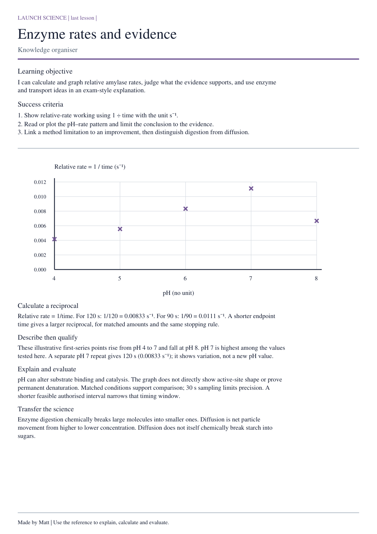

Practical reference data and models
LAUNCH · GCSE Biology · Amylase Rate, Graph and Topic 1 Consolidation
Enzyme: biological catalyst; speeds a reaction without being used up. Substrate: substance it acts on. pH: a measure of acidity or alkalinity. Amylase acts on starch, producing smaller sugars.
pH | Endpoint / s | Relative rate / s⁻¹
4 | 240 | 0.00417
5 | 180 | 0.00556
6 | 120 | 0.00833
7 | 90 | 0.0111
8 | 150 | 0.00667

Supplied illustrative observations — not your practical results. Single runs; equal starting amounts and the same iodine endpoint. Samples every 30 s. pH 7: blue-black at 30/60 s, orange-brown at 90 s. Record 90 s.
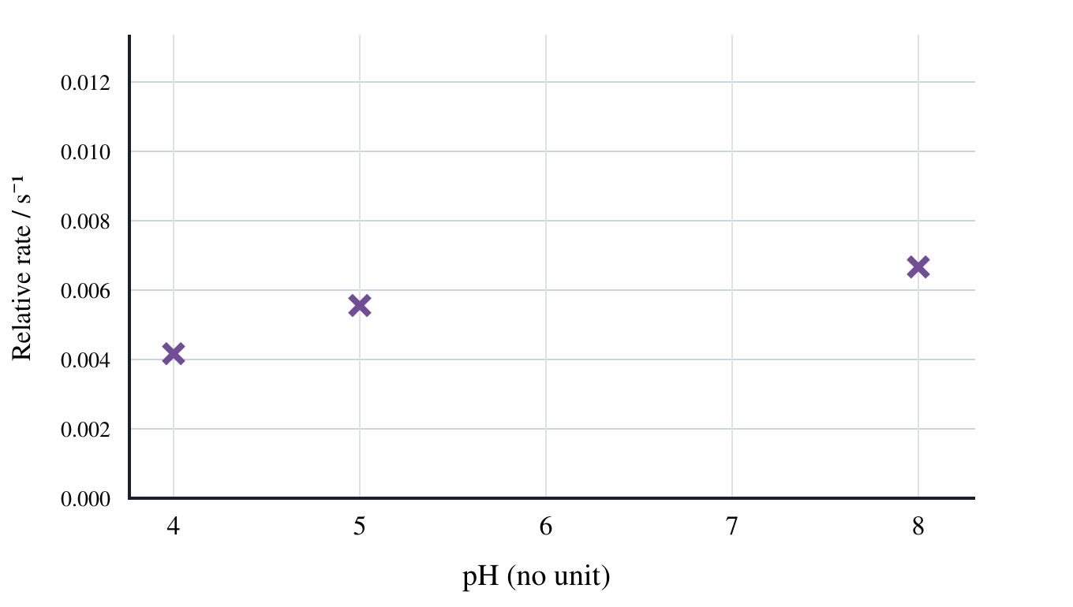
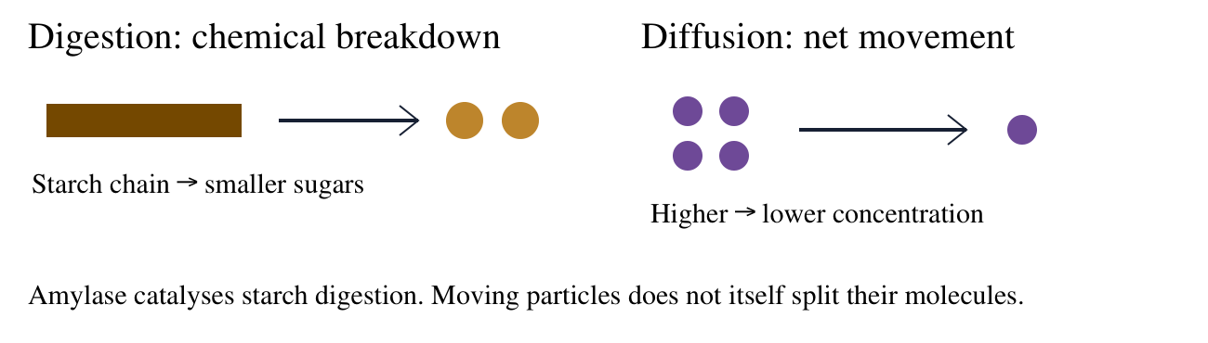
Complete the reference graph: pH 4, 5 and 8 are shown; add pH 6 and pH 7. Aspire: add the separate repeat with a distinct symbol.
Rate: 1 ÷ endpoint time. At pH 7: 1 ÷ 90 = 0.0111 s⁻¹ (3 significant figures). These are single-run rates, not means. Highest among tested: pH 7; exact optimum is not established. The extra pH 7 repeat (120 s) is a separate trial, not silently averaged.
Topic 1 transfer: digestion breaks large molecules into smaller molecules. Diffusion is net particle movement from higher to lower concentration; it does not break a starch molecule apart. Enzymes are catalysts, not living organisms. pH changes can alter activity; slower timing alone does not prove permanent denaturation.
Describe = give a pattern; explain = link cause and effect; evaluate = use evidence and limits. An unobserved endpoint by 300 s establishes no exact reciprocal rate.

Science · LAUNCH · Autumn 1 · Week 08 · SCI-LAUNCH-A1-W08-L3 · Date __________
Amylase Rate, Graph and Topic 1 Consolidation
Today I can… ☐ Show relative-rate working using 1 ÷ time with the unit s⁻¹ ☐ Read or plot the pH–rate pattern and limit the conclusion to the evidence ☐ Link a method limitation to an improvement, then distinguish digestion from diffusion
Feedback: ☐ VF ☐ WS ☐ I ☐ NS ☐ E ☐ R __________________________

Staff: cut these apart before the lesson.
Move these pieces for the task. Record the answer and reason in your book.
Reciprocal value: Endpoint 120 s gives 1/120 = 0.00833 s⁻¹. | Direction check: The shortest time should correspond to the largest reciprocal rate.
Highest tested rate: The largest first-series relative rate occurs at pH 7 among pH 4–8 tested here. | Rise then fall: First-series relative rate rises from pH 4 to pH 7, then falls at pH 8.
Subjective endpoint: Different observers may judge a borderline iodine colour differently. | Shorter interval: A shorter fixed sampling interval could narrow the endpoint-time window if the authorised method allows it.
Preserve anomaly: One repeat is far from the others; keep it visible, check the method and justify any treatment.

