Source A · NHS public information
Present inheritance and one biological effect.
Connect claims to two visible source labels.
Answer a question without exceeding the evidence.

Cystic fibrosis is inherited. Altered gene copies from both parents cause thick, sticky mucus. This can affect the lungs and digestion. Treatments can help ease symptoms. Care depends on the person.
This source gives a public overview. It does not tell us one person’s exact symptoms or future.
Publisher: NHS. Title: Cystic fibrosis. Use the Causes, Symptoms and Treatments sections.
Source A full page: ask an adult to use the link in the page tools or staff notes.
Accessed 24 October 2026. Page reviewed 28 February 2025. This is a classroom paraphrase, not a quotation. The full page can be opened by the teacher.

Source B · NHS Genomics Education
Present inheritance and one biological effect.
Connect claims to two visible source labels.
Answer a question without exceeding the evidence.

Cystic fibrosis usually involves harmful variants in both copies of CFTR. This is an autosomal recessive condition. A carrier has one changed copy in this model. The effects can vary.
Two carrier parents: each pregnancy | Model chance
Child has the condition | 1 in 4 = 25%
Child is a carrier | 2 in 4 = 50%
Child inherits neither changed copy | 1 in 4 = 25%

These chances apply each time. They do not predict a set family count or the severity of one person’s symptoms.
NHS Genomics Education Programme. Page: Cystic fibrosis. Read Genomics, then Inheritance and genomic counselling. Use these parts to check the gene and how changed copies pass to a child.
Source B full page: ask an adult to use the link in the page tools or staff notes.
Checked 24 October 2026. This card uses our own words. It is not a quote. We have not given a review date for this source.

Sources · purpose and limits
Present inheritance and one biological effect.
Connect claims to two visible source labels.
Answer a question without exceeding the evidence.

Both sources are NHS sources. They have different readers and are not wholly independent publishers.
Source A | Source B
Public information about effects and care | More detail about genes and inheritance

Both support inherited cause. More detail does not by itself mean a conflict. Check the actual claim, source section, date and purpose.
Read the source, cover it, explain the meaning in your own words, then check it. Keep the source label beside each claim.
Use fictional cases. Do not ask for family details or predict a person’s future. Inheritance and infection precautions are separate matters.

Arrival · Supported
Present inheritance and one biological effect.
Connect claims to two visible source labels.
Answer a question without exceeding the evidence.

Four checks. Point, speak, sign, draw, write or direct an adult. An adult may read or scribe your exact words. Choose one route; do not complete all three.
1. Focus
What are the two main parts of the research question?
Help: Read or point first. Inheritance and a biological effect.
2. Source
How can your audience check a claim?
Help: Read or point first. Make the source visible.
3. Uncertainty
What can you say when the sources do not answer a question?
Help: Read or point first. An honest gap is allowed.
4. Choice
Must this be a public speech?
Help: Read or point first. You may show your work to one person or write it down.
My response: ____________________

Independent · Supported
Present inheritance and one biological effect.
Connect claims to two visible source labels.
Answer a question without exceeding the evidence.

Point, speak, sign, draw, write or direct an adult. An adult may read or scribe your exact words. Choose one route; do not complete all three.
1. Create
Complete the four-panel planning sheet.
Help: Use the four-section outline: question / biological explanation / inheritance model / uncertainty and sources.
2. Present
Communicate the explanation using your chosen mode.
Help: Choose speaking, pointing to a poster or exact-word scribing. Follow the four headings rather than memorising a script.
3. Respond
Answer: “Will every person with CF have exactly the same symptoms?”
Help: Use: the source supports ___, but it does not establish ___. A responsible next check would be ___.
My response: ____________________
One partner explains. The other asks for the clue. Swap roles. Keep your own first answer, feedback and next step.
Use one route for the full 10 minutes. Keep your own record and response.

Exit · Supported
Present inheritance and one biological effect.
Connect claims to two visible source labels.
Answer a question without exceeding the evidence.

1. Explain
Use two sentences. Explain how CF is passed on through genes. Link this to one effect on the body.
Help: Use: my answer is ___ because ___. Point to a model or card first. Use CFTR, two altered alleles and thick mucus.
2. Qualify
State one thing that your sources do not show. Keep this limit in your talk or work.
Help: Use: the evidence shows ___, but cannot yet show ___. The source does not show one person’s future. Say what it does show.
My response: ____________________

Arrival · Independent
Present inheritance and one biological effect.
Connect claims to two visible source labels.
Answer a question without exceeding the evidence.

Four checks. Point, speak, sign, draw, write or direct an adult. An adult may read or scribe your exact words. Choose one route; do not complete all three.
1. Focus
What are the two main parts of the research question?
Help: Inheritance and a biological effect.
2. Source
How can your audience check a claim?
Help: Make the source visible.
3. Uncertainty
What can you say when the sources do not answer a question?
Help: An honest gap is allowed.
4. Choice
Must this be a public speech?
Help: You may show your work to one person or write it down.
My response: ____________________

Independent · Independent
Present inheritance and one biological effect.
Connect claims to two visible source labels.
Answer a question without exceeding the evidence.

Point, speak, sign, draw, write or direct an adult. An adult may read or scribe your exact words. Choose one route; do not complete all three.
1. Create
Complete the four-panel planning sheet.
Help: Use one accurate claim per panel rather than long paragraphs.
2. Present
Communicate the explanation using your chosen mode.
Help: A private one-to-one explanation is equally valid.
3. Respond
Answer: “Will every person with CF have exactly the same symptoms?”
Help: Refer to variation and the limits of the sources.
My response: ____________________
One partner explains. The other asks for the clue. Swap roles. Keep your own first answer, feedback and next step.
Use one route for the full 10 minutes. Keep your own record and response.

Exit · Independent
Present inheritance and one biological effect.
Connect claims to two visible source labels.
Answer a question without exceeding the evidence.

1. Explain
Use two sentences. Explain how CF is passed on through genes. Link this to one effect on the body.
Help: Use CFTR, two altered alleles and thick mucus.
2. Qualify
State one thing that your sources do not show. Keep this limit in your talk or work.
Help: The source does not show one person’s future. Say what it does show.
My response: ____________________

Arrival · Aspire
Present inheritance and one biological effect.
Connect claims to two visible source labels.
Answer a question without exceeding the evidence.

Four checks. Point, speak, sign, draw, write or direct an adult. An adult may read or scribe your exact words. Choose one route; do not complete all three.
1. Focus
What are the two main parts of the research question?
Help: Inheritance and a biological effect.
2. Source
How can your audience check a claim?
Help: Make the source visible.
3. Uncertainty
What can you say when the sources do not answer a question?
Help: An honest gap is allowed.
4. Choice
Must this be a public speech? Give a reason.
Help: You may show your work to one person or write it down.
My response: ____________________

Independent · Aspire
Present inheritance and one biological effect.
Connect claims to two visible source labels.
Answer a question without exceeding the evidence.

Point, speak, sign, draw, write or direct an adult. An adult may read or scribe your exact words. Choose one route; do not complete all three.
1. Create
Complete the four-panel planning sheet.
Help: Use one accurate claim per panel rather than long paragraphs.
2. Present
Communicate the explanation using your chosen mode.
Help: A private one-to-one explanation is equally valid.
3. Refine for audience
Choose one sentence with science terms. Make it clear for a new reader. Keep the same meaning and its limits.
Help: Keep the source name. State what it does not tell us about one person.
My response: ____________________
One partner explains. The other asks for the clue. Swap roles. Keep your own first answer, feedback and next step.
Use one route for the full 10 minutes. Keep your own record and response.

Exit · Aspire
Present inheritance and one biological effect.
Connect claims to two visible source labels.
Answer a question without exceeding the evidence.

1. Explain
Use two sentences. Explain how CF is passed on through genes. Link this to one effect on the body.
Help: Use CFTR, two altered alleles and thick mucus.
2. Refine for audience
Choose one sentence with science terms. Make it clear for a new reader. Keep the same meaning and its limits.
Help: Keep the source name. State what it does not tell us about one person.
My response: ____________________

Word page
Present inheritance and one biological effect.
Connect claims to two visible source labels.
Answer a question without exceeding the evidence.

Word | Meaning
Source | Where the information comes from.
Publisher | Who is responsible for the source.
Paraphrase | Explain the meaning in your own words.
Carrier | One altered allele in this recessive model.
Autosomal recessive | Two altered copies are usually needed. The gene is on a non-sex chromosome.
Uncertainty | What the source does not establish.

Say the idea in your own words. Keep its meaning and name the source.

Knowledge organiser
Present inheritance and one biological effect.
Connect claims to two visible source labels.
Answer a question without exceeding the evidence.

Present an accurate, source-linked explanation and respond to a question without exceeding the evidence.
Show how CF passes through genes. Link this to an effect on the body. Name the source for each claim. Hear a question. Say what your sources show and what they do not show.
Research step | What I do
Find | Keep a bounded question and two named sources.
Label | Keep publisher, title, date, purpose and claim together.
Map | Link inheritance to one effect on the body.
Gap | State what the sources do not establish.

CF usually involves altered CFTR alleles from both parents. Thick mucus can affect lungs and digestion. A model chance does not predict one person’s exact symptoms.
Source A: NHS public information. Source B: NHS Genomics Education. Their different emphasis need not be a conflict.
Use fictional cases. Do not ask for family details or predict a person’s future. Inheritance and infection precautions are separate matters.

Starter
Present inheritance and one biological effect.
Connect claims to two visible source labels.
Answer a question without exceeding the evidence.

Which answer to an audience question is strongest?
A. I will make up a confident answer
B. That is outside what my sources establish; I can identify what evidence would be needed
C. Everyone with the condition is exactly the same
Keep a first choice. Give the clue before you check the answer.

Find
Present inheritance and one biological effect.
Connect claims to two visible source labels.
Answer a question without exceeding the evidence.

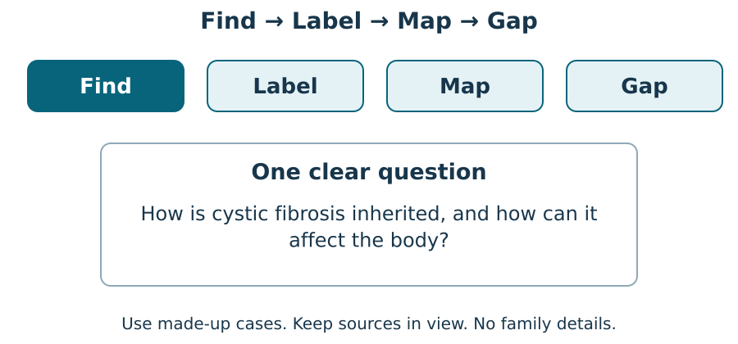
Use a clear question. Find two NHS sources. Keep the question beside your work. What does each source help you find out?

Label
Present inheritance and one biological effect.
Connect claims to two visible source labels.
Answer a question without exceeding the evidence.

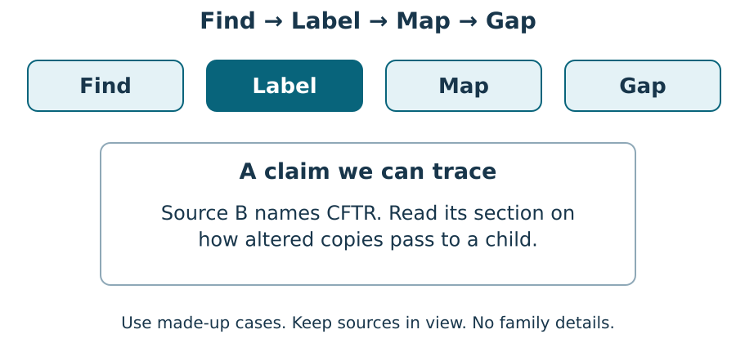
Name who wrote it and the page title. Keep the date and the claim. Show the line you used. What does it support?

Map
Present inheritance and one biological effect.
Connect claims to two visible source labels.
Answer a question without exceeding the evidence.

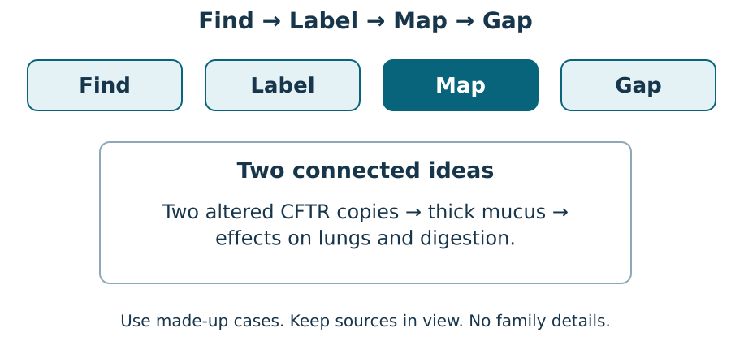
Link the gene copies to an effect on the body. Keep one limit. Point to each link and say what the sources show.

Keep a gap visible
Present inheritance and one biological effect.
Connect claims to two visible source labels.
Answer a question without exceeding the evidence.

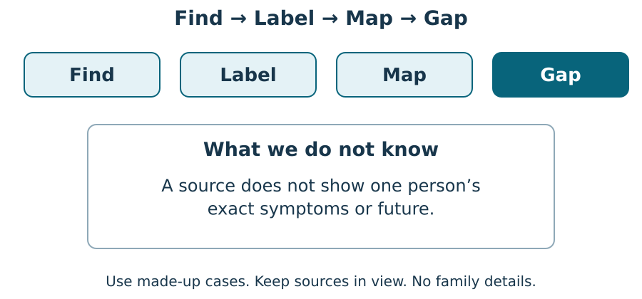
Say what the source shows. Then say what it cannot show about one person. What would you need to check next?

We do · sort with evidence
Present inheritance and one biological effect.
Connect claims to two visible source labels.
Answer a question without exceeding the evidence.

Choose a group for each card. Give the source clue for one choice.
Card | Your group
A bounded question | ________________
An accurate inheritance model | ________________
Visible source labels | ________________
A stated uncertainty | ________________
Private details about a classmate | ________________
A guaranteed prediction for one person | ________________

Groups: Keep in my work / Remove or change.
One partner explains. The other asks for the clue. Swap roles. Keep your own first answer, feedback and next step.

I do 2 · a worked example
Present inheritance and one biological effect.
Connect claims to two visible source labels.
Answer a question without exceeding the evidence.

Hear the question. Which part can your sources answer?
Point to the line that helps. Say what it shows.
If there is a gap, say so. The source may show how CF is passed on but not one person’s future.
Name the evidence you would need. Do not make up an answer to fill the gap.

Four panels · planning sheet
Present inheritance and one biological effect.
Connect claims to two visible source labels.
Answer a question without exceeding the evidence.

Plan one claim for each panel. Show the source for each claim. Use two named sources. Keep one limit. You may show it to your partner, write or direct a scribe.
Panel | My own explanation
1. A bounded question | ________________________
2. Recessive inheritance model | ________________________
3. One effect and its source | ________________________
4. Two sources and one uncertainty | ________________________

My chosen mode: ____________________

Audience question and my response
Present inheritance and one biological effect.
Connect claims to two visible source labels.
Answer a question without exceeding the evidence.

Audience question: will every person with CF have exactly the same symptoms?
What my sources support: ____________________
What they do not establish: ____________________
A responsible next check: ____________________
What the adult heard: ____________________
My next response, or why I kept it: ____________________
Keep your first answer. Hear what the adult noticed. Make one real change, or give a reason to keep it. Ask for a read-back if it helps.

Staff answers · shared work
Starter
An honest boundary protects accuracy and respect. Not every question can be answered from the chosen sources.
Worked example
Answer an audience question that is outside the source evidence.
Listen to the actual question.
Identify which part your sources do and do not address.
Say: “These sources explain general inheritance, not that person’s future.”
Name the missing evidence without inventing a confident answer.
Shared evidence task
A good response links two altered CFTR alleles with recessive inheritance, explains one effect such as thick mucus, identifies A and B appropriately and does not predict individual severity. Response mode is not part of the science judgement.
Card placements
Card | Group
A bounded question | Keep in my work
An accurate inheritance model | Keep in my work
Visible source labels | Keep in my work
A stated uncertainty | Keep in my work
Private details about a classmate | Remove or change
A guaranteed prediction for one person | Remove or change

Staff answers · Supported
Arrival
1. Focus: How the condition is inherited and how it can affect the body.
2. Source: Give a clear source label/title/link connected to the claim.
3. Uncertainty: “These sources do not establish that; I would need further evidence.”
4. Choice: No.
Independent / application
1. Create: Accept a coherent question, inheritance model, biological effect, sources and uncertainty.
2. Present: Judge biological accuracy, traceable evidence and a clear limitation; not confidence, eye contact or amount of writing.
3. Respond: No. Symptoms and severity vary; the classroom sources do not predict an individual’s exact experience.
Two-check exit
1. Explain: For example: cystic fibrosis usually involves altered CFTR copies inherited from both parents. This affects salt/water movement and can lead to thick mucus affecting lungs and digestion.
2. Qualify: For example, these sources cannot predict an individual’s exact symptoms or severity.

Staff answers · Independent
Arrival
1. Focus: How the condition is inherited and how it can affect the body.
2. Source: Give a clear source label/title/link connected to the claim.
3. Uncertainty: “These sources do not establish that; I would need further evidence.”
4. Choice: No.
Independent / application
1. Create: Accept a coherent question, inheritance model, biological effect, sources and uncertainty.
2. Present: Judge biological accuracy, traceable evidence and a clear limitation; not confidence, eye contact or amount of writing.
3. Respond: No. Symptoms and severity vary; the classroom sources do not predict an individual’s exact experience.
Two-check exit
1. Explain: For example: cystic fibrosis usually involves altered CFTR copies inherited from both parents. This affects salt/water movement and can lead to thick mucus affecting lungs and digestion.
2. Qualify: For example, these sources cannot predict an individual’s exact symptoms or severity.

Staff answers · Aspire
Arrival
1. Focus: How the condition is inherited and how it can affect the body.
2. Source: Give a clear source label/title/link connected to the claim.
3. Uncertainty: “These sources do not establish that; I would need further evidence.”
4. Choice: No. Accept a scientifically correct reason that uses the relevant model or evidence.
Independent / application
1. Create: Accept a coherent question, inheritance model, biological effect, sources and uncertainty.
2. Present: Judge biological accuracy, traceable evidence and a clear limitation; not confidence, eye contact or amount of writing.
3. Refine for audience: For example: “CF is usually inherited when a child receives an altered CFTR copy from each parent; effects vary between people” (Source B).
Two-check exit
1. Explain: For example: cystic fibrosis usually involves altered CFTR copies inherited from both parents. This affects salt/water movement and can lead to thick mucus affecting lungs and digestion.
2. Refine for audience: For example: “CF is usually inherited when a child receives an altered CFTR copy from each parent; effects vary between people” (Source B).

Staff guidance · pair, access and feedback
The pair works with a shared model and individual evidence. One explains and one asks for the clue, then they swap. Hear both independent reasons before moving on. Re-model an unsure learner’s step and use a fresh parallel question while the other continues.
No cold calling or forced public reading. A learner may pass. Point, sign, speak, draw, type, write, direct an adult or use exact scribing. Read the task exactly when needed. Keep the science challenge and allow planning in any language. EAL is language, not SEN.
Use a stable tray or large cards and the agreed accessible input. Give processing time. Agree a quiet supervised pause and a brief first–then cue. Re-enter at the last completed step. Do not gather evidence while a learner is distressed.
Record actual VF, WS, I, NS(+), E, R, // and ? only when they occur. Keep deepest adult prompt separate from the pupil response. A real adult receives and names back the science. R requires the pupil’s response to an NS(+) next step and real Audience; never award it for a click or completion. Keep the pupil’s own wording and own-colour response.

Staff guidance · evidence and handover
Keep each first response, result or labelled explanation, the feedback and the pupil’s edit or justified decision to keep it. E requires an observable curriculum action on [SYS]. Use SCI-LAUNCH-A2-W06-L3 for written, spoken, practical or photographic evidence. Record prompt level, response mode, support faded and what was independent.
At Independent agree actual adult roles and swap across the week. If one adult attends, use the actual staffing plan. Follow individual support and behaviour plans. Record access, regulation and curriculum actions against the learner’s own targets without recording a diagnosis as evidence.
If behind, preserve each source-linked claim, each learner’s response and the safety teaching. After a secure check shorten repeated oral rehearsal. Record any change, reason and coverage impact. Pass checked understanding, deepest prompt and unresolved errors to Week 7. Do not replace incomplete individual work with a group product.
Evaluation: date taught; delivered as planned; criteria met; actual adaptations and reasons; changes to the scheme and coverage; evidence banked. Source evidence mapping remains [AWARD] [QUAL]; no unit or qualification award is claimed by this lesson.

Staff · sources and lesson scope
Weekly outcome: Research a genetic condition online; present.
Exact goal: Present an accurate, source-linked explanation and respond to a question without exceeding the evidence.
Source: Launch/W14-W15_2026-27/SCI_L_W14L3_Genetic_Condition_Presentation_Do.html; revision c4ca8ffab98e6186a9ef2fed3921644b177f0d6d.
Workbook: _authoring/science_2026-27/_toolchain/scheme_references/LAUNCH_SOW.xlsx; LAUNCH Weekly - Autumn B44 Aut2·W6; C44 above.
The workbook says online. Preserve the accepted prepared offline source-card route; teacher-opened full sources are optional, with no automatic external loads and no pupil phone required.
Source A: NHS, Cystic fibrosis. https://www.nhs.uk/conditions/cystic-fibrosis/
Source B: NHS Genomics Education, Cystic fibrosis. https://www.genomicseducation.hee.nhs.uk/genotes/knowledge-hub/cystic-fibrosis/
Both pages checked 24 October 2026. Use the source cards for classroom access, with the full source for checking. Do not diagnose or invite personal medical disclosure.
The two NHS sources serve different audiences and are not fully independent. Current Source A does not explicitly state the salt/water mechanism; the classroom card does not attribute that sentence to it.
No [AWARD] or [QUAL] assessment alignment is newly asserted. Career link: a genetic counsellor explains chances and limits with care.

TA brief · access and source checks
Agree who supports each learner. Swap roles across the week. Hear each learner’s first response. Point, sign, speak, draw, type or write. You may pass or pause. An adult can read or scribe your exact words. Plan in any language.
Use large source cards and a clear desk. Keep the question and source beside the task. Let the pupil point to the line before asking for a full explanation.
Least prompt first: wait; point to the source; ask one short question; rephrase; model a different example, then return the task. Record deepest prompt separately from independence.
I do: name the source and the claim. We do: ask which line supports it. Independent: help access the card while keeping the learner’s science decision.
No cold calling, forced public reading or disclosure. Agree a private pause and re-entry at the last completed step. No evidence collection during distress.
Use fictional cases. Do not ask for family details or predict a person’s future. Inheritance and infection precautions are separate matters.
Use prepared cards and fictional cases. No biological samples, family history or diagnosis. Staff check local risk assessment and internet access.

TA brief · feedback and handover
Keep the first answer. The adult names back the pupil’s meaning. The pupil chooses a real edit or explains why to keep it.
Use VF, WS, I, NS(+), E, R, // and ? only when they occur. R requires the real response loop; a click or completed sheet alone is not enough.
Record valid spoken, written or directed evidence under SCI-LAUNCH-A2-W06-L3 on [SYS]. Keep each learner’s own claim, source, limit, actual feedback and next response.
Handover: checked criteria, misconception, prompt depth, independence, valid mode, adaptation and reason, next example. Follow the learner’s own plan and targets.
If behind, shorten secure rehearsal. Preserve each learner’s sourced explanation and exit. Record any coverage moved. Week 7 reviews autumn science.
Timing: Arrival 4 min; Starter 4 min; I do 5 min; We do 5 min; I do 2 4 min; We do 2 4 min; Independent 10 min; Exit 4 min. Total 40 minutes. Alternate route views share the same stage time.

