Arrival
I can order copy, separate and split for mitosis.
I can mark one gene as part of DNA.
I can use a simple cross as probability, not a promise.

Look at the cell and allele models. Point to one detail you notice.
Point, sign, speak, draw, type or write. An adult may read or scribe your exact words. You may pass or take an agreed pause. Plan in any language.

Three rehearsal models
I can order copy, separate and split for mitosis.
I can mark one gene as part of DNA.
I can use a simple cross as probability, not a promise.

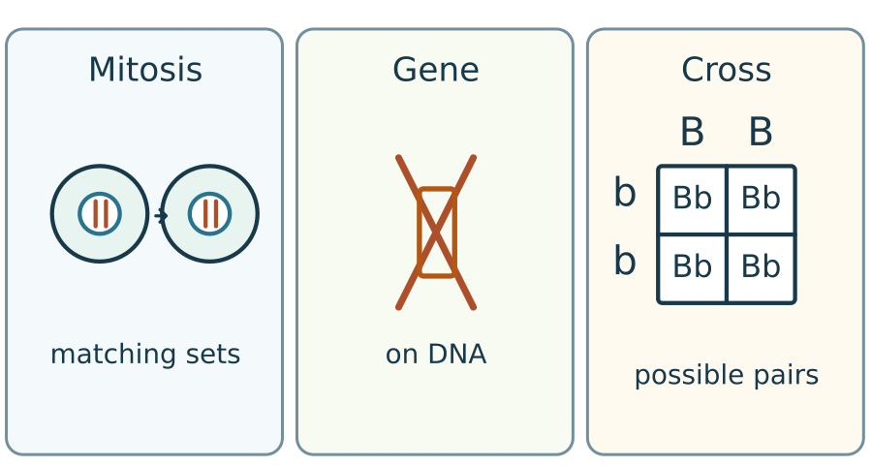
These are separate model pictures. The rehearsal cross is BB × bb. Put these pictures away before your own check. Sizes do not match real life.

Starter
I can order copy, separate and split for mitosis.
I can mark one gene as part of DNA.
I can use a simple cross as probability, not a promise.

Show one answer at a time. Keep your first try.
1. Which named source supports our cystic fibrosis card?
2. How does a gene relate to DNA?
3. Which part of an animal cell holds chromosomes?

Word page
I can order copy, separate and split for mitosis.
I can mark one gene as part of DNA.
I can use a simple cross as probability, not a promise.

Word | Meaning | Example
mitosis | division of the nucleus to separate matching chromosome sets | Mitosis helps make matching body cells.
gene | a section of DNA that codes for a protein | A gene is a part of the DNA string.
allele | a version of a gene | A and a stand for two alleles in our invented model.
evidence | a fact or model detail that supports a claim | The labelled chromosome sets are evidence for my answer.

Use your own language to plan or explain these words.

I do · a parallel model
I can order copy, separate and split for mitosis.
I can mark one gene as part of DNA.
I can use a simple cross as probability, not a promise.

Label a body-cell model with copied chromosome sets. Explain that mitosis separates them into two nuclei. Point to a detail that supports your answer. Cover the labels before your own check.
Show me: does describe need a model detail or a personal story?

We do · the missing step
I can order copy, separate and split for mitosis.
I can mark one gene as part of DNA.
I can use a simple cross as probability, not a promise.

The chromosome sets are copied. Mitosis moves the sets to ___ nuclei. The detail I used is ___.
Supported: use a different model and the command words first.
Independent: explain which model detail supports a claim.
Aspire: give a limit. A diagram shows order, but leaves out some steps.
Choose first on your own. One partner explains and the other asks for the clue. Swap roles. Each learner keeps their own response.
Take an agreed reset within this stage.

We do · match the evidence
I can order copy, separate and split for mitosis.
I can mark one gene as part of DNA.
I can use a simple cross as probability, not a promise.

Card | Your match
Two matching chromosome sets | ________________
Short marked part of a DNA string | ________________
Four possible allele pairs | ________________

Groups: Cell model, DNA model, Cross model. Give a reason for one match.

We do 2 · choose a statement
I can order copy, separate and split for mitosis.
I can mark one gene as part of DNA.
I can use a simple cross as probability, not a promise.

Which paired statement is scientifically accurate?
A. Mitosis halves chromosome number; a gene is the whole genome.
B. Mitosis removes DNA; an allele is a separate cell.
C. Mitosis makes one unsplit cell; DNA is only in proteins.
D. Mitosis gives matching body cells; a gene is a section of DNA.
Choose privately. Show your answer to the adult. Then give your reason.

Independent · Supported
I can order copy, separate and split for mitosis.
I can mark one gene as part of DNA.
I can use a simple cross as probability, not a promise.

Complete a short three-part check: order copy/separate/split, mark a gene on DNA, and use Aa × aa to state a possible pair and chance.
Order the three stages and mark one gene on the model. Then use the cross.
First ___; then ___; last ___.
Use the blank check sheet. Put the rehearsal model away. Work on your own for the full 8 minutes. Keep your first response.

Independent · Independent
I can order copy, separate and split for mitosis.
I can mark one gene as part of DNA.
I can use a simple cross as probability, not a promise.

Complete a short three-part check: order copy/separate/split, mark a gene on DNA, and use Aa × aa to state a possible pair and chance.
Explain matching body cells and why a gene is only part of DNA.
The model shows ___ because ___.
Use the blank check sheet. Put the rehearsal model away. Work on your own for the full 8 minutes. Keep your first response.

Independent · Aspire
I can order copy, separate and split for mitosis.
I can mark one gene as part of DNA.
I can use a simple cross as probability, not a promise.

Complete a short three-part check: order copy/separate/split, mark a gene on DNA, and use Aa × aa to state a possible pair and chance.
Use Aa × aa to reject the claim that a probability promises an exact family count.
The model chance is ___; the real count may differ because ___.
Use the blank check sheet. Put the rehearsal model away. Work on your own for the full 8 minutes. Keep your first response.

My own check · cells and DNA
I can order copy, separate and split for mitosis.
I can mark one gene as part of DNA.
I can use a simple cross as probability, not a promise.

1. Put these stages in order: Split / Copy / Separate. Explain what each step does.
My order and reason: ______________________________
2. Mark one short part of the DNA string as a gene in this simple model. Explain your mark.
DNA string model
A T C G G T A T C G

This short string is a model, not a real gene sequence.
My explanation: ______________________________

My own check · a chance
I can order copy, separate and split for mitosis.
I can mark one gene as part of DNA.
I can use a simple cross as probability, not a promise.

3. Use Aa × aa. Label the top and side, fill each box, then give one possible pair and its chance.
Side / top | ______ | ______
____________ | ______ | ______
____________ | ______ | ______

My possible pair and chance: __________________
Does this promise an exact family count? My reason: __________________
This is an invented one-gene model. Keep personal and family details private.

After the check · two claims
I can order copy, separate and split for mitosis.
I can mark one gene as part of DNA.
I can use a simple cross as probability, not a promise.

After you hand in your first response, judge these claims.
Claim A: two aa boxes out of four promise exactly two aa children in every family of four.
Claim B: if two offspring are not aa, the next one must be aa.
Name each error. Repair it with a reason. Keep this work separate from the checked answer.

Review
I can order copy, separate and split for mitosis.
I can mark one gene as part of DNA.
I can use a simple cross as probability, not a promise.

Keep your first answer. Hear the actual feedback. Make one real change, or give a reason to keep it. Record the next step you chose.
Mark a true self-edit // and ask for a read-back ? if it helps.
Actual feedback: __________________
My change, or why I kept it: __________________

Exit
I can order copy, separate and split for mitosis.
I can mark one gene as part of DNA.
I can use a simple cross as probability, not a promise.

Show one correct model detail and explain how it supports your answer.
My feedback was: __________________
Next I need to: __________________
Choose one model error to repair and explain in the next lesson.

Knowledge organiser
I can order copy, separate and split for mitosis.
I can mark one gene as part of DNA.
I can use a simple cross as probability, not a promise.

I am learning to use cell and inheritance models to show what I know and choose one next step.
DNA is copied before mitosis. The copies separate into matching sets in two nuclei. The cell then splits.
A chromosome contains DNA. A gene is one section of DNA. An allele is a version of a gene.
A simple cross shows possible allele pairs and their chances. It does not promise an exact family count.
Use a model detail as evidence. State one limit. Keep your first answer and one precise next step.

Staff answers · checks and next steps
Starter: the NHS public page and NHS Genomics Education Programme support the earlier prepared CF card. A gene is a section of DNA. Animal-cell chromosomes are in the nucleus. Check actual earlier coverage; do not presume it.
Model: copied chromosome sets separate into two nuclei. Describe needs a model detail. Missing word: two. Sort: Cell model; DNA model; Cross model.
Hinge D. A confuses mitosis with halving and gene with genome. B treats DNA as used up and an allele as a cell. C misses cell splitting and confuses DNA with protein. Hear both learners privately. Re-model the unsure idea using a different example, then ask: is a gene a marked DNA section, a whole organism, a cell outside DNA, or an empty grid? Expected: a marked section.
Own check: Copy, Separate, Split. Copy during interphase; mitosis separates complete chromosome sets into nuclei; cytokinesis splits the cell. The pupil marks a short subsection of the model DNA and explains that a gene is part of DNA, not the whole genome.
Aa × aa gives Aa, Aa, aa, aa. Accept transposed grids and a valid two-box model with equal weights. Aa and aa each have a 50% chance per fertilisation. A family count need not match the predicted ratio.
After-check claims: A mistakes chance for a fixed count. B treats previous outcomes as using up chance. Each fertilisation is independent in this model. Keep corrections distinct from the first check.
Rehearsal cross changed to BB × bb, giving Bb throughout, so the displayed cross differs from the Aa × aa check. No personal inference is allowed.

Staff · source and assessment scope
Weekly outcome: Topics 2 to 3 assessment (Dec).
Exact goal: I am learning to use cell and inheritance models to show what I know and choose one next step.
Source: Launch/Autumn_2_2026-27/SCI_LAUNCH_A2_W07/SCI_LAUNCH_A2_W07.html; revision c4ca8ffab98e6186a9ef2fed3921644b177f0d6d.
Workbook: _authoring/science_2026-27/_toolchain/scheme_references/LAUNCH_SOW.xlsx; LAUNCH Weekly - Autumn B45 Aut2·W7; C45 above.
The classroom checkpoint samples taught Autumn 2 content. It does not assess every topic point or give a [QUAL] grade. Keep raw evidence, access arrangements and actual content support distinct.
Use fictional allele models and supplied study data. No family history, diagnosis or prediction about an individual is invited.
Keep the real first answer, precise feedback and the pupil’s next response. Marking codes require an actual event; clicks or completed boxes give no automatic R, E, Audience or Influence credit.
Spring 1 scheme lines await owner confirmation. Record any unfinished coverage and hand over the evidence without inventing the next lesson.

TA brief · access and materials
Two learners. In rehearsal, one explains and one checks the clue, then swap. Each chooses privately first. Hear both at each hinge. Re-model only the unsure step; the secure learner tries a fresh example. Keep two individual records.
For the pair: two pupil record or paper sets, two pens, one tray of large prepared model/card pieces, and one staff key kept out of sight. Teacher device/projector optional. Provide two blank model/cross mats and one set of rehearsal cards. No practical or biological sample is required.
Use prepared cards and large model pieces on a tray. No biological samples or personal family details. Check the local risk assessment. No forced touch, cutting, public reading or pupil phone.
Point, sign, speak, draw, type or write. An adult may read or scribe your exact words. You may pass or take an agreed pause. Plan in any language.
No cold calling or public comparison. Use an agreed quiet pause and one-step re-entry. Follow each pupil’s plan; no evidence collection during distress.
Use the least prompt first: wait; point to the instruction; ask one short question; rephrase; model a different example. Return the science decision to the learner. Keep independent check items unsupported by answer cues.

TA brief · evidence and handover
Agree who supports each learner before the lesson. Record the response mode, deepest prompt, actual science and any unresolved error. Keep adult words separate from the pupil’s words.
Keep rehearsal separate from the first independent response. After collection, the adult names back the pupil’s meaning, offers a precise next step and hears the pupil’s response.
Record real VF, WS, I, NS(+), E, R, // and ? events under SCI-LAUNCH-A2-W07 on [SYS]. R needs Voice, Audience, a next-step prompt and the pupil’s own response. Never infer evidence from a click.
If behind, shorten secure rehearsal. Preserve each learner’s own response and record any moved coverage. Do not invent the Spring 1 task.
Timing: Arrival 5 min; Starter 3 min; I do 5 min; We do 7 min; We do 2 5 min; Independent 8 min; Review 4 min; Exit 3 min. Total 40 minutes. Alternatives and continuations share each stage clock.

