Arrival · Supported
Respond to the command word.
Select a value or mechanism that supports the answer.
Improve a claim by adding an appropriate limitation.

Four checks. Point, speak, sign, draw, write or direct an adult. An adult may read or scribe your exact words. Choose one route; do not complete all three.
1. Describe
What does “describe” ask you to do?
Help: Read or point first. State the pattern or what happens.
2. Explain
What must an explanation add?
Help: Read or point first. A scientific reason or link.
3. Calculate
What should accompany a calculated answer?
Help: Read or point first. Working and any appropriate units.
4. Evaluate
What should an evaluation consider?
Help: Read or point first. Evidence and limitations, not just an opinion.
My response: ______________________________

Independent · Supported
Respond to the command word.
Select a value or mechanism that supports the answer.
Improve a claim by adding an appropriate limitation.

Point, speak, sign, draw, write or direct an adult. An adult may read or scribe your exact words. Choose one route; do not complete all three.
1. Explain
Improve the mitosis answer in two linked sentences.
Help: Use two linked sentences: DNA is copied during ___. The copies then ___ so each new nucleus ___.
2. Calculate
Show the working for 7/20 as a percentage.
Help: Write the fraction 7/20. Divide 7 by 20, then multiply by 100. Show the intermediate decimal.
3. Evaluate
Replace the safety claim with a qualified conclusion and a relevant improvement.
Help: Use: the study suggests ___, but does not establish ___. A useful improvement would be ___ because ___.
My response: ______________________________
Use one route within the stated stage time. Keep your own original response.

Exit · Supported
Respond to the command word.
Select a value or mechanism that supports the answer.
Improve a claim by adding an appropriate limitation.

1. Improve
Improve “the cells grew” using a supplied change from 2.0 to 2.8 mm.
Help: Use: my answer is ___ because ___. Point to a model or card first. Use a value and unit; do not invent a cause.
2. Explain
Why is “because it does” not a useful explanation of identical daughter nuclei?
Help: Use: my answer is ___ because ___. Point to a model or card first. Add copying and separation.
My response: ______________________________

Arrival · Independent
Respond to the command word.
Select a value or mechanism that supports the answer.
Improve a claim by adding an appropriate limitation.

Four checks. Point, speak, sign, draw, write or direct an adult. An adult may read or scribe your exact words. Choose one route; do not complete all three.
1. Describe
What does “describe” ask you to do?
Help: State the pattern or what happens.
2. Explain
What must an explanation add?
Help: A scientific reason or link.
3. Calculate
What should accompany a calculated answer?
Help: Working and any appropriate units.
4. Evaluate
What should an evaluation consider?
Help: Evidence and limitations, not just an opinion.
My response: ______________________________

Independent · Independent
Respond to the command word.
Select a value or mechanism that supports the answer.
Improve a claim by adding an appropriate limitation.

Point, speak, sign, draw, write or direct an adult. An adult may read or scribe your exact words. Choose one route; do not complete all three.
1. Explain
Improve the mitosis answer in two linked sentences.
Help: Use before / then / so.
2. Calculate
Show the working for 7/20 as a percentage.
Help: Divide, multiply by 100, add %.
3. Evaluate
Replace the safety claim with a qualified conclusion and a relevant improvement.
Help: Match the improvement to short follow-up.
My response: ______________________________
Use one route within the stated stage time. Keep your own original response.

Exit · Independent
Respond to the command word.
Select a value or mechanism that supports the answer.
Improve a claim by adding an appropriate limitation.

1. Improve
Improve “the cells grew” using a supplied change from 2.0 to 2.8 mm.
Help: Use a value and unit; do not invent a cause.
2. Explain
Why is “because it does” not a useful explanation of identical daughter nuclei?
Help: Add copying and separation.
My response: ______________________________

Arrival · Aspire
Respond to the command word.
Select a value or mechanism that supports the answer.
Improve a claim by adding an appropriate limitation.

Four checks. Point, speak, sign, draw, write or direct an adult. An adult may read or scribe your exact words. Choose one route; do not complete all three.
1. Describe
What does “describe” ask you to do?
Help: State the pattern or what happens.
2. Explain
What must an explanation add?
Help: A scientific reason or link.
3. Calculate
What should accompany a calculated answer?
Help: Working and any appropriate units.
4. Evaluate
What should an evaluation consider? Give a reason.
Help: Evidence and limitations, not just an opinion.
My response: ______________________________

Independent · Aspire
Respond to the command word.
Select a value or mechanism that supports the answer.
Improve a claim by adding an appropriate limitation.

Point, speak, sign, draw, write or direct an adult. An adult may read or scribe your exact words. Choose one route; do not complete all three.
1. Explain
Improve the mitosis answer in two linked sentences.
Help: Use before / then / so.
2. Calculate
Show the working for 7/20 as a percentage.
Help: Divide, multiply by 100, add %.
3. Choose evidence
A response lists four numbers but explains none. How would you improve it without making it much longer?
Help: Select the most relevant comparison and link it to the conclusion.
My response: ______________________________
Use one route within the stated stage time. Keep your own original response.

Exit · Aspire
Respond to the command word.
Select a value or mechanism that supports the answer.
Improve a claim by adding an appropriate limitation.

1. Improve
Improve “the cells grew” using a supplied change from 2.0 to 2.8 mm.
Help: Use a value and unit; do not invent a cause.
2. Choose evidence
A response lists four numbers but explains none. How would you improve it without making it much longer?
Help: Select the most relevant comparison and link it to the conclusion.
My response: ______________________________

Word page
Respond to the command word.
Select a value or mechanism that supports the answer.
Improve a claim by adding an appropriate limitation.

Word | Meaning
Describe | Say what happens or what the evidence shows.
Explain | Connect a statement to a scientific reason.
Calculate | Use values and show the working.
Evaluate | Weigh evidence and identify a limitation.
Evidence | A value, observation or source supporting a claim.
Independent event | An outcome that does not determine the next outcome.

Reference for teaching or later review. Use the command word to choose the kind of answer.

Knowledge organiser
Respond to the command word.
Select a value or mechanism that supports the answer.
Improve a claim by adding an appropriate limitation.

Use command words, selected evidence and a clear scientific link to improve exam-style responses.
Copy DNA before mitosis. Each daughter cell retains the chromosome set.
Stem cell evidence needs benefits, risks and uncertainty.
A gene is a section of DNA. DNA has complementary base pairs: A with T, and C with G.
A genetic cross predicts a chance for each fertilisation.
Reference for teaching or later review. Choose evidence and add the scientific link.

Starter
Respond to the command word.
Select a value or mechanism that supports the answer.
Improve a claim by adding an appropriate limitation.

Which answer best explains identical daughter nuclei?
A. They are identical because they match
B. DNA is copied, then chromosome copies are separated into two complete sets
C. The cell gets bigger
Keep your first choice. Give a reason before the answer is checked.

Cells
Respond to the command word.
Select a value or mechanism that supports the answer.
Improve a claim by adding an appropriate limitation.

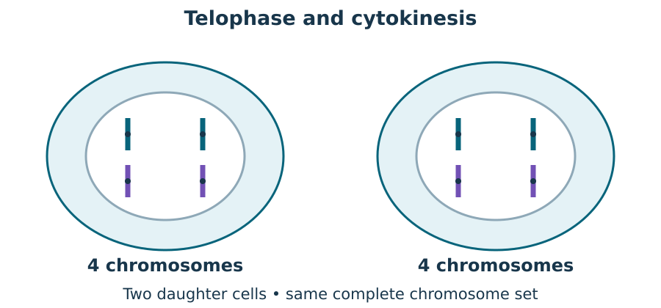
The DNA is copied before mitosis. The copies move apart into two sets. Each new cell gets a full set of genes.

Evidence
Respond to the command word.
Select a value or mechanism that supports the answer.
Improve a claim by adding an appropriate limitation.

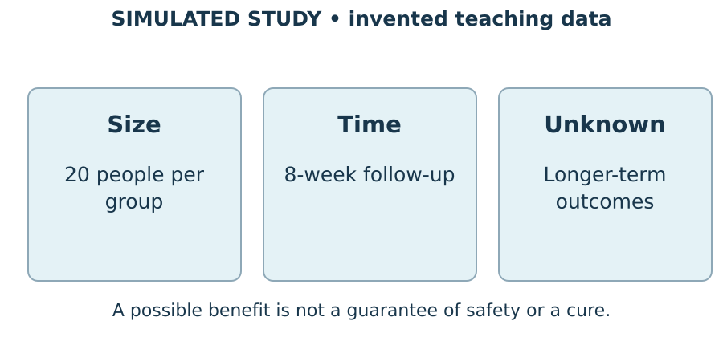
Use numbers and a comparison before making a stem cell claim.

Genetic information
Respond to the command word.
Select a value or mechanism that supports the answer.
Improve a claim by adding an appropriate limitation.

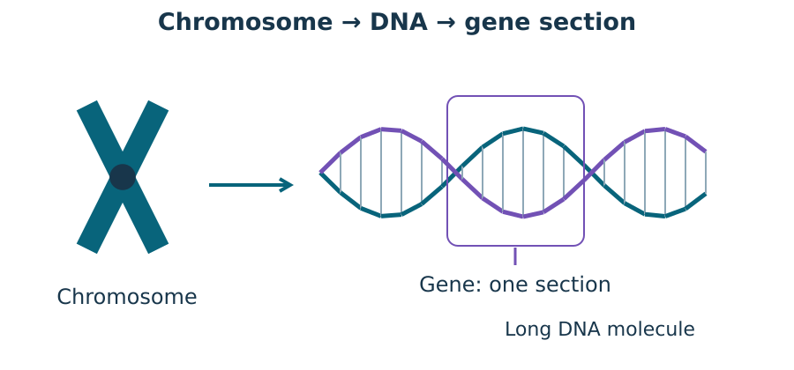
Connect nucleus, chromosome, DNA and gene; pair A–T and C–G.

Inheritance
Respond to the command word.
Select a value or mechanism that supports the answer.
Improve a claim by adding an appropriate limitation.

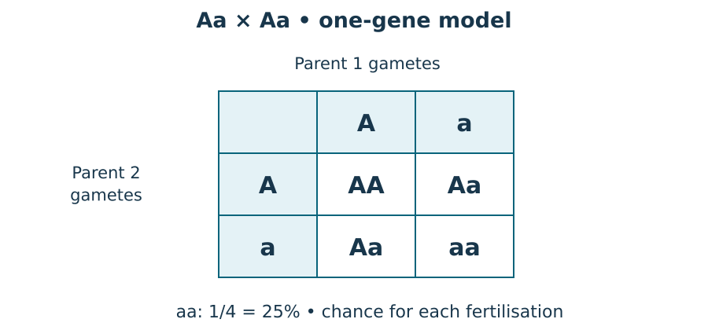
Use gametes and a Punnett square, then interpret chance cautiously.

We do · sort the cards
Respond to the command word.
Select a value or mechanism that supports the answer.
Improve a claim by adding an appropriate limitation.

Card | Your group
The length rose from 2.0 to 2.8 mm | ________________
Chromosomes line up at the centre | ________________
Copies separate so each nucleus receives a full set | ________________
A root hair increases surface area for absorption | ________________
The small sample limits generalisation | ________________
A benefit is possible, but harms and follow-up matter | ________________

Groups: Describe / Explain / Evaluate.
Choose first on your own. One partner explains and the other asks for the clue. Swap roles. Each learner keeps their own response.

I do 2 · one example
Respond to the command word.
Select a value or mechanism that supports the answer.
Improve a claim by adding an appropriate limitation.

Find the percent for 8 out of 25.
8 ÷ 25 = 0.32.
0.32 × 100 = 32%.
In this sample, 32 in each 100 is the same share as 8 in 25.
The sample may differ from a wider group. We cannot give that group’s chance from this result alone.

Three practice answers
Respond to the command word.
Select a value or mechanism that supports the answer.
Improve a claim by adding an appropriate limitation.

These are practice items, not the final test. Keep each first answer. Add a science link or a useful value, and qualify a claim that is too strong.
Prompt | Weak answer
Explain mitosis outcome | The cells match because they match
Calculate 7/20 as percent | It is about a third
Evaluate a short study | It proves the treatment is safe forever

My evidence and reasoning: __________________
One limit or useful check: __________________

My improvement and next check
Respond to the command word.
Select a value or mechanism that supports the answer.
Improve a claim by adding an appropriate limitation.

First answer: __________________
The value or model detail I used: __________________
My science link: __________________
My fair limit: __________________
Keep your first answer. Hear the actual feedback. Make one real change, or give a reason to keep it. Record the next step you chose.
My next response: __________________

Staff answers · shared work
Starter
The second gives a linked mechanism rather than repeating the outcome.
Worked example
Calculate 8/25 as a percentage and interpret it carefully.
8 ÷ 25 = 0.32.
0.32 × 100 = 32%.
This describes the observed fraction in that sample.
It does not by itself prove a general population probability.
Shared evidence task
Explain: DNA is copied before mitosis and chromosome copies separate into complete matching sets. Calculate: 7 ÷ 20 × 100 = 35%. Evaluate: short follow-up cannot establish long-term safety; more appropriate evidence is needed.
Card placements
Card | Group
The length rose from 2.0 to 2.8 mm | Describe
Chromosomes line up at the centre | Describe
Copies separate so each nucleus receives a full set | Explain
A root hair increases surface area for absorption | Explain
The small sample limits generalisation | Evaluate
A benefit is possible, but harms and follow-up matter | Evaluate

Staff answers · Supported
Arrival
1. Describe: State relevant features, events or a pattern.
2. Explain: A reason linking how or why the event happens.
3. Calculate: Relevant working and appropriate units.
4. Evaluate: Strengths or benefits, limitations or risks, and a justified conclusion.
Independent / application
1. Explain: DNA is copied before mitosis. Copies separate so each daughter nucleus gets a complete identical set.
2. Calculate: 7 ÷ 20 × 100 = 35%.
3. Evaluate: Short follow-up leaves long-term safety uncertain; extend follow-up and record later adverse events.
Two-check exit
1. Improve: The sample length increased by 0.8 mm, from 2.0 to 2.8 mm; length alone does not show which growth processes caused it.
2. Explain: It lacks a mechanism. Explain that DNA is copied before mitosis and the copies are shared into two complete sets.

Staff answers · Independent
Arrival
1. Describe: State relevant features, events or a pattern.
2. Explain: A reason linking how or why the event happens.
3. Calculate: Relevant working and appropriate units.
4. Evaluate: Strengths or benefits, limitations or risks, and a justified conclusion.
Independent / application
1. Explain: DNA is copied before mitosis. Copies separate so each daughter nucleus gets a complete identical set.
2. Calculate: 7 ÷ 20 × 100 = 35%.
3. Evaluate: Short follow-up leaves long-term safety uncertain; extend follow-up and record later adverse events.
Two-check exit
1. Improve: The sample length increased by 0.8 mm, from 2.0 to 2.8 mm; length alone does not show which growth processes caused it.
2. Explain: It lacks a mechanism. Explain that DNA is copied before mitosis and the copies are shared into two complete sets.

Staff answers · Aspire
Arrival
1. Describe: State relevant features, events or a pattern.
2. Explain: A reason linking how or why the event happens.
3. Calculate: Relevant working and appropriate units.
4. Evaluate: Strengths or benefits, limitations or risks, and a justified conclusion. Accept a scientifically correct reason that uses the relevant model or evidence.
Independent / application
1. Explain: DNA is copied before mitosis. Copies separate so each daughter nucleus gets a complete identical set.
2. Calculate: 7 ÷ 20 × 100 = 35%.
3. Choose evidence: Keep the decisive benefit or risk comparison, explain what it supports and state one limit; remove irrelevant values.
Two-check exit
1. Improve: The sample length increased by 0.8 mm, from 2.0 to 2.8 mm; length alone does not show which growth processes caused it.
2. Choose evidence: Keep the decisive benefit or risk comparison, explain what it supports and state one limit; remove irrelevant values.

Staff · source and assessment scope
Weekly outcome: Topics 2 to 3 assessment (Dec).
Exact goal: Use command words, selected evidence and a clear scientific link to improve exam-style responses.
Source: Launch/Autumn2_W7_2026-27/SCI_L_A2_W7L2_Topics_2_3_Assessment_Explore.html; revision c4ca8ffab98e6186a9ef2fed3921644b177f0d6d.
Workbook: _authoring/science_2026-27/_toolchain/scheme_references/LAUNCH_SOW.xlsx; LAUNCH Weekly - Autumn B45 Aut2·W7; C45 above.
The classroom checkpoint samples taught Autumn 2 content. It does not assess every topic point or give a [QUAL] grade. Keep raw evidence, access arrangements and actual content support distinct.
Use fictional allele models and supplied study data. No family history, diagnosis or prediction about an individual is invited.
Keep the real first answer, precise feedback and the pupil’s next response. Marking codes require an actual event; clicks or completed boxes give no automatic R, E, Audience or Influence credit.
Spring 1 scheme lines await owner confirmation. Record any unfinished coverage and hand over the evidence without inventing the next lesson.

TA brief · access and materials
Two learners. In rehearsal, one explains and one checks the clue, then swap. Each chooses privately first. Hear both at each hinge. Re-model only the unsure step; the secure learner tries a fresh example. Keep two individual records.
For the pair: two pupil record or paper sets, two pens, one tray of large prepared model/card pieces, and one staff key kept out of sight. Teacher device/projector optional. Provide two blank model/cross mats and one set of rehearsal cards. No practical or biological sample is required.
Use prepared cards and large model pieces on a tray. No biological samples or personal family details. Check the local risk assessment. No forced touch, cutting, public reading or pupil phone.
Point, sign, speak, draw, type or write. An adult may read or scribe your exact words. You may pass or take an agreed pause. Plan in any language.
No cold calling or public comparison. Use an agreed quiet pause and one-step re-entry. Follow each pupil’s plan; no evidence collection during distress.
Use the least prompt first: wait; point to the instruction; ask one short question; rephrase; model a different example. Return the science decision to the learner. Keep independent check items unsupported by answer cues.

TA brief · evidence and handover
Agree who supports each learner before the lesson. Record the response mode, deepest prompt, actual science and any unresolved error. Keep adult words separate from the pupil’s words.
Keep rehearsal separate from the first independent response. After collection, the adult names back the pupil’s meaning, offers a precise next step and hears the pupil’s response.
Record real VF, WS, I, NS(+), E, R, // and ? events under SCI-LAUNCH-A2-W07-L2 on [SYS]. R needs Voice, Audience, a next-step prompt and the pupil’s own response. Never infer evidence from a click.
If behind, shorten secure rehearsal. Preserve each learner’s own response and record any moved coverage. Do not invent the Spring 1 task.
Timing: Arrival 4 min; Starter 4 min; I do 5 min; We do 5 min; I do 2 4 min; We do 2 4 min; Independent 10 min; Exit 4 min. Total 40 minutes. Alternatives and continuations share each stage clock.

