Humanities · BUILD · Autumn 2 · Week 2 · HUM_BUILD_A2_W02

Knowledge organiser
Reflect on peace and remembrance.
People can think of lives touched by war, learn from the past and hope for peace. Each person can choose how to show care.
Tier | Word | Meaning
Tier 3 | remembrance | Taking time to think of people and events from the past.
Tier 2 | peace | Life without fighting.
Tier 2 | respect | Treating people with care.
Tier 2 | symbol | A sign or thing that stands for an idea.
People remember ____. My ____ helps because ____.

Humanities · BUILD · Autumn 2 · Week 2 · HUM_BUILD_A2_W02

Poppy and quiet words
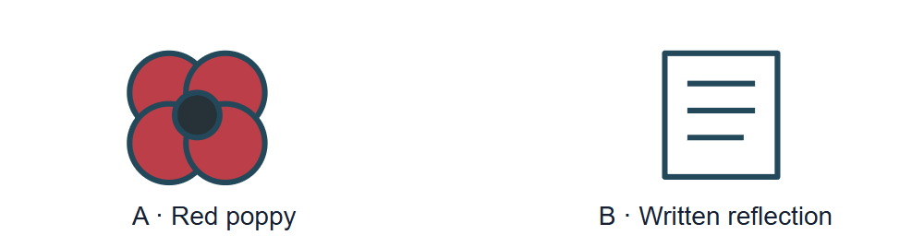
Picture A is a red poppy. Picture B is a sheet with quiet words.
Use card A with the poppy. Use card C to read a short line.

Humanities · BUILD · Autumn 2 · Week 2 · HUM_BUILD_A2_W02

Evidence cards A and B

A · Red poppy
The red poppy can help people remember those hurt by war. It can show hope for peace and support for people who serve or have served.
This card explains one use of the poppy. People remember in other ways too.

B · A choice
Each person can choose if they wear a poppy. People can show care by listening, learning or making a quiet sign.
A symbol does not tell us what someone thinks or feels.

Humanities · BUILD · Autumn 2 · Week 2 · HUM_BUILD_A2_W02

Evidence card C

C · Quiet caption
We think of people hurt by war. We learn from the past. We hope for peace.
These are class words. They give a broad thought about peace.

Humanities · BUILD · Autumn 2 · Week 2 · HUM_BUILD_A2_W02

Shared investigation
Pick a calm sign or short line. Say how a fact and a card label help us show care. You may point, work alone or pass.
1. Which card backs up a poppy sign?
2. Which card has a quiet line?
3. What can a card label do?
Choice | Think about
Poppy | What can this sign mean?
Quiet words | How do the words show care?
Card label | Which card backs up the fact?
Our explanation
____________________________________________________________

Optional · respond to feedback together
Optional: show an adult one fact or source label. Hear one piece of feedback. Reply with a change, a reason to keep it or a request for help. Keep your own thoughts private.
My response or improvement
____________________________________________________________

Humanities · BUILD · Autumn 2 · Week 2 · HUM_BUILD_A2_W02

We do decision checkpoint
One person wears a poppy. One person uses quiet words. Can both show care?
1. Yes, both can show care
2. Only a poppy can show care
3. Only words can show care
My claim and clue
____________________________________________________________

Humanities · BUILD · Autumn 2 · Week 2 · HUM_BUILD_A2_W02

Worked model

Ask why we remember
People whose lives were touched by war. We can show care and learn from the past.

Find a fact
Card A tells us what a red poppy can mean. A poppy can show hope for peace.

Make a short line
We think of people hurt by war. We hope for peace. Add card A for the link to peace. Card C gives a sample line.

Check the words
Use true words and keep the card label. No. A calm sign or short line can show care.

Humanities · BUILD · Autumn 2 · Week 2 · HUM_BUILD_A2_W02

Arrival Supported
 | Ready to learn?  ● Green · Ready  ● Amber · Help  ● Red · Pause  You may point, choose or pass.
  1. Point to the picture that matches the top one.  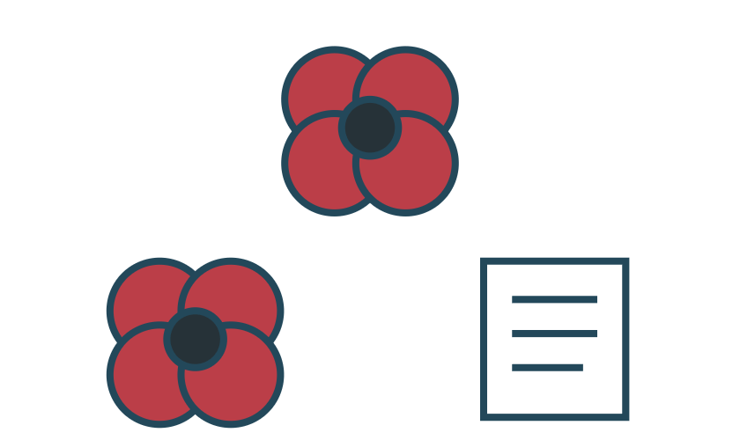  __________________  __________________ | 2. Do we take time to think of the past when we remember?  __________________  __________________
  3. What can the poppy stand for?  __________________  __________________ | 4. Do you have to wear a poppy to show care?  __________________  __________________
Point, speak, sign, draw, write or choose. You may pass. An adult may note your own words or choice.

Humanities · BUILD · Autumn 2 · Week 2 · HUM_BUILD_A2_W02

You do Supported
Staff mark I · S · C beside the task.
1. Start in your book. Pick a calm sign or a few words. You may give a private reply.
2. Use one fact from a card. Add the card label.
3. Say, point to or write why you chose that sign or word.
Word bank: peace · remember · care · hope.
My example and card detail
____________________________________________________________
My reason and check
____________________________________________________________
Point, speak, sign, draw, write or choose. You may pass. An adult may note your own words or choice.

Humanities · BUILD · Autumn 2 · Week 2 · HUM_BUILD_A2_W02

Review and exit Supported
Edit in the same colour, on the same page.
Why might people think of those hurt by war?
____________________________________________________________
What helps a short line show care?
____________________________________________________________
Point, speak, sign, draw, write or choose. You may pass. An adult may note your own words or choice.

Humanities · BUILD · Autumn 2 · Week 2 · HUM_BUILD_A2_W02

Arrival Independent
 | Ready to learn?  ● Green · Ready  ● Amber · Help  ● Red · Pause  You may point, choose or pass.
  1. Point to the picture that matches the top one.  __________________  __________________ | 2. What does remembrance mean?  __________________  __________________
  3. Why might people think of those hurt by war?  __________________  __________________ | 4. What helps a short line show care?  __________________  __________________
Point, speak, sign, draw, write or choose. You may pass. An adult may note your own words or choice.

Humanities · BUILD · Autumn 2 · Week 2 · HUM_BUILD_A2_W02

You do Independent
Staff mark I · S · C beside the task.
1. Make a calm sign with a short line in your book, or give a private reply.
2. Use a true detail and give its card label.
3. Say why one word or sign fits.
Word bank: peace · remember · care · hope.
My example and card detail
____________________________________________________________
My reason and check
____________________________________________________________
Point, speak, sign, draw, write or choose. You may pass. An adult may note your own words or choice.

Humanities · BUILD · Autumn 2 · Week 2 · HUM_BUILD_A2_W02

Review and exit Independent
Edit in the same colour, on the same page.
Give one reason why people remember.
____________________________________________________________
What helps make a good caption?
____________________________________________________________
Point, speak, sign, draw, write or choose. You may pass. An adult may note your own words or choice.

Humanities · BUILD · Autumn 2 · Week 2 · HUM_BUILD_A2_W02

Arrival Aspire
 | Ready to learn?  ● Green · Ready  ● Amber · Help  ● Red · Pause  You may point, choose or pass.
  1. Point to the picture that matches the top one.  __________________  __________________ | 2. What does peace mean?  __________________  __________________
  3. What can card A tell us about a poppy?  __________________  __________________ | 4. What can card B tell us about choice?  __________________  __________________
Point, speak, sign, draw, write or choose. You may pass. An adult may note your own words or choice.

Humanities · BUILD · Autumn 2 · Week 2 · HUM_BUILD_A2_W02

You do Aspire
Staff mark I · S · C beside the task.
1. Try this challenge after one sign or line. Give two ways people can show care.
2. Use a card clue to say why people may choose in different ways.
3. Keep your thought private.
Word bank: peace · remember · care · hope.
My example and card detail
____________________________________________________________
My reason and check
____________________________________________________________
Point, speak, sign, draw, write or choose. You may pass. An adult may note your own words or choice.

Humanities · BUILD · Autumn 2 · Week 2 · HUM_BUILD_A2_W02

Review and exit Aspire
Edit in the same colour, on the same page.
Why might people choose more than one way to remember?
____________________________________________________________
What can a short caption say with care?
____________________________________________________________
Point, speak, sign, draw, write or choose. You may pass. An adult may note your own words or choice.

Humanities · BUILD · Autumn 2 · Week 2 · HUM_BUILD_A2_W02

You do Choice
Staff mark I · S · C beside the task.
1. Choose a calm sign, words or a private reply. Use your book for the part you choose to keep.
2. Use one fact and show the card label. Give one reason for a word or sign.
Word bank: peace · remember · care · hope.
My example and card detail
____________________________________________________________
My reason and check
____________________________________________________________
Point, speak, sign, draw, write or choose. You may pass. An adult may note your own words or choice.

Humanities · BUILD · Autumn 2 · Week 2 · HUM_BUILD_A2_W02

Review and exit Choice
Show or say one reason why people remember.
____________________________________________________________
Show one thing that helps us check a caption.
____________________________________________________________
Point, speak, sign, draw, write or choose. You may pass. An adult may note your own words or choice.

Humanities · BUILD · Autumn 2 · Week 2 · HUM_BUILD_A2_W02

Route card
Choose one: □ Supported · □ Independent · □ Aspire · □ Choice.
Start in your book and keep your evidence and check together.

Staff feedback boxes and pupil responses

□ VF
My response
____________________________________________________________

□ WS
My response
____________________________________________________________

□ I
My response
____________________________________________________________

□ NS + …
My response
____________________________________________________________

□ E
My response
____________________________________________________________

□ R
My response
____________________________________________________________

□ //
My response
____________________________________________________________

□ ?
My response
____________________________________________________________

Humanities · BUILD · Autumn 2 · Week 2 · HUM_BUILD_A2_W02

Catch-up absence or access only
For absence or access only.
Use card A. Pick one calm sign or one word. Add a fact or point to the card. Join the main task with that one choice.

Humanities · BUILD · Autumn 2 · Week 2 · HUM_BUILD_A2_W02

Word page
Picture A is a red poppy. Picture B is a sheet with quiet words.
Tier | Word | Meaning
Tier 3 | remembrance | Taking time to think of people and events from the past.
Tier 2 | peace | Life without fighting.
Tier 2 | respect | Treating people with care.
Tier 2 | symbol | A sign or thing that stands for an idea.

Humanities · BUILD · Autumn 2 · Week 2 · HUM_BUILD_A2_W02

Book strips
Humanities · BUILD · Autumn 2 · Week 2 · HUM_BUILD_A2_W02
Peace and remembrance

Today I can
I can say why people may want to remember. · I can use one fact from a card. · I can make a calm sign or use quiet words.
Humanities · BUILD · Autumn 2 · Week 2 · HUM_BUILD_A2_W02
Peace and remembrance

Today I can
I can say why people may want to remember. · I can use one fact from a card. · I can make a calm sign or use quiet words.
Humanities · BUILD · Autumn 2 · Week 2 · HUM_BUILD_A2_W02
Peace and remembrance

Today I can
I can say why people may want to remember. · I can use one fact from a card. · I can make a calm sign or use quiet words.
Humanities · BUILD · Autumn 2 · Week 2 · HUM_BUILD_A2_W02
Peace and remembrance

Today I can
I can say why people may want to remember. · I can use one fact from a card. · I can make a calm sign or use quiet words.

